Amazon Fire Phone - The Not So User-Centered Design

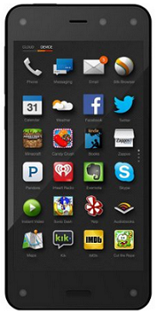Based on Loewy’s 3 principles – functions, cost to manufacture, and aesthetics, the Amazon’s Fire smartphone meets all 3. Nonetheless, this product is an epic failure for Amazon because the entire design, from its inception to mass production stages, was centered about its CEO Jeff Bezos.

I was a member of the design team. During product development process I found the Fire phone product planners particularly ambitious in planning for a product so difficult to bring to market, especially when the company did not have previous engineering experience with smartphone building. The picture on the left reveals such ambition immediately. Notice the 3 circles towards the top edge and the other 2 circles towards the bottom edge. Those are camera locations. The Fire smartphone takes 5 cameras to achieve the same functions of a single camera in smartphone from other makers. The drive to do better, faster, and cheaper resulted in an expensive, slower, and much worse performance when the Fire phone finally hit the market last year.

Another point worth mention here is that major smartphone makers such as Apple, Samsung, and Nokia, to name a few, had virtually an army of experts and a history of successful product deliveries to enable them to specialize in this highly competitive market segment. Amazon failed to see the complexity of building smartphones and took a big risky step to please its CEO because the Fire phone was Jeff Bezos’ baby. As a result, the resultant product resembled a shrunk-down version of a Kindle Fire tablet E-Reader, causing a big user disappointment right on the day the product hit the market.

Everyone in my team expected this poor user experience because throughout the process we were not building the phone for the customers – We were building it for Jeff Bezos. The CEO managed every critical decision to the point where we began second-guessing ourselves trying to anticipate how Jeff would react.

I am certain the outcome would have been different if Jeff had left the jobs to the experts. We had a UX team in the house, for peace sake. This failure had virtually disbanded my team. I hope Amazon leaders had learned a costly lessons to keep them from repeating this mistake in future products.owever, th