CST315  
**USER INTERFACE DESIGN TECHNIQUES**

HIEU PHAM

https://lh4.googleusercontent.com/1fjjSXmW6pbNPtjkH9Zw5iEcdN8vnn5DY6VN9j7gl08jZJyuq96wsKz_e5vFM7uS5kRTbIFRbLJevfZa_ugPekrEJbQq1K1dXrIbMNKUAvPd8WALkX7osvt0s4WuBN52m5iVAEkY

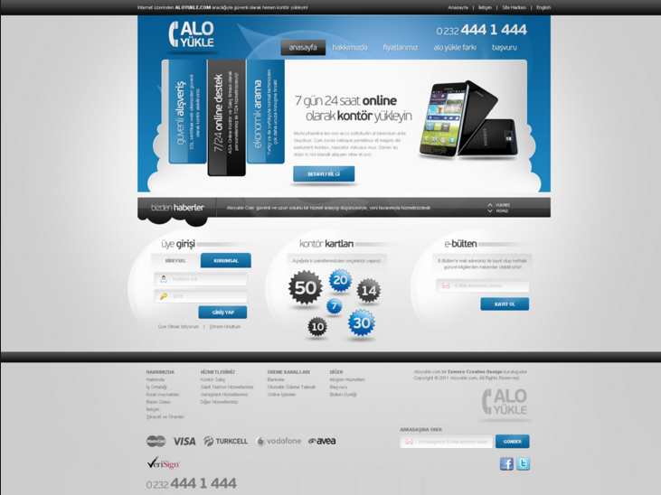

**Introduction**

In software engineering, there are many techniques available for User-Interface (UI) due to many software products. These techniques become application-specific because they work best for the specific type of application under development but not all application types. For example, the UI techniques used in Web application development are not optimal for a hand-held medical device. Nonetheless, they all share a common UI design philosophy that is simplicity.

**User Interface Design Element**

There was an illustration of the User-Centered Design elements in one of the handouts which showed the Interface Design as second element from the top. See  following image for details.

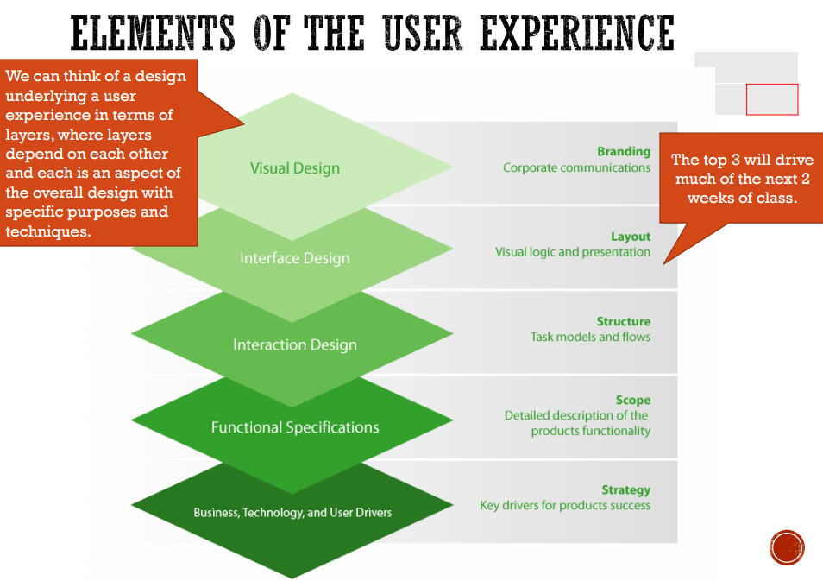

The Interface Design element itself involves layout of the user interface to support visual logic and presentation aspects; however, it only serves as a general approach to User Interface design because it is not a generic element. There must be problem-domain specific logic requirements to be considered. For instance, while it may be acceptable to use a design technique having options as shown below for a Web application, 

it may not be for an embedded medical device such as the picture below.

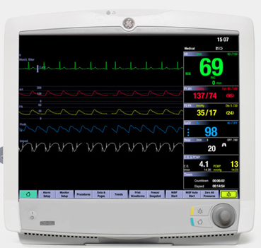

This is where Interface Design element listed in the UCD material needs further refinements to account for different classes of products . Furthermore, the ISO 13407 and ISO 9241-210 (2008) standards are for generic User-Centered Design scenarios. The requirements they impose are quite loose, making them unfit for use in more serious classes of products such as medical devices and military systems.

**Current Generic Best User Interface Design Techniques**

With increasing number of applications designed for operating systems running in Graphic Modes, some overall UI design techniques are currently being treated as known best practices, as listed below.

1. Visibility of System Status
2. Integration of keyboard shortcuts or navigation
3. Options, Upgrading/Downgrading
4. Advertise Features
5. Color-coded lists
6. Aesthetic, personalization options
7. Help Message display attraction
8. Strategic design of feedback messages
9. Proper use of Tabbed navigation
10. Modal window background coloring
11. Lightboxes and Slideshows
12. Short User Input Data forms

**Conclusion**

The most important aspect of User Interface design technique is to deliver a simple connection between the user and the product. The more intuitive and simple the user interface design is the more successful outcome of the product in the market. As the founder of Apple, Inc. Steve Jobs once said, “design is not just what it looks like and feels like. Design is how it works.” A statement so true since the overall usefulness of User Interface design is governed by how easily all intended functions are accessed by the users.