UCD AND EDP PROCESS MODELS – A COMPARE AND CONTRAST

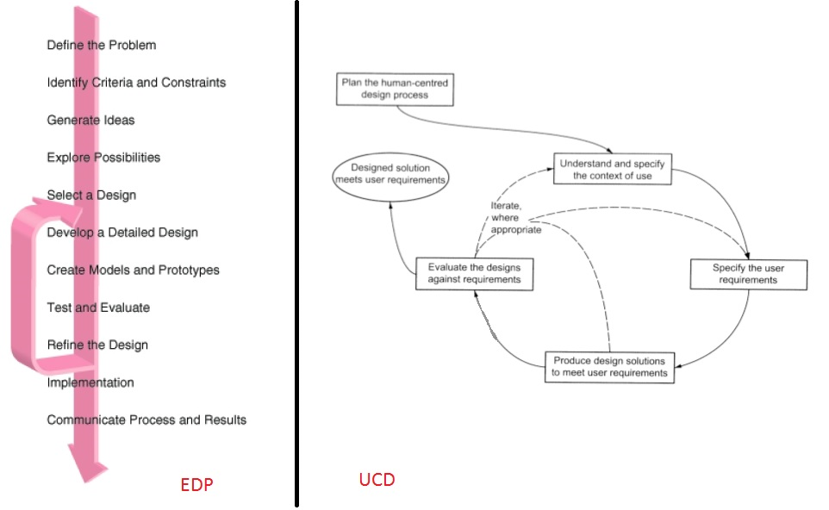

Figure 1: The EDP (left) and the UCD process (right)

The EDP and UCD process share many common steps. First of all, both processes are iterative. While the UCD process appears to look simpler than the EDP, it is quite easy to group a couple steps in the EDP to form an equivalent block in the UCD process. For example, the “Define the Problem” and “Identify Criteria and Constraints” steps can easily be combined into the “Plan the human-centered design process” block. The “Generate Ideas” step is arguably unique to EDP, but the “Explore Possibilities” of the EDP closely resembles the “Understand and specify the context of use” and “Specify the user requirements” blocks in the UCD process. In this case, the UCD process should merge the “Understand and specify the context of use” and “Specify the user requirements” blocks to be equivalent to the “Explore Possibilities” step.

Then, the EDP “Select a Design”, “Develop a Detailed Design”, and “Create Models and Prototypes” steps, after combining together, will form an equivalent “Produce Design Solutions to meet user requirements” block on the UCD process side.

The “Evaluate the Designs against requirements” block on the UCD process side is equivalent to the “Test and Evaluate” and “Refine the Design” steps on the EDP side.

The UCD process oval item labeled “Design solution meets user requirements” is definitely comparable to the combined “Implementation” and “Communicate Process and Results” steps on the EDP side.

Although both EDP and UCD processes share an important iterative signature, the UCD process differs from the EDP iteration in the selective iteration nature – The UCD process can iterate the “understand and specify the context of use” and repeat the entire design cycle as necessary, or it can iterate from the “Specify the user requirements” and repeat partial design cycle, or from the “Produce design solutions to meet user requirements” and repeat the shortest partial design cycle. On the other hand, the EDP loops is fixed from the “Refine the Design” step back to the “Develop a Detailed Design” step without selection for any step in between. In this sense, the UCD process is more robust and more logical to follow. However, I also came across an updated EDP as shown below:

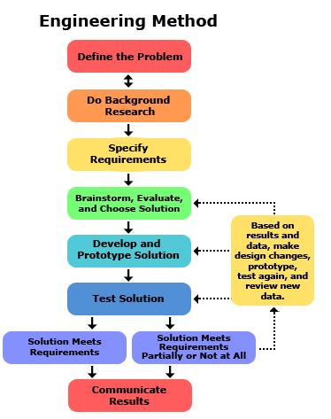

This updated model is definitely much better than the previous model and more compatible to the UCD model.

Part 3: Opinion

|  |  |  |  |
| --- | --- | --- | --- |
| EDP | UCD | PROS | CONS |
|  |  |  |  |
|  |  |  |  |
|  |  |  |  |
|  |  |  |  |
|  |  |  |  |
|  |  |  |  |
|  |  |  |  |