# **Task 1**

1. For the first principle, “User familiarity”, of the interaction design, I have to vote for the following web site: <http://go.coverity.com/register-for-scan-report-2014.html?utm_source=google&utm_medium=cpc&utm_term=static%20analysis&utm_campaign=gdn_na_static_analysis&utm_content=static_analysis_text&gclid=CLDjvcik7sgCFQRrfgodjDsBxw> . The name of this company is Coverity. It is a software development firm specializing in source code analysis. Despite the complexity of the business that this company deals with, its web site design for user-based project request is very simple.
2. For a bad IxD design, the Cadence Allegro PCB Editor UI design has the worst design in the world. This type of design suggests a lengthy learning curve while promising to remain in this graphical arrangement for a long time to sustain the same UX level. An example is shown below.

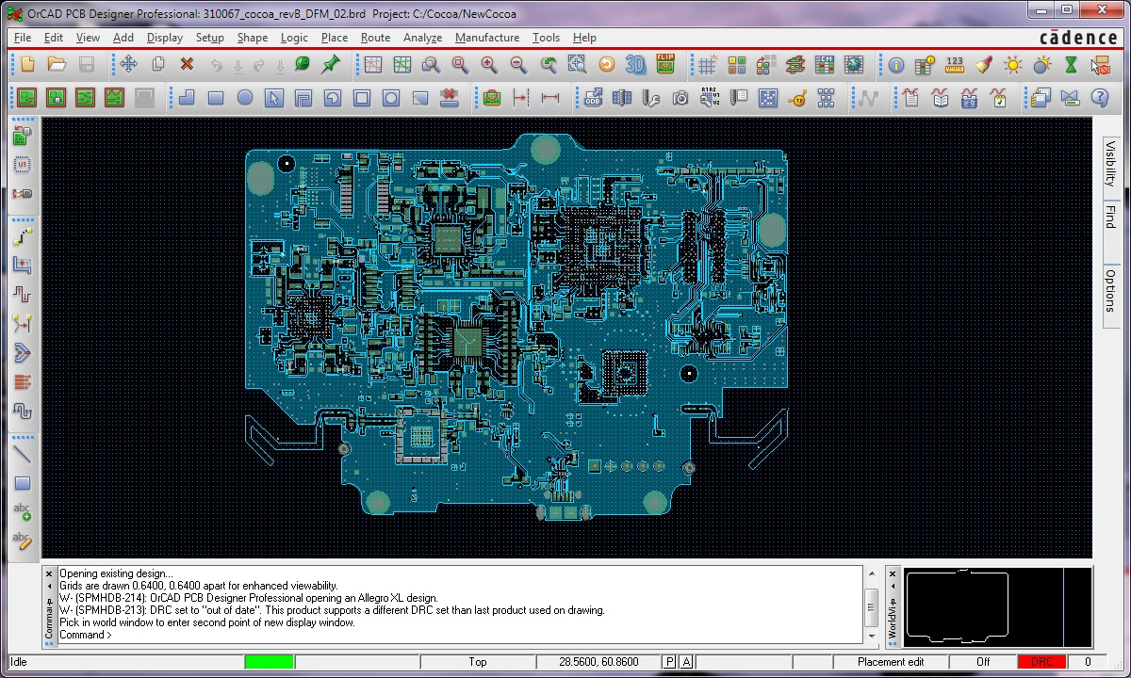

Figure 1: Complex UI/IxD

1. For “Consistency” IxD, my vote is for an open-source operating known as Ubuntu. This operating system managed to maintain good consistency throughout revisions, resulting in a good UX and very minimal adjustments from the users to the new release. For example, there were not too many changes from an UI perspective between version 12.04 LTX and version 14.0 LTS.
2. In contrast, Microsoft Windows operating system Windows XP version transitioned to Windows Vista with much disappointment from the users because the UI changed drastically. See picture below for details.

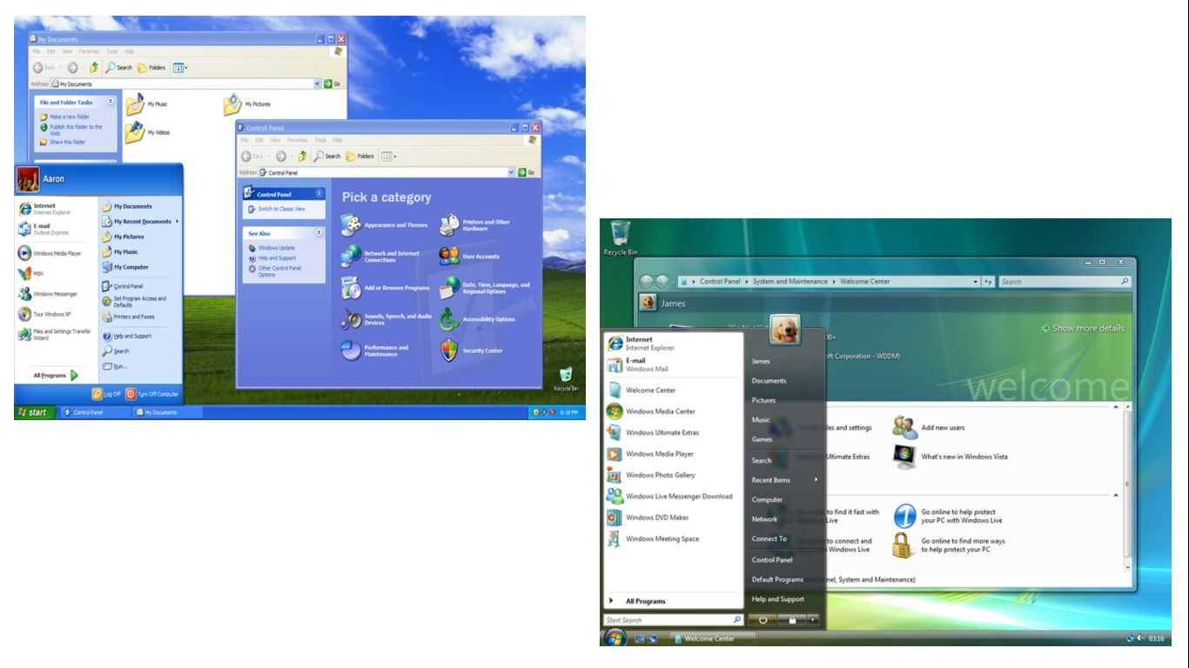

Figure 2: IxD with inconsistent UI implementation.

1. For “Minimal Surprise” IxD, the best implementation is <http://combadi.com/>. This site keeps everything as intuitive as possible to maintain visitor’s interest level while surfing the site. No extra pop-ups with confusing messages to steal the focus allowed. The UI was simple large buttons or links.
2. In contrast, a GUI design such as the one shown below will pose a big surprise to color blind users and other type of users for the amount of items it shows.

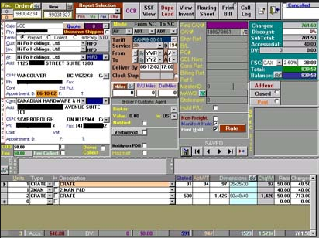

Figure 3: IxD with color choices unaccounted for color blind users.

1. For “Recoverability” IxD, my vote is <https://www.tumblr.com/> . The picture and messages explained very much of what happened to the site. No recovery needed here as the user can leave the site with the back arrow browser click. See figure 4 below.



Figure 4: Down time error

1. In contrast, a recovery strategy such as shown below may stir up unnecessary emotion from its users due to many red errors.

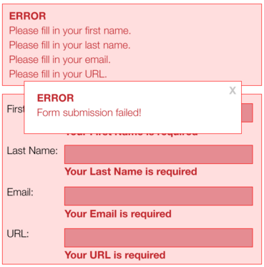

Figure 5: Sea of errors.

1. For “Guidance” IxD, my vote is the implementation shown in figure 6 below. The guidance pointed out, by using a signpost, what the user failed to provide.



Figure 6: Good IxD guidance

1. In contrast, A simple guidance to where the errors are, as shown on figure 7 below, needs more explanation so the users may know what the proper inputs must be to prevent recurrences.

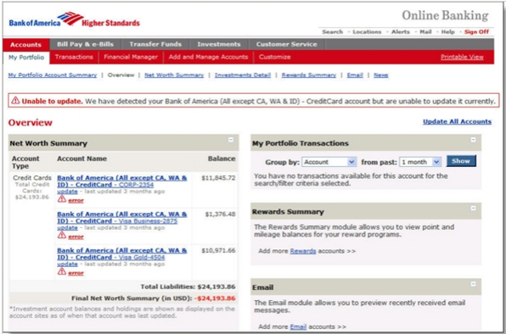

Figure 7: Bad IxD guidance

1. For “User Diversity”, I must agree that <http://www.wrigley.com/> does this best. As shown in figure 8 below, users from Asian culture and European culture were taken into account naturally here.



Figure 8: Good IxD that considered user diversity.

1. In contrast, <http://www.drivingskills.on.ca/> did not care to keep their web site simple. They have messages in the background, graphically display as cloud or O-ring smoke patches, and a host of bad techniques including the use of Canadian and US flags, having thoughtless messages and lengthy scrolling to the bottom of the site to gather additional information.

# **Task 2**

The following sites utilize Hub/Spoke taskflow:

* <http://www.facebook.com>
* <http://www.flipboard.com>
* <http://www.foursquare.com>

A good example for IxD employing the Wizard taskflow is Microsoft Office, as shown below.

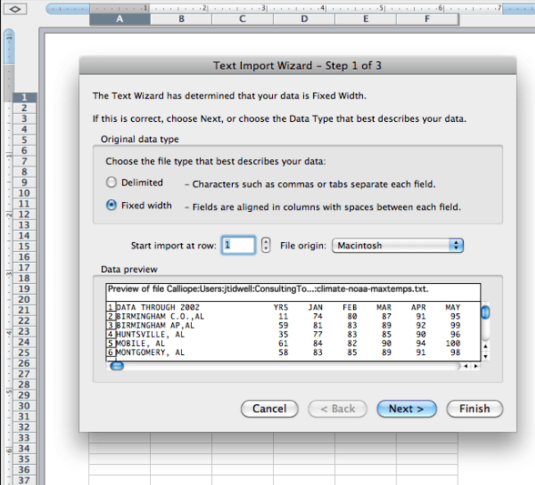

Figure 9: Wizard task flow found in MS Office.

Also from Microsoft .Net Visual Studio design suite is an IxD utilizing Guide task flow, as shown in figure 10 below.

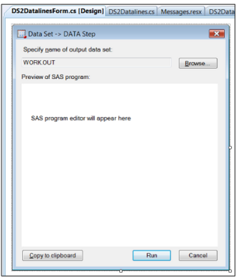

Figure 10: IxD with Guides.

In this design, Guidance messages exist in each tab, showing user what to do next.

IxD utilizing “Progressive Disclosure” exists in mobile operating systems and applications as shown in figure 11 below.

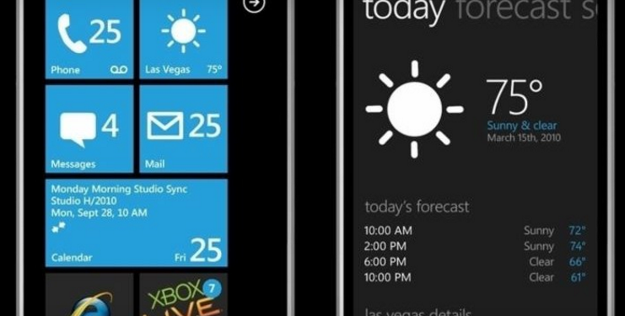

Figure 11: IxD utilizing Progressive Disclosure.

This technique represents balances two contradicting requirements, simplicity and completeness, via a simple, yet powerful idea:

1. initially, show users only a few of the most important options
2. offer them a larger set of specialized options upon request by disclosing additional features only if a user asks for them or needs them.

# **Task 3 – Scenarios**

Timothy (Tim) Spaciba takes PHY122 from ASU online this semester. The online class redirects Tim to the Kentucky Education Television website where his assignment is located. As the first time user, Tim decides to visit the site to get familiar with it. Tim then logs in with the user name and password provided to him by Professor Tracogna. Tim discovered that he has 2 tasks to be handed in. Tim was asked to complete a calibration of a couple of equipment prior to the experiment for a few different measurement ranges. Thereafter, Tim conducted his kinetic motion in 2D experiment and collected the raw data which must be displayed graphically to show rate of change. Tim becomes more curious about other items on KET site and learned that they are not available yet. Time then finishes up his 2 tasks by a short write-up, followed by an email to Professor Tracogna with some questions and publishes his work. He logs out after midnight.