UCD TECHNIQUE – PERSONA, USE CASE, AND PROTOTYPING

**Application of the UCD Process**

1. Plan the human-centered design process
2. Understand & Specify the Context of Use

**Who are the target users (Stake holders)?**

1. Industry Co-op/Intern managers
2. University faculty
3. Software Engineering Senior Students

**Identify User Profiles**

The following set of characteristics is considered as general user profile,

* Age
* Gender
* Education
* Computer use level
* Computer comfort level
* Alternate mobile device comfort level
* Business background

**Personas**

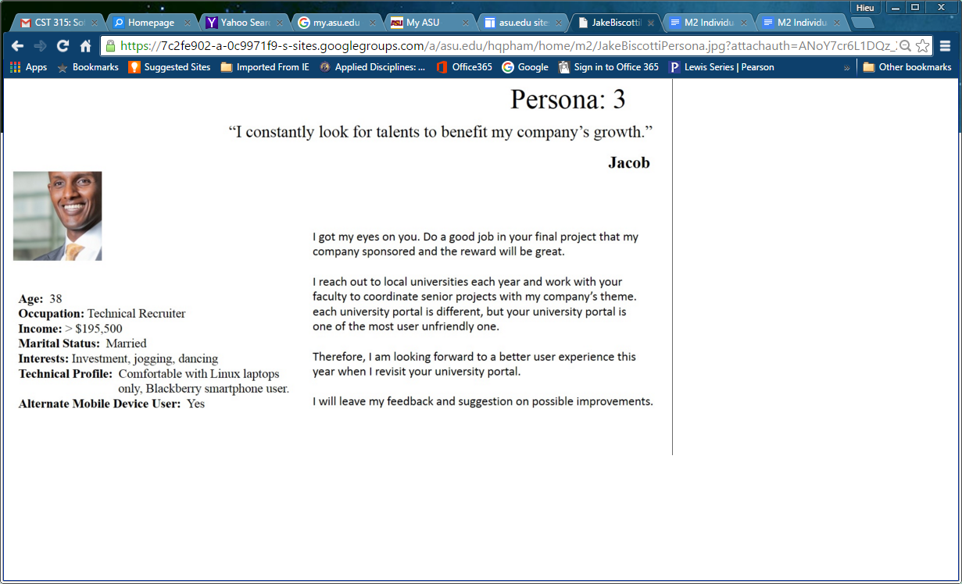

Figure 1: Persona for user type 1

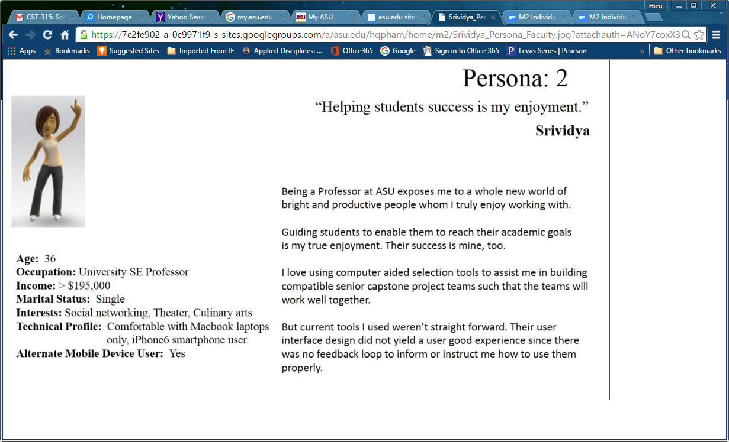

Figure 2: Persona for user type 2

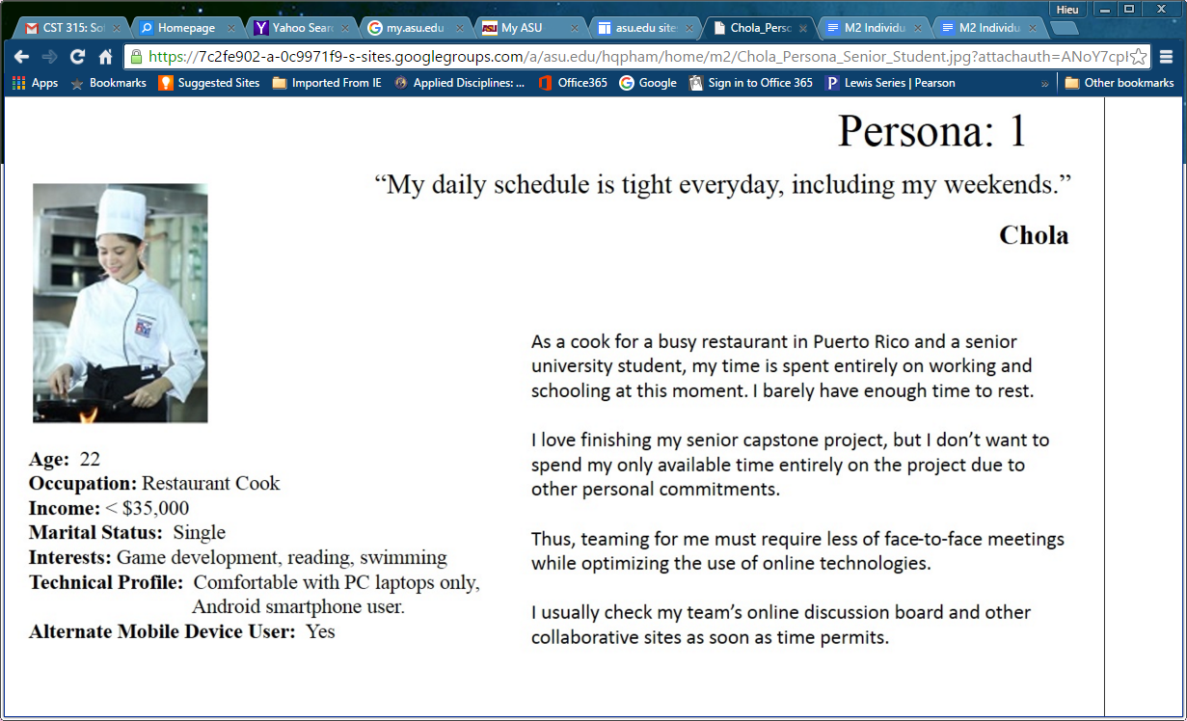

Figure 3: Persona for user type 3

Once I got all the personas worked out, I am moving on to the next step which involved creating a Use Case Diagram. I decided to use Visio because I owned a copy of this software in my laptop. Otherwise I would use Visual Paradigm. The image below depicts the conceived use cases.

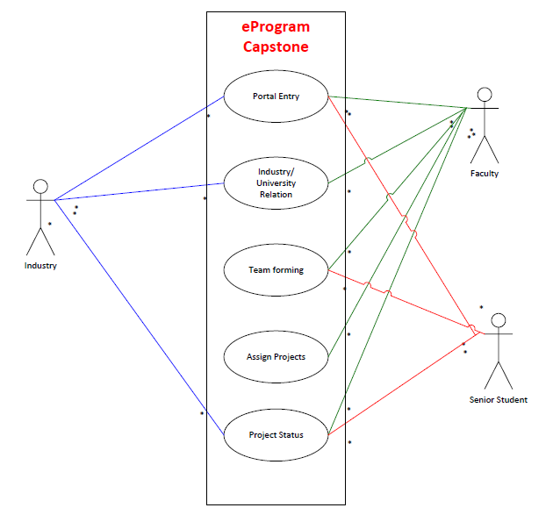

Figure 4: The conceived use case diagram

I came to the online meeting with my team. We decided to use online whiteboard as a means to communicate our ideas. We held a couple of sessions to decide the way we would like our prototype to look. I went ahead and re-iterate a few more turns to convert into my individual prototype. The image below depicts a general UI for which I will code my application by.

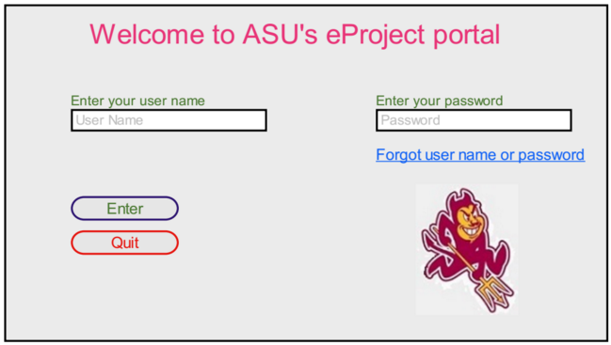

Figure 5: The first UI – The portal.

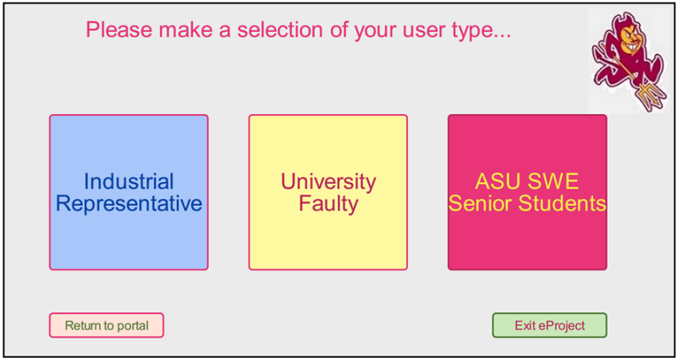

Figure 6: The second UI – User Type Selection

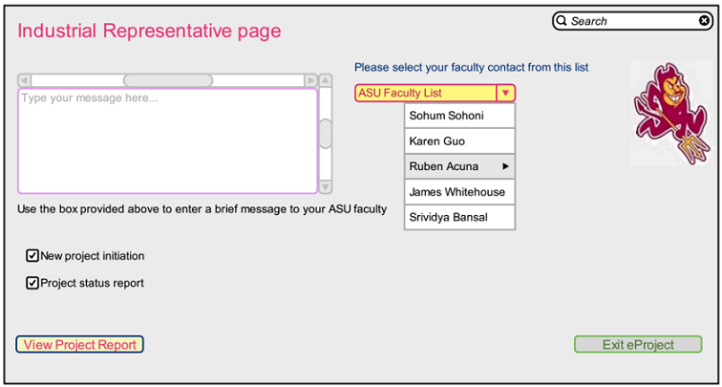

Figure 7: Third UI – Industrial Representative page

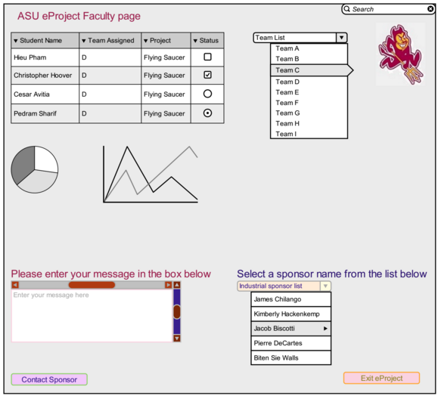

Figure 8: The fourth UI – Faculty page

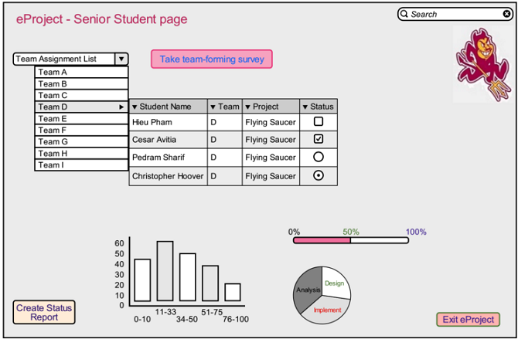

Figure 9: The fifth UI – Student page

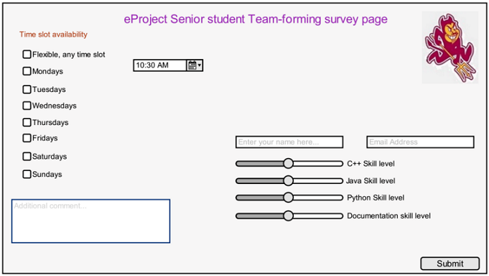

Figure 10: The sixth UI – Student team-forming survey page

# Persona Research Techniques

In this assignment I did not engage real human to create my personas due to not knowing anyone besides my team. So I employed virtual humans to get through the assignment.

The greatest strength in creating a persona is to enable designer to fine-tune the general design method to accommodate for target end-users due to one simple fact that not all applications are designed for everyone – We normally design software to serve a specific group of users.

The greatest weakness in creating a persona is the ever changing mood of users under study that have direct impact on the outcomes. The information we gathered for the persona at one moment may not be true at a later time, thus an erroneous persona.

Using persona alone is not a good approach to UCD due to the purpose of persona in the context of UI design. Personas work best with other techniques such as JAD where clarifications can be made, in addition to Use Case Diagrams, Mind-Map, and many other techniques.

My prototype had gone through 3 iterations. The first iteration only gave a general idea and provided a detection for the missing requirements which did not get prototyped for. Subsequent prototypes captured the rest of the requirements.

Hand-drawn sketches are good for presenting a “quick and dirty” idea for what the prototype looks like the first time through the design.

Tool-oriented sketches serve 2 purposes:

1. Formal UI design
2. Simulation of UI design