**Issues with Air Pollution in Asia**

Managing growth in sustainable ways remains to be one of the greatest challenges facing humanity in the 21st Century. The consequences of economic growth, coupling with its effects on the environment, in addition to possible changes to global climate, is a primary concern. Although from a political perspective the topic remains controversial. Scientific communities argue that human emissions of CO2 could contribute to a global greenhouse effect, resulting in an increase in global temperature known as the “global warming” crisis. Developing countries in Asia have recognized climate change as a potential threat and have taken steps to reduce emissions with varying success, but China and India have shown that their emissions are growing rapidly, and their industrialization may contribute to a noticeable increase in CO2 emissions despite the environmental protection efforts of other developed countries.

Since 1900, atmospheric CO2 concentration level has risen from the historical baseline determined by ice core measurements[1]. In the same period, global CO2 emissions from fossil fuel burning has increased by one order of magnitude, and global average temperature has increased nearly 1°C[3].

Unfortunately, the United States was also a global leader in CO2 emissions and energy usage in the latter half of the 20th Century per statistics produced by Gapminder World web site, as shown in figure 1-1 below.

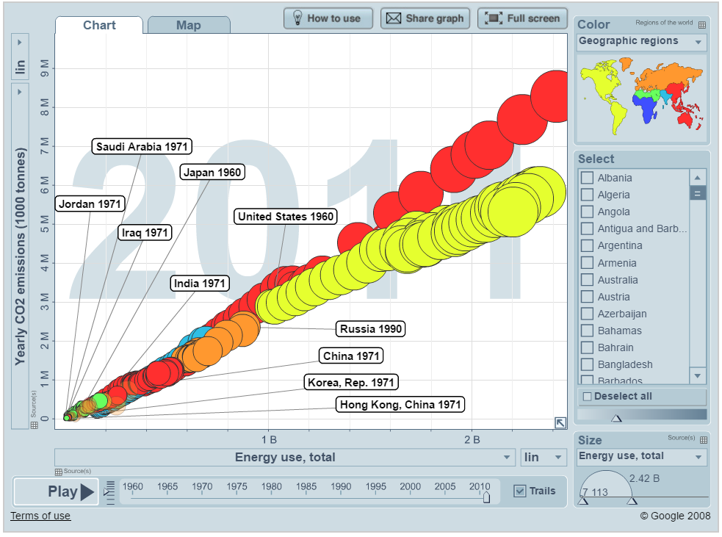Figure 1-1 Changes in total energy use and CO2 emissions of highly populated countries on each continent, 1971-2011

Although starting from a high baseline, however, the growth of CO2 emissions in the United States has remained slow, regressing in the first decade of the 21st Century. On the other hand, China had unprecedented growth in CO2 emissions from 2001 to 2010. China's CO2 emissions in 2001 were comparable to the United States in 1966, and China's CO2 emissions in 2010 had surpassed that level at least by 2-fold. India, though starting from a smaller baseline, its CO2 emissions also nearly doubled in the same period. India now has the third highest CO2 emissions, after the United States and China.

Evidently, CO2 emissions in developing countries have increased at a rate of 4.4% per year, as compared to a 1% increase per year as a global baseline[2]. Coupling with the recent economic growth in India and China, this change may quickly become uncontrollable if it is not brought to attention immediately. Controlling CO2 emissions is clearly a global interest because of its permanent global impact. To this end, the United States, Russia, and other well-developed countries must continue to take steps to reduce their own CO2 emissions, but they must also help China and India grow responsibly to keep their CO2 emissions in control.

[1] Rapp, D, *Assessing Climate Change*. Springer, 2014.

[2] Ravindranath, N; Sathaye, J, *Climate Change and Developing Countries*. Springer, 2002.

[3] Boden, T.A., Marland, G., *Andres, RJ, Global, Regional, and National Fossil-Fuel CO2 Emissions*. Carbon Dioxide Information Analysis Center, 2010.

Counter argument

While I agree that a high driver for nations acquiring computers and technology is so that they can compete and interact on the global setting, I also believe much of this has to do with the cost and aid. As you stated in regards to Ethiopia implementing more tech-focused higher education programs, I would say that much of that is possible through lowered cost of technology and aid from other countries. As an example from my own past, my first computer was priced over $2000 dollars and didn’t even have a GB worth of hard drive space; and that was the late 90s. Now computers with much more power and capability can be purchased today at a lower comparable price than in the past [1], [2]. So basically, since the cost of technology is much lower than it once was, more and more affordable computers can now be purchased by the people. As you can see in Figure 1-1 above, the number of computers in total by nation increases as the people in the nation becomes wealthier.

As I mentioned before, initiatives have also been taken by many countries to aid in the supply of computers to tech-limited countries [3]. Many of these low-income countries have taken advantage of this by starting computer literacy programs and teaching the educators on how to use technology in the classroom [4]. As technology education increases, I can see more and more interest in the field, as you stated before. So with low cost, plus aid, plus interest in the field, I can certainly believe an upward trend in the number of total computers in a country.

References

[1] BLS. (2013). *Recent Price Trends in the Computer & Peripheral Industry*. [Online]. Available: http://www.bls.gov/mxp/computer.pdf

[2] M. Perry. (2009). *Computer Prices Have Fallen By 90% Over the Last Ten Years: Is That Evidence of Monopoly Power?* Washington Post. [Online]. Available: http://wallstreetpit.com/4300-computer-prices-have-fallen-by-90-over-the-last-ten-years-is-that-evidence-of-monopoly-power/

[3] Computer aid reaches key milestone. (2012). Appropriate Technology, vol. 39(2), pp. 45-47. [Online]. Available: http://login.ezproxy1.lib.asu.edu/login?url=http://search.proquest.com/docview/1029864461?accountid=4485

[4] E. Gaible and M. Burns. (2005). Using Technology to Train Teachers: Appropriate   Uses of ICT for Teacher Professional Development in Developing Countries. [Online]. Available: http://www.infodev.org/infodev-files/resource/InfodevDocuments_13.pdf.