**Module 1 Learning Objectives**

1. Navigate EGR 104 - Critical Inquiry in Engineering online
2. Identify course objectives, expectations
3. Summarize **intellectual traits** important to engineering reasoning
4. Identify the **structures of thought**
5. Network with peers as class

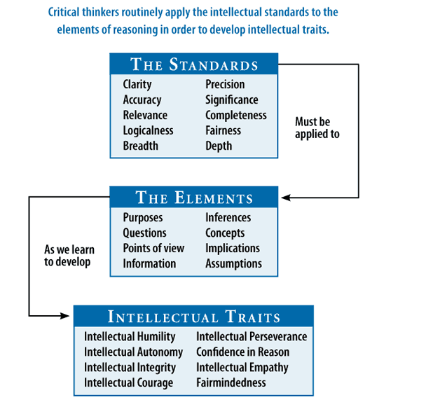

The **8 Elements** to live and breathe throughout this training:

1. **Purposes**
2. **Questions**
3. **Points of view**
4. **Information**
5. **Inferences**
6. **Concepts**
7. **Implications**
8. **Assumptions**

**Module 2 Learning Objectives**

1. Interpret **Elements of Thought** in engineering
2. Explain **Intellectual Standards** in your own words
3. Demonstrate the elements of thought in summarizing intellectual traits in historic engineering examples
4. Apply the four components of formulating questions with PICO