**Bastian the Consultant**

**Nationality:** German

**Age**: 30 - 35

**Gender**: M

**Education**: Masters’ degree

**Languages**: German / English

**Degree**: Economics & MBA

**Experience**: 7+ years

Bastian is an experienced economist with a master’s in business administration and many years of experience on the field whilst managing it, great with customer service, experience as a consultant and as a team leader. Has never used a generator as he is skilled and likes to personalize the cover letter but would like a bot cross reference with the ad and his cover letter or a draft created as a start.

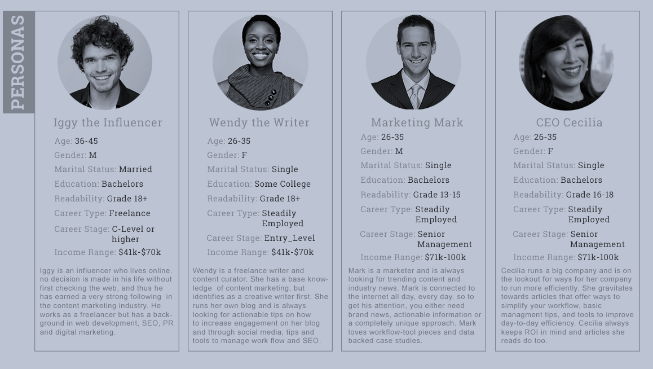

**Applications**: 3 -5 specific applications per month

**Time spent creating cover letters**: 1 – 2 days, trying to make it perfect.

**Channels used**: LinkedIn, Xing, Monster Jobs, Indeed and mostly directly with the company.

**Cover letter requirement**: High

**Top needs from the app**: Job searching engine, referral person search, salary estimator and interview bot for preparation.

**Sandra the Expat Marketing Major**

**Nationality:** American

**Age**: 25 - 27

**Gender**: F

**Education**: Bachelors’ degree

**Languages**: English

**Degree**: Marketing

**Experience**: 3+ years

Sandra is coming to a new country trying to find a job but is unaware of all the changes she requires to do to her cv and cover letter style to have a good standing with the new German companies she is applying to and is slowly learning now about her mistakes after months of not replies from all her hard work applying. Used a generator once but it was not so helpful for her to learn structure or manage to get the point across. Would like to use one to help her get the main information in and the specify the small details so she can tailor her CV and cover letter to the new margins and structural style required in Germany within er field.

**Applications**: 10 - 12 applications per month

**Time spent creating cover letters**: 2 – 4 hours

**Channels used**: LinkedIn, Indeed and company sites.

**Cover letter requirement**: Medium - High

**Top needs from the app**: Job searching engine, job matching algorithm, bot review and learning the new cover letter and CV structure used abroad.

**Kunal the Computer Science**

**Nationality:** Indian

**Age**: 23 - 26

**Gender**: M

**Education**: Masters’ degree

**Languages**: English, Hindi

**Degree**: Computer Science

**Experience**: 4+ years

Kunal is an a computer science major with experience in IT consulting, coming to a new country through his studies to fins himself having a hard time getting interviews, and when he does, he always get the rejection in the last round. To get a better chance of finding a job, he needs to play the numbers game. Kunal wants to be able to apply to more jobs without spending so much time on cover letters when needed and to be able to practice his interviewing skills to see what he can do better. He wants an efficient generator that gets his point and skills across without have to spend days procrastinating for each one as he is better with coding than he is in selling himself.

**Applications**: 6 - 7 applications per month

**Time spent creating cover letters**: 1 -2 days

**Channels used**: LinkedIn, Indeed and company sites, Stepstone, Glassdoor, etc.

**Cover letter requirement**: Medium

**Top needs from the app**: Skill matching, bot review, bot interview practice, grammar check and job searching / matching.