**>. Blog Article Template**

*This template should help you to write your blog article, the mentioned questions present just a guideline but are no fixed content.*

*The goal is to present your project from problem description to solution strategy to implementation in a concise way. To whom it should be addressed depends on who you want to present it to in the future. Overall, you can assume that your reader understands the technical basics and has some prior knowledge. Images help your readers to better understand your project. Especially when outsiders read the article this can be a huge advantage! However, images are not a must from our side.*

*Your blog article should be two (max. three) pages.*

*With sending this document to those responsible for TechLabs Dortmund e. V., you agree that TechLabs Dortmund e. V. can use the included information, images, and personal data for publication on their e. g. websites, social media accounts and events, especially for the publication on techlabsdortmund.medium.com as well as in promoting events.*

*We took note of the disclaimer.*

*The following information appears on the certificate and on the blog!*

**Project titel:**

TraDel

**Project tagline:**

Please advertise your project in a short, meaningful sentence.

Let’s revolutionize global shipping together!

*This project was carried out as part of the TechLabs “Digital Shaper Program” in Dortmund (winter term 2021/22).*

**In a nutshell:**

Please give a brief (4-5 sentences) summary of your project.

TraDel – Travel Delivery – is a non-commercial Crowd Shipping platform for private shipping connecting travelers who have some luggage space left to people who search for an affordable shipping option around the globe. Using available travel routes for private shipping can open new, more flexible and cheaper shipping options while reducing emissions and allowing travelers to compensate travel costs as well as doing something good. The website has a straightforward structure with a register and login function and the options to post a delivery request or offer and to search for available posts. Once a match is found all shipping conditions including price and date are privately discussed between the users.

*The following information appears on the blog!*

**Introduction:**

What was the idea / background of the project?

Which was the specific problem to be solved?

What was your solution approach?

Many people leave their home countries temporarily or even permamently for studies abroad, as expats or for other, diverse social or economic reasons. The number of international migrants increased across the globe over the past decade, especially in Europe, Asia and North America [1]. Nowadays, in a highly globalized and digitalized world it is easy to stay in contact with the loved ones at home but it is expensive or in the case of less-developed countries sometimes simply not possible at all to ship private packages, globally. For example, private shipping of a simple package between 2 kg and 5 kg would cost between 8 € and 16 € from Germany to a destination inside the European Union [2], about 27 € to the UK or Switzerland and 37 € to 45 € to the USA, China or another international destination [3]. However, prices for international shipping to Germany can substantially differ, especially for less developed countries with other currencies. Sending a 4 kg package from Nigera to Germany would again for example cost about NGN 148.412 [4], which is about 323 € [5].

The solution?

TraDel, “Travel Delivery”, is a a non-commercial Crowd Shipping platform connecting people searching for a delivery option with travelers which have some luggage space left. The benefits of using available travel routes for private shipping are the opening of new shipping options which might be cheaper and more flexible than offered by commercial logistic companies. Furthermore, emissions, pollution and noise which would be caused by extra shipping routes can be reduced. Travelers delivering the package could make some extra money and thus, compensate parts of the travel costs and actually make somebodies day by helping delivering packages to their loved ones - tech for good!

The project aims to offer a platform, which operates like a marketplace where people can post delivery requests or travel offers. All shipping conditions, such as time, price, items or legal requirements for customs are then privately discussed and decided by the users. This is the key value of TraDel: in contrast to available shipping platforms TraDel is strictly non-commercial, does not charge any additional fees for using the website and has no restrictions for shipping destinations, price or payment options. The only limitation is that the website can only be used for non-commercial items which do not violate any federal, national or international law, or any requirements of customs laws or other regulations that may apply as well as requirements by transport companies, e.g. airlines, regarding safety.

**Methodology:**

How did you proceed to develop a solution?

Which methods / tools from your learning tracks did you use to solve the problem?

Our project team consisted of web developers and data scientists but as the focus of the project was to create a Crowd Shipping platform it did not necessarily require data acquisition and data analysis. Thus, we focussed on building a website with a basic, straightforward, clean design and structure using html, css and javascript. Using the python knowledge we created SQLite databases for storing user information such as name, address and contact details and shipping information such as destination, package weight and delivery date and connected those to the developed website using FastAPI. For editing and sharing codes we used Visual Studio Code and GitHub.

For project management we used a notion website created for the project including available options for recording notes, editing texts for the website, preparing and tracking the project roadmap and To-Do’s. For sharing larger files we used Google Drive. Additionally, the project channel on Slack was used for quick updates and discussions, weekly project meetings as well as the regular project updates and mentoring sessions with the TechLabs mentors.

**Results:**

What is the final solution of your project?

What are the central results of your project?

What is the impact of your results?

What could be possible next steps in the development of your project?

What could be a long-term goal for this project?

The first version of the website starts with a short introduction and information on the project idea, the benefits and the functionality and includes a short FAQ section. As intended the structure and design was kept clear and simple using a single-page web design as well as plain colours.

For using TraDel the users need to register and provide basic user information via the register form. All user data are stored in the respective database. Afterwards, the user can login and post a delivery option again providing basic information such as the start point, the shipping destination and package weight. In this form the user also needs to select if it is a delivery request (in case of a package sender) or if they want to offer a delivery (as traveler). These data are stored in a second database.

To connect the travelers with the package senders the website also offers a search option, which is connected to the database. Using this function all available offers and requests can be filtered and - in case of a match - the contact details of the matching users should be found. All shipping conditions such as price, date, size, weight and content of the package as well as additional information such as custom information are then privately exchanged, discussed and decided by the users. Currently, the search function is available in the backend and will be fully integrated in the frontend in the next steps. In a later version of the website, the search function should then also be connected to a chat function, so that all personal details and shipping information can be exchanged and discussed on the website itself.

Furthermore, a user rating system and user verification system (using the phone number, mail or ID) should be implemented in a later version, as well. This functions ought to provide quality assurance and ought to prevent misuse of the platform. To increase the user experience the website might at a later stage also provide further information on customs and legal regulations which might apply as well as available shipping options and shipping costs from commercial logistic companies. The commercial costs might also function as reference value for negotiating shipping prices on the website. Thereby, TraDel ought to provide people with the possibility to send packages to their friends and relatives in the most cost- and stress-efficient way.

**GitHub repository (and similar):**

All your data must be uploaded to the GitHub account of TechLabs Dortmund e. V. by the submission date on April 5!

https://github.com/TechLabs-Dortmund/shipping-platform-for-less-developed-countries

**Team members:**

Track: First name, surname [email, LinkedIn, responsibility in the project, …]

Web development:

- Paulinus Ayere Aghughu (paulynpen@gmail.com)

- Hikmatullah Ahmadzai (hiko.a1919@gmail.com)

Data Science (Python):

- Michael Majemite (michaelmajemite@gmail.com)

- Paul Imhomoh (paulgeoph@gmail.com)

- Taylan Yildiz (taylan.yildiz@tu-dortmund.de)

- Nele Markert (n.markert@posteo.de)

**Team mentors:**

First name, surname, responsible project part / track

- Miguel Krause, Data Science & Web Dev Mentor

- Nils Jannasch, Web Dev Mentor

- Tom Stein, Web Dev Mentor

- Saumya Bhatt, UX Design Mentor

**Sources:**

For reasons of data protection, it is necessary that if you are using somebody else's data, you need to cite your sources over here.

[1] IOM (2022). World Migration Report 2022. https://worldmigrationreport.iom.int/wmr-2022-interactive/

[Accessed: April 05, 2022]

[1] European Commission (2022). Public tariffs on cross-border parcel delivery services. Year: 2021, Origin: Germany,

https://ec.europa.eu/growth/sectors/postal-services/parcel-delivery-eu/public-tariffs-cross-border-parcel-delivery-services_en

[Accessed: March 27, 2022]

[2] DHL (2022). Prices DHL Germany Paket International.

https://www.dhl.de/en/privatkunden/pakete-versenden/weltweit-versenden/paket.html

[Accessed: March 27, 2022]

[3] DHL (2022). Prices DHL Nigera – Get a quote.

https://mydhl.express.dhl/ng/en/shipment.html#/rate-and-quote#delivery-options

[Accessed: April 03, 2022]

[4] finanzen.net (2022). Währungsrechner: Naira - Euro

https://www.finanzen.net/waehrungsrechner/naira_euro

[Accessed: April 03, 2022]

*Please make sure that your text is long enough so this line appears at least on page 5, but not on page 7!*

**Figures / Images (optional):**

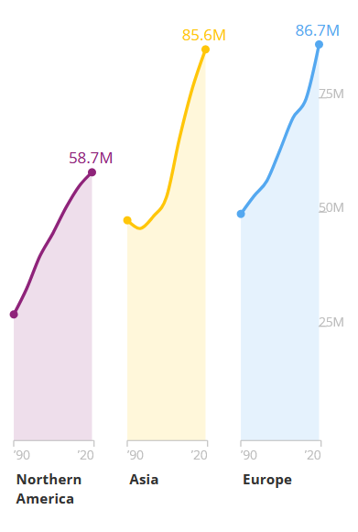

Figure 1:Number of international migrants across North America, Asia and Europe (©UN DESA 2021 [1])

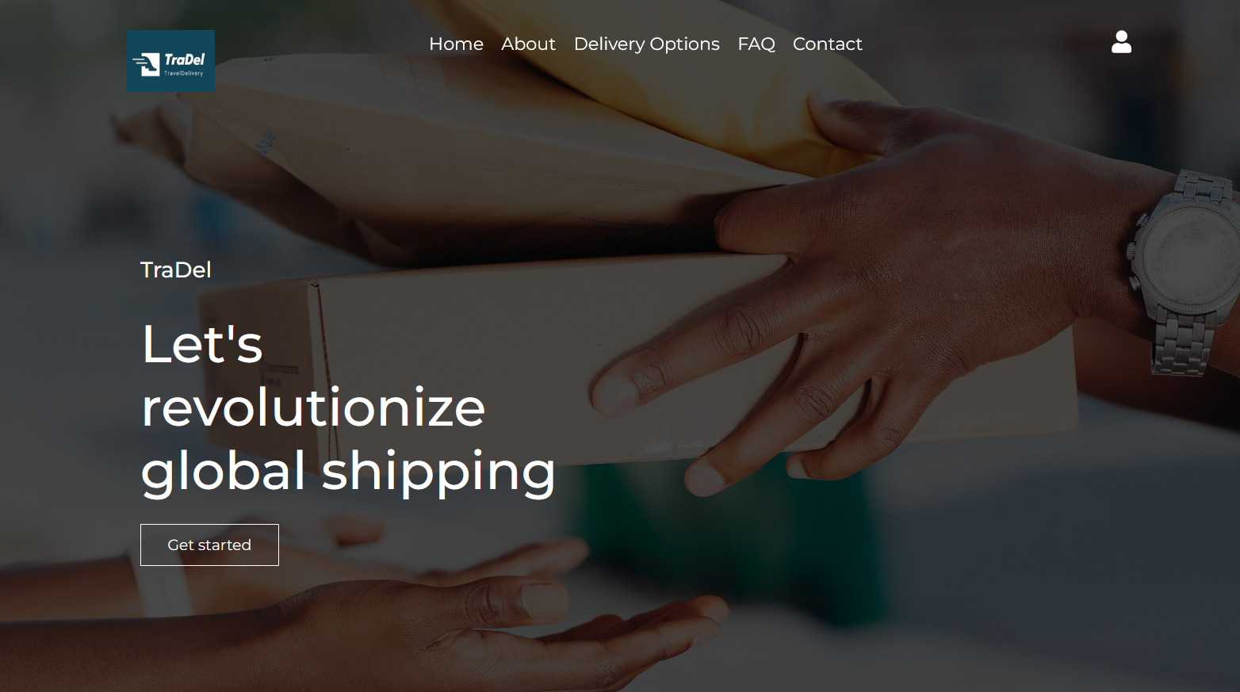

Figure 2:TraDel – Header

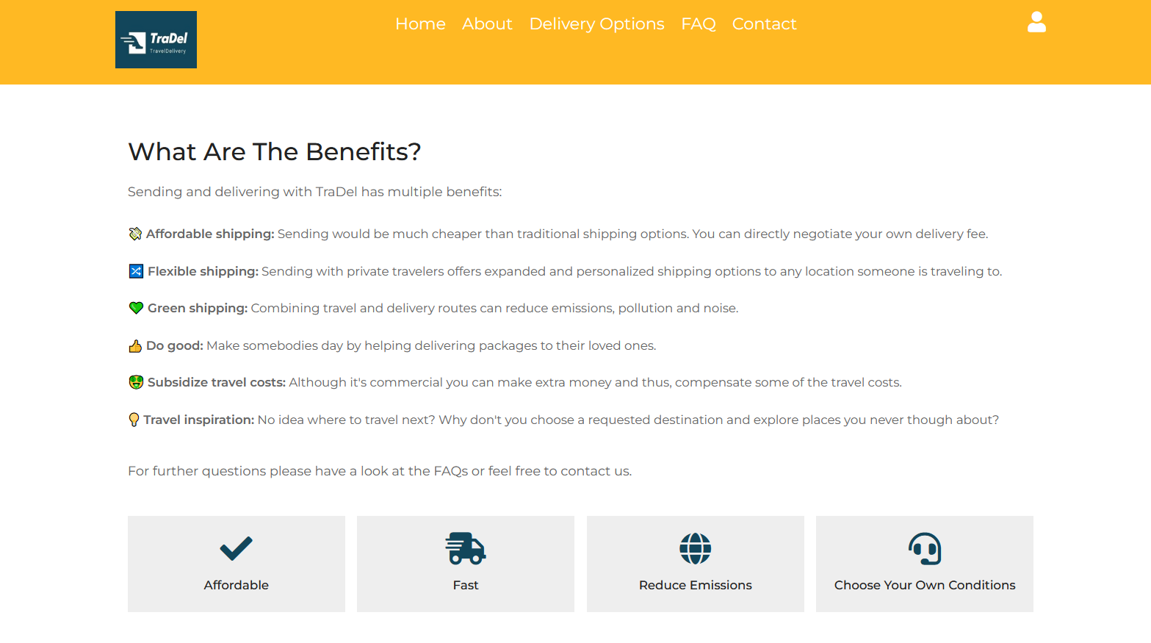

Figure 3: TraDel – Benefits

**Video (optional):**

Your video needs to be available as a (private) YouTube link!

**[none]**