# Redirect when admin logged in successfully

# Check on Add Product Type (New Id) - Done

# Check Product Paging - Done

* Resolve : sort based on PROID

# Delete on all page in admin if had - Done



# Seller: Click on Id to edit product - Done

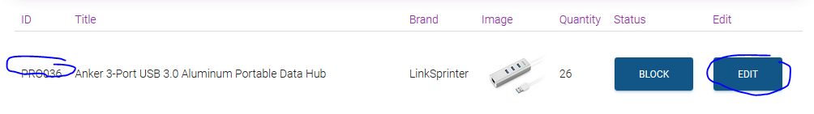

# xxxDetails : create list of 2 products based on type or cate

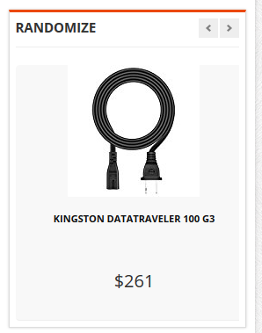

# Create Add to Cart link - Done

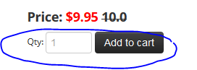

# Create Add Comment - Done

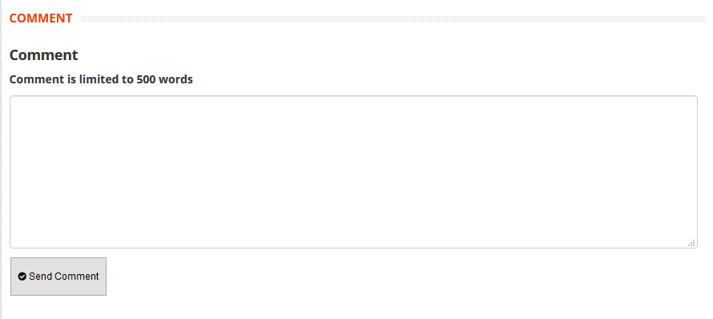

# Find and change banner - Done

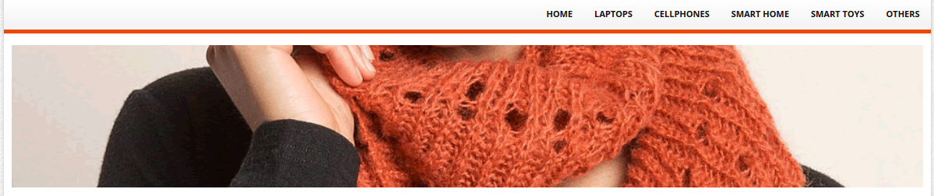

# Search on Index => Apply for Business Rule - Done



# Create Dynamic Data for search on Index

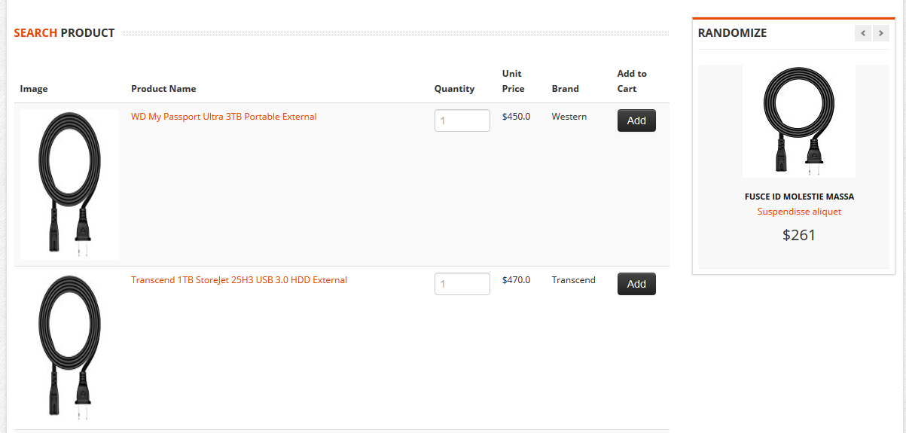

# Update Text for link on blue hightlight and Update text and link for Red hightlight field => New rule concern

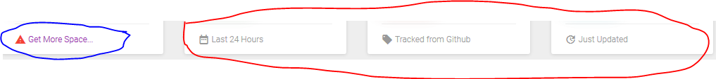

# Still show Customer or Seller or Product or Cate or brand but change text and link on button from Block to Enable - Done

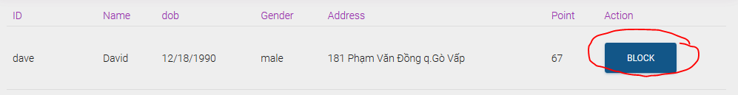

# Check on Servlets (View – Highest bug)

# Click on Name to show Details

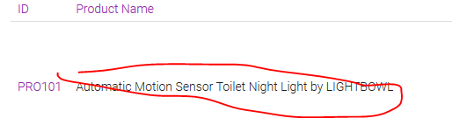

# Create Filter and Search for User in Customer Detail

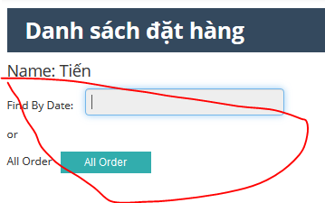

# Fix link for Home on Customer’s pages - Done

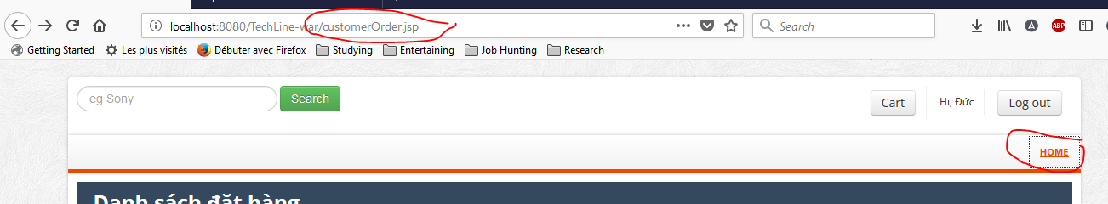

# Fix on Brand Icon for Customer’s pages. - Done

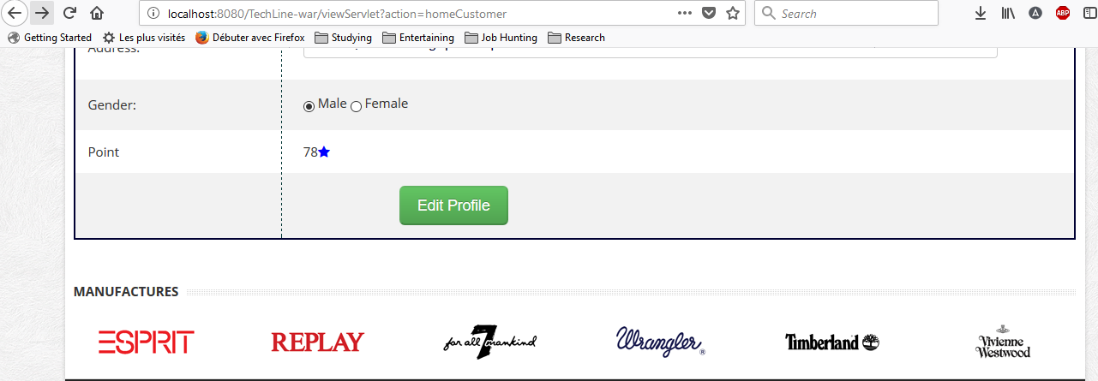

# Same in Discount and Seller Product on Index page - Done

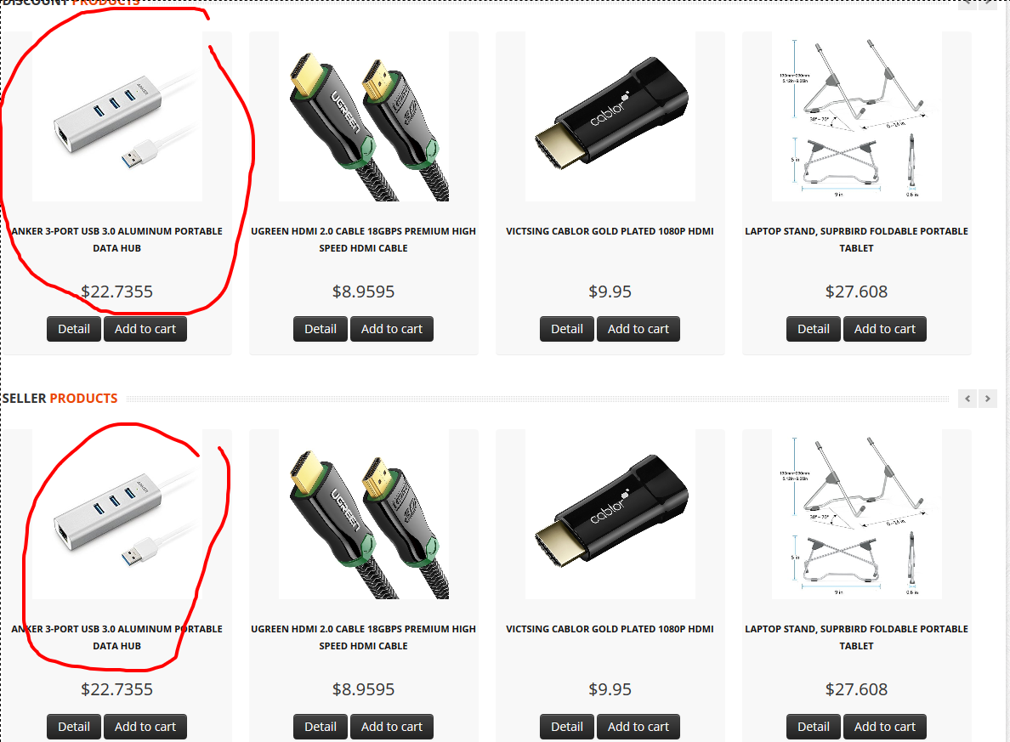

# Create button for print report next to add button

Rule: Print list of all product based on number of orders.

Fields : Id, Name, Brands, Quantity, Number of Orders

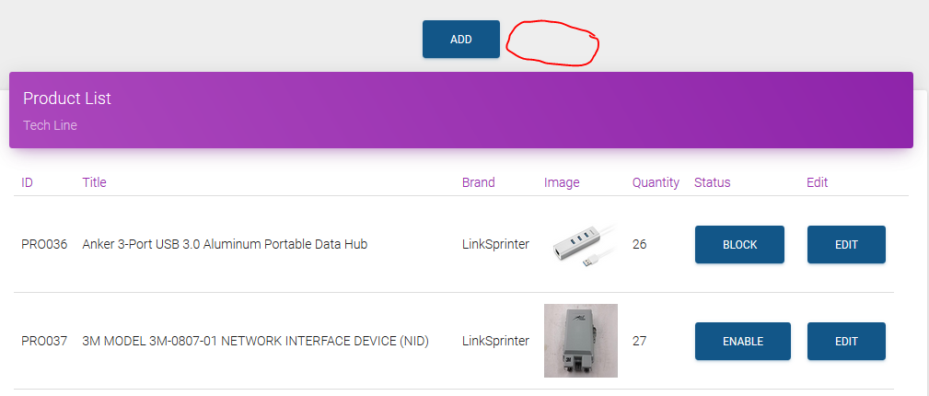

# Remove Delete button in Order page for admin and seller - Done

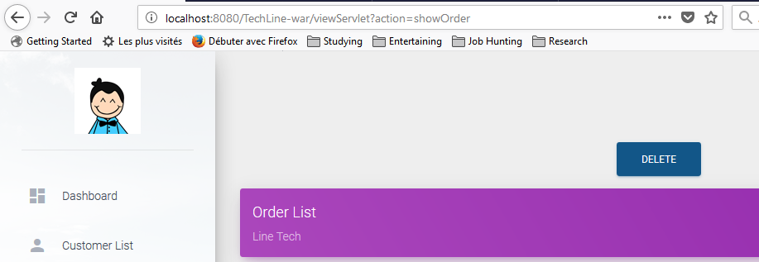

# Rule for Search - Done

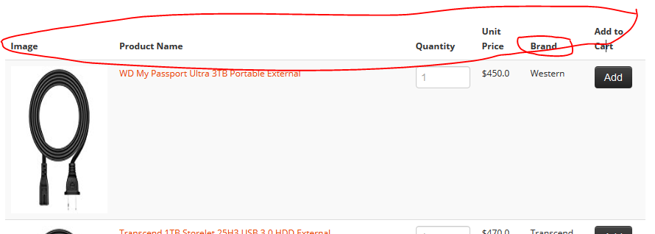

# Top Product Based on Author Selection

# Check on Footer

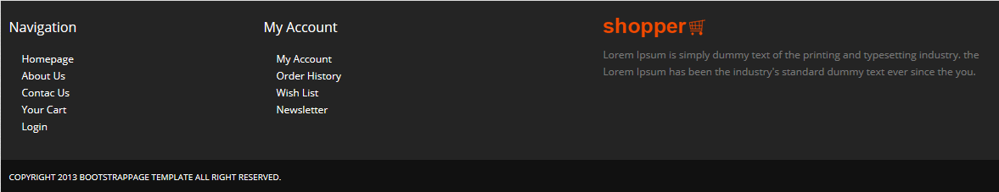

# Seller cannot edit information

# Change Title of Seller’s Page

# Fix hack session

# Search still show Product when it been disabled

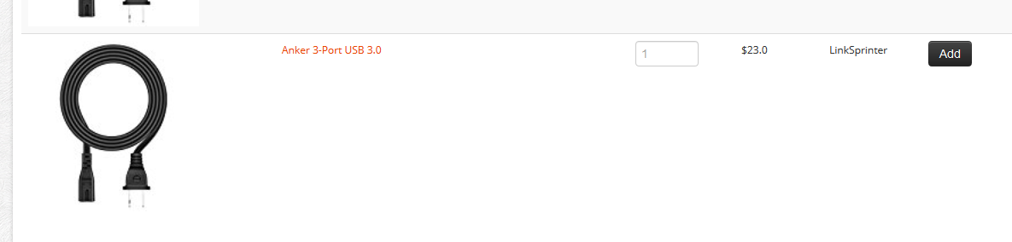

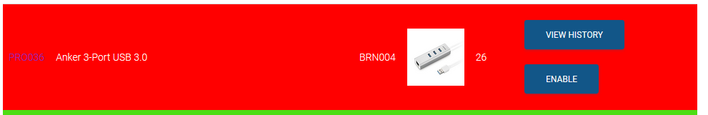

# Change Text on this

