|  |  |
| --- | --- |
|  | **VIỆN ĐÀO TẠO QUỐC TẾ FPT**  **LẬP TRÌNH VIÊN QUỐC TẾ** **FPT - APTECH** |

**TechLine**

**Installation Guide**

**Faculty: Phan Minh Tam**

**Batch No: F2-13-1604-T0**

**Group No: 5**

**Students:**

|  |  |  |
| --- | --- | --- |
| **No** | **Full Name** | **Roll No** |
| **1** | **Nguyễn Thế Huân** | **Student932536** |
| **2** | **Nguyễn Minh Tiến** | **Student924965** |
| **3** | **Cung Đình Uy** | **GC60506** |
| **4** | **Trần Khánh Vương** | **Student924994** |

**Getting started**

All procedures, which are described in this file, are based on Microsoft® Windows® XP,

WIN7, VISTA, WIN10. Modify the steps if you are using a different version of

Windows.

**System Requirements:**

The tables below list requirements for different installation options of **TechLine**

The Notes that identified here apply to both tables

**1. System Requirements for Installing TechLine shop**

**1.1 Hardware:**

**1.1.1 Web Server**

|  |  |
| --- | --- |
| Processor | Core 2 Duo or higher |
| Memory | 1GB RAM or higher |
| Modem/ADSL | Connecting to internet 24/24 |

**1.1.2 Client**

|  |  |
| --- | --- |
| Processor | Core 2 Duo or higher. |
| Memory | 2 GB RAM or higher. |
| Monitor | Super VGA (1366x768) or higher resolution with 256 colors. |
| Pointing Device | Microsoft Mouse, Microsoft IntelliMouse®, or compatiblepointing device . |
| Modem/ADSL | Connecting to internet |

**1.2 Software**

**1.2.1 Web Server**

|  |  |
| --- | --- |
| Operation System | Windows 7 or higher. |
| Browser | Internet Explorer 8.1 or higher. |
| Database | Microsoft SQL Server 2012 |
| Software | Java SDK 1.7 |
|  | GlashFish Services 4.0 |
|  | SQL JDBC 4 |

**1.2.2 Client**

|  |  |
| --- | --- |
| Operation System | Windows 7 or higher. |
| Browser | Internet Explorer 8.1 or higher. |

**2. Get Source**

**2.1 Copy Source from USB**

**Copy folder TechLineSource from USB**

**3. Setup Microsoft SQL Server 2012:**

**2.1 Open SQL Server Configuration Manager:**

Start > All programs > Microsoft SQL Server 2012> Configuration Tools > SQL

Server Configuration Manager

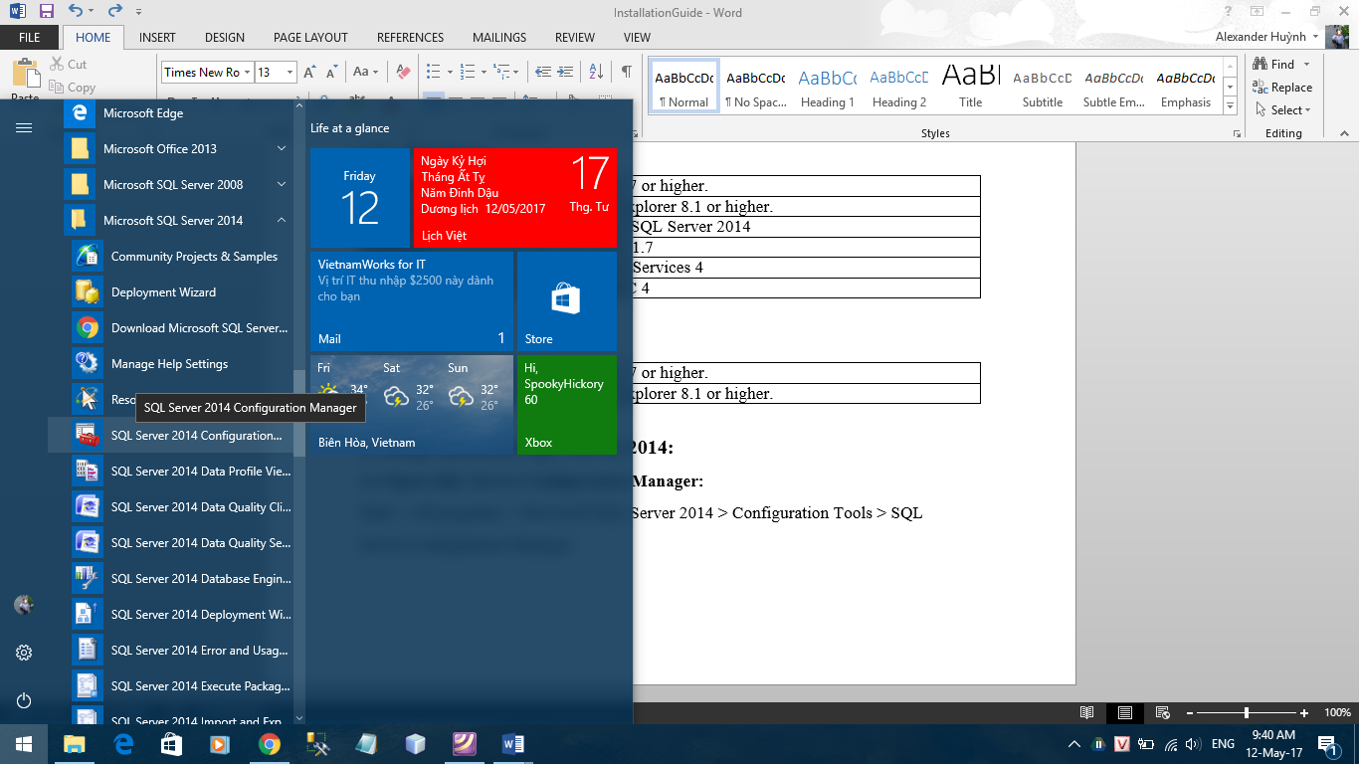

**2.2 Configure TCP/IP:**

**Step 1: Set TCP/IP:**

Right Click TCP/IP > Properties (in Protocols for MSSQLSERVER)

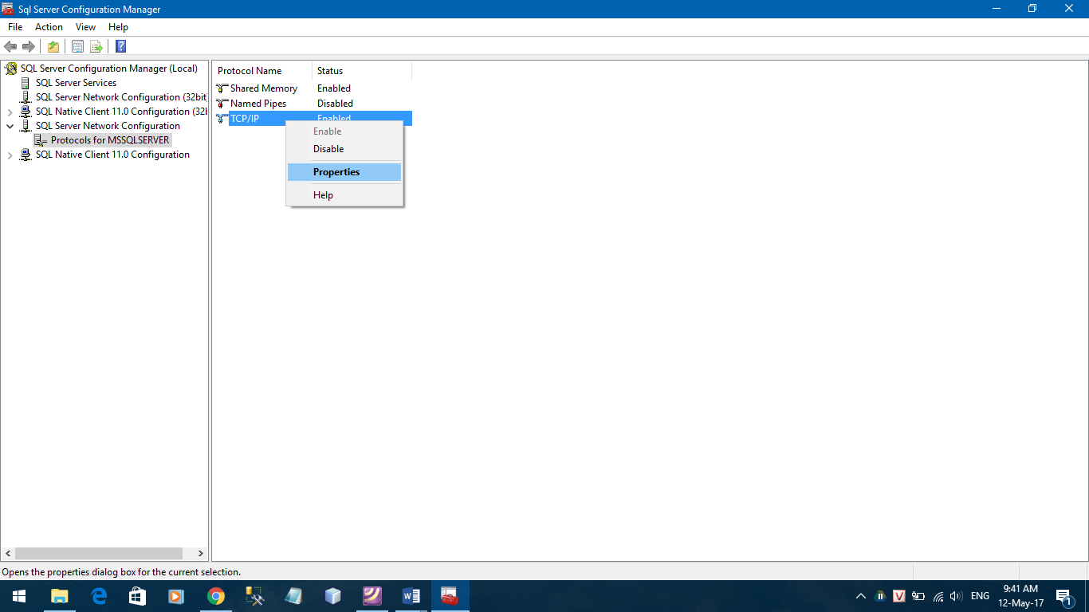

Select **IP Addresses** tab

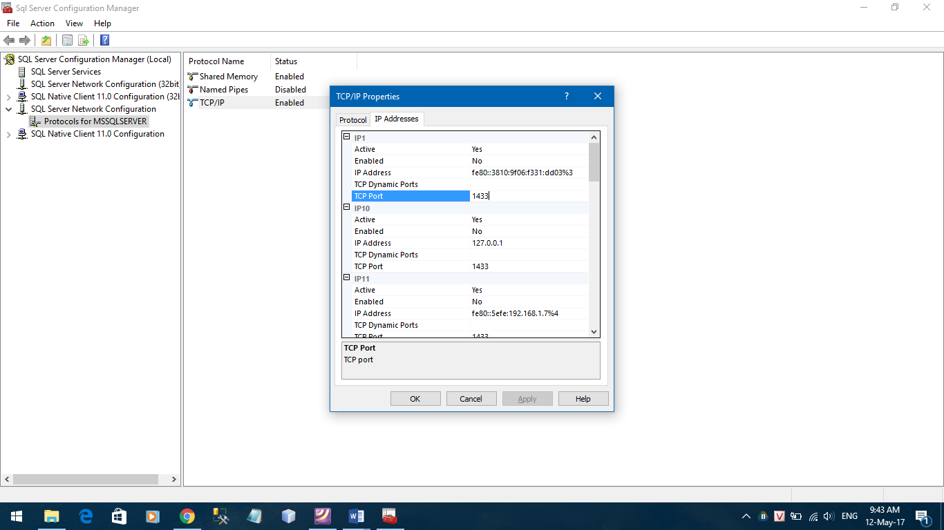

On IP1, set value for **TCP Port**:

**TCP Port:** 1433

Click **OK** button

**Step 2: Enable TCP/IP:**

Right Click TCP/IP > Enable

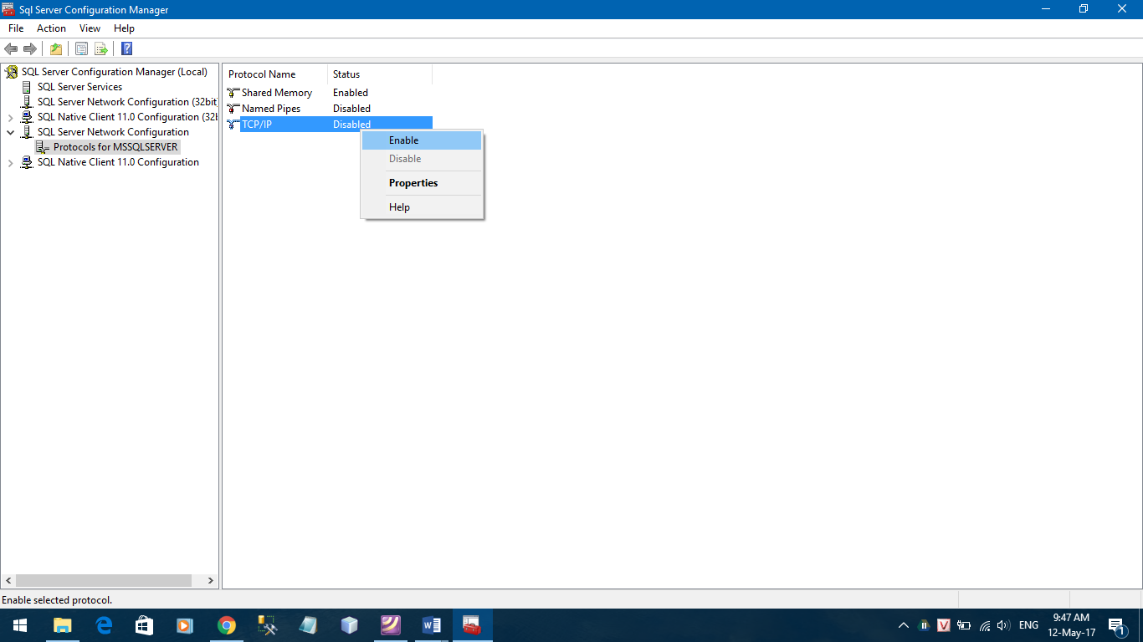

Select **OK**

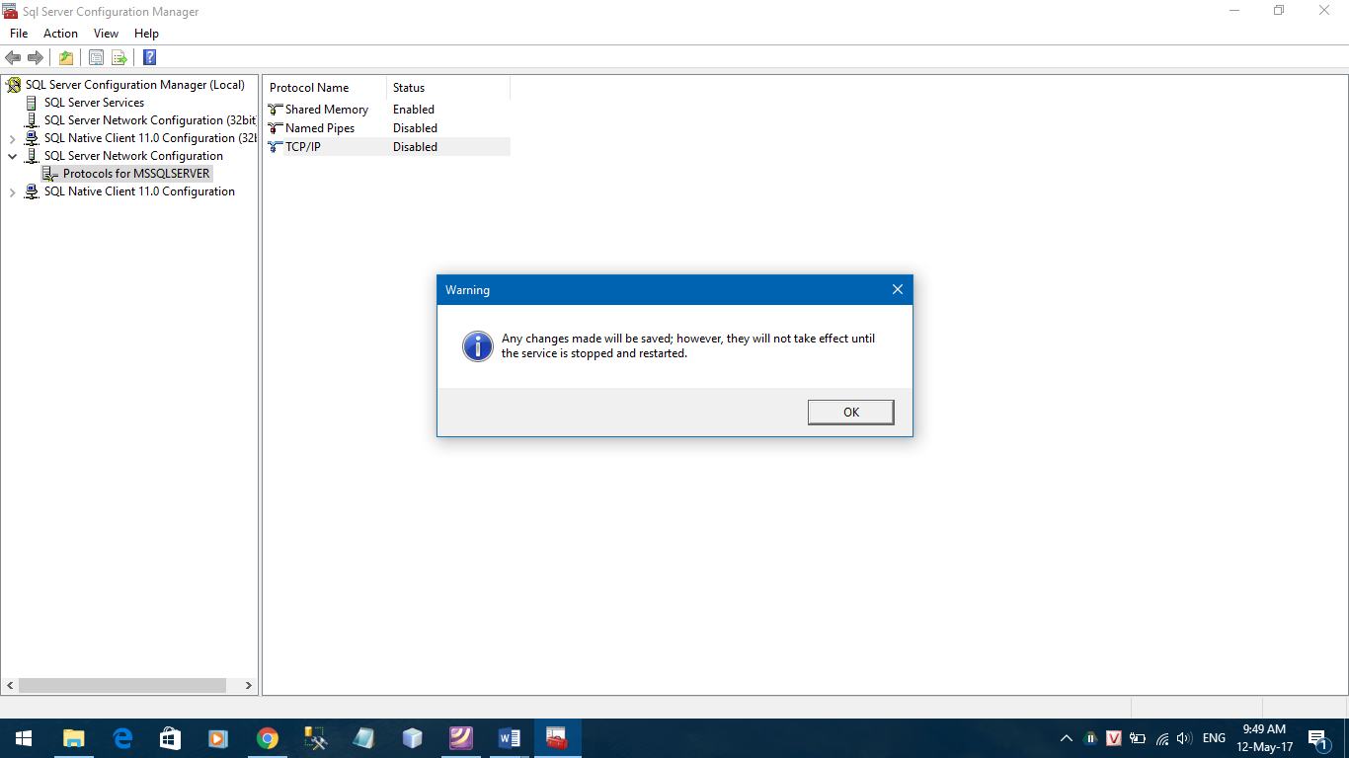

**Result:** TCP/IP is **Enabled**

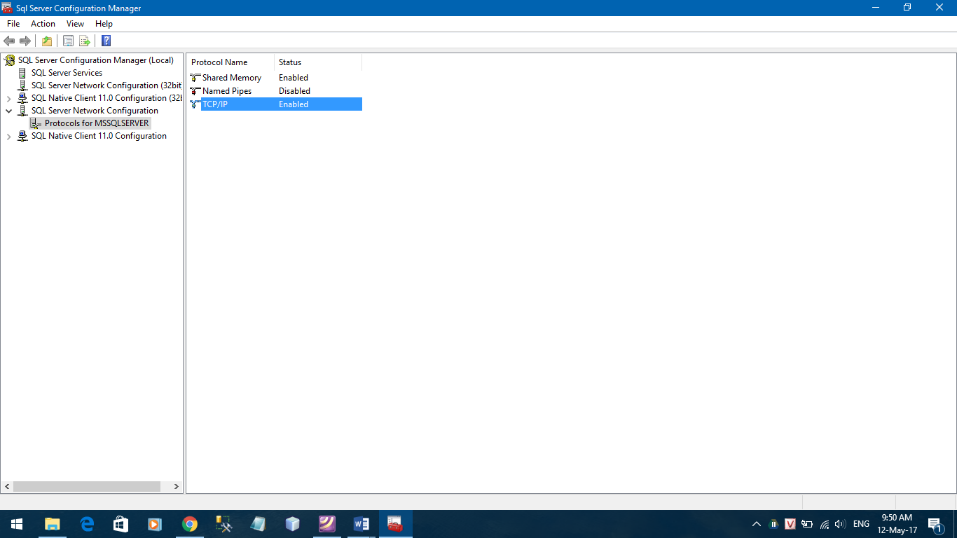

**Step 3: Restart SQL Server 2012 to apply change:**

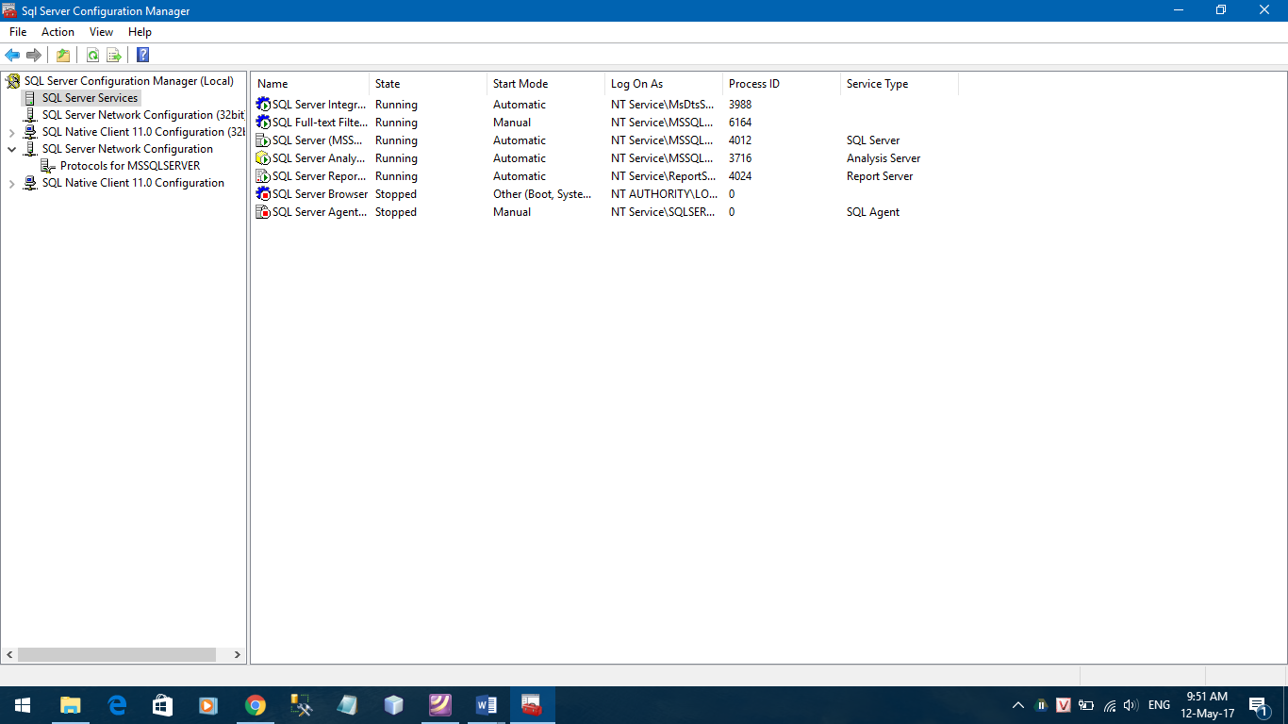

Select SQL Server Services -> Right click SQL Server (MSSQLSERVER) -> Restart

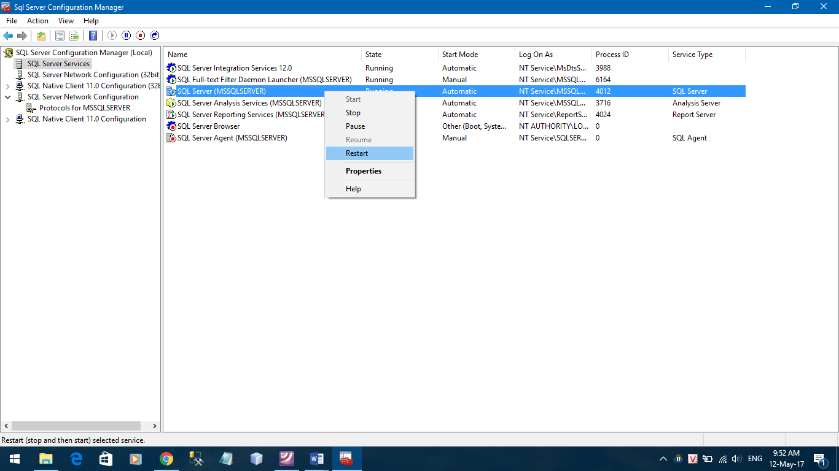

**3. Setup TechLine Database:**

**3.1 Open MS SQL Server 2014 Management Studio:**

Start > All programs > Microsoft SQL Server 2012 > SQL Server Management Studio

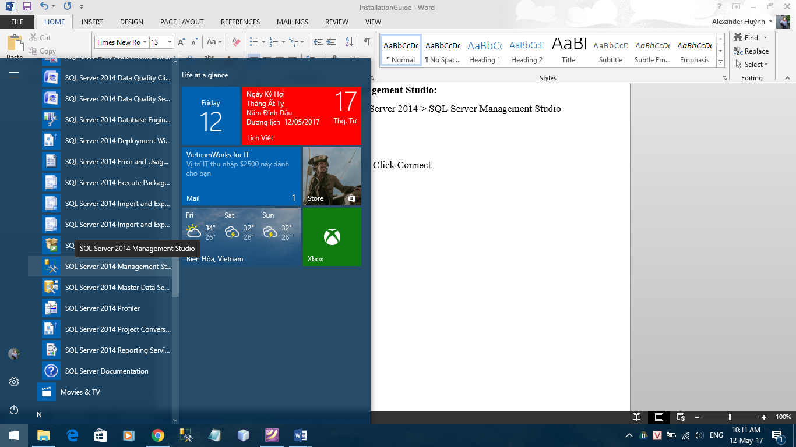

Input your Login and password

Remember to login as user “sa”

And password: 123

> Click Connect

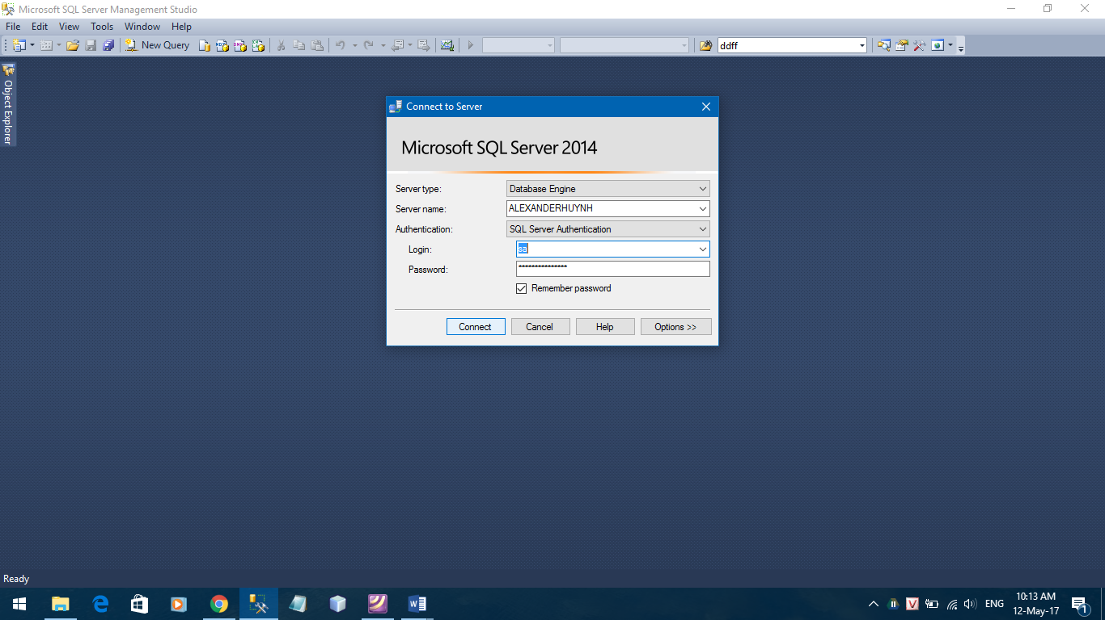

**3.2 Setup database:**

**Open TechLine.sql from folder Database/TechLine.sql file to setup database:**

Menu File > Open > Files…

Select TechLine.sql file in folder Database, click Open

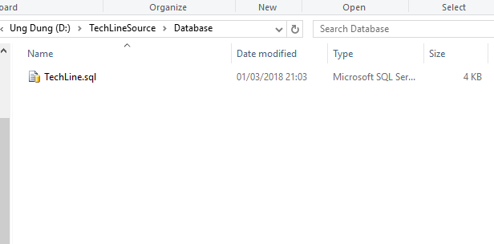

Execute TechLine.sql file to create TechLine database (Click

Execute button on toolbar or Press F5 on keyboard).

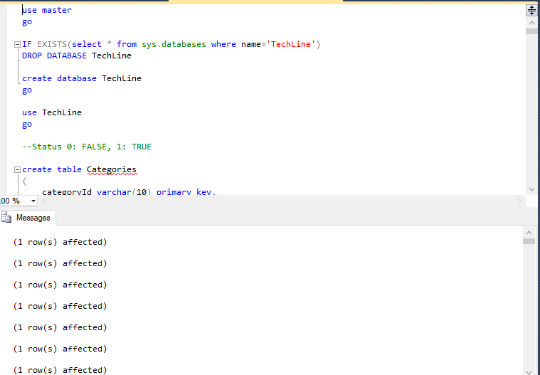

Right Click Databases > Refresh

Result: Appear the TechLine database in Databases folder

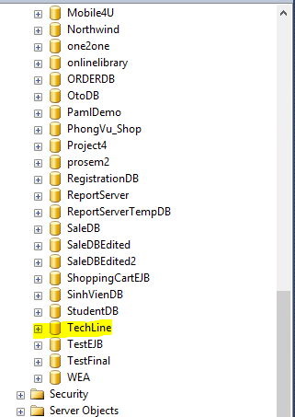

Create database successfully

**4. Config JDK**

In Desktop, Right Click to Computer, choose Properties.

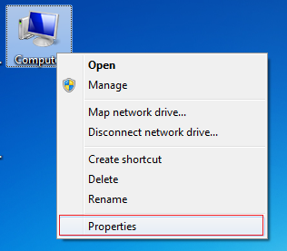

Choose Advanced system settings

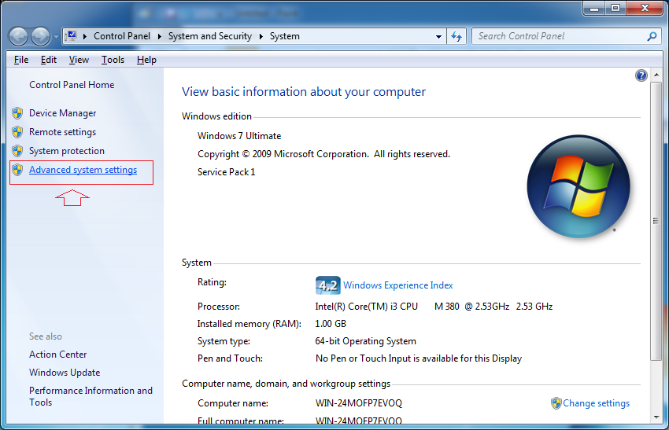

In tab Advanced chose Environment Variables

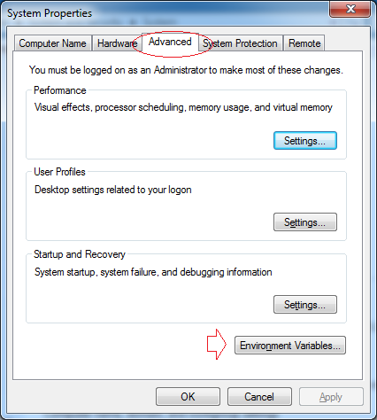

Click **New**

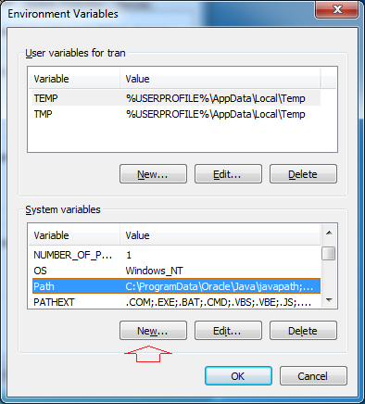

Input path folder you save JDK in your computer

* **Variable name:** JAVA_HOME
* **Variable value:** Example: C:\Program Files (x86)\Java\jdk1.7.0_51 (Jdk depends on machine)

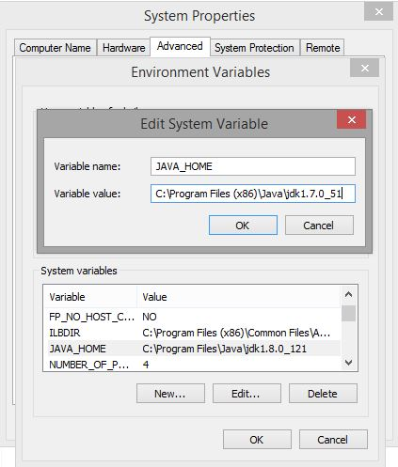

Next step choose Edit in Path Variables

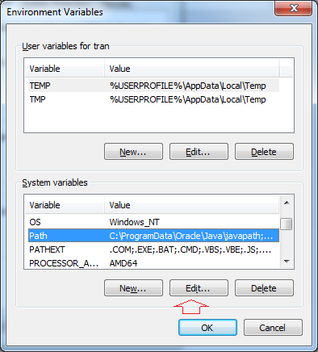

Add to the front of the value of the environment variable **Path** like picture:

* **%JAVA_HOME%\bin;**

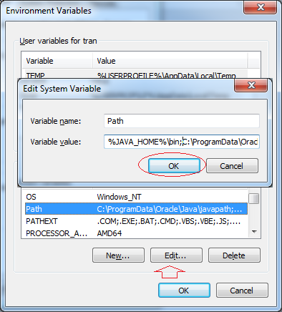

Click **OK** to finish config JDK

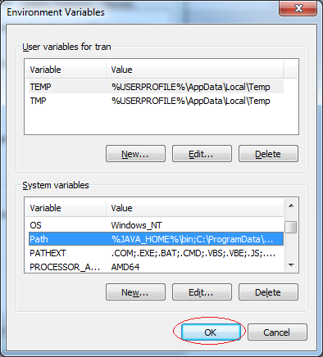

**5. Setup Glassfish:**

**Step 1: Copy file drivers: sqljdbc4.jar from TechLineSource**

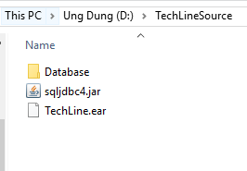

**And put sqljdbc4.jar in folder ext of folder glassfish as follows:**



**Result:**

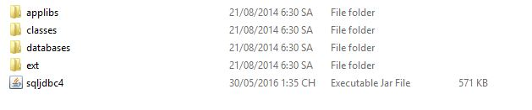

1. **Run Application:**
   1. **Step1: Start glassfish 4:**

* **Run as Administrator from file “C:\Program Files\glassfish-4.0\glassfish\bin\asadmin.bat” or double click**

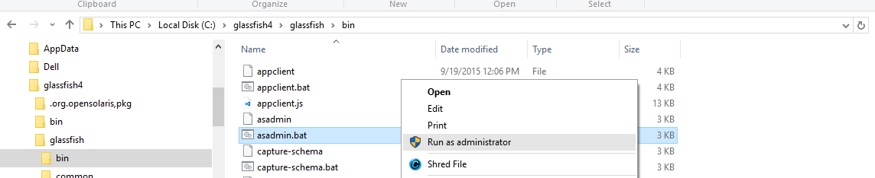

In command prompt window, typing the command line: **start-domain** to start glassfish:

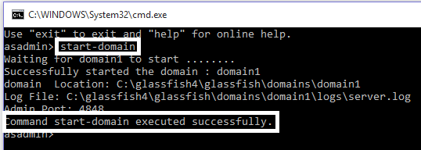

If the server starts successful, “Command start-domain executed successfully” wills be appeared.

NOTE: the server wills run as window services. To able to stop server, Run as Administrator file **asadmin.bat** and execute command **stop-domain**

1. **Step 2: Configuration server for project:**

* **Setting up connection pool:**
* **Open the browser and type the address:** [**http://localhost:4848/**](http://localhost:4848/)
* 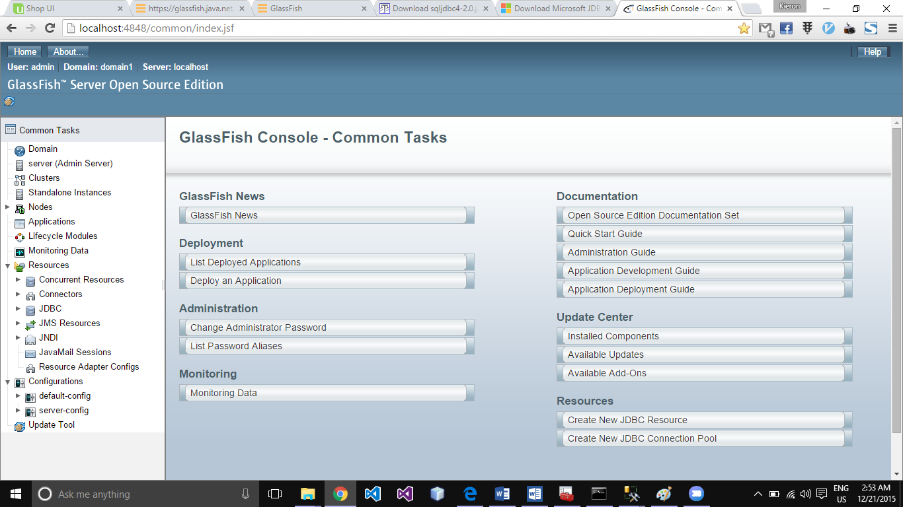**Login as user admin for glassfish**

-To **Resources > JDBC > JDBC Connection Pools > new** for creating new connection pools.

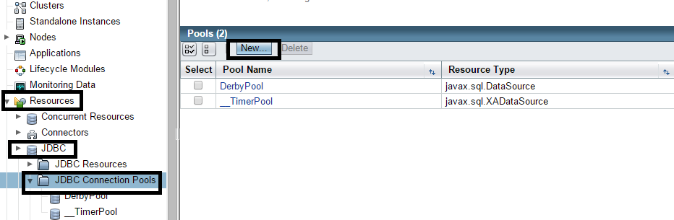

-On **New_JDBC_Connection_Pool** page, typing or choosing these options as following:

- Name: **microsoft_sql_TechLine_saPool**

- Resource Type: **javax.sql.DataSource**

- Database Vendor: **MicrosoftSqlServer**

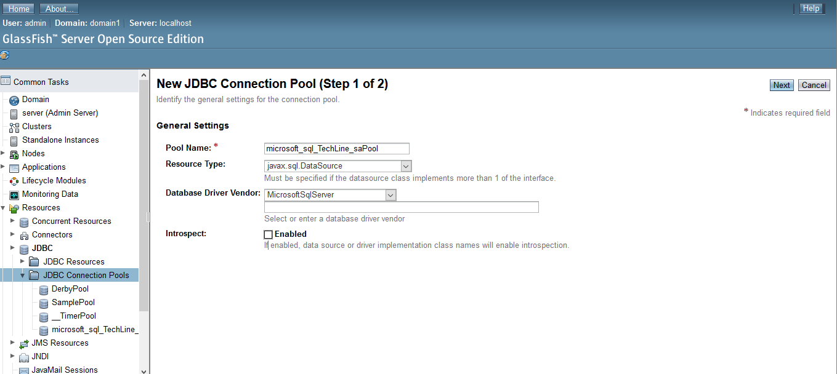

Then click **Next** for next step **New JDBC Connection Pool (Step 2 of 2)**. After that, Scrolling down to **Additional Properties** then typing these information:

- Passsword: **123**

- URL: jdbc:sqlserver://localhost:1433;databaseName=TechLine

- User: **sa**

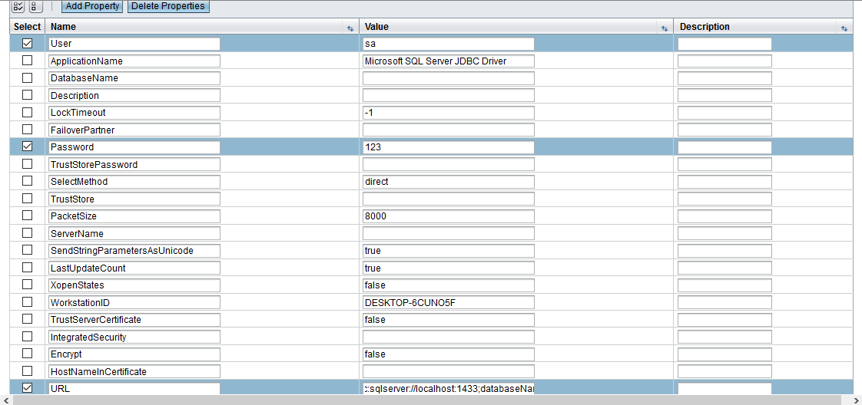

NOTE: **User**: target database username,

**Password**: target database password,

**URL**: target connection string.

Then click **Finish**.

To the next step, testing connection pool:

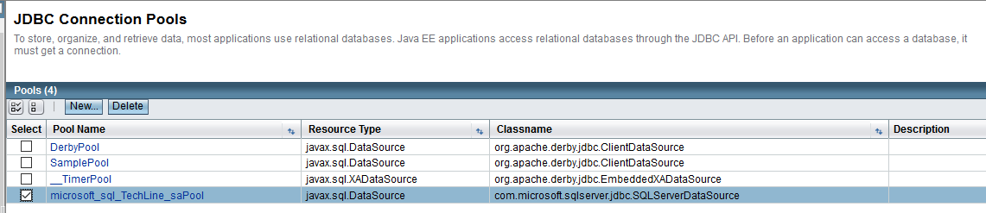

Click **microsoft_sql_TechLine_saPool** to ping database

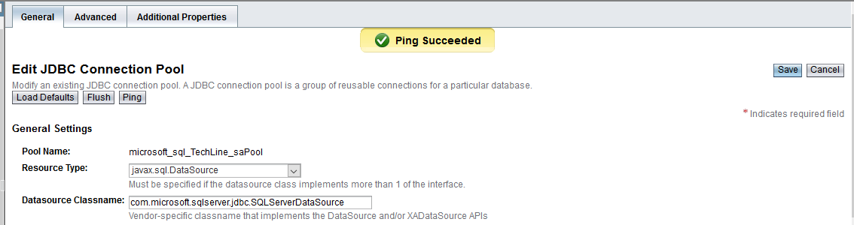

Click ‘**Ping’**, if connect successful, “Ping Succeeded” should appear.

Now create **JDBC Resources** base on **microsoft_sql_TechLine_saPool** to run the Project.

Create a new **JDBC Resources**. Click ‘**JDBC Resources’** and choose **‘New’**

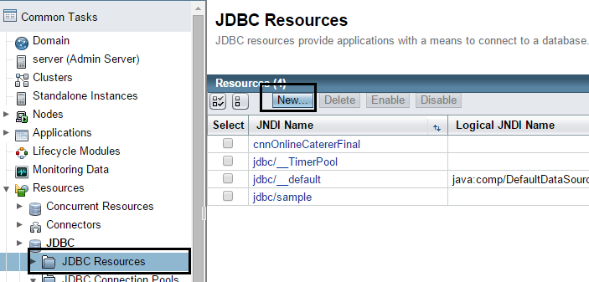

Filling the values in JNDI Name (**TechLine_JNDI**) and Pool Name (**microsoft_sql_TechLine_saPool)** as below. Then click ‘OK’ 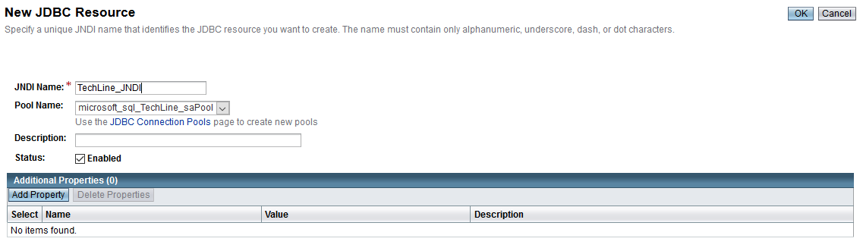

You’ll see the **TechLine_JNDI** in **JDBC Resources**.

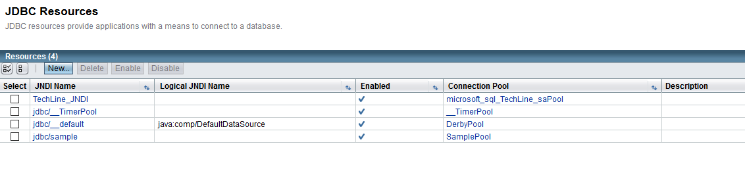

**Restart server to apply changed**.

Come back to command line where you start domain glassfish and type new command: **restart-domain** as belows:

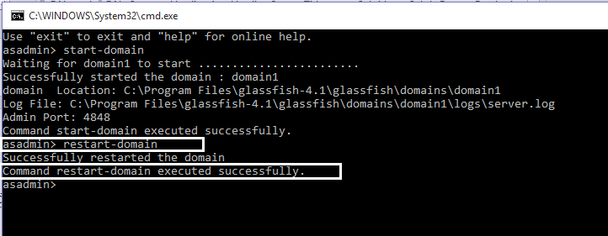

**Step 3: Deploy Application**

Now you can deploy TechLine shop. Click ‘**Application’** and click ‘**Deloy’** button.

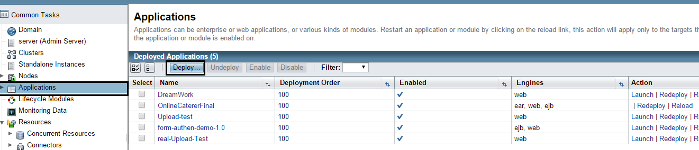

Click ‘**Choose File’** button.

Select file **TechLine.ear from TechLineSource Folder.**

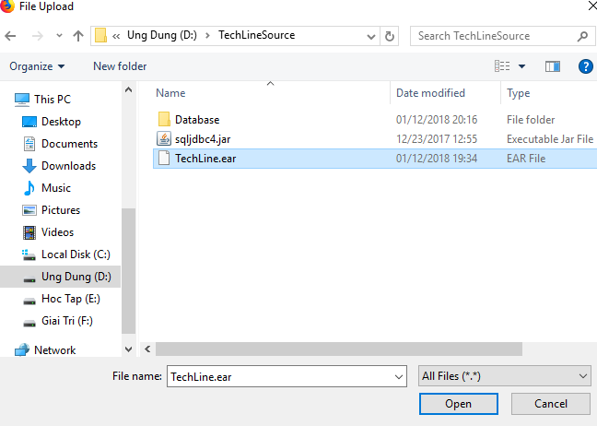

Input Context Root: TechLine-war

Input Application Name: TechLine-war

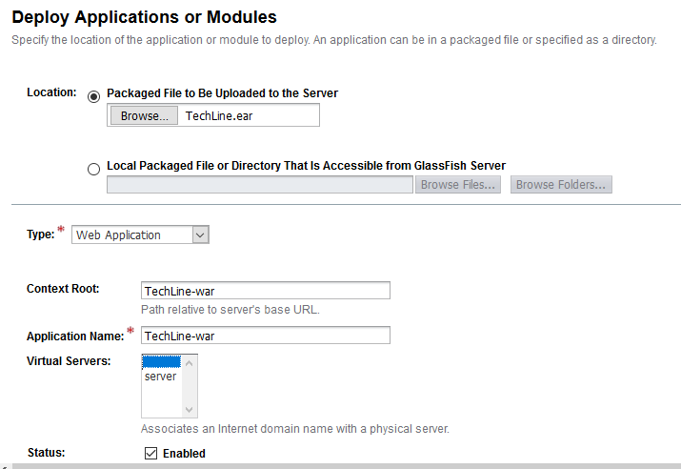

Then click ‘OK’, you’ll see **TechLine-war** in Applications frame

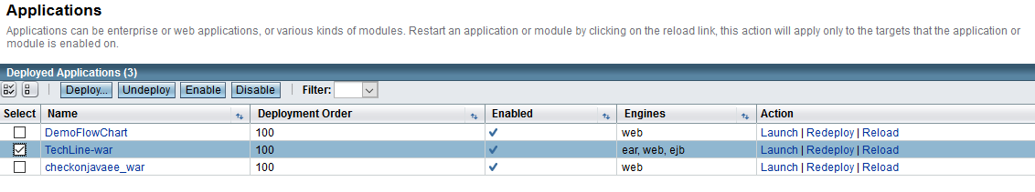

Click **Launch** link on same row with **TechLine-war** to launch it.



**Step 4: Lauch Project Click ‘Launch’.**

**After this window happen, chose one of below links:**

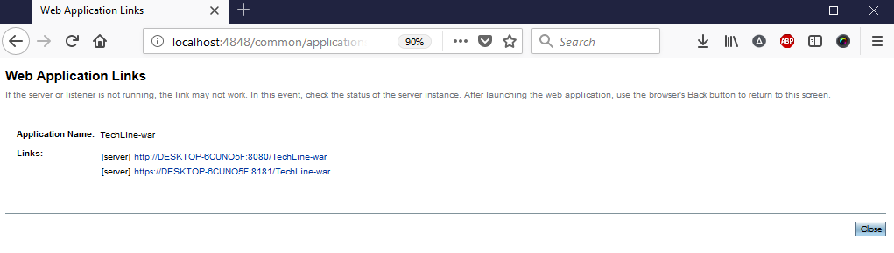

Click the first link: example http://localhost:8080/TechLine-war/and then the first web page will appear for you.



**Run Website on Browser:**

Go to Internet browser type http://localhost:8080/TechLine-war/ on address, should use Firefox.

Click Login to Login:

**Login for Administrator:**

Username: admin

Password: admin

**Login for User:**

Username: tuyetbich

Password: 123456

**Login for Seller:**

Username: kenny

Password: 123abca