1. Extract the Camunda zip folder which was downloaded from [https://camunda.org/download](https://camunda.org/download/)

2. Download Camunda modeler from <https://camunda.org/download/modeler/>

3. Create java maven project and edit the pom.xml with the following dependencies

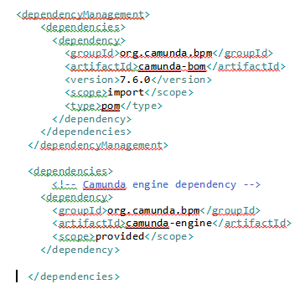

4. Create a sample BPMN diagram with the help of modeler and save it **resources** folder

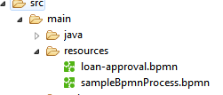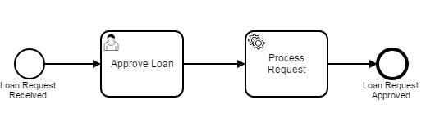

5. Create a simple java class by extending ServletProcessApplication, which will help in loading all bpmn files created in the resources folder, with the help of process engine.

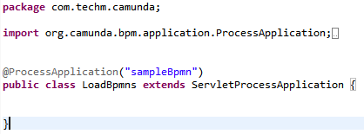

6. Create a .war file using maven build and place it in camunda server’s webapp folder, which is located in the extracted camunda zip (step 1).

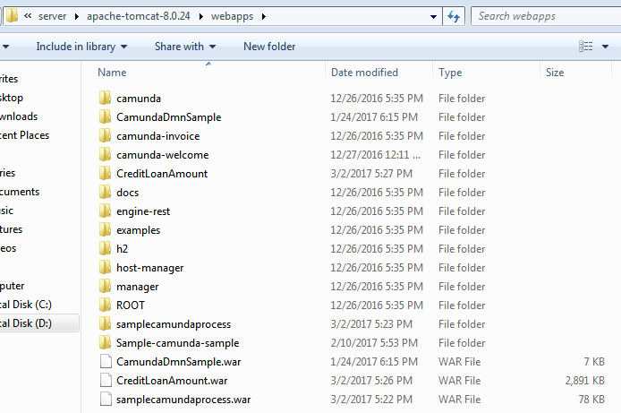

7. Start the camunda server by executing start-camunda located in extracted camunda zip(step1)

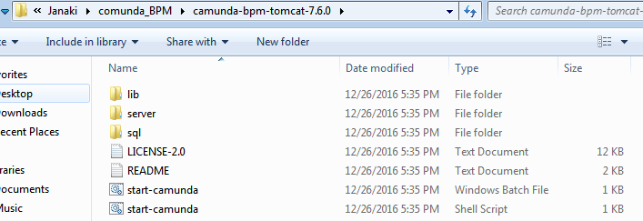

8. Go to **camunda tasklist** populated from <http://localhost:8080/camunda-welcome/index.html> , click on **startProcess** and start the process which was created (you could see name of the process specified while creating bpmn in the list).

