KEYCLOAK SERVER EXPORT AND IMPORT

1. EXPORT ALL DATA FROM KEYCLOAK SERVER
1.1 Access the bin folder of the keycloak server as the example:
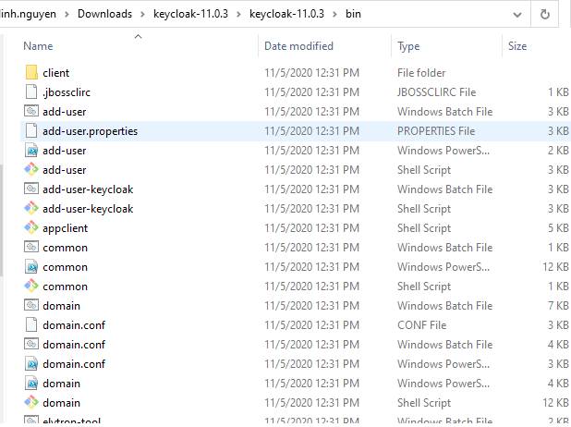
1.2 Turn on cmd
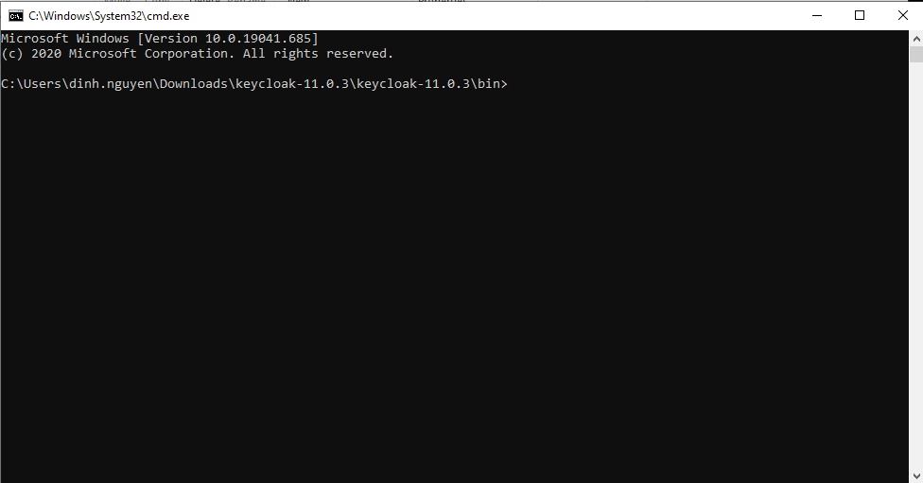

1.3 Create folder keycloak_docker/keycloak and run command

standalone.bat -Dkeycloak.migration.action=export -Dkeycloak.migration.provider=dir -Dkeycloak.migration.dir=your_folder

1.4 Result
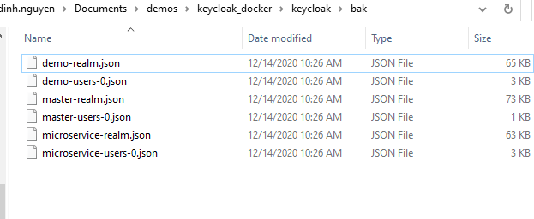

2. Create the file with name Dockerfile in the keycloak folder

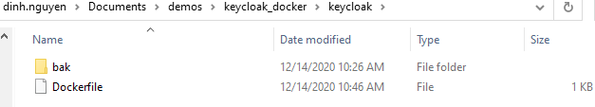
3. Prepare the contents of Dockerfile as following:

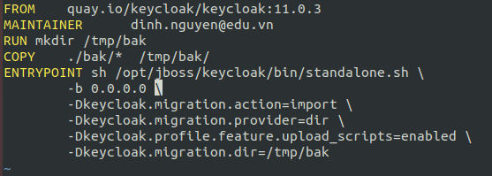

Note:
FROM quay.io/keycloak/keycloak:11.0.3
(This is an image of keycloak in hub docker)

MAINTAINER dinh.nguyen@edu.vn
(This is a name of the creator)

RUN mkdir /tmp/bak
(Create new bak folder in the /tmp folder)

COPY ./bak/* /tmp/bak
(Copy the data was backup before into the /tmp/bak)

RUN bash opt/jboss/keycloak/bin/standalone.sh \
-b 0.0.0.0 \
-Dkeycloak.migration.action=import \
-Dkeycloak.migration.provider=dir \
-Dkeycloak.migration.dir=/tmp/bak
-Dkeycloak.profile.feature.upload_scripts=enabled

4. Cd to the the keycloak_docker folder
Create the docker-compose.yml file:
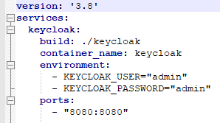

version: ‘3.8’ (version of docker-compose file) (You must have the docker version >= 19.0)
services: (Node parrent)
keycloak: the name of a service (You can put your name)
build: ./keycloak (point to the folder contain the Dockerfile)
container_name: keycloak (The name of container, you can customize this name)
environment:
- KEYCLOAK_USER=”admin”
- KEYCLOAK_PASSWORD=”admin”
(Setup the default account when start keycloak server)
ports:
- “8080:8080” (port_container:port_public_on_machine)

5. Run docker-compose with the command:
With current folder is docker_docker, you open cmd and run:

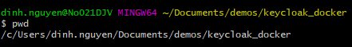

5.1 docker-compose build
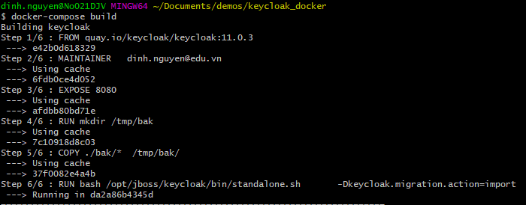

5.2 Access the address: http://localhost:8080

