Coherent HIS website feedback – 29-August-2025
- Main menu
  - Remove “Regions”, add “Revenue Cycle Management” and “NABIDH Compliance” under “Offerings”
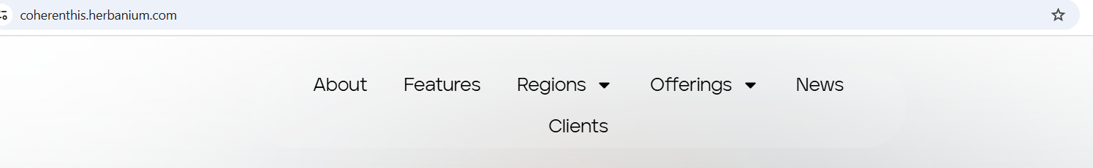
- Let’s Talk > Book a Demo
- 1st Title Statement:
Coherent – Redefining Clinical Efficiency with AI-Driven EMR
Transform patient care, ensure compliance, and optimize practice revenue with an intelligent EMR and practice management platform built exclusively for modern clinics in the Middle East.
- 2nd Title Statement:
Modern Healthcare. Unified Data. Better Outcomes.
Coherent connects your clinic with UAE health information exchanges (Malaffi, NABIDH & Riayati), ensuring smarter decision-making, stronger compliance, and optimized patient care.
- 3rd Title Statement:
AI-Powered Efficiency. Patient-Centered Care.
Streamline your clinic operations with intelligent automation—reducing documentation time, boosting compliance, and enhancing patient experiences.
- Reel ?
- This section can be removed
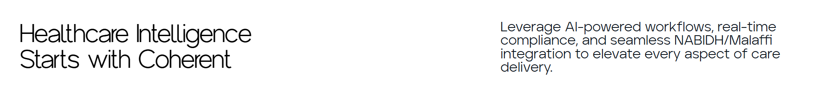
- This section does not look good (Please remove it)
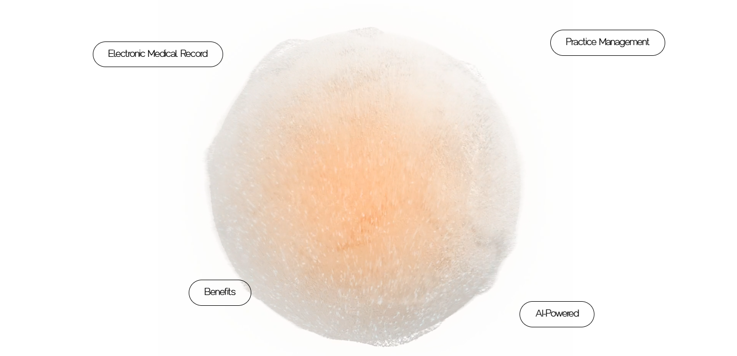
- Please add “Benefits” section
- “Contact” section:
  - Display company name “Teknoloje Solutions LLC
  - Address “Shams Business Center, Sharjah Media City, Al Messaned, Sharjah, UAE”
- Footer:
  - Remove social media links for now
  - 2025. All rights reserved. Product of Teknoloje Solutions LLC
- About page:
About Coherent HIS
Coherent HIS is your complete clinic management solution, combining Electronic Medical Records (EMR), Enterprise Practice Management (EPM), and Revenue Cycle Management (RCM) in one intelligent platform. Built for the Middle East, Coherent simplifies clinical workflows, captures comprehensive patient records, and streamlines revenue cycles—while meeting the strictest Department of Health (DOH), Dubai Health Authority (DHA) and Ministry of Health (MOH) compliance requirements.
With advanced features such as AI-Powered Clinical Documentation, integrated laboratory and radiology workflows, medication and allergy management, and robust billing and claims processing, Coherent helps clinics deliver accurate, efficient, and patient-centered care. Secure, intuitive, and scalable, Coherent empowers clinics to enhance patient outcomes, reduce administrative burden, and achieve sustainable growth with confidence.
- Features page
When all Features panel is completed after scrolling down, then all panels to be displayed at once.
Features > Smart Features for Smarter Clinics
Coherent HIS combines powerful Electronic Medical Record (EMR), Enterprise Practice Management (EPM), and Revenue Cycle Management (RCM) tools with next-generation innovations like AI-driven clinical notes, laboratory & radiology workflows, and automated claims management. Designed for the Middle East, the platform ensures full DOH, DHA and MOH compliance, while giving clinics the tools to reduce documentation time, improve care accuracy, and maximize financial performance.
Seamless Patient Registration (New)
Coherent HIS simplifies patient onboarding with quick registration, insurance coverage capture, temporary registration, and intelligent alerts. Built for accuracy and speed, empowering front-desk teams to deliver smoother patient journeys.
Scheduling > Smart Scheduling & Appointments
Streamline clinic operations with Coherent HIS scheduling. Manage consultations, OT, and modality bookings with ease, while tracking clinician availability, patient status, and check-in rules. Integrated online eligibility verification ensures smoother workflows for both service excellence and call center teams, improving patient experience and operational efficiency.
Billing > Streamlined Medical Billing
Automate your financial workflows with invoice generation, payment collections, advance payments, refunds, and e-claim submissions. Coherent HIS ensures faster reimbursements, remittance posting, claim resubmissions, and accurate patient account reconciliation.
EMR > Comprehensive Clinical module
Capture every detail with a unified problem list, patient history, allergies, immunizations, vital signs, and medications. Enhance efficiency with AI-Powered clinical documentation, and nursing notes —all designed for accuracy and smarter care delivery.
Smarter Orders, Faster Outcomes (New)
From prescriptions and diagnostic requests to referrals and follow-up scheduling, Coherent HIS connects every step of the care journey. Access results quickly and deliver more coordinated, patient-centered care.
Compliance > Trusted, Secure, and Fully Compliant
Built for the Middle East healthcare ecosystem, Coherent HIS delivers end-to-end compliance with Malaffi, NABIDH, and Riayati standards. With ADHICS-compliant security controls, your clinic can provide smarter, connected, and regulatory-ready care while protecting patient confidentiality at every step.
Integration > Connected Care to Cash Flow
With Coherent HIS, the Billing and EMR modules work in harmony, streamlining claim submission and automating insurance processes. The result is faster revenue cycles, fewer rejections, and improved practice efficiency.
Analytics > Actionable Insights for Smarter Decisions
Coherent HIS delivers powerful reports and analytics that track both clinical outcomes and financial performance. Gain real-time visibility into operations, identify trends, and make data-driven decisions to improve efficiency, optimize revenue, and enhance patient care.
Interface > Designed for Ease and Efficiency
Our modern, web-based interface simplifies navigation across clinical, administrative, and billing tasks—helping healthcare teams save time, reduce errors, and deliver seamless patient experiences.
Remove “Navigation” and “Performance”
- Clients page
- Mubadala Health
Coherent HIS proudly serves as the primary health information platform across multiple medical centers operated by Mubadala Health, one of the Middle East’s leading healthcare investment companies. Implemented as the primary health information platform, Coherent HIS supports 150+ daily users with seamless integration to DOH, Malaffi, MOHRE, laboratory systems, and CRM — delivering connected, compliant, and patient-focused care.
By partnering with Mubadala Health, Coherent HIS continues to demonstrate its ability to deliver scalable, intelligent, and secure healthcare technology solutions that empower providers and enhance patient outcomes.
- Women Health Center – A Center of Excellence in Women’s Health & Wellness
As part of Mubadala Health, the Women Health Center stands as a premier Center of Excellence, offering a comprehensive range of services dedicated to women’s health — from early adulthood to elderly care. The center’s gynecologists and clinical specialists uphold the highest medical standards, delivering advanced, gender-based consultative services to support women facing complex medical and gynecological challenges at every stage of life.
To strengthen clinical excellence, Coherent HIS has been successfully implemented within the Women Health Center, empowering physicians and care teams with an integrated platform for Electronic Medical Records (EMR), Practice Management, and Revenue Cycle Management. The system facilitates seamless workflows across all specialties, including:
- General Obstetrics & Gynecology
- Maternal-Fetal Medicine
- Minimally Invasive Surgery
- Urogynecology
With Coherent HIS, the Women Health Center benefits from streamlined patient record management, compliance with UAE health regulations, and improved operational efficiency, enabling the delivery of patient-focused, technology-driven healthcare.
- HealthPlus Fertility Center – Personalized, Advanced Reproductive Care
HealthPlus Fertility Center, part of Mubadala Health, is recognized as one of the leading fertility and reproductive health providers in the region. With a strong focus on personalized patient care, the center combines medical expertise with the latest advancements in reproductive medicine to deliver the best outcomes for couples. Services include In Vitro Fertilization (IVF), reproductive surgery, male and female fertility treatments, and advanced assisted reproductive technologies.
To enhance patient care and streamline clinical workflows, Coherent HIS has been successfully implemented at HealthPlus Fertility Center. The platform enables seamless management of patient medical records, IVF cycles, surgical procedures, treatment plans, and laboratory data, ensuring data accuracy, regulatory compliance, and improved care coordination.
With Coherent HIS, HealthPlus Fertility Center continues to provide state-of-the-art fertility care powered by intelligent, integrated healthcare technology.
- HealthPlus Family Health Centers – Comprehensive Primary Care Across Every Life Stage
The HealthPlus Family Clinics, part of the HealthPlus Network, are dedicated to delivering personalized, comprehensive, and family-centered healthcare. From newborn checkups and preventive care to the treatment of fevers, falls, urgent conditions, and common ailments, the clinics focus on providing accessible, high-quality medical care for patients of all ages.
With three strategically located centers in Al Bandar, Al Forsan, and Saadiyat Island, HealthPlus Family Clinics serve as trusted healthcare providers for families across Abu Dhabi.
To enhance care delivery and streamline operations, Coherent HIS has been implemented across all Family Health Centers. The platform supports general and specialist consultations, urgent care services, and family medicine specialties, ensuring efficient patient record management, improved clinical workflows, and seamless coordination of care.
By integrating patient-focused technology with compassionate medical expertise, HealthPlus Family Clinics continue to uphold their mission of keeping families healthy, active, and well-supported throughout every stage of life.
- Diabetes & Endocrinology Center – A Center of Excellence in Diabetes Care
The HealthPlus Diabetes & Endocrinology Center, part of the HealthPlus Network of Specialty Centers, is recognized as a Center of Excellence in Diabetes Care through its partnership with the internationally renowned Diabetes Zentrum Mergentheim (DZM), Germany. With a balanced focus on patient care, clinical outcomes, education, and training, the center delivers comprehensive and patient-centric healthcare services.
Specialties include Diabetology, Endocrinology, Ophthalmology, Cardiology, Internal Medicine, Podiatry, Psychiatry, Nutrition, and Special Infusion Therapy—ensuring multidisciplinary support for complex patient needs.
To enhance clinical efficiency and improve care delivery, Coherent HIS has been successfully implemented at the HealthPlus Diabetes & Endocrinology Center. The system provides seamless integration with the in-house CRM, Department of Health (DOH), Malaffi (Abu Dhabi Health Information Exchange), MOHRE Emirates ID card reader, laboratory systems, and SMS gateway. This creates a connected, compliant, and patient-focused digital ecosystem that streamlines workflows, strengthens interoperability, and elevates the patient experience.
With Coherent HIS, the HealthPlus Diabetes & Endocrinology Center continues to lead the way in digitally empowered, world-class diabetes and endocrine care.
- Trust Fertility Clinic – Advanced Fertility Care Powered by Coherent HIS
Trust Fertility Clinic, the newest and largest fertility clinic in the UAE, is strategically located within Burjeel Medical City in Abu Dhabi. With a mission to deliver compassionate, patient-centered reproductive care, the clinic combines world-class expertise with the latest advancements in fertility treatments, achieving some of the highest success rates in the region. Its state-of-the-art facility is designed to ensure that every patient’s journey to parenthood is comfortable, supportive, and stress-free.
To enhance operational efficiency and clinical excellence, Coherent HIS has been successfully implemented at Trust Fertility Clinic. The solution supports a wide range of functionalities, including:
- Patient Registration & Scheduling
- Electronic Medical Records (EMR)
- Orders & Results Management
- Scanning & Document Archival
- Messaging & Task Management
Additionally, the implementation ensures seamless interoperability through the following integrations:
- Malaffi (Abu Dhabi Health Information Exchange)
- Department of Health (DOH)
- SAP integration for Financial Reporting
- Laboratory system
- SMS Gateway
This creates a fully connected digital ecosystem, empowering clinicians and staff to deliver exceptional patient care while ensuring compliance with healthcare regulations.
With Coherent HIS, Trust Fertility Clinic continues to redefine fertility care in the UAE, setting new benchmarks for quality, innovation, and patient outcomes.
- Vein Care and Surgery Center – Advanced Vascular Care with Coherent HIS
Strategically located within Dubai Healthcare City, the Vein Care and Surgery Center (VCSC) is a premier facility with 73 medical staff across 16 specialties, dedicated to delivering North American standards of vascular and vein care. The center specializes in day case treatments, ensuring patients receive safe, effective, and minimally invasive procedures without prolonged hospital stays.
VCSC offers a comprehensive range of services, including:
- Laser Treatments for Varicose Veins
- Phlebectomy
- Sclerotherapy
The facility is fully equipped with two examination rooms, an ultrasound room, an operating room, and a recovery room, creating a complete ecosystem for high-quality patient care.
To further strengthen its operations and patient experience, Coherent HIS has been implemented within VCSC. The system streamlines:
- Patient Registration & Scheduling
- Clinical Documentation
- Orders & Results Management
- Billing & Revenue Cycle
- Electronic Claims Submission & Remittance Retrieval
With Coherent HIS, Vein Care and Surgery Center ensures seamless workflows, efficient billing, and improved patient outcomes, reinforcing its reputation as a trusted destination for advanced vein and vascular treatments in Dubai.

