Factory Default Rescue/Loader System Quick Start Guide
Version 2018.06.30.2

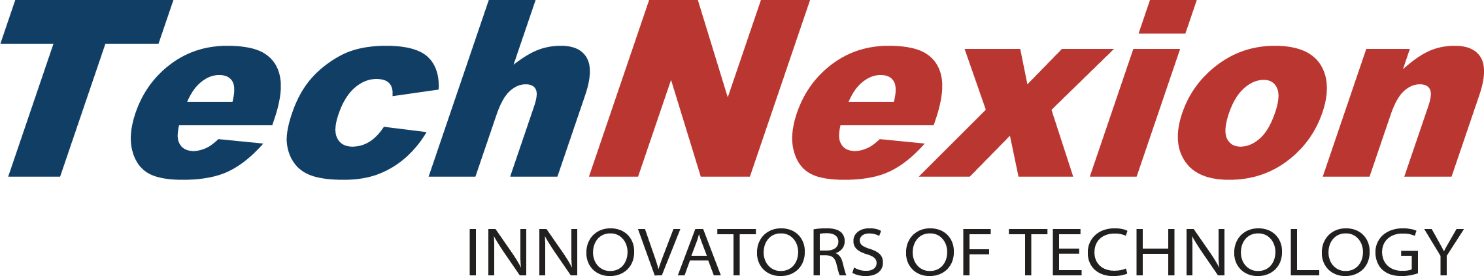

Quick Start Guide

Table of Contents
1 Overview 3
2 Supported Hardware 3
3 Download the factory default rescue/loader system 3
4 Flashing the Image into SD Card 4
5 Setup Boot Mode to boot from eMMC or SD Card on target board 5
6 Running the Factory Default Rescue/Loader System (with GUI) 5
6.1 System Check 6
6.2 Discovering TechNexion Rescue File Server 9
6.2.1 Choose OS 10
6.2.2 Choose Board 11
6.2.3 Choose Display 12
6.2.4 Choose Storage 14
6.3 Program 16
6.4 After Program Processes 20
6.4.1 Download and Flash Complete 21
6.4.2 Download and Flash Failed 23
7 Factory Default Rescue/Loader System in CLI 25
8 Useful Links 25

Overview
This documents describes quick start guide to use the factory default rescue/loader system.

Supported Hardware
The factory default rescue/loader system comes preloaded in:
- PICO-i.MX7D-eMMC System-On-Module (SOM)
- EDM-CF-IMX6-eMMC (TOUCAN1000)
Alternatively the factory default rescue/loader system can be flashed onto a SD card and boot from the SD card.

Download the factory default rescue/loader system
The factory default rescue/loader system should come preloaded into your development board. If not, please visit TechNexion’s download page:
ftp://ftp.technexion.net/factory_default_reset/

Flashing the Image into SD Card
If your PC runs Windows OS:
1. Unzip the win32diskimager.zip
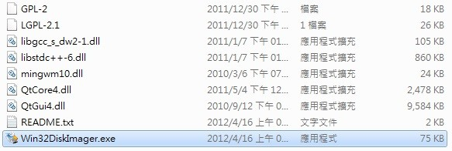
2. Execute Win32DiskImager.exe.
3. Prepare a microSD card. Insert this microSD card into the card reader of PC.
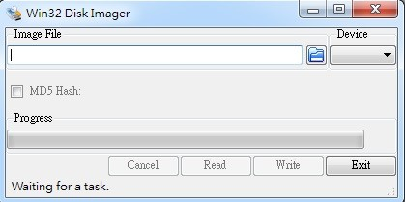
4. Choose microSD you inserted for the “Device” drop-down choice.
5. Select the “tn-pico-imx7d_pico-boards_rescue.img” for the “Image File” input box.
6. Then, click “Write” button. Win32DiskImager will flash rescue system image into SD card.

If your PC runs Ubuntu OS:
1. Prepare a microSD card. Insert this microSD card into the card reader of PC.
2. Use ‘dd’ command to flash factory default rescue image into microSD Card.
$ sudo dd if=tn-pico-imx7d_pico-boards_rescue.img of=/dev/sd<disk> bs=1M oflag=dsync

Setup Boot Mode to boot from eMMC or SD Card on target board
Switch the boot mode to boot from the baseboard SD card or module eMMC to run the factory default rescue/loader system. The factory default rescue/loader system will install from available OS image on TechNexion rescue web server into SOM’s eMMC or a different storage device on the target board.

Running the Factory Default Rescue/Loader System (with GUI)
After booting the target board, GUI version of factory default rescue/loader system automatically starts up. If a display panel is attached to the target board, the GUI client for the rescue/loader system will display.
If you do not have a display, and wishes to use command line interface to flash an OS image, then please skip to chapter 7: Factory Default Rescue/Loader System in CLI.

System Check
The first action that the default factory rescue/loader system do, is a system check for a correctly running installer daemon/service, started by “systemctl start installerd” command in the systemd initialization scripts. If the installerd daemon/service is not running, an error message will pop up as shown in Figure 1: System Check for Installer Daemon/Service.

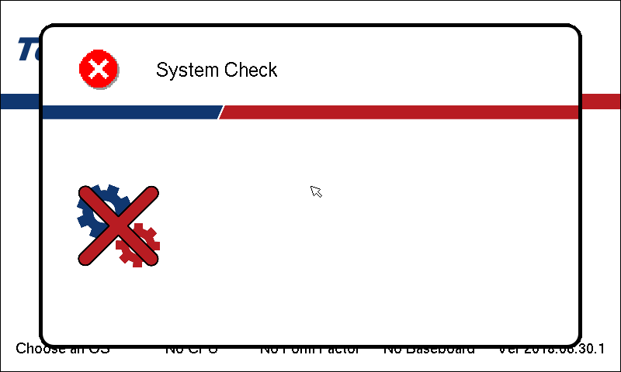
Figure 1: System Check for Installer Daemon/Service
Then, the next actions are checking for network interface, checking for network cable connection, and finally checking for connectivity to TechNexion’s rescue server which contains OS images for different target boards.
When a check is passed, a green tick  is shown instead of a red cross  on the check list item.
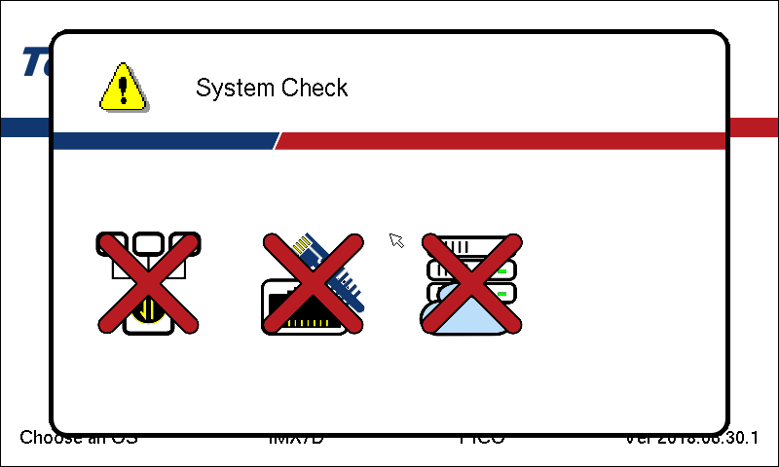
Figure 2: Network Interface, Network Cable, and Rescue Server Checks
The available storage on the target system is also checked, if no storage in the target development board, an error message box will show up as illustrated in Figure 3: Check for available storage in the target development board.

NOTE: The system check message box may pop up a few times until all checks are passed, if one of the system check is failed, the pop up message will stay on the screen until the issue is resolved.

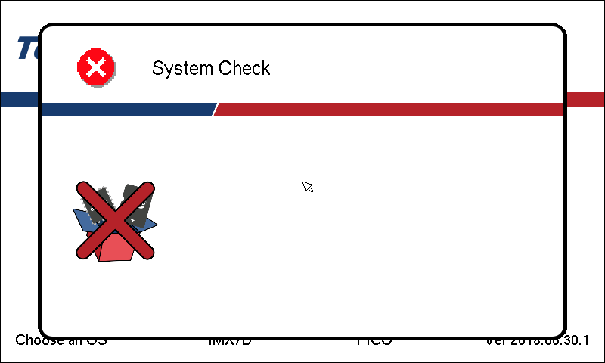
Figure 3: Check for available storage in the target development board
It is a critical error that there is no storage in the target development system, so either insert an SD card for programming an available OS system on, or use an SOM with build-in eMMC.
If an SD card is inserted to the target development board, please restart the rescue/loader system to restart the install/rescue process.

Discovering TechNexion Rescue File Server
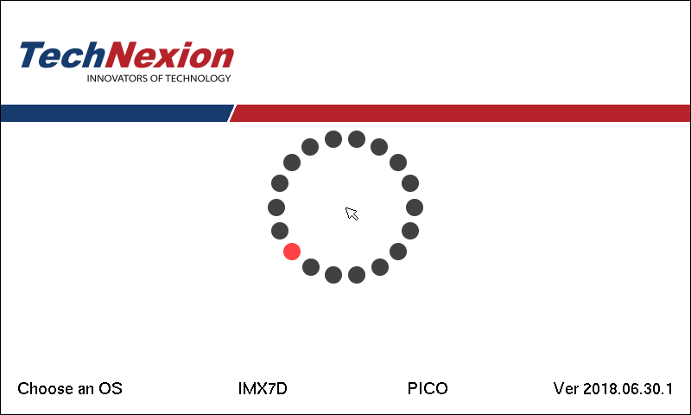
Figure 4: Crawling through the TechNexion Server to obtain downloadable image files
Once the system check validated the installer service, network, and available storage, the next action is to discover all available OS images for your target development board from TechNexion’s Rescue File Server (see chapter 8: Useful Links).

Choose OS
Once a valid OS image for your target development board is found, the GUI rescue/loader system moves to the OS selection stage as show in Figure 5: Choose an available OS.

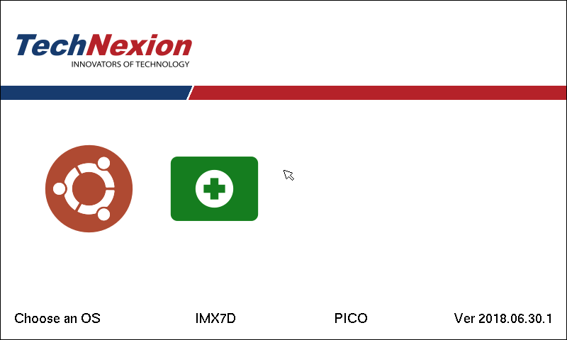
Figure 5: Choose an available OS
In this stage, discovered OS images are shown on the screen, other available OS icons are listed in the table. Please choose an OS you want, and then move to the next selection stage.

Choices | OS
 | Android 6.0/7.0
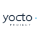 | Yocto 1.7/2.0/2.1
 | Ubuntu 14.04/16.04
 | Latest Rescue System

Choose Board
In this selection stage, all supported boards will be displayed.

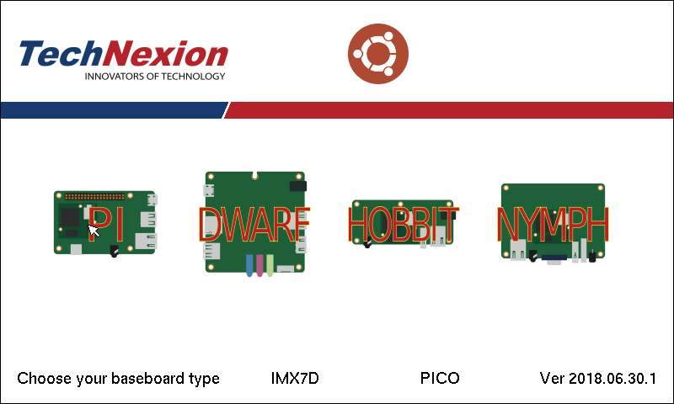
Figure 6: Choose an available baseboard
There are many baseboards for TechNexion SOMs, these are roughly categorized in two pico boards, edm, boards, and others as show in table below.

Choices | Name | Board Type
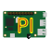 | Pico-Pi Baseboard | PICO
 | Pico-Hobbit Basboard | PICO
 | Pico-Nymph Baseboard | PICO
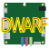 | Pico-Dwarf Baseboard | PICO
 | EDM1-CF-FAIRY Baseboard | EDM
 | EDM1-CF-TOUCAN1000  EDM1-CF-TOUCAN700 | EDM

NOTE: EDM, TEP, TEK system are complete systems, which means that there is one to one relationship between SOM and EDM boards. When cases like this happens, the choose board and choose display stages are skipped directly to choose target storage.

Choose Display
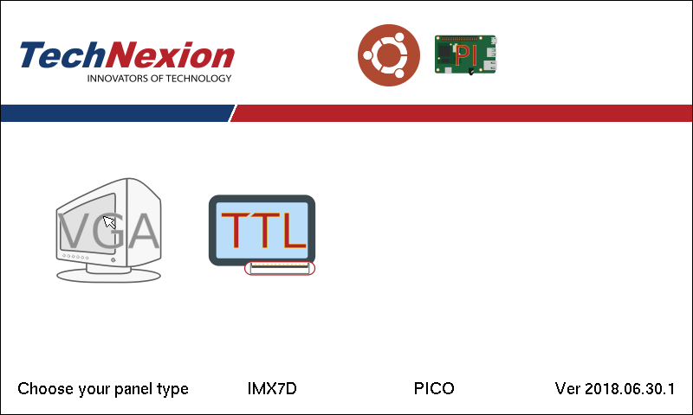
Figure 7: Choose an available display panel
Most of PICO boards support lvds display interface, but some boards also has HDMI, VGA, and MIPI interface, etc. All the available display interface types are show in the table below.

Choices | Panel/Display interface
 | VGA interface
 | TTL interface
 | LVDS interface
 | HDMI interface
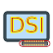 | MIPI serial interface
 | MIPI parallel interface

NOTE: EDM, TEP, TEK, systems has pre-configured display interfaces, which usually means a one to one relationship with the SOM, so the choose display stage might be skipped.

Choose Storage
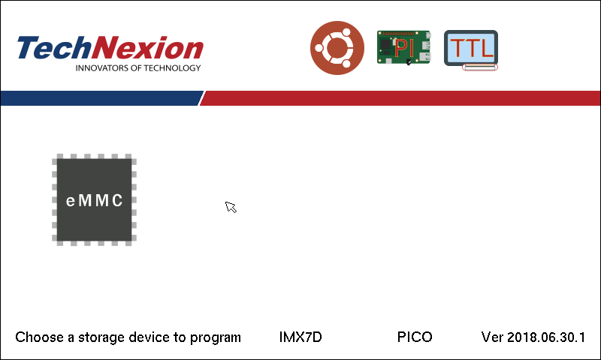
Figure 8: Choose available storage to install the OS
The final stage is choosing an available target storage for programming the selected OS image. There are several storage types available for selection, however, the target storage must be detected first.

Choices | Storage Types
 | ATA/SATA hard disk type
 | eMMC storage type
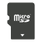 | Micro SD card type
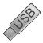 | USB stick storage type

NOTE: If you choose the same storage as you boot the factory default rescue system, the factory default rescue system will be over-written.

Program

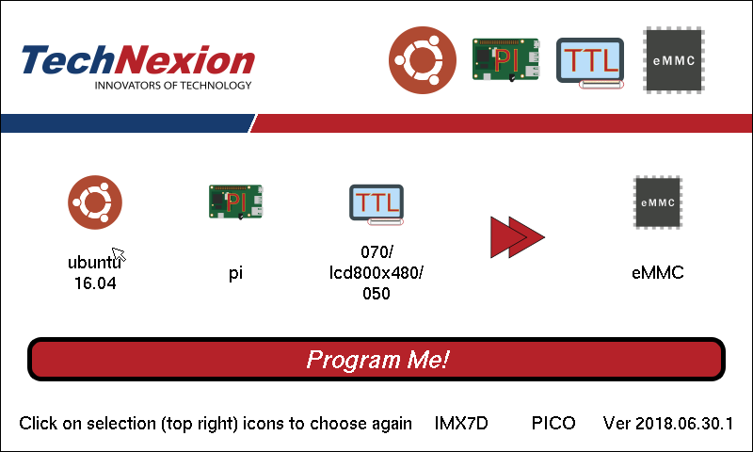
Figure 9: Display user choices and ready to program

When all the selection stages are done, the GUI factory default rescue/loader system goes into a ready-to-program stage, displaying all the selection information and waiting for user to confirm the choice and to issue the next “program” action.
If you wish to change a selection, click on one of the top right selected item icons, and the GUI factory default rescue/loader system will take you back to the appropriate choosing stage to select a different choice.
Finally, confirm your OS image selection, and click “Program Me!” button to download and flash the OS image of your choice to the selected target storage of your target development board.

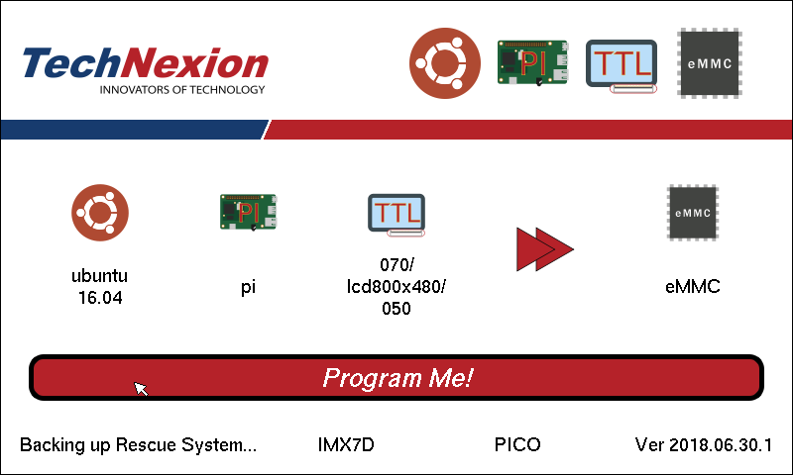
Figure 10: Backing up Rescue System on target storage
Before the download and flash starts, the factory default rescue/loader system will back up itself first. The factory default rescue/loader system will write itself back to the target storage if the download and flash process has failed (see chapter 6.4.2: Download and Flash Failed).
Once the backup of Rescue System on the target storage finishes, the download and flash process starts, and an updating progress bar with estimated remaining time is shown as additional information (see Figure 11: Programming the chosen OS to chosen storage).

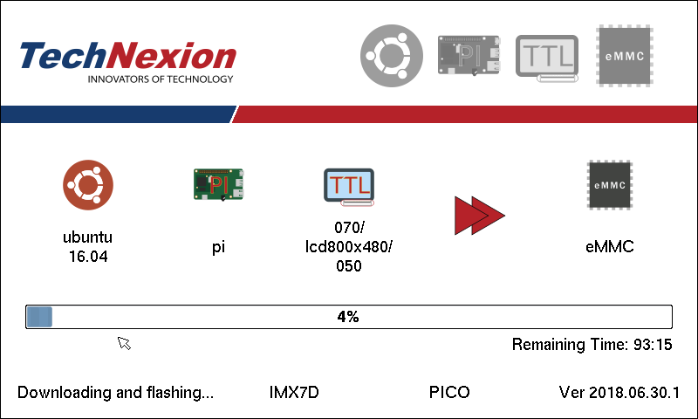
Figure 11: Programming the chosen OS to chosen storage
NOTE: The OS image on the TechNexion server are stored in xz format, the GUI factory default rescue/loader system download and decompress the online xz file at the same time, and then write to the target storage through low level disk I/O. This process is not very fast, for example, download and flash an Ubuntu 16.04 OS image of about 3.4GB takes roughly around 25~40 minutes.

After Program Processes

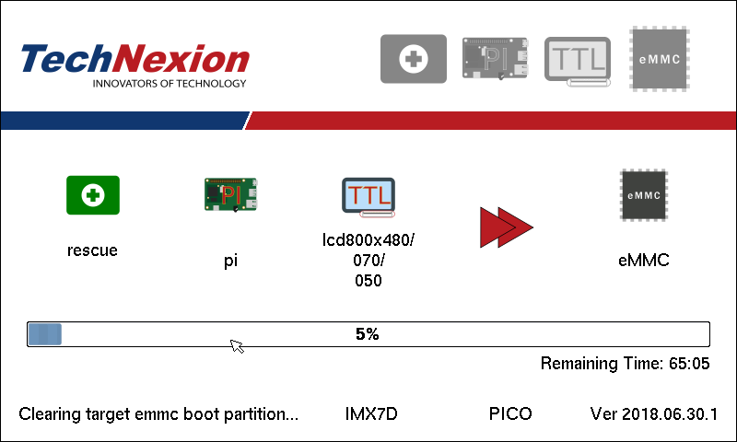
Figure 12: Clear eMMC boot partition
Once download and flash process finishes successfully, the GUI factory default rescue/loader system will perform some after program procedures.
Since all TechNexion OS images boot without using eMMC boot partition options, the factory default rescue/loader system will try to clear the eMMC boot partition and disable emmc boot from boot partition options.

Download and Flash Complete

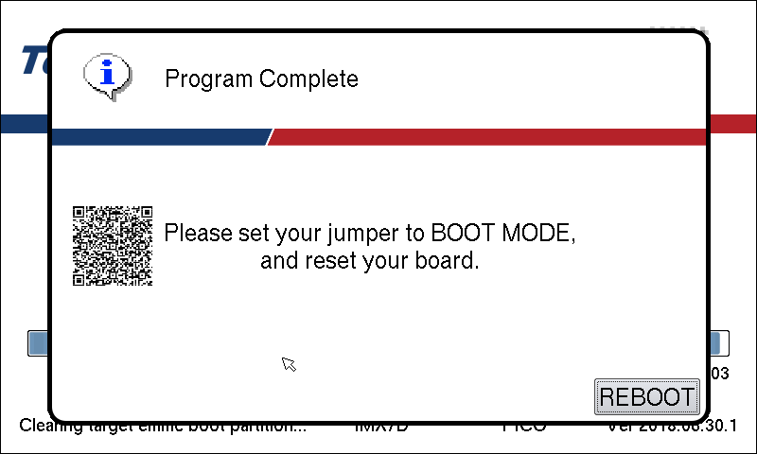
Figure 13: Program completion
A QRCode is also displayed when the programming of OS image completes successfully, the end user could simply scan the QRCode and email the download information to him/herself for future reference.
As per displayed information on the message box, please change the jumper of your target development board to BOOT Mode, and click on “REBOOT” to reboot into your newly programmed OS.

Download and Flash Failed

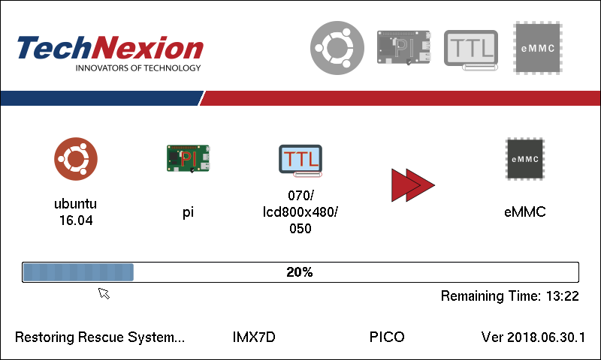
Figure 14: Restoring Rescue System to target storage
When download and flash failed, the GUI factory default rescue/loader system will restore itself back to the target storage. This ensures your target development board to be booted into GUI factory rescue/loader system in an usable state.
After the GUI factory default rescue/loader system is restored, a critical warning message box will show (see Figure 15: Programming failed), and clicking on “REBOOT” button allows you to reboot back into the GUI factory default rescue/loader system.

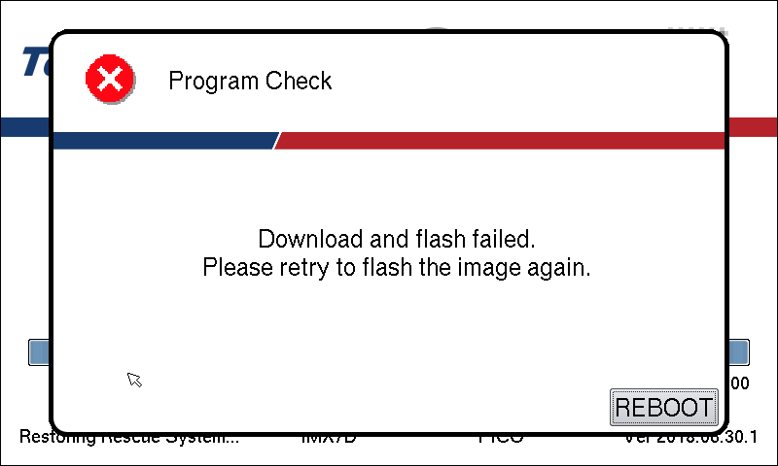
Figure 15: Programming failed

Factory Default Rescue/Loader System in CLI
1. Make sure you connect a debug console to your target development board.
2. In your debug console, log in to the rescue/loader system with user ‘root’ and password ‘root’.
3. Issue following commands,

# cd /home/rescue
# ./installer.py
or
# python3 installer.py

4. Follow the command line prompts to flash a suitable OS image to a target storage on your target development board.

Useful Links
1. TechNexion rescue file server: http://rescue.technexion.net/rescue/

Known Issue:
1. Occasionally the rescue system’s installer daemon server will request and retain too much memory. And cause the Kernel to kill the process due to Out Of Memory (OOM). The rescue system is restored when this happens and can be restarted after reboot. If all attempts to download and program an OS failed using the rescue system. Please issue following commands from the rescue debug console.
$ wget -q -O - URL-to-download-file.xz | xzcat | dd of=/dev/mmcblkX
where URL-to-download-file.xz is located in http://rescue.technexion.net/rescue/

2. The Font size on some large HDMI panel may appear small and thin.
3. Currently, the Rescue System will boot to use HDMI if the hdmi cable is connected during power on, otherwise, it will boot to use MIPI SDI display panel.

