Development of an AI-powered system to detect anomalies, fraud, and inefficiencies in MPLAD Scheme implementation regd. (26102)
Proposed solution:-
1. Geographic Fraud Detection
- Put MPLADS projects on an interactive map.
- Use: Leaflet + OpenStreetMap
- Markers:
- 🟢 Low Risk
🟡 Medium Risk
🟠 High Risk
🔴 Critical Risk
2. AI Investigation Assistant
Ex-Show me suspicious projects in Delhi.
3. trend analysis*
The government doesn't only want to find individual suspicious projects. It also wants to understand patterns over time and across locations.
4. MPLADS Data Dashboard*
Show:
- Total allocated funds
- Total expenditure
- Fund utilization %
- Total works
- Completed works
- Ongoing works
- Delayed works
- High-risk projects
- District-wise expenditure
- Category-wise spending
5. AI Anomaly Detection Engine*
6. Risk Scoring System*
7. Duplicate Work Detection*
8. early warning mechanism*

Datasets:-
india-mplads-works/csv/MPLADS.csv at main · Vonter/india-mplads-works · GitHub
Empowered Indian - Making Government Data Accessible
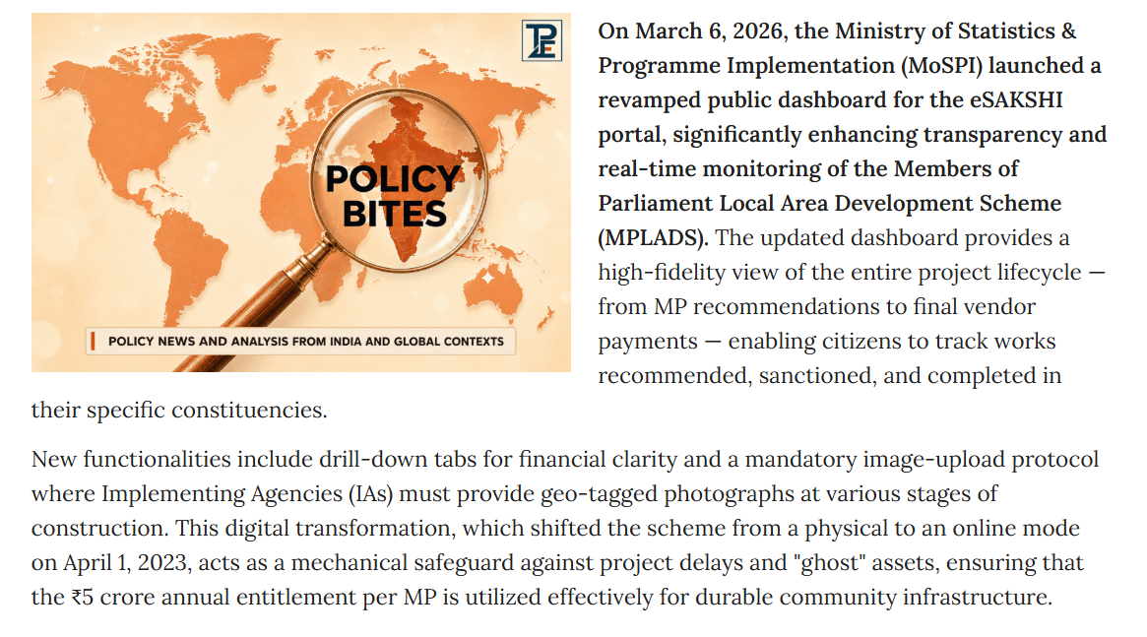
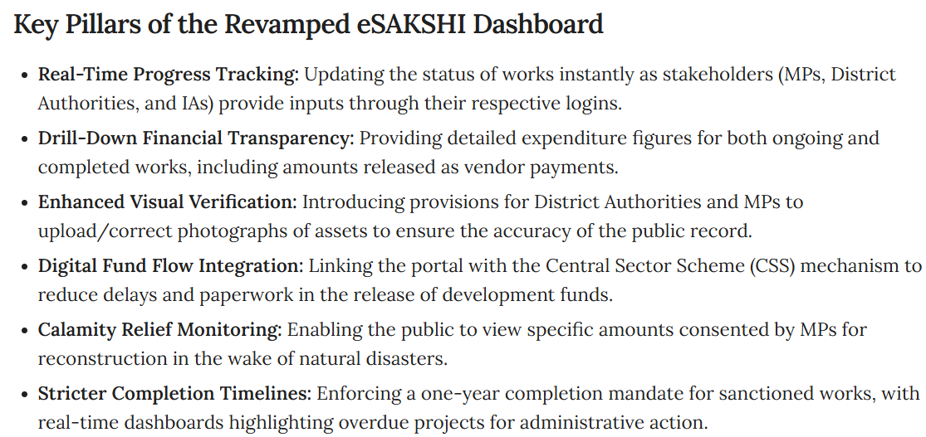
The Government says eSAKSHI has dedicated monitoring reports and dashboards for Central, State and District authorities, with real-time information about work status/progress and pending works
We are not replacing eSAKSHI. We are proposing an AI-based intelligence layer on top of MPLADS data that automatically identifies high-risk works, anomalies, potential duplicate works, unusual expenditure/payment behaviour, and emerging delays. eSAKSHI provides the data and operational workflow; our system converts that data into risk-based decision support.
Existing solution:- Nirikshak AI — AI-Powered MPLADS Monitoring & Risk Intelligence Platform

