**SSN COLLEGE OF ENGINEERING, KALAVAKKAM**

**DEPARTMENT OF COMPUTER SCIENCE AND ENGINEERING**

**UCS1712 – GRAPHICS AND MULTIMEDIA LAB**

------------------------------------------------------------------------------------------------------------

**Lab Exercise 10**: : Creating a 3D Scene in C++ using OpenGL

Write a C++ program using Opengl to draw atleast four 3D objects. Apply lighting and texture and render the scene. Apply transformations to create a simple 3D animation. [Use built-in transformation functions.

***Aim:***

To create a 3D Scene in C++ using OpenGL

***Algorithm:***

1. Initialize OpenGL, set window dimensions, and create a window using GLUT.
2. Set clear color and enable depth testing for accurate rendering.
3. Load a texture and set its parameters for later use in the scene using SOIL.
4. Enable lighting and set light parameters (position, ambient, diffuse, specular).
5. Enable texture mapping and set the shading model to GL_FLAT.
6. Set up the perspective projection using gluPerspective.
7. Define the display function to clear buffers, set the projection and modelview matrices, and draw 3D objects.
8. Inside the display function, draw a teapot, a scaled sphere, a scaled and translated cone, and a torus using built-in functions.
9. Apply transformations to each object (translation, rotation, scaling) to create the desired arrangement using built-in functions..
10. Implement an update function to control the rotation angle for animation.
11. Set up the main function, specify the display and update functions, and initialize the scene.
12. Enter the GLUT main loop to handle events and continuously render the scene.

***10.cpp:***

#include <GL/glut.h>

#include <SOIL/SOIL.h>

const int windowWidth = 800;

const int windowHeight = 600;

GLfloat angle = 0.0f; // Initial rotation angle

// Texture variables

GLuint textureID;

// Rotation angles

float angleX = 0.0f;

float angleY = 0.0f;

// Texture coordinates

float texCoordX = 0.0f;

float texCoordY = 0.0f;

void init()

{

glClearColor(0.0, 0.0, 0.0, 1.0);

glEnable(GL_DEPTH_TEST);

// Load texture

glGenTextures(1, &textureID);

glBindTexture(GL_TEXTURE_2D, textureID);

int width, height;

unsigned char *image = SOIL_load_image("texture1.jpg", &width, &height, 0, SOIL_LOAD_RGB);

glTexImage2D(GL_TEXTURE_2D, 0, GL_RGB, width, height, 0, GL_RGB, GL_UNSIGNED_BYTE, image);

SOIL_free_image_data(image);

// Set texture parameters

glTexParameteri(GL_TEXTURE_2D, GL_TEXTURE_MIN_FILTER, GL_LINEAR);

glTexParameteri(GL_TEXTURE_2D, GL_TEXTURE_MAG_FILTER, GL_LINEAR);

// Enable lighting and set light parameters

glEnable(GL_LIGHTING);

glEnable(GL_LIGHT0);

GLfloat light_position[] = {1.0, 1.0, 1.0, 0.0};

GLfloat ambient[] = {0.2, 0.2, 0.2, 1.0};

GLfloat diffuse[] = {1.0, 1.0, 1.0, 1.0};

GLfloat specular[] = {1.0, 1.0, 1.0, 1.0};

glLightfv(GL_LIGHT0, GL_POSITION, light_position);

glLightfv(GL_LIGHT0, GL_AMBIENT, ambient);

glLightfv(GL_LIGHT0, GL_DIFFUSE, diffuse);

glLightfv(GL_LIGHT0, GL_SPECULAR, specular);

// Enable texture and set shading model

glEnable(GL_TEXTURE_2D);

glShadeModel(GL_FLAT);

// Set up perspective projection

glMatrixMode(GL_PROJECTION);

gluPerspective(45.0f, 1.0f, 1.0f, 100.0f);

glMatrixMode(GL_MODELVIEW);

}

void drawTeapot()

{

glEnable(GL_TEXTURE_2D);

glBindTexture(GL_TEXTURE_2D, textureID); // Bind the texture

glutSolidTeapot(1.0); // Draw a teapot

glDisable(GL_TEXTURE_2D);

}

// glusolid

void drawSphere()

{

glEnable(GL_TEXTURE_2D);

glBindTexture(GL_TEXTURE_2D, textureID); // Bind the texture

GLUquadricObj *sphere = gluNewQuadric();

gluQuadricTexture(sphere, GL_TRUE);

gluSphere(sphere, 0.5, 20, 20);

gluDeleteQuadric(sphere);

glDisable(GL_TEXTURE_2D);

}

void drawConeInit()

{

glEnable(GL_TEXTURE_2D);

glBindTexture(GL_TEXTURE_2D, textureID); // Bind the texture

GLUquadricObj *cone = gluNewQuadric();

gluQuadricTexture(cone, GL_TRUE);

gluCylinder(cone, 0.0, 0.5, 1.0, 20, 20); // Draw a cone

gluDeleteQuadric(cone);

glDisable(GL_TEXTURE_2D);

}

void drawCone()

{

glEnable(GL_TEXTURE_2D);

glBindTexture(GL_TEXTURE_2D, textureID); // Bind the texture

GLUquadricObj *cone = gluNewQuadric();

gluQuadricTexture(cone, GL_TRUE);

gluCylinder(cone, 0.0, 0.5, 1.0, 20, 20); // Draw the cone

glPushMatrix();

glTranslatef(0.0, 0.0, 1.0); // Move to the base of the cone

gluDisk(cone, 0.0, 0.5, 20, 20); // Draw the base circle

glPopMatrix();

gluDeleteQuadric(cone);

glDisable(GL_TEXTURE_2D);

}

void drawCylinder()

{

glEnable(GL_TEXTURE_2D);

glBindTexture(GL_TEXTURE_2D, textureID); // Bind the texture

GLUquadricObj *cylinder = gluNewQuadric();

gluQuadricTexture(cylinder, GL_TRUE);

gluCylinder(cylinder, 0.5, 0.5, 1.0, 20, 20);

gluDeleteQuadric(cylinder);

glDisable(GL_TEXTURE_2D);

}

void drawTorus()

{

glEnable(GL_TEXTURE_2D);

glBindTexture(GL_TEXTURE_2D, textureID); // Bind the texture

glutSolidTorus(0.3, 0.7, 20, 20);

glDisable(GL_TEXTURE_2D);

}

void display()

{

glViewport(0, 0, windowWidth, windowHeight); // Set the viewport size

glClear(GL_COLOR_BUFFER_BIT | GL_DEPTH_BUFFER_BIT);

glMatrixMode(GL_PROJECTION);

glLoadIdentity();

gluPerspective(45.0, static_cast<double>(windowWidth) / windowHeight, 0.1, 100.0); // Adjusted near and far planes

glMatrixMode(GL_MODELVIEW);

glLoadIdentity();

gluLookAt(0.0, 0.0, 5.0, 0.0, 0.0, 0.0, 0.0, 1.0, 0.0); // Adjusted camera position

glTranslatef(0.0f, 0.0f, -5.0f); // Move the scene back along the z-axis

glRotatef(angle, 1.0f, 1.0f, 0.0f); // Rotate around the x and y-axis

// Apply material properties (color, etc.)

GLfloat material_diffuse[] = {0.7f, 0.7f, 0.7f, 1.0f};

glMaterialfv(GL_FRONT, GL_DIFFUSE, material_diffuse);

// Draw 3D objects

drawTeapot(); // Draw a teapot

glTranslatef(2.0f, 2.0f, 0.0f);

glScalef(2.0f, 2.0f, 2.0f); // Scale

drawSphere(); // Draw a sphere

glScalef(0.5f, 0.5f, 0.5f); // Scale

glTranslatef(-4.0f, -4.0f, 0.0f);

drawCone(); // Draw a cylinder

glTranslatef(4.0f, -2.0f, 0.0f);

drawTorus(); // Draw a torus

glTranslatef(0.0f, 0.0f, -5.0f);

glutSwapBuffers();

}

void update(int value)

{

angle += 2.0f; // Update rotation angle

if (angle > 360)

{

angle -= 360; // Keep the angle within 0 to 360 degrees

}

glutPostRedisplay(); // Trigger a redraw

glutTimerFunc(16, update, 0); // Call update function every 16 milliseconds

}

int main(int argc, char **argv)

{

glutInit(&argc, argv);

glutInitDisplayMode(GLUT_DOUBLE | GLUT_RGB | GLUT_DEPTH);

glutInitWindowSize(windowWidth, windowHeight); // Set window size

glutCreateWindow("OpenGL 3D Scene");

// Add these lines for proper initialization

glClearColor(0.0, 0.0, 0.0, 0.0);

glEnable(GL_DEPTH_TEST);

glutDisplayFunc(display);

glutTimerFunc(25, update, 0);

init();

glutMainLoop();

return 0;

}

***run.sh:***g++ 10.cpp -lGL -lglut -lGLU -lSOIL

./a.out

***Sample I/O:***

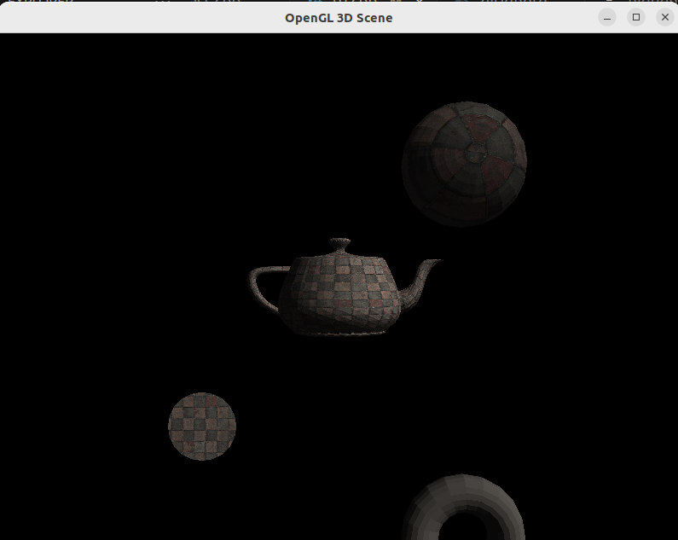

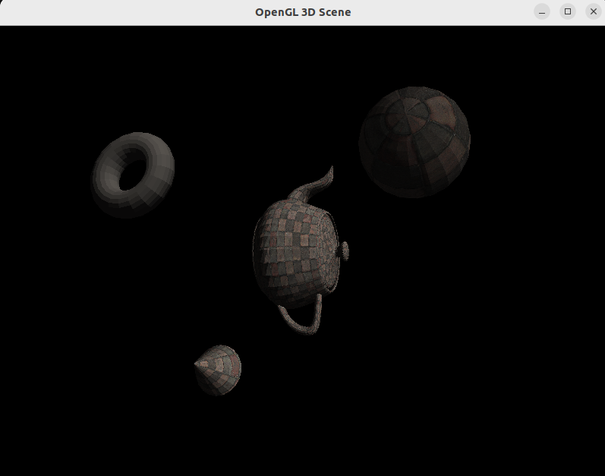

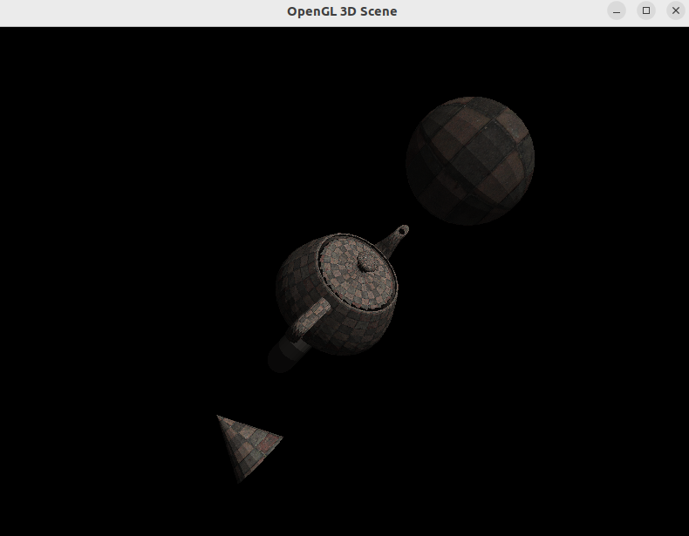

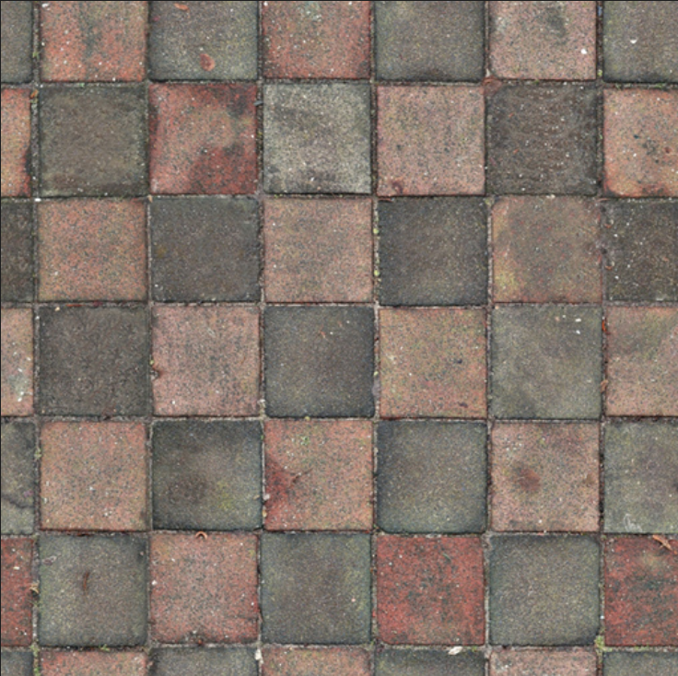

***Learning Outcomes:***

Thus, 3D objects were drawn and lighting and textures were applied and the scene was rendered in C++ using OpenGL.