**SSN COLLEGE OF ENGINEERING, KALAVAKKAM**

**DEPARTMENT OF COMPUTER SCIENCE AND ENGINEERING**

**UCS1712 – GRAPHICS AND MULTIMEDIA LAB**

------------------------------------------------------------------------------------------------------------

**Lab Exercise 11: Image Editing and Manipulation**

a) Using GIMP, include an image and apply filters, noise and masks.

b) Using GIMP, create a GIF animated image.

***Aim:***

To do image editing and manipulation on a image file using GIMP software.

***a:***

original image:



***Sample Output:***

1. ***Filters:***
2. ***Disort – Ripple:***

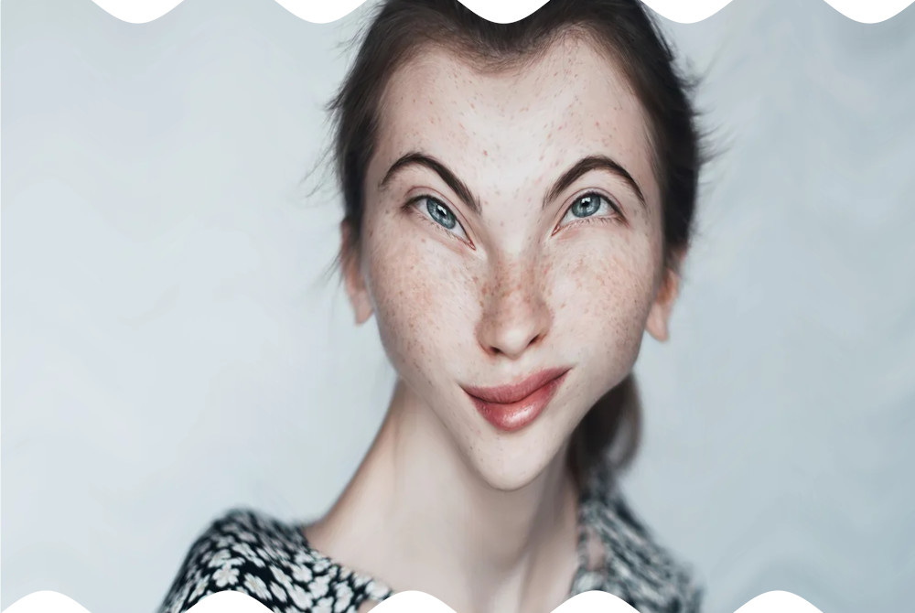

1. ***Focus – Blur:***

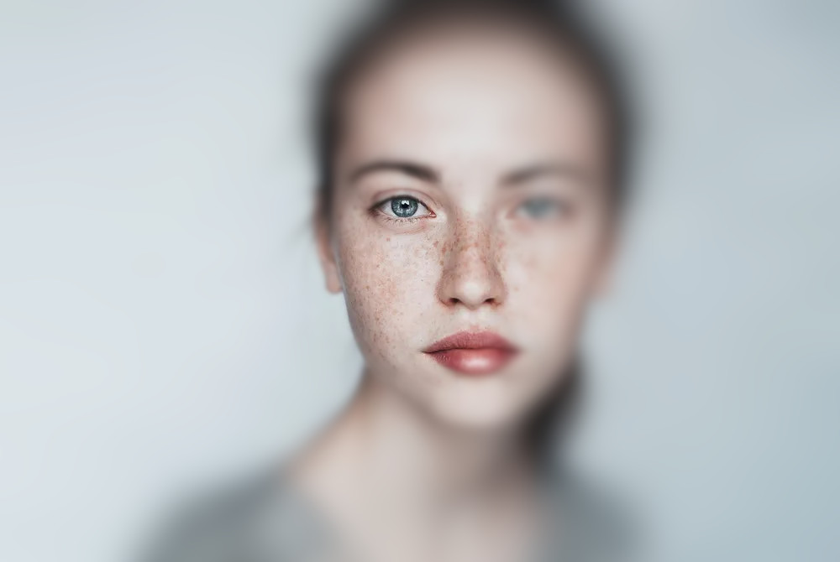

1. ***Noise:***
   1. ***Noise - RBG Noise:***

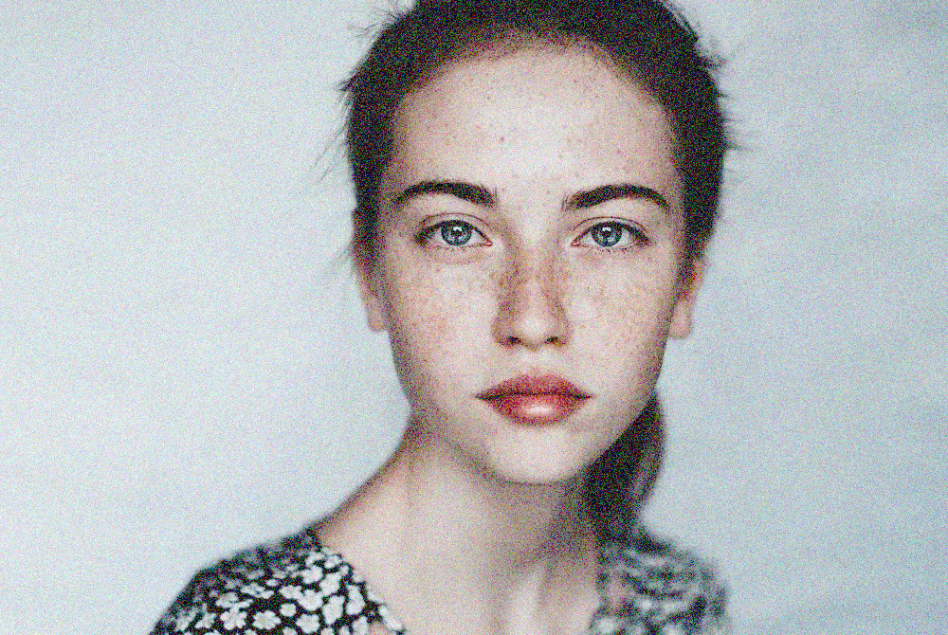

1. ***Mask:***
   1. ***Enchance – Unsharp Mask:***

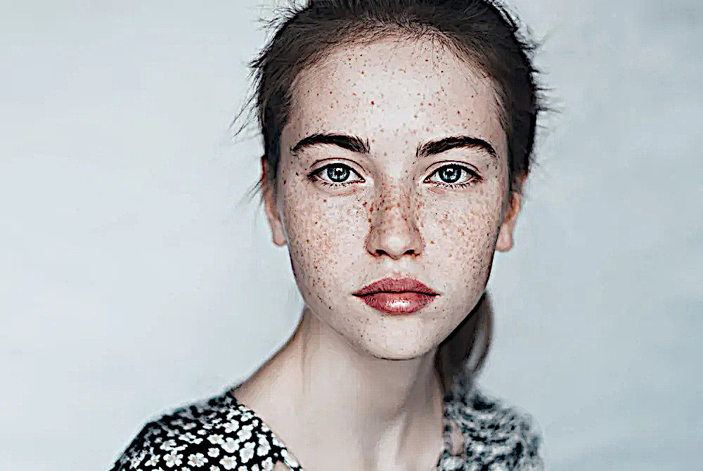

***b:***



***Learning Outcomes:***

Learnt to do image editing and manipulation on a image file using GIMP software.