**SSN COLLEGE OF ENGINEERING, KALAVAKKAM**

**DEPARTMENT OF COMPUTER SCIENCE AND ENGINEERING**

**UCS1712 – GRAPHICS AND MULTIMEDIA LAB**

------------------------------------------------------------------------------------------------------------

**Lab Exercise 2** : DDA Line Drawing Algorithm in C++ using OpenGL

To plot points that make up the line with endpoints (x0,y0) and (xn,yn) using DDA line drawing algorithm.

Case 1: +ve slope Left to Right line

Case 2: +ve slope Right to Left line

Case 3: -ve slope Left to Right line

Case 4: -ve slope Right to Left line

Each case has two subdivisions

(i) |m|<= 1 (ii) |m|>1

Note that all four cases of line drawing must be given as test cases.

***Aim:***

To implement DDA line drawing algorithm

***Algorithm:***

1. Accept two endpoints `P1(x1, y1)` and `P2(x2, y2)` of the line to be drawn.
2. Calculate the differences in x and y coordinates:

dx = x2 - x1

dy = y2 – y1

1. Determine the number of steps required for drawing the line. Use the larger of `dx` and `dy` as the number of steps:

steps = max(abs(dx), abs(dy))

1. Calculate the incremental values for `x` and `y`:

x_increment = dx / steps

y_increment = dy / steps

1. Initialize a loop and start drawing the line by repeatedly adding the incremental values to `x` and `y`:

x = x1

y = y1

for i from 1 to steps:

Plot the point (x, y)

x = x + x_increment

y = y + y_increment

1. The loop will draw the line from `P1` to `P2` by plotting points along the line at regular intervals.
2. End the algorithm.

***Code:***

#include <stdio.h>

#include <GL/glut.h>

#include <math.h>

#include <cstring>

#define pi 3.142857

void output(int x, int y, const char *string)

{

glRasterPos2f(x, y);

int len, i;

len = (int)strlen(string);

for (i = 0; i < len; i++)

{

glutBitmapCharacter(GLUT_BITMAP_HELVETICA_12, string[i]);

}

}

void draw_pixel(int x, int y)

{

glBegin(GL_POINTS);

glVertex2i(x, y);

glEnd();

}

void myInit(void)

{

glClearColor(0.0, 0.0, 0.0, 1.0);

glColor3f(0.0, 1.0, 0.0); // making picture color green (in RGB mode), as middle argument is 1.0

glPointSize(1.0);

glMatrixMode(GL_PROJECTION);

glLoadIdentity();

gluOrtho2D(-780, 780, -420, 420);

}

void drawLineDDA(float x0, float y0, float xn, float yn)

{

// glClear(GL_COLOR_BUFFER_BIT);

float dx = xn - x0;

float dy = yn - y0;

float steps = fabs(dx) > fabs(dy) ? fabs(dx) : fabs(dy);

float xIncrement = dx / steps;

float yIncrement = dy / steps;

float x = x0;

float y = y0;

for (int i = 0; i <= steps; ++i)

{

draw_pixel(static_cast<int>(x + 0.5), static_cast<int>(y + 0.5));

x += xIncrement;

y += yIncrement;

}

}

void display()

{

glClear(GL_COLOR_BUFFER_BIT);

glColor3f(1.0, 1.0, 1.0);

glBegin(GL_LINES);

glVertex2d(0, 420);

glVertex2d(0, -420);

glEnd();

glBegin(GL_LINES);

glVertex2d(780, 0);

glVertex2d(-780, 0);

glEnd();

glColor3f(0.0, 1.0, 0.0);

drawLineDDA(0, 0, 400, 200);

output(420, 200, "(400,200)");

drawLineDDA(0, 0, 200, 400);

output(220, 400, "(200,400)");

drawLineDDA(-400, 200, 0, 0);

output(-420, 200, "(-400,200)");

drawLineDDA(-200, 400, 0, 0);

output(-220, 400, "(-200,400)");

drawLineDDA(0, 0, 400, -200);

output(420, -200, "(400,-200)");

drawLineDDA(0, 0, 200, -400);

output(220, -400, "(200,-400)");

drawLineDDA(-400, -200, 0, 0);

output(-420, -200, "(-400,-200)");

drawLineDDA(-200, -400, 0, 0);

output(-220, -400, "(-200,-400)");

glFlush();

}

int main(int argc, char **argv)

{

glutInit(&argc, argv);

glutInitDisplayMode(GLUT_SINGLE | GLUT_RGB);

// giving window size in X- and Y- direction

glutInitWindowSize(1366, 768);

glutInitWindowPosition(0, 0);

// Giving name to window

glutCreateWindow("DDA line Drawing");

myInit();

glutDisplayFunc(display);

glutMainLoop();

return 0;

}

***run.sh:***g++ 2.cpp -lGL -lglut -lGLU

./a.out

***Sample I/O:***

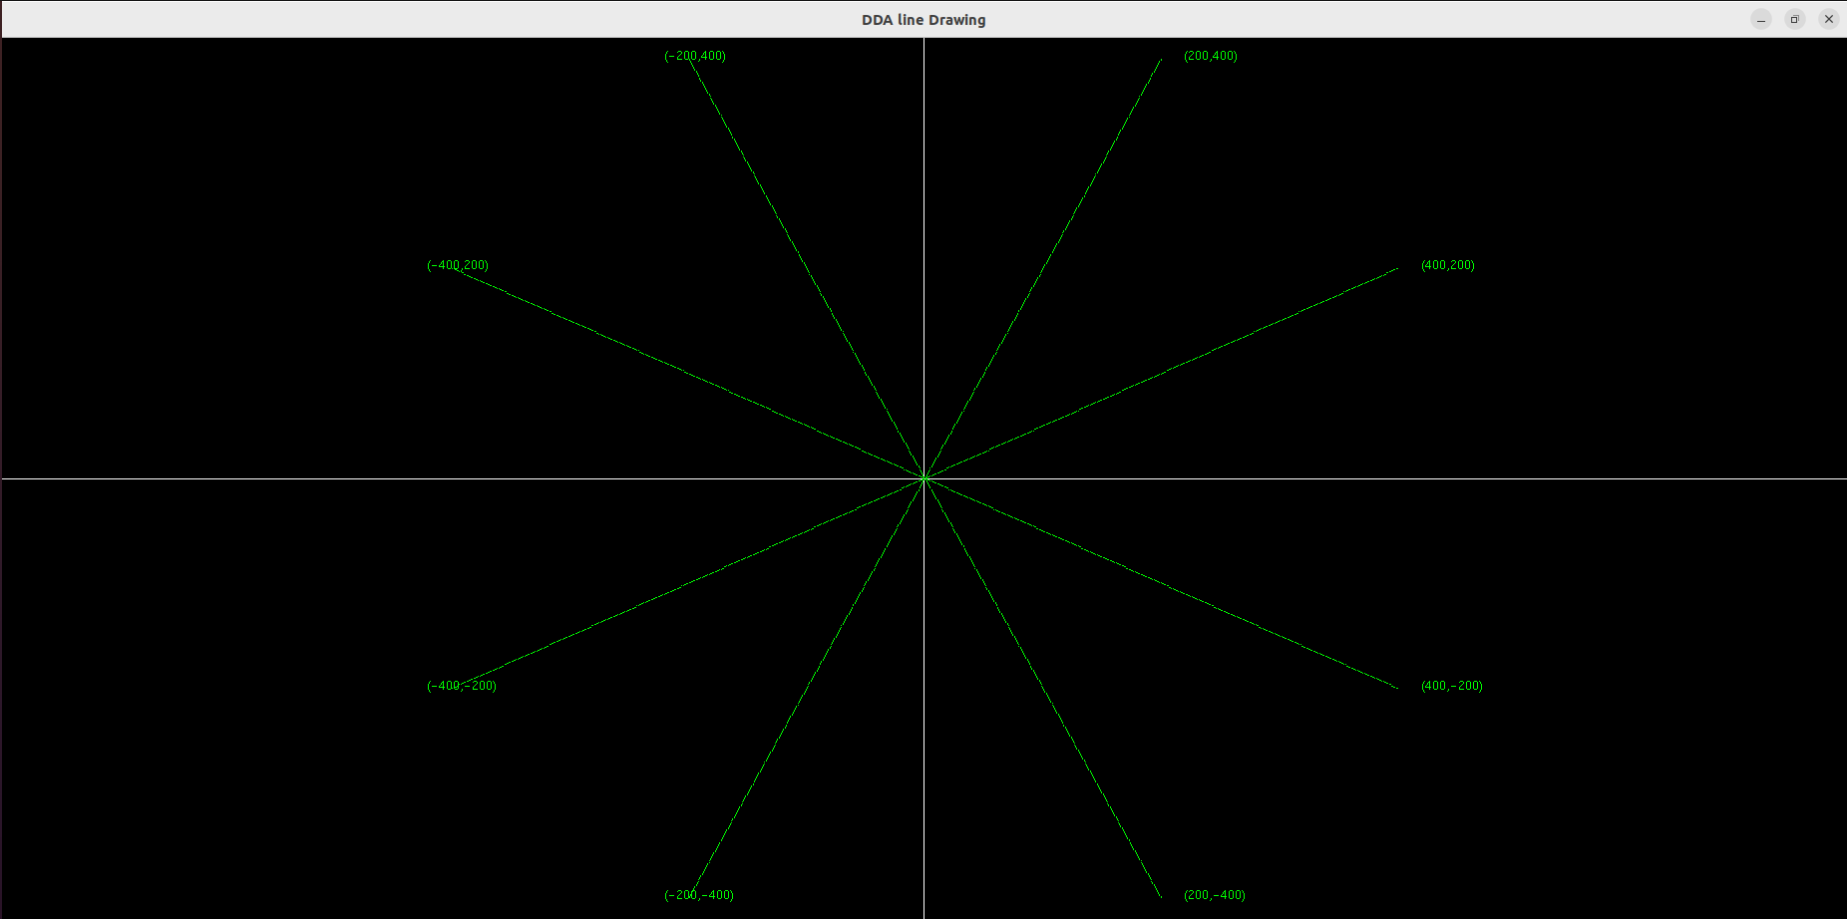

***Learning Outcomes:***

Thus, DDA line drawing algo has been implemented with OpenGL and GLUT frameworks.