**SSN COLLEGE OF ENGINEERING, KALAVAKKAM**

**DEPARTMENT OF COMPUTER SCIENCE AND ENGINEERING**

**UCS1712 – GRAPHICS AND MULTIMEDIA LAB**

------------------------------------------------------------------------------------------------------------

**Lab Exercise 4**: Midpoint Circle Drawing Algorithm in C++ using OpenGL

a) To plot points that make up the circle with center (xc,yc) and radius r using Midpoint circle drawing

algorithm. Give atleast 2 test cases.

Case 1: With center (0,0)

Case 2: With center (xc,yc)

b) To draw any object using line and circle drawing algorithms.

***Aim:***

To implement circle drawing mid point algorithm.

***Algorithm:***

1. Input radius r and circle center (xc, yc). set the first point (x0 , y0 ) = (0, r ).
2. Calculate the initial value of the decision parameter as p0 = 1 – r.
3. At each xk position, starting at k = 0, perform the following test:
4. If pk <0,
5. plot(xk +1,yk )andpk+1 =pk +2xk+1 +1,
6. Else,
7. where2xk+1 =2xk +2and2yk+1 =2yk –2.
8. plot (xk+1,yk –1)andpk+1 =pk +2xk+1 +1–2yk+1,
9. Determine symmetry points on the other seven octants.
10. Move each calculated pixel position (x, y) onto the circular path centered on (xc, yc) and plot the coordinate values: x = x +xc ,y=y+yc
11. Repeat steps 3 though 5 until x y.
12. For all points, add the center point (xc, yc)

***Code:***

#include <stdio.h>

#include <GL/glut.h>

#include <math.h>

#include <cstring>

#include <iostream>

#define pi 3.142857

using namespace std;

int windowWidth = 1000;

int windowHeight = 1000;

void myInit(void)

{

glClearColor(0.0, 0.0, 0.0, 1.0);

glColor3f(0.0, 1.0, 0.0); // making picture color green (in RGB mode), as middle argument is 1.0

glPointSize(1.0);

glMatrixMode(GL_PROJECTION);

glLoadIdentity();

gluOrtho2D(-windowHeight / 2, windowHeight / 2, -windowWidth / 2, windowWidth / 2);

}

void draw_pixel(int x, int y)

{

glBegin(GL_POINTS);

glVertex2i(x, y);

glEnd();

glFlush();

}

void drawLineDDA(float x0, float y0, float xn, float yn)

{

// glClear(GL_COLOR_BUFFER_BIT);

float dx = xn - x0;

float dy = yn - y0;

float steps = fabs(dx) > fabs(dy) ? fabs(dx) : fabs(dy);

float xIncrement = dx / steps;

float yIncrement = dy / steps;

float x = x0;

float y = y0;

for (int i = 0; i <= steps; ++i)

{

draw_pixel(static_cast<int>(x + 0.5), static_cast<int>(y + 0.5));

x += xIncrement;

y += yIncrement;

}

}

void draw_axis()

{

glColor3f(1.0, 1.0, 1.0);

glBegin(GL_LINES);

glVertex2d(-2000, 0);

glVertex2d(2000, 0);

glEnd();

glBegin(GL_LINES);

glVertex2d(0, 2000);

glVertex2d(0, -2000);

glEnd();

glFlush();

}

void draw_in_each_oct(GLint xk, GLint yk, GLint xc, GLint yc)

{

draw_pixel(xc + xk, yc + yk);

draw_pixel(xc + yk, yc + xk);

draw_pixel(xc - yk, yc + xk);

draw_pixel(xc - xk, yc + yk);

draw_pixel(xc - xk, yc - yk);

draw_pixel(xc - yk, yc - xk);

draw_pixel(xc + yk, yc - xk);

draw_pixel(xc + xk, yc - yk);

}

void midPtCircle(GLint xc, GLint yc, GLint r)

{

GLint pk, xk, yk;

pk = 1 - r;

xk = 0;

yk = r;

draw_in_each_oct(xk, yk, xc, yc);

while (xk <= yk)

{

if (pk < 0)

{

xk = xk + 1;

pk = pk + (2 * xk) + 1;

}

else

{

xk = xk + 1;

yk = yk - 1;

pk = pk + (2 * xk) + 1 - (2 * yk);

}

draw_in_each_oct(xk, yk, xc, yc);

}

}

void display()

{

glClear(GL_COLOR_BUFFER_BIT);

draw_axis();

glColor3f(0.0, 1.0, 0.0);

GLint xc, yc, r;

cout << "Enter xc, yc, radius(resp): ";

cin >> xc >> yc >> r;

midPtCircle(xc, yc, r);

drawLineDDA(0, r, r, 0);

drawLineDDA(r, 0, 0, -r);

drawLineDDA(0, -r, -r, 0);

drawLineDDA(-r, 0, 0, r);

}

int main(int argc, char **argv)

{

glutInit(&argc, argv);

glutInitDisplayMode(GLUT_SINGLE | GLUT_RGB);

glutInitWindowSize(windowHeight, windowWidth);

glutInitWindowPosition(0, 0);

glutCreateWindow("Circle Drawing");

myInit();

glutDisplayFunc(display);

glutMainLoop();

return 1;

}

***run.sh:***g++ 4.cpp -lGL -lglut -lGLU

./a.out

***Sample I/O:***

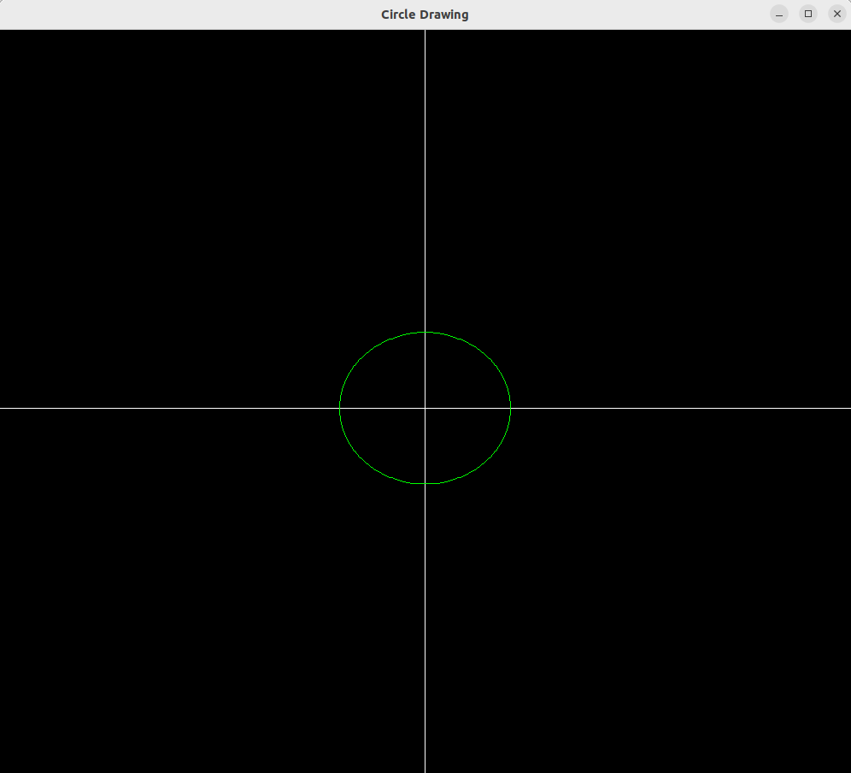

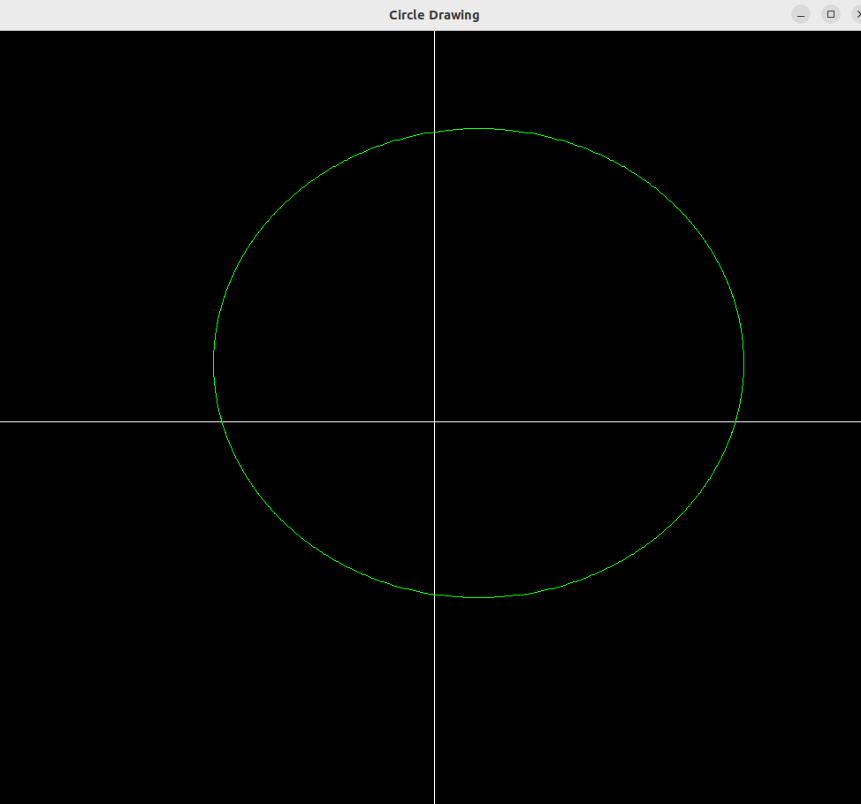

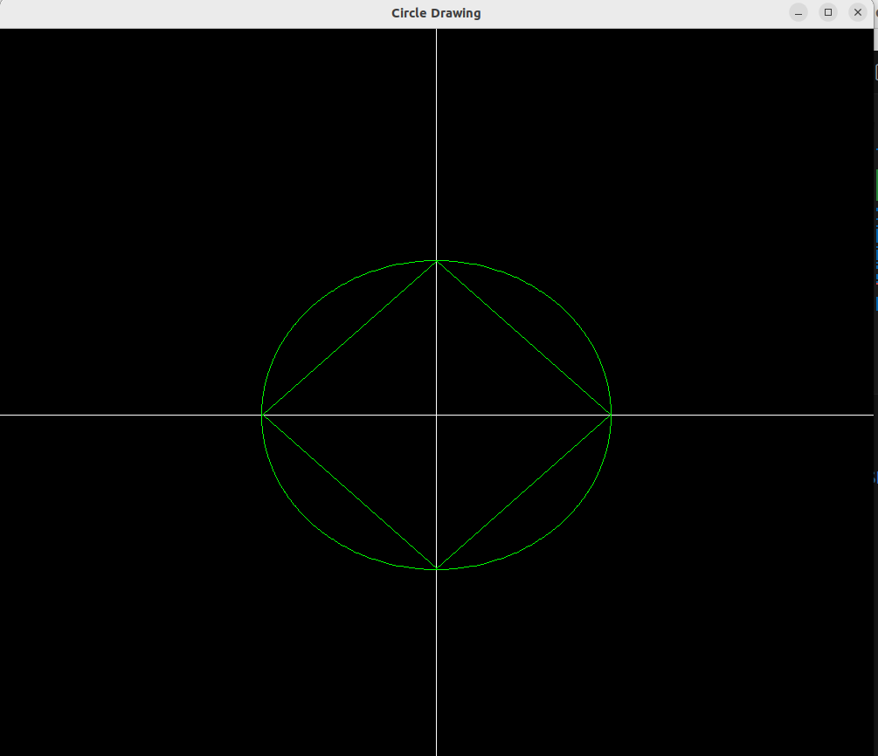

***Learning Outcomes:***

I learned how to use the midpoint circle drawing algorithm in c++ using the openGL library to draw circles.