**SSN COLLEGE OF ENGINEERING, KALAVAKKAM**

**DEPARTMENT OF COMPUTER SCIENCE AND ENGINEERING**

**UCS1712 – GRAPHICS AND MULTIMEDIA LAB**

------------------------------------------------------------------------------------------------------------

**Lab Exercise 6**: 2D Composite Transformations and Windowing in C++ using OpenGL

a) To compute the composite transformation matrix for any 2 transformations given as input by

the user and applying it on the object.

The transformation can be any combination of the following.

1) Translation

2) Rotation

3) Scaling

4) Reflection

5) Shearing

Display the original and the transformed object.

Calculate the final transformation matrix by multiplying the two individual transformation

matrices and then apply it to the object.

Note: Use Homogeneous coordinate representations and matrix multiplication to perform

transformations. Divide the output window into four quadrants. (Use LINES primitive to draw x

and y axis)

b) Create a window with any 2D object and a different sized viewport. Apply window to viewport

transformation on the object. Display both window and viewport.

***Aim:***

To implement Composite 2D transformations on objects and windowing using C++ using OpenGL

***Algorithm:***

***6a.cpp:***

1. Get points of the object as input.

2. Draw the object.

3. Transform each vertex of the object.

4. Draw the object with the transformed vertices.

***6b.cpp:***

1. Store the window dimensions and the viewport dimensions.

2. Get points of the object as input and draw it on the window.

3. Apply window to viewport transformation on the object as:

a. Sx = (xvmax - xvmin) / (xwmax - xwmin)

b. xv = xvmin + (xw - xwmin) * Sx

c. Similarly, for the y-coordinates.

4. Draw the object on the viewport.

***Code:***

***6a.cpp:***

#include <GL/glut.h>

#include <iostream>

#include <vector>

#include <cmath>

#include <cstring>

#include <stdio.h>

#define pi M_PI

using namespace std;

void myInit()

{

glClearColor(0.5, 1.0, 1.0, 0.0);

glColor3f(0.0f, 0.0f, 0.0f);

glPointSize(1);

glMatrixMode(GL_PROJECTION);

glLoadIdentity();

gluOrtho2D(-320.0, 320.0, -240.0, 240.0);

}

vector<vector<float>> translation()

{

float tx, ty;

cout << "Enter tx, ty: ";

cin >> tx >> ty;

vector<vector<float>> translate(3, vector<float>(3, 0.0));

(translate)[0][0] = 1;

(translate)[0][2] = tx;

(translate)[1][1] = 1;

(translate)[1][2] = ty;

(translate)[2][2] = 1;

return translate;

}

vector<vector<float>> rotate()

{

float deg;

cout << "Enter deg: ";

cin >> deg;

vector<vector<float>> rotate(3, vector<float>(3, 0.0));

deg *= M_PI / 180;

cout << deg << " : deg" << endl;

rotate[0][0] = cos(deg);

rotate[0][1] = -sin(deg);

rotate[1][0] = sin(deg);

rotate[1][1] = cos(deg);

rotate[2][2] = 1;

// rotate[0][2] = tx*(1-cos(deg))+ty*sin(deg);

// rotate[1][2] = ty*(1-cos(deg))-tx*sin(deg);

return rotate;

}

vector<vector<float>> scale()

{

float sx, sy;

cout << "Enter sx, sy: ";

cin >> sx >> sy;

vector<vector<float>> scale(3, vector<float>(3, 0.0));

scale[0][0] = sx;

scale[1][1] = sy;

scale[2][2] = 1;

// scale[0][2] = tx * (1 - sx);

// scale[1][2] = ty * (1 - sy);

return scale;

}

vector<vector<float>> reflect()

{

float axis;

cout << "Enter option 1.x-axis 2.y-axis 3.origin 4.x=y (1/2/3/4): ";

cin >> axis;

vector<vector<float>> reflect(3, vector<float>(3, 0.0));

reflect[0][0] = 1;

reflect[1][1] = 1;

reflect[2][2] = 1;

if (axis == 1)

reflect[1][1] = -1;

else if (axis == 2)

reflect[0][0] = -1;

else if (axis == 3)

{

reflect[0][0] = -1;

reflect[1][1] = -1;

}

else if (axis == 4)

{

reflect[0][1] = 1;

reflect[0][0] = 0;

reflect[1][0] = 1;

reflect[1][1] = 0;

}

return reflect;

}

vector<vector<float>> shear()

{

float op;

cout << "Enter option 1.x-shear 2.y-shear (1/2): ";

cin >> op;

float sh, ref;

if (op == 1)

cout << "Enter shx, yref: ";

else if (op == 2)

cout << "Enter shy, xref: ";

cin >> sh >> ref;

vector<vector<float>> shear(3, vector<float>(3, 0.0));

shear[0][0] = 1;

shear[1][1] = 1;

shear[2][2] = 1;

if (op == 1)

{

shear[0][1] = sh;

shear[0][2] = -sh * ref;

}

else if (op == 2)

{

shear[1][0] = sh;

shear[1][2] = -sh * ref;

}

return shear;

}

vector<vector<float>> matrixMul(vector<vector<float>> t1,

vector<vector<float>> t2, vector<vector<float>> res, int n)

{

for (int i = 0; i < 3; i++)

{

for (int j = 0; j < n; j++)

{

res[i][j] = 0;

for (int k = 0; k < 3; k++)

{

res[i][j] += t1[i][k] * t2[k][j];

}

}

}

return res;

}

void matrixDisp(vector<vector<float>> m)

{

cout << endl;

for (auto arrp : m)

{

for (auto p : arrp)

{

cout << p << " ";

}

cout << endl;

}

}

void display()

{

glClear(GL_COLOR_BUFFER_BIT);

int op1, op2;

cout << "Enter any 2 tranformations:- \n1.translation \n2.rotation\n3.scaling \n4.reflection \n5.shearing(1 / 2 / 3 / 4 / 5) \ninc order(op1, op2) : ";

cin >> op1 >> op2;

vector<vector<float>> t1, t2;

if (op1 == 1)

{

t1 = translation();

}

else if (op1 == 2)

{

t1 = rotate();

}

else if (op1 == 3)

{

t1 = scale();

}

else if (op1 == 4)

{

t1 = reflect();

}

else if (op1 == 5)

{

t1 = shear();

}

// for op2

if (op2 == 1)

{

t2 = translation();

}

else if (op2 == 2)

{

t2 = rotate();

}

else if (op2 == 3)

{

t2 = scale();

}

else if (op2 == 4)

{

t2 = reflect();

}

else if (op2 == 5)

{

t2 = shear();

}

for (auto a : t1)

{

for (auto x : a)

{

cout << x << " ";

}

cout << endl;

}

for (auto a : t2)

{

for (auto x : a)

{

cout << x << " ";

}

cout << endl;

}

int n;

cout << "Enter no. of points for polygon: ";

cin >> n;

// points matrix

vector<vector<float>> points(3, vector<float>(n));

for (int i = 0; i < n; i++)

{

cout << "Enter x, y coords: ";

cin >> points[0][i] >> points[1][i];

points[2][i] = 1;

}

// order for now is op1 then op2

// result matrix

vector<vector<float>> res(3, vector<float>(n));

// t2 x t1

res = matrixMul(t2, t1, res, 3);

matrixDisp(res);

// t21 x points

res = matrixMul(res, points, res, n);

matrixDisp(res);

// axis

glBegin(GL_LINES);

glVertex2d(-320, 0);

glVertex2d(320, 0);

glVertex2d(0, -240);

glVertex2d(0, 240);

glEnd();

// original shape

glBegin(GL_LINE_LOOP);

for (int i = 0; i < n; i++)

{

glVertex2f(points[0][i], points[1][i]);

}

glEnd();

// result shape plot

glRasterPos2i(res[0][n / 2], res[1][n / 2] - 15);

glutBitmapCharacter(GLUT_BITMAP_HELVETICA_18, int('S'));

glBegin(GL_LINE_LOOP);

glColor3f(1.0f, 0.0f, 0.0f);

for (int i = 0; i < n; i++)

{

glVertex2f(res[0][i], res[1][i]);

}

glEnd();

glFlush();

}

int main(int argc, char **argv)

{

glutInit(&argc, argv);

glutInitDisplayMode(GLUT_SINGLE | GLUT_RGB);

glutInitWindowSize(640, 480);

glutCreateWindow("ex6");

glutDisplayFunc(display);

myInit();

glutMainLoop();

return 0;

}

***6b.cpp:***

#include <cmath>

#include <cstring>

#include <stdio.h>

#include <GL/glut.h>

using namespace std;

// screen dimensions

const int windowWidth = 1300;

const int windowHeight = 1300;

void myInit(void)

{

glClearColor(0.0, 0.0, 0.0, 1.0);

glPointSize(1.0);

glMatrixMode(GL_PROJECTION);

glLoadIdentity();

gluOrtho2D(-windowWidth / 2, windowWidth / 2, -windowHeight / 2, windowHeight / 2);

// glViewport(0, 0, windowWidth, windowHeight);

}

void mykey(unsigned char key, int x, int y)

{

switch (key)

{

case 27:

exit(0);

}

}

// Just to draw a point

void draw_pixel(int x, int y)

{

glPointSize(1.0); // Specify point thickness

glBegin(GL_POINTS);

glVertex2i(x, y);

glEnd();

}

void obj(int a, int b, int c, int d, int e, int f)

{

glBegin(GL_POLYGON);

glVertex2d(a, b);

glVertex2d(c, d);

glVertex2d(e, f);

glEnd();

}

// window to viewport transformation

void wov(int *x, int *y, int x_wmax,

int y_wmax, int x_wmin, int y_wmin,

int x_vmax, int y_vmax, int x_vmin,

int y_vmin)

{

// point on viewport

int x_v, y_v;

// scaling factors for x coordinate and y coordinate

float sx, sy;

// calculating Sx and Sy

sx = (float)(x_vmax - x_vmin) / (x_wmax - x_wmin);

sy = (float)(y_vmax - y_vmin) / (y_wmax - y_wmin);

// calculating the point on viewport

x_v = x_vmin + (float)((*x - x_wmin) * sx);

y_v = y_vmin + (float)((*y - y_wmin) * sy);

*x = x_v;

*y = y_v;

}

void display1(void)

{

glClear(GL_COLOR_BUFFER_BIT);

// Green

glColor3f(0.0, 1.0, 0.0);

// Call function

obj(-200, 150, 500, 150, -400, -450);

// White

glColor3f(1.0, 1.0, 1.0);

glFlush();

glutSwapBuffers();

}

void display2(void)

{

glClear(GL_COLOR_BUFFER_BIT);

int xmin = -375, xmax = 525, ymin = -200, ymax = 600;

// Green

glColor3f(0.0, 1.0, 0.0);

// Call function

int x1[2], x2[2], x3[2];

x1[0] = -200, x1[1] = 150, x2[0] = 500, x2[1] = 150, x3[0] = -400, x3[1] = -450;

// Red

glColor3f(1.0, 0.0, 0.0);

glBegin(GL_LINES);

glVertex2i(xmin, ymax);

glVertex2i(xmax, ymax);

glEnd();

glBegin(GL_LINES);

glVertex2i(xmin, ymax);

glVertex2i(xmin, ymin);

glEnd();

glBegin(GL_LINES);

glVertex2i(xmin, ymin);

glVertex2i(xmax, ymin);

glEnd();

glBegin(GL_LINES);

glVertex2i(xmax, ymax);

glVertex2i(xmax, ymin);

glEnd();

// Green

glColor3f(0.0, 1.0, 0.0);

x1[0] = -200, x1[1] = 150, x2[0] = 500, x2[1] = 150, x3[0] = -400, x3[1] = -450;

wov(&x1[0], &x1[1], windowHeight / 2, windowWidth / 2, -windowHeight / 2, -windowWidth / 2, xmax, ymax, xmin, ymin);

wov(&x2[0], &x2[1], windowHeight / 2, windowWidth / 2, -windowHeight / 2, -windowWidth / 2, xmax, ymax, xmin, ymin);

wov(&x3[0], &x3[1], windowHeight / 2, windowWidth / 2, -windowHeight / 2, -windowWidth / 2, xmax, ymax, xmin, ymin);

obj(x1[0], x1[1], x2[0], x2[1], x3[0], x3[1]);

glFlush();

glutSwapBuffers();

}

int main(int argc, char **argv)

{

glutInit(&argc, argv);

glutInitDisplayMode(GLUT_DOUBLE | GLUT_RGB);

glutInitWindowSize(windowWidth, windowHeight);

glutInitWindowPosition(0, 0);

glutCreateWindow("Window");

// glutReshapeFunc(handleResize);

glutDisplayFunc(display1);

myInit();

glutKeyboardFunc(mykey);

glutInitWindowPosition(500, 500);

glutCreateWindow("Viewport");

// glutReshapeFunc(handleResize);

glutDisplayFunc(display2);

myInit();

glutKeyboardFunc(mykey);

glutMainLoop();

}

***run.sh:***g++ 6.cpp -lGL -lglut -lGLU

./a.out

***Sample I/O:***

***6a.cpp:***

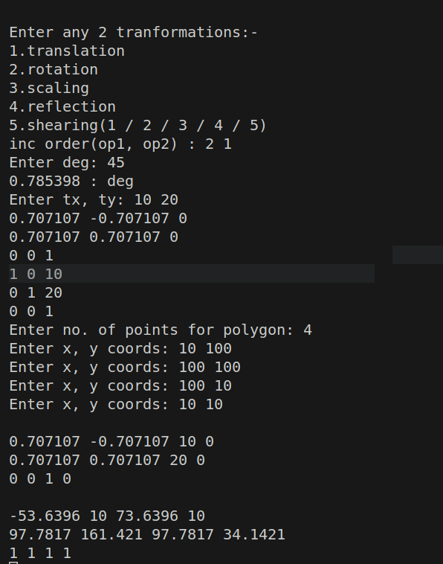

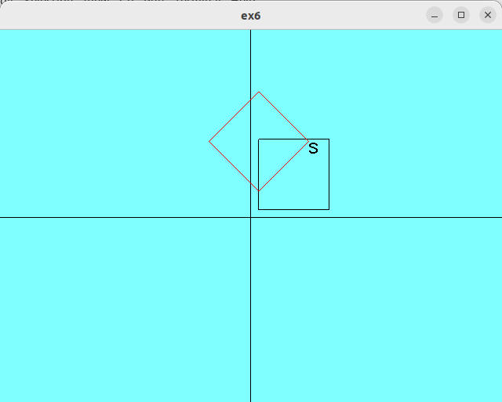

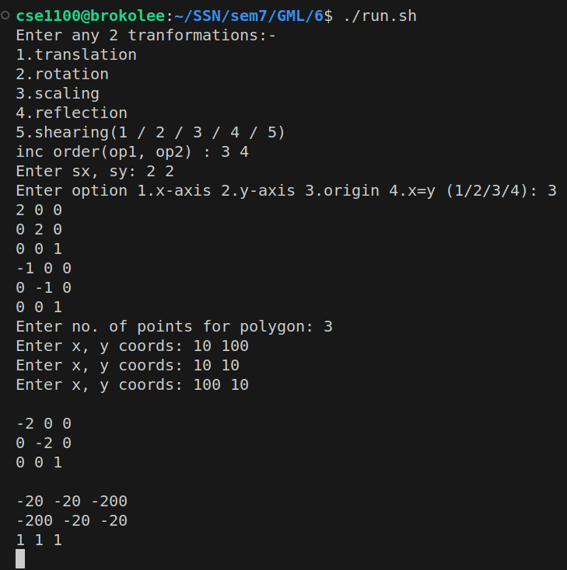

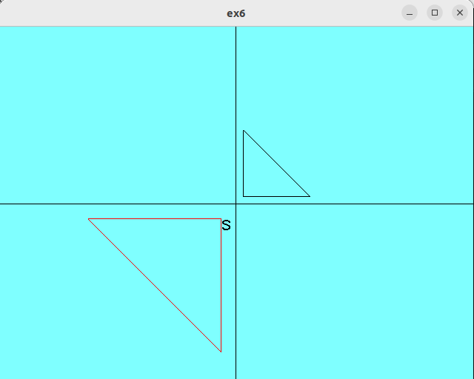

***6b.cpp:***

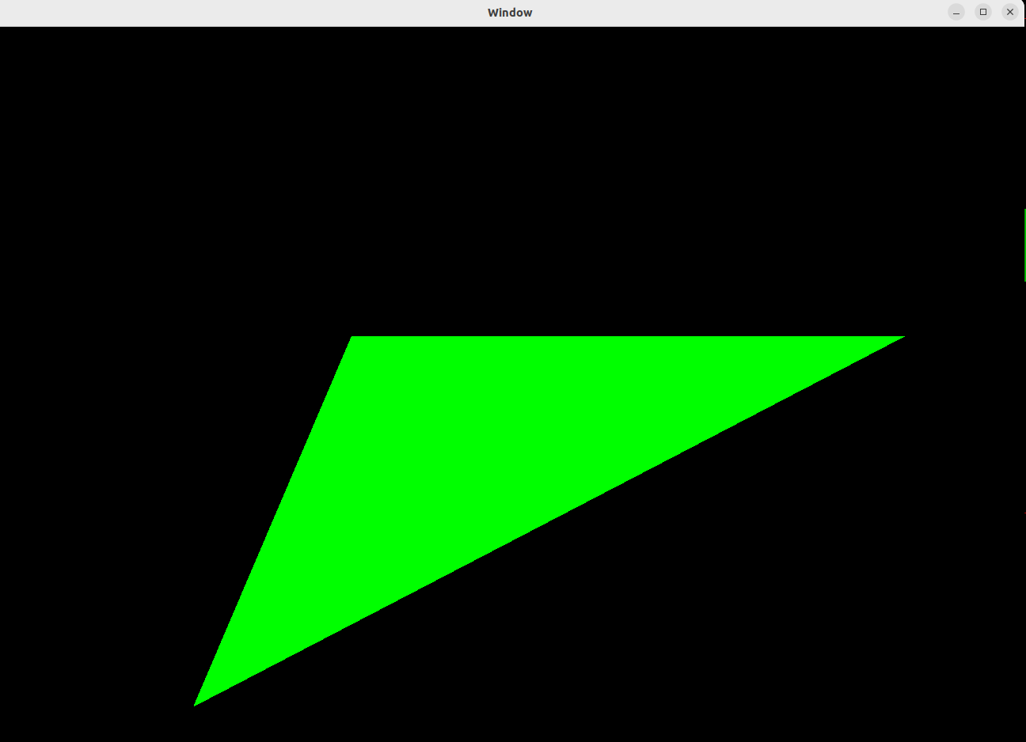

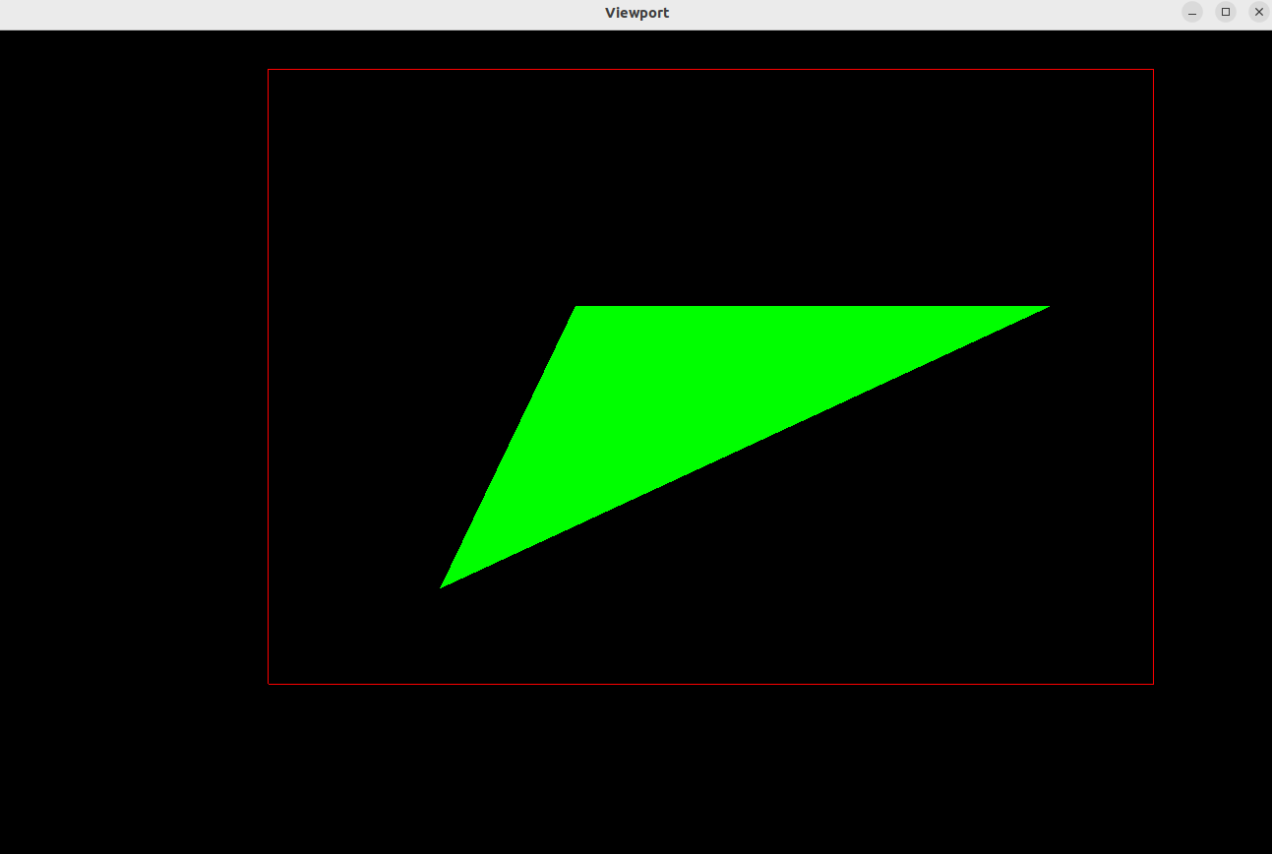

***Learning Outcomes:***

Learnt to do composite transformations. Learnt to do translation, reflection, shearing, rotation and scaling.