**SSN COLLEGE OF ENGINEERING, KALAVAKKAM**

**DEPARTMENT OF COMPUTER SCIENCE AND ENGINEERING**

**UCS1712 – GRAPHICS AND MULTIMEDIA LAB**

------------------------------------------------------------------------------------------------------------

**Lab Exercise 8**: : 3-Dimensional Transformations in C++ using OpenGL

Perform the following basic 3D Transformations on any 3D Object.

1) Translation

2) Rotation

3) Scaling

Use only homogeneous coordinate representation and matrix multiplication to

perform transformations.

Set the camera to any position on the 3D space. Have (0,0,0) at the center of the

screen. Draw X , Y and Z axis.

***Aim:***

To implement 3D transformations on objects using C++ using OpenGL

***Algorithm:***

1. Get points of the object as input.

2. Draw the object.

3. Transform each vertex of the object.

4. Draw the object with the transformed vertices.

***Code:***

***8.cpp:***

#include <stdio.h>

#include <GL/glut.h> //Change to <GLUT/glut.h> in Mac

#include <math.h>

#include <string.h>

#include <iostream>

using namespace std;

#define pi 3.142857

typedef float Matrix4[4][4];

Matrix4 theMatrix;

static GLfloat input[8][3] = {{40, 40, -50}, {90, 40, -50}, {90, 90, -50}, {40, 90, -50}, {30, 30, 0}, {80, 30, 0}, {80, 80, 0}, {30, 80, 0}};

float output[8][3];

float tx = 100, ty = 100, tz = 100;

float sx = -2, sy = 2, sz = 2;

float angle = 60;

int choice, choiceRot;

void setIdentityM(Matrix4 m)

{

for (int i = 0; i < 4; i++)

for (int j = 0; j < 4; j++)

m[i][j] = (i == j);

}

// PUT SOME FUNCTION HERE

void translate(int tx, int ty, int tz)

{

for (int i = 0; i < 8; i++)

{

output[i][0] = input[i][0] + tx;

output[i][1] = input[i][1] + ty;

output[i][2] = input[i][2] + tz;

}

}

void scale(int sx, int sy, int sz)

{

theMatrix[0][0] = sx;

theMatrix[1][1] = sy;

theMatrix[2][2] = sz;

}

void RotateX(float angle)

{

angle = angle * 3.142 / 180;

theMatrix[1][1] = cos(angle);

theMatrix[1][2] = -sin(angle);

theMatrix[2][1] = sin(angle);

theMatrix[2][2] = cos(angle);

}

void RotateY(float angle)

{

angle = angle * 3.14 / 180;

theMatrix[0][0] = cos(angle);

theMatrix[0][2] = -sin(angle);

theMatrix[2][0] = sin(angle);

theMatrix[2][2] = cos(angle);

}

void RotateZ(float angle)

{

angle = angle * 3.14 / 180;

theMatrix[0][0] = cos(angle);

theMatrix[0][1] = sin(angle);

theMatrix[1][0] = -sin(angle);

theMatrix[1][1] = cos(angle);

}

void multiplyM()

{

for (int i = 0; i < 8; i++)

{

for (int j = 0; j < 3; j++)

{

output[i][j] = 0;

for (int k = 0; k < 3; k++)

{

output[i][j] = output[i][j] + input[i][k] * theMatrix[k][j];

}

}

}

}

// To draw the solid

void draw(float a[8][3])

{

glBegin(GL_QUADS);

glColor3f(0.7, 0.4, 0.5); // behind

glVertex3fv(a[0]);

glVertex3fv(a[1]);

glVertex3fv(a[2]);

glVertex3fv(a[3]);

glColor3f(0.8, 0.2, 0.4); // bottom

glVertex3fv(a[0]);

glVertex3fv(a[1]);

glVertex3fv(a[5]);

glVertex3fv(a[4]);

glColor3f(0.3, 0.6, 0.7); // left

glVertex3fv(a[0]);

glVertex3fv(a[4]);

glVertex3fv(a[7]);

glVertex3fv(a[3]);

glColor3f(0.2, 0.8, 0.2); // right

glVertex3fv(a[1]);

glVertex3fv(a[2]);

glVertex3fv(a[6]);

glVertex3fv(a[5]);

glColor3f(0.7, 0.7, 0.2); // up

glVertex3fv(a[2]);

glVertex3fv(a[3]);

glVertex3fv(a[7]);

glVertex3fv(a[6]);

glColor3f(1.0, 0.1, 0.1);

glVertex3fv(a[4]);

glVertex3fv(a[5]);

glVertex3fv(a[6]);

glVertex3fv(a[7]);

glEnd();

}

/* This is just to call the functions

also draw X and Y axis here and use output to label stuff) */

void display(void)

{

glClear(GL_COLOR_BUFFER_BIT | GL_DEPTH_BUFFER_BIT);

// black

glColor3f(0.0, 0.0, 0.0);

gluLookAt(0, 0, 1, 0, 0, 0, 0, 1, 0); // Camera, Center & Up Vector

glBegin(GL_LINES); // Plotting X-Axis

glVertex3d(-1000, 0, 0);

glVertex3d(1000, 0, 0);

glEnd();

glBegin(GL_LINES); // Plotting Y-Axis

glVertex3d(0, -1000, 0);

glVertex3d(0, 1000, 0);

glEnd();

glBegin(GL_LINES); // Plotting Z-Axis

glVertex3d(0, 0, -1000);

glVertex3d(0, 0, 1000);

glEnd();

// Call function

draw(input);

setIdentityM(theMatrix);

switch (choice)

{

case 1:

translate(tx, ty, tz);

break;

case 2:

scale(sx, sy, sz);

multiplyM();

break;

case 3:

switch (choiceRot)

{

case 1:

RotateX(angle);

break;

case 2:

RotateY(angle);

break;

case 3:

RotateZ(angle);

break;

default:

break;

}

multiplyM();

break;

}

// gluLookAt(1, 0, 0, 0, 0, 0, 0, 1, 0); // Camera, Center & Up Vector

draw(output);

glFlush();

glFlush();

}

int main(int argc, char **argv)

{

/*--------WINDOW INITS-------*/

glutInit(&argc, argv); // Mandatory. Initializes the GLUT library.

glutInitDisplayMode(GLUT_SINGLE | GLUT_RGB | GLUT_DEPTH);

glutInitWindowSize(1380, 700); // Set the size of output window (kinda optional)

glutInitWindowPosition(200, 200); // position of output window on screen (optional)

glutCreateWindow("3D TRANSFORMATIONS"); // Giving name to window

/*-------OTHER INITS-------*/

glClearColor(1.0, 1.0, 1.0, 1.0); // Clear the buffer values for color AND set these values

/*can set initial color here also*/

glMatrixMode(GL_PROJECTION); // Uses something called "projection matrix" to represent

glLoadIdentity(); // load the above matrix to fill with identity values

glOrtho(-454.0, 454.0, -250.0, 250.0, -250.0, 250.0);

gluPerspective(100, 100, 100, 100);

glEnable(GL_DEPTH_TEST);

cout << "Enter your choice number:\n1.Translation\n2.Scaling\n3.Rotation\n=>";

cin >> choice;

switch (choice)

{

case 1:

break;

case 2:

break;

case 3:

cout << "Enter your choice for Rotation about axis:\n1.parallel to X-axis."

<< "(y& z)\n2.parallel to Y-axis.(x& z)\n3.parallel to Z-axis."

<< "(x& y)\n =>";

cin >> choiceRot;

break;

default:

break;

}

glutDisplayFunc(display); // sets the display callback for the current window

glutMainLoop(); // Enters event processing loop. Compulsory

return 0;

}

***run.sh:***g++ 8.cpp -lGL -lglut -lGLU

./a.out

***Sample I/O:***

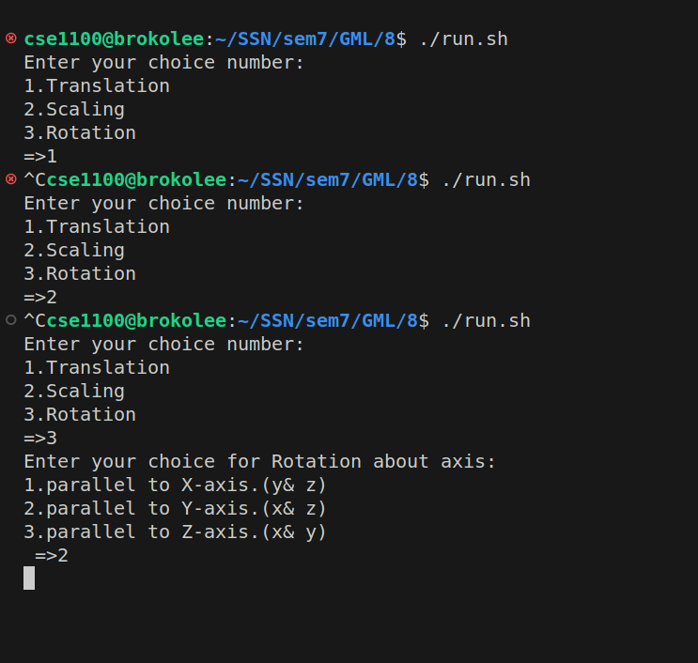

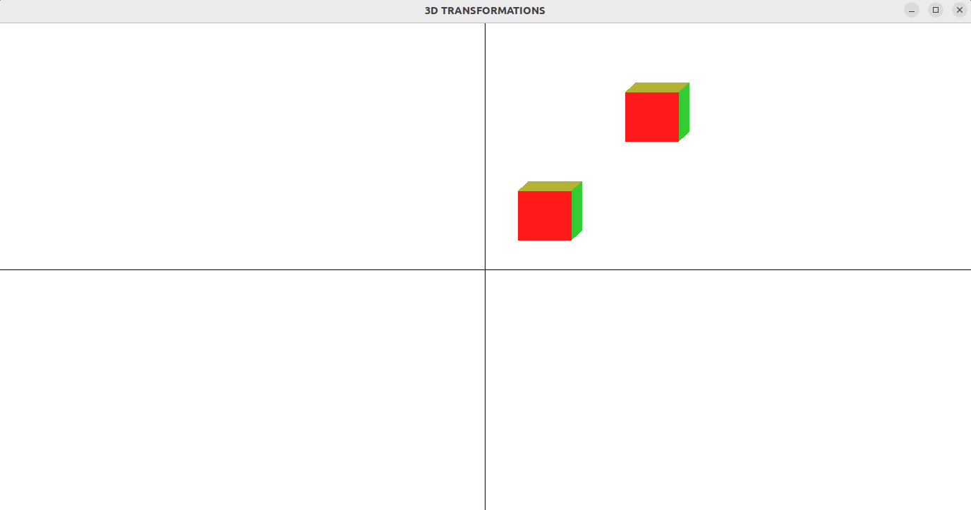

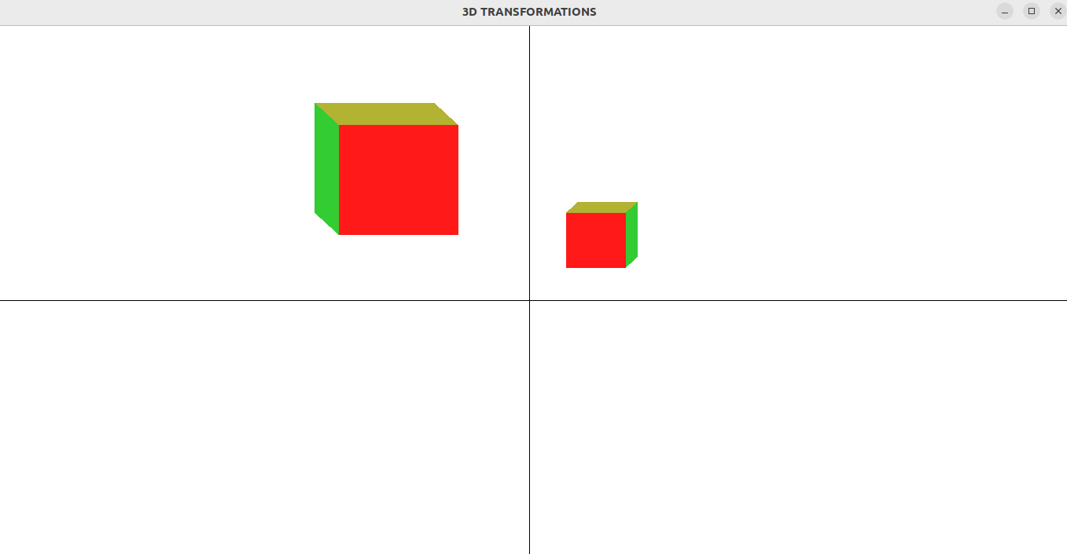

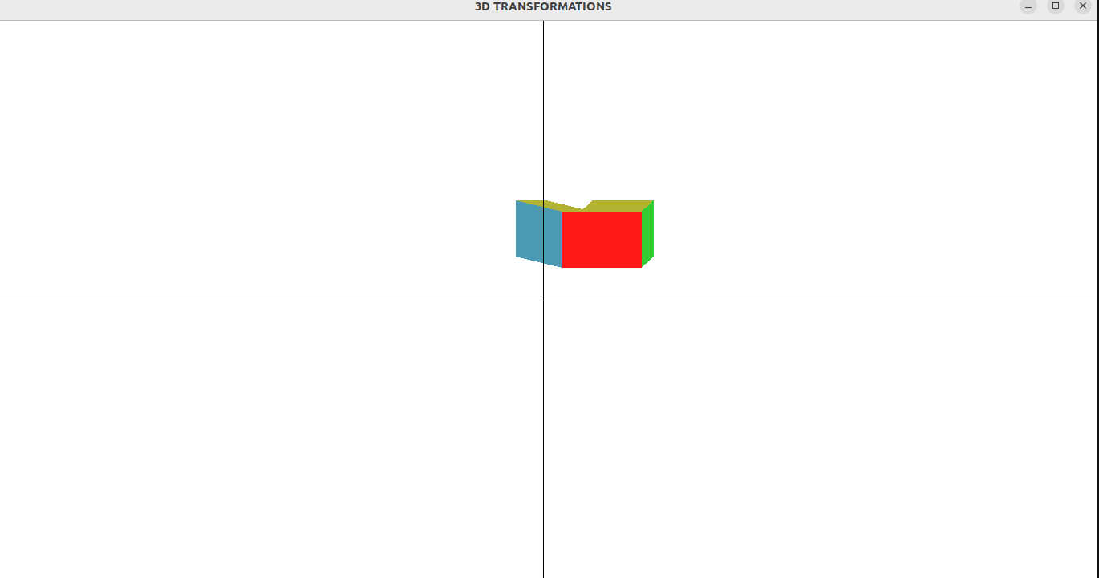

***Learning Outcomes:***

Thus, 3D Transformations has been implemented on objects using OpenGL.