**SSN COLLEGE OF ENGINEERING, KALAVAKKAM**

**DEPARTMENT OF COMPUTER SCIENCE AND ENGINEERING**

**UCS1712 – GRAPHICS AND MULTIMEDIA LAB**

------------------------------------------------------------------------------------------------------------

**Lab Exercise 9**: : 3-Dimensional Projections in C++ using OpenGL

Write a menu driven program to perform Orthographic parallel projection and Perspective projection on any 3D object. Set the camera to any position on the 3D space. Have (0,0,0) at the center of the screen. Draw X, Y and Z axis. You can use gluPerspective() to perform perspective projection. Use keyboard functions to rotate and show different views of the object. [Can use built-in functions for 3D transformations].

***Aim:***

To implement 3D projections on objects using C++ using OpenGL

***Algorithm:***

1. Include necessary OpenGL and GLUT libraries.

2. Declare global variables for rotation angles and camera position.

3. Specify the vertices of the 3D object.

4. Implement a function to draw X, Y, and Z axes.

5. Create a function to draw the 3D object using glBegin(GL_QUADS) and glVertex3fv.

6. Set up the display function. Use gluLookAt for camera positioning, incorporate rotation transformations using glRotatef, call drawAxes and drawObject within the display function, and use glutSwapBuffers to swap the front and back buffers.

7. Implement a keyboard function to handle user input. Update rotation angles based on key presses (e.g., 'x', 'y', 'z') and allow the user to exit the program (e.g., 'q').

8. Initialize OpenGL and GLUT, set up the window and callback functions for display and keyboard input, configure perspective or orthographic projection, and enter the main event loop.

***Code:***

***9.cpp:***

#include <iostream>

#include <stdio.h>

#include <cmath>

#include <cstring>

#include <GL/glut.h>

using namespace std;

// Global constants

const float windowHeight = 1000;

const float windowWidth = 1000;

const float X_MIN = -500;

const float X_MAX = 500;

const float Y_MIN = -500;

const float Y_MAX = 500;

const int FPS = 60;

// Global variables to handle rotation

GLfloat x_rotate = 0;

GLfloat y_rotate = 0;

// Global variable for projection

bool isOrthoProjection = true;

void initializeDisplay();

void keyboardKeys(unsigned char key, int x, int y);

void drawAxes();

void myInit(void)

{

glClearColor(0.0, 0.0, 0.0, 1.0);

glColor3f(0.0, 0.0, 1.0);

glPointSize(1.0);

glMatrixMode(GL_PROJECTION);

glLoadIdentity();

gluOrtho2D(-windowWidth / 2, windowWidth / 2, -windowHeight / 2, windowHeight / 2);

}

void drawAxes()

{

// To draw X and Y axis

glColor3d(1, 0, 0);

glBegin(GL_LINES);

glVertex2f(-2, 0);

glVertex2f(2, 0);

glVertex2f(0, -2);

glVertex2f(0, 2);

glEnd();

glFlush();

}

void keyboardKeys(unsigned char key, int x, int y)

{

// Callback function for keyboard interactivity

key = tolower(key);

switch (key)

{

case 'w':

{

// glLoadIdentity(); // Reset transformations

x_rotate += 5;

break;

}

case 's':

{

x_rotate -= 5;

break;

}

case 'd':

{

y_rotate += 5;

break;

}

case 'a':

{

y_rotate -= 5;

break;

}

case 27:

exit(0);

case 32:

{

// Spacebar for changing projections

isOrthoProjection = !isOrthoProjection;

x_rotate = 0;

y_rotate = 0;

break;

}

}

// Update the display

glutPostRedisplay();

}

void display()

{

// Initialize display parameters

glClearColor(1, 1, 1, 1);

glClear(GL_COLOR_BUFFER_BIT);

// Translucency

glEnable(GL_BLEND);

glBlendFunc(GL_SRC_ALPHA, GL_ONE_MINUS_SRC_ALPHA);

// Line width

glLineWidth(3);

// Apply the transformations & drawing on the model view matrix

glMatrixMode(GL_MODELVIEW);

// Draw the X and Y axis

drawAxes();

// Transform only the drawn object, so use the matrix stack accordingly

glPushMatrix();

if (isOrthoProjection)

{

// Parallel Projection

glOrtho(-2, 2, -2, 2, -2, 2);

}

else

{

// Perspective Projection

gluPerspective(120, 1, 0.1, 50); // FoVy = 120, Aspect Ratio = 1

}

gluLookAt(0, 0, 1, 0, 0, 0, 0, 1, 0); // Camera, Center & Up Vector

glPushMatrix(); // Create a separate transformation matrix

glRotatef(x_rotate, 1, 0, 0); // Keyboard based rotations

glRotatef(y_rotate, 0, 1, 0);

glColor4f(0, 0, 1, 0.3); // Draw the object

glutWireTeapot(0.5);

glPopMatrix(); // Pop the transformation matrix

glPopMatrix(); // Pop the matrix back into the model view stack

glFlush();

}

int main(int argc, char **argv)

{

glutInit(&argc, argv);

glutInitDisplayMode(GLUT_SINGLE | GLUT_RGB);

glutInitWindowSize(windowWidth, windowHeight);

glutCreateWindow("3D Projections");

printf("Enter (1) for orthographic and (0) for perspective: ");

int oop;

scanf("%d", &oop);

isOrthoProjection = oop;

// Register the callback functions

glutDisplayFunc(display);

glutKeyboardFunc(keyboardKeys);

glutMainLoop();

return 0;

}

***run.sh:***g++ 9.cpp -lGL -lglut -lGLU

./a.out

***Sample I/O:***

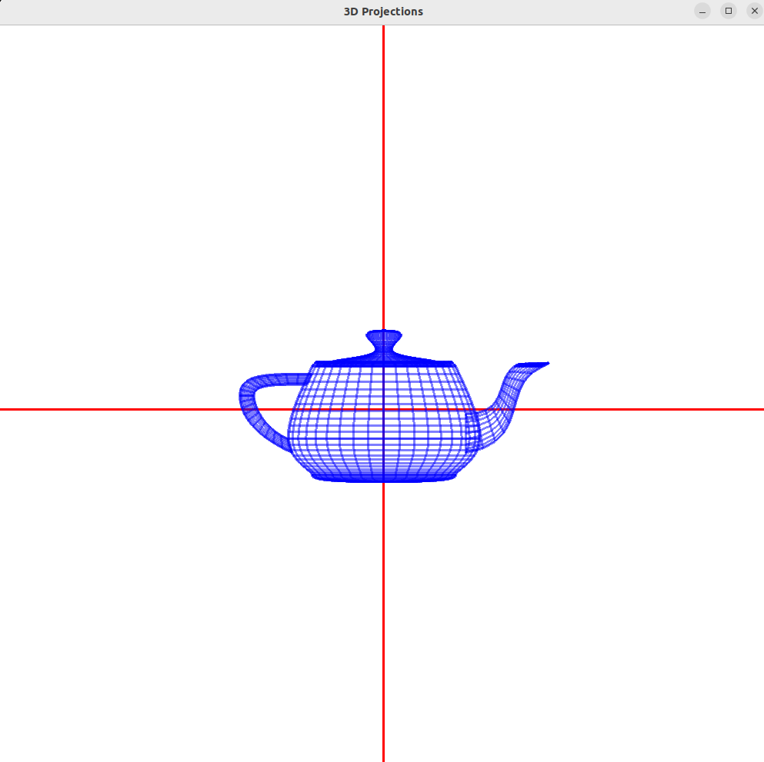

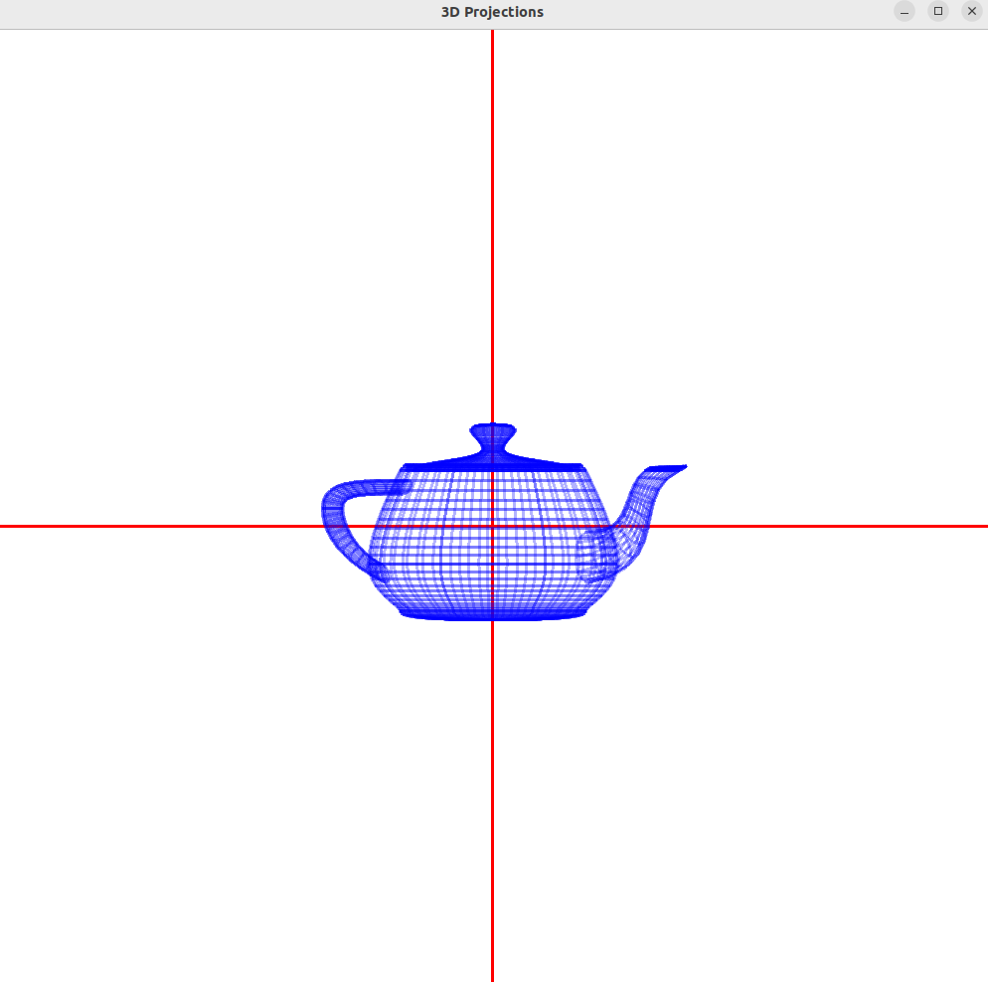

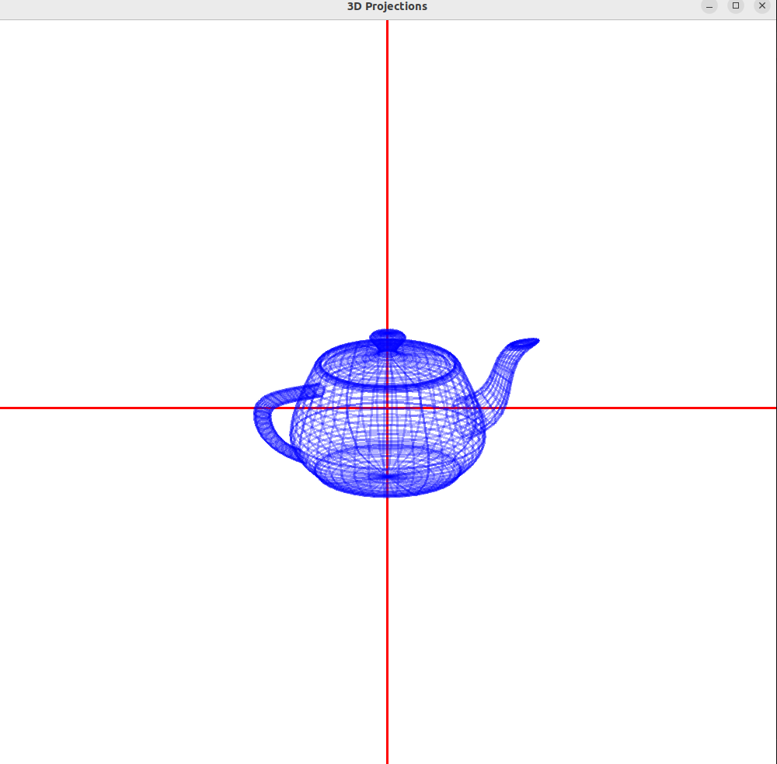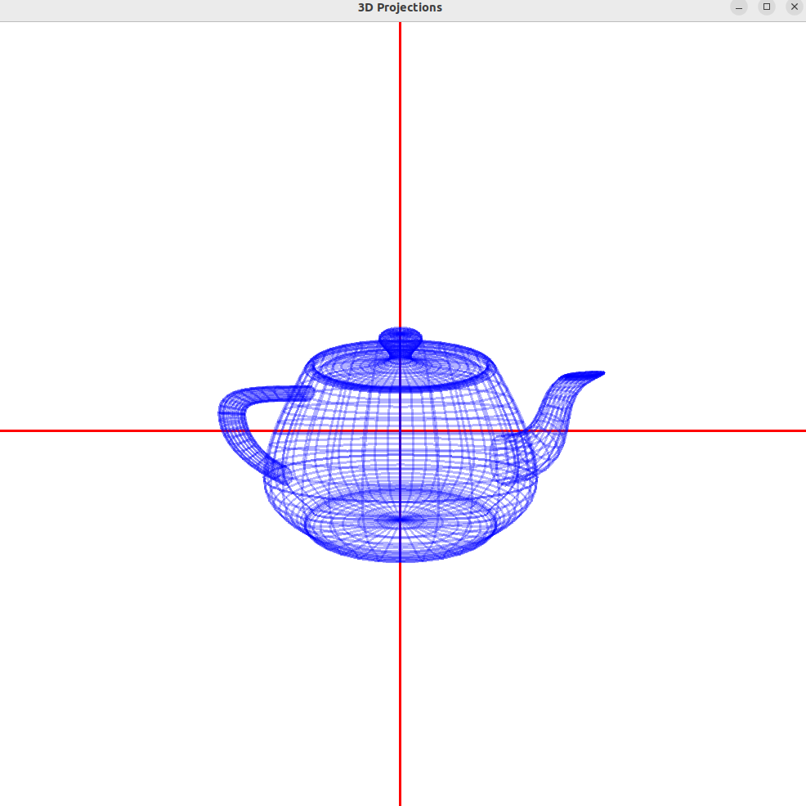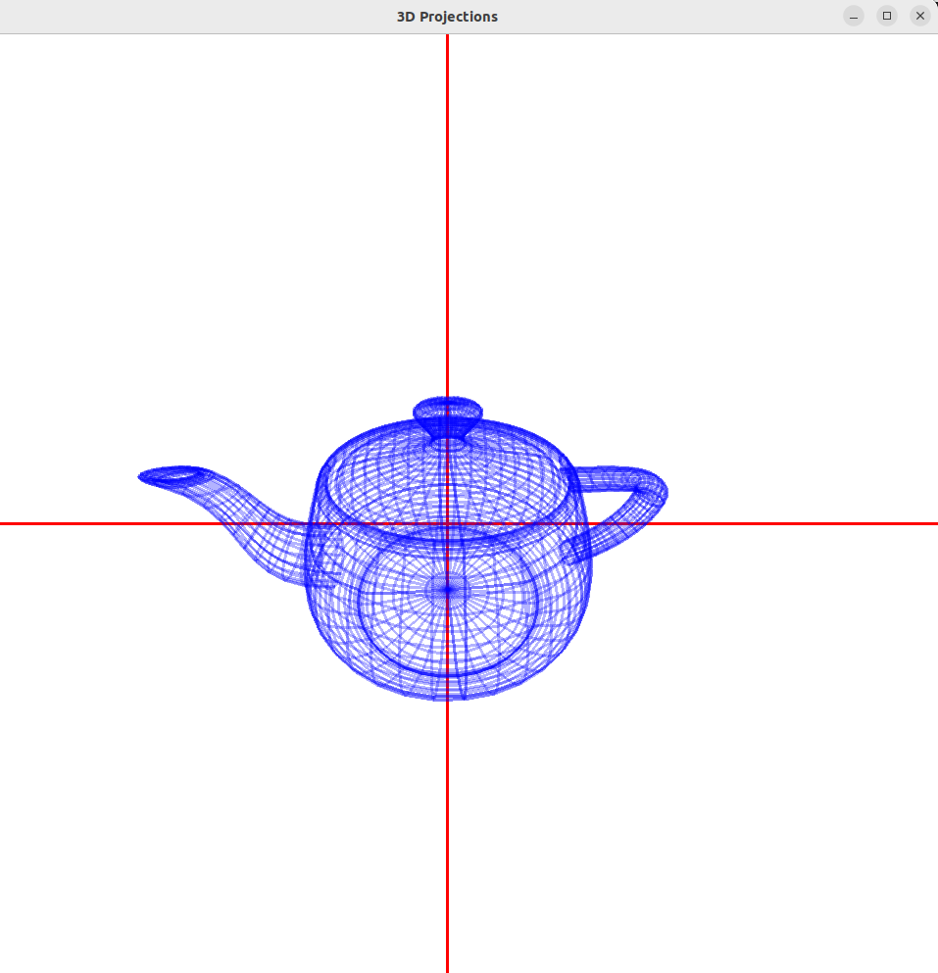

***Learning Outcomes:***

Thus, 3D projections has been implemented on objects using OpenGL.