# Exercise 1 - Designing Health Insurance Form using GUI Components

T Shivcharan

205001100

CSE-B

## Aim

Generate a Health Insurance registration form to register the patient details under each group.

**Patient Details -** Title, Patient Name, Patient Phone Number (Mobile or Landline use Checkbox), Address, Age, DOB, Gender, Marital Status

**Employer Details -** Patient Employer, Employment Status (full time, parttime, unemployed, retired, student, other Checkbox)

**Emergency contact Details -** Name, Relationship, Address, Phone Number

Use Submit (Button) to submit the details and display the contents. Use the Reset button to clear the form. Display using Table layout.

## Code

### activity_main.xml

<?xml version="1.0" encoding="utf-8"?>

<ScrollView xmlns:android="http: /schemas.android.com/apk/res/android" xmlns:app="http: /schemas.android.com/apk/res-auto"

xmlns:tools="http: /schemas.android.com/tools"

android:layout_width="match_parent"

android:layout_height="match_parent">

<LinearLayout

android:layout_width="match_parent"

android:layout_height="match_parent"

android:layout_marginLeft="16dp"

android:layout_marginRight="16dp"

android:layout_marginBottom="8dp"

android:orientation="vertical"

tools:context=".MainActivity">

<TextView

android:id="@+id/titleTextView"

android:layout_width="match_parent"

android:layout_height="128dp"

android:gravity="center"

android:text="Health Insurance Registration" android:textSize="32sp"

android:textStyle="bold"

android:typeface="serif" >

<TextView

android:id="@+id/title"

android:layout_width="match_parent"

android:layout_height="32dp"

android:gravity="left"

android:text="Patient Details"

android:textSize="22sp"

android:textStyle="bold"

android:typeface="serif" >

<TextView

android:id="@+id/name"

android:layout_width="match_parent"

android:layout_height="26dp"

android:layout_marginTop="16dp"

android:gravity="left"

android:text="Name"

android:textSize="18sp"

android:textStyle="bold"

android:typeface="normal" >

<EditText

android:id="@+id/editName"

android:layout_width="match_parent"

android:layout_height="54dp"

android:hint="Name:"

android:inputType="text"

android:textColor="#0000FF"

android:typeface="sans" >

<TextView

android:id="@+id/number"

android:layout_width="match_parent"

android:layout_height="26dp"

android:layout_marginTop="16dp"

android:gravity="left"

android:text="Number"

android:textSize="18sp"

android:textStyle="bold"

android:typeface="normal" >

<RadioGroup

android:id="@+id/radio_group_id"

android:layout_width="wrap_content"

android:layout_height="wrap_content"

android:layout_marginTop="4dp">

<RadioButton

android:id="@+id/phone_radio_button_id" android:layout_width="wrap_content"

android:layout_height="wrap_content"

android:text="Phone" >

<RadioButton

android:id="@+id/landline_radio_button_id" android:layout_width="wrap_content"

android:layout_height="wrap_content"

android:text="Landline" >

/RadioGroup>

<EditText

android:id="@+id/editNumber"

android:layout_width="match_parent"

android:layout_height="54dp"

android:hint="Number:"

android:inputType="phone" >

<TextView

android:id="@+id/address"

android:layout_width="match_parent" android:layout_height="26dp"

android:layout_marginTop="16dp" android:gravity="left"

android:text="Address"

android:textSize="18sp"

android:textStyle="bold"

android:typeface="normal" >

<EditText

android:id="@+id/editAddress"

android:layout_width="match_parent" android:layout_height="54dp"

android:hint="Address:"

android:inputType="text"

android:textColor="#0000FF"

android:typeface="sans" >

<TextView

android:id="@+id/age"

android:layout_width="match_parent" android:layout_height="26dp"

android:layout_marginTop="16dp" android:gravity="left"

android:text="Age"

android:textSize="18sp"

android:textStyle="bold"

android:typeface="normal" >

<EditText

android:id="@+id/editAge"

android:layout_width="match_parent" android:layout_height="54dp"

android:hint="Age:"

android:inputType="number"

android:textColor="#0000FF"

android:typeface="sans" >

<TextView

android:id="@+id/dob"

android:layout_width="match_parent" android:layout_height="26dp"

android:layout_marginTop="16dp"

android:gravity="left"

android:text="DOB"

android:textSize="18sp"

android:textStyle="bold"

android:typeface="normal" >

<DatePicker

android:id="@+id/dobPicker"

android:layout_width="match_parent" android:layout_height="wrap_content" android:gravity="center" >

<TextView

android:id="@+id/gender"

android:layout_width="match_parent" android:layout_height="26dp"

android:layout_marginTop="16dp"

android:gravity="left"

android:text="Gender"

android:textSize="18sp"

android:textStyle="bold"

android:typeface="normal" >

<RadioGroup

android:id="@+id/gender_group"

android:layout_width="wrap_content" android:layout_height="wrap_content" android:layout_marginTop="4dp">

<RadioButton

android:id="@+id/male"

android:layout_width="wrap_content" android:layout_height="wrap_content" android:text="Male" >

<RadioButton

android:id="@+id/female"

android:layout_width="wrap_content" android:layout_height="wrap_content" android:text="Female" >

/RadioGroup>

<TextView

android:id="@+id/marital_status"

android:layout_width="match_parent"

android:layout_height="26dp"

android:layout_marginTop="16dp"

android:gravity="left"

android:text="Marital Status"

android:textSize="18sp"

android:textStyle="bold"

android:typeface="normal" >

<Spinner

android:id="@+id/marital_status_spinner"

android:layout_width="match_parent"

android:layout_height="wrap_content"

android:entries="@array/marital_status_options" >

<TextView

android:id="@+id/employer"

android:layout_width="match_parent"

android:layout_height="32dp"

android:layout_marginTop="48dp"

android:gravity="left"

android:text="Employer Details"

android:textSize="22sp"

android:textStyle="bold"

android:typeface="serif" >

<TextView

android:id="@+id/employer_name"

android:layout_width="match_parent"

android:layout_height="26dp"

android:layout_marginTop="16dp"

android:gravity="left"

android:text="Employer Name"

android:textSize="18sp"

android:textStyle="bold"

android:typeface="normal" >

<EditText

android:id="@+id/editEmployerName"

android:layout_width="match_parent"

android:layout_height="54dp"

android:hint="Employer Name:"

android:inputType="text"

android:textColor="#0000FF"

android:typeface="sans" >

<TextView

android:id="@+id/employment_status"

android:layout_width="match_parent"

android:layout_height="26dp"

android:layout_marginTop="16dp"

android:gravity="left"

android:text="Employment Status"

android:textSize="18sp"

android:textStyle="bold"

android:typeface="normal" >

<Spinner

android:id="@+id/employment_status_spinner" android:layout_width="match_parent"

android:layout_height="wrap_content"

android:entries="@array/employment_status_options" >

<TextView

android:id="@+id/emergency"

android:layout_width="match_parent"

android:layout_height="32dp"

android:layout_marginTop="48dp"

android:gravity="left"

android:text="Emergency Details"

android:textSize="22sp"

android:textStyle="bold"

android:typeface="serif" >

<TextView

android:id="@+id/emergency_name"

android:layout_width="match_parent"

android:layout_height="26dp"

android:layout_marginTop="16dp"

android:gravity="left"

android:text="Emergency Contact Name"

android:textSize="18sp"

android:textStyle="bold"

android:typeface="normal" >

<EditText

android:id="@+id/edit_emergency_name" android:layout_width="match_parent"

android:layout_height="54dp"

android:hint="Employer Contact Name:" android:inputType="text"

android:textColor="#0000FF"

android:typeface="sans" >

<TextView

android:id="@+id/emergency_relationship" android:layout_width="match_parent"

android:layout_height="26dp"

android:layout_marginTop="16dp"

android:gravity="left"

android:text="Relationship"

android:textSize="18sp"

android:textStyle="bold"

android:typeface="normal" >

<EditText

android:id="@+id/edit_emergency_relationship" android:layout_width="match_parent"

android:layout_height="54dp"

android:hint="Relationship:"

android:inputType="text"

android:textColor="#0000FF"

android:typeface="sans" >

<TextView

android:id="@+id/emergency_address"

android:layout_width="match_parent"

android:layout_height="26dp"

android:layout_marginTop="16dp"

android:gravity="left"

android:text="Address"

android:textSize="18sp"

android:textStyle="bold"

android:typeface="normal" >

<EditText

android:id="@+id/edit_emergency_address" android:layout_width="match_parent" android:layout_height="54dp"

android:hint="Address:"

android:inputType="text"

android:textColor="#0000FF"

android:typeface="sans" >

<TextView

android:id="@+id/emergency_phone" android:layout_width="match_parent" android:layout_height="26dp"

android:layout_marginTop="16dp"

android:gravity="left"

android:text="Phone"

android:textSize="18sp"

android:textStyle="bold"

android:typeface="normal" >

<EditText

android:id="@+id/edit_emergency_phone" android:layout_width="match_parent" android:layout_height="54dp"

android:hint="Phone Number:"

android:inputType="phone"

android:textColor="#0000FF"

android:typeface="sans" >

<Button

android:id="@+id/submit"

android:layout_width="match_parent" android:layout_height="64dp"

android:layout_marginTop="32dp"

android:backgroundTint="#4CAF50"

android:gravity="center"

android:hint="Register"

android:onClick="openTableActivity" > <Button

android:id="@+id/reset"

android:layout_width="match_parent"

android:layout_height="64dp"

android:layout_marginTop="16dp"

android:backgroundTint="#F44336"

android:gravity="center"

android:hint="Reset"

android:onClick="resetFormFields" >

/LinearLayout>

/ScrollView>

### MainActivity.java

package *com.example.a1*;

import *android.content.Intent*;

import *android.support.v7.app.AppCompatActivity*; import *android.os.Bundle*;

import *android.view.View*;

import *android.widget.DatePicker*;

import *android.widget.EditText*;

import *android.widget.RadioButton*;

import *android.widget.Spinner*;

import *java.util.Calendar*;

public class *MainActivity* extends *AppCompatActivity* {

*@Override*

protected void *onCreate*(*Bundle savedInstanceState*) { super.*onCreate*(*savedInstanceState*);

*setContentView*(*R*.*layout*.activity_main);

}

public void *openTableActivity*(*View view*) {

*Intent* intent = new *Intent*(this, *TableActivity*.class);

intent.*putExtra*("name", ((*EditText*)

*findViewById*(*R*.*id*.editName)).*getText*().*toString*()); if (((*RadioButton*)

*findViewById*(*R*.*id*.phone_radio_button_id)).*isChecked*())

intent.*putExtra*("number_type", "Phone");

else if (((*RadioButton*)

*findViewById*(*R*.*id*.phone_radio_button_id)).*isChecked*())

intent.*putExtra*("number_type", "Landline");

intent.*putExtra*("number", ((*EditText*)

*findViewById*(*R*.*id*.editNumber)).*getText*().*toString*());

intent.*putExtra*("address", ((*EditText*)

*findViewById*(*R*.*id*.editAddress)).*getText*().*toString*());

intent.*putExtra*("age", ((*EditText*)

*findViewById*(*R*.*id*.editAge)).*getText*().*toString*());

*DatePicker* datePicker = *findViewById*(*R*.*id*.dobPicker);

int day = datePicker.*getDayOfMonth*();

int month = datePicker.*getMonth*();

int year = datePicker.*getYear*();

*Calendar* calendar = *Calendar*.*getInstance*();

calendar.*set*(year, month, day);

intent.*putExtra*("dob", calendar.*getTime*().*toString*());

if (((*RadioButton*) *findViewById*(*R*.*id*.male)).*isChecked*())

intent.*putExtra*("gender", "Male");

else if (((*RadioButton*) *findViewById*(*R*.*id*.female)).*isChecked*()) intent.*putExtra*("gender", "Female");

intent.*putExtra*("marital_status", ((*Spinner*)

*findViewById*(*R*.*id*.marital_status_spinner)).*getSelectedItem*().*toString*());

intent.*putExtra*("employer_name", ((*EditText*)

*findViewById*(*R*.*id*.editEmployerName)).*getText*().*toString*()); intent.*putExtra*("employment_status", ((*Spinner*)

*findViewById*(*R*.*id*.employment_status_spinner)).*getSelectedItem*().*toString*());

intent.*putExtra*("emergency_name", ((*EditText*)

*findViewById*(*R*.*id*.edit_emergency_name)).*getText*().*toString*()); intent.*putExtra*("emergency_relationship", ((*EditText*)

*findViewById*(*R*.*id*.edit_emergency_relationship)).*getText*().*toString*()); intent.*putExtra*("emergency_address", ((*EditText*)

*findViewById*(*R*.*id*.edit_emergency_address)).*getText*().*toString*()); intent.*putExtra*("emergency_phone", ((*EditText*)

*findViewById*(*R*.*id*.edit_emergency_phone)).*getText*().*toString*());

*startActivity*(intent);

}

public void *resetFormFields*(*View view*) {

((*EditText*) *findViewById*(*R*.*id*.editName)).*setText*("");

((*RadioButton*)

*findViewById*(*R*.*id*.phone_radio_button_id)).*setChecked*(false); ((*RadioButton*)

*findViewById*(*R*.*id*.landline_radio_button_id)).*setChecked*(false); ((*EditText*) *findViewById*(*R*.*id*.editNumber)).*setText*("");

((*EditText*) *findViewById*(*R*.*id*.editAddress)).*setText*("");

((*EditText*) *findViewById*(*R*.*id*.editAge)).*setText*("");

((*DatePicker*) *findViewById*(*R*.*id*.dobPicker)).*updateDate*(1970, 0, 1); ((*RadioButton*) *findViewById*(*R*.*id*.male)).*setChecked*(false);

((*RadioButton*) *findViewById*(*R*.*id*.female)).*setChecked*(false); ((*Spinner*) *findViewById*(*R*.*id*.marital_status_spinner)).*setSelection*(0);

((*EditText*) *findViewById*(*R*.*id*.editEmployerName)).*setText*(""); ((*Spinner*)

*findViewById*(*R*.*id*.employment_status_spinner)).*setSelection*(0);

((*EditText*) *findViewById*(*R*.*id*.edit_emergency_name)).*setText*(""); ((*EditText*)

*findViewById*(*R*.*id*.edit_emergency_relationship)).*setText*(""); ((*EditText*) *findViewById*(*R*.*id*.edit_emergency_address)).*setText*(""); ((*EditText*) *findViewById*(*R*.*id*.edit_emergency_phone)).*setText*(""); }

}

### activity_table.xml

<?xml version="1.0" encoding="utf-8"?>

<TableLayout xmlns:android="http: /schemas.android.com/apk/res/android" android:layout_width="match_parent"

android:layout_height="match_parent"

android:stretchColumns="*">

<TableRow>

<TextView

android:id="@+id/textView_title1"

android:layout_width="100dp"

android:layout_height="wrap_content"

android:text="Patient details"

android:textAlignment="center"

android:textSize="48px"

android:textStyle="bold" >

/TableRow>

<TableRow>

<TextView

android:id="@+id/textView_name"

android:layout_width="100dp"

android:layout_height="wrap_content" android:text="Name" >

<TextView

android:id="@+id/textView_name_value" android:layout_width="match_parent"

android:layout_height="wrap_content" > /TableRow>

<TableRow>

<TextView

android:id="@+id/textView_number"

android:layout_width="100dp"

android:layout_height="wrap_content" android:text="Number" >

<TextView

android:id="@+id/textView_number_value" android:layout_width="match_parent"

android:layout_height="wrap_content" > /TableRow>

<TableRow>

<TextView

android:id="@+id/textView_address"

android:layout_width="100dp"

android:layout_height="wrap_content" android:text="Address" >

<TextView

android:id="@+id/textView_address_value" android:layout_width="match_parent"

android:layout_height="wrap_content" > /TableRow>

<TableRow>

<TextView

android:id="@+id/textView_age"

android:layout_width="100dp"

android:layout_height="wrap_content" android:text="Age" >

<TextView

android:id="@+id/textView_age_value" android:layout_width="match_parent"

android:layout_height="wrap_content" > /TableRow>

<TableRow>

<TextView

android:id="@+id/textView_dob"

android:layout_width="100dp"

android:layout_height="wrap_content" android:text="DOB" >

<TextView

android:id="@+id/textView_dob_value" android:layout_width="match_parent"

android:layout_height="wrap_content" > /TableRow>

<TableRow>

<TextView

android:id="@+id/textView_gender"

android:layout_width="100dp"

android:layout_height="wrap_content" android:text="Gender" >

<TextView

android:id="@+id/textView_gender_value"

android:layout_width="match_parent"

android:layout_height="wrap_content" >

/TableRow>

<TableRow>

<TextView

android:id="@+id/textView_marital_status"

android:layout_width="100dp"

android:layout_height="wrap_content"

android:text="Marital Status" >

<TextView

android:id="@+id/textView_marital_status_value" android:layout_width="match_parent"

android:layout_height="wrap_content" >

/TableRow>

<TableRow>

<TextView

android:id="@+id/textView_title2"

android:layout_width="100dp"

android:layout_height="wrap_content"

android:layout_marginTop="32px"

android:text="Employer details"

android:textAlignment="center"

android:textSize="48px"

android:textStyle="bold" >

/TableRow>

<TableRow>

<TextView

android:id="@+id/textView_employer_name"

android:layout_width="100dp"

android:layout_height="wrap_content"

android:text="Employer Name" >

<TextView

android:id="@+id/textView_employer_name_value"

android:layout_width="match_parent"

android:layout_height="wrap_content" >

/TableRow>

<TableRow>

<TextView

android:id="@+id/textView_employment_status" android:layout_width="100dp"

android:layout_height="wrap_content"

android:text="Employement Status" >

<TextView

android:id="@+id/textView_employment_status_value" android:layout_width="match_parent"

android:layout_height="wrap_content" >

/TableRow>

<TableRow>

<TextView

android:id="@+id/textView_title3"

android:layout_width="100dp"

android:layout_height="wrap_content"

android:layout_marginTop="32px"

android:text="Emergency details"

android:textAlignment="center"

android:textSize="48px"

android:textStyle="bold" >

/TableRow>

<TableRow>

<TextView

android:id="@+id/textView_emergency_name"

android:layout_width="100dp"

android:layout_height="wrap_content"

android:text="Emergency name" >

<TextView

android:id="@+id/textView_emergency_name_value" android:layout_width="match_parent"

android:layout_height="wrap_content" >

/TableRow>

<TableRow>

<TextView

android:id="@+id/textView_emergency_relationship" android:layout_width="100dp"

android:layout_height="wrap_content"

android:text="Emergency relationship" >

<TextView

android:id="@+id/textView_emergency_relationship_value" android:layout_width="match_parent"

android:layout_height="wrap_content" >

/TableRow>

<TableRow>

<TextView

android:id="@+id/textView_emergency_address"

android:layout_width="100dp"

android:layout_height="wrap_content"

android:text="Emergency address" >

<TextView

android:id="@+id/textView_emergency_address_value" android:layout_width="match_parent"

android:layout_height="wrap_content" >

/TableRow>

<TableRow>

<TextView

android:id="@+id/textView_emergency_phone"

android:layout_width="100dp"

android:layout_height="wrap_content"

android:text="Emergency phone" >

<TextView

android:id="@+id/textView_emergency_phone_value" android:layout_width="match_parent"

android:layout_height="wrap_content" >

/TableRow>

/TableLayout>

### TableActivity.java

package *com.example.a1*;

import *android.content.Intent*;

import *android.support.v7.app.AppCompatActivity*;

import *android.os.Bundle*;

import *android.widget.TextView*;

public class *TableActivity* extends *AppCompatActivity* {

*@Override*

protected void *onCreate*(*Bundle savedInstanceState*) {

super.*onCreate*(*savedInstanceState*);

*setContentView*(*R*.*layout*.activity_table);

*Intent* intent = *getIntent*();

*Bundle* extras = intent.*getExtras*();

if (extras = null) return;

((*TextView*)

*findViewById*(*R*.*id*.textView_name_value)).*setText*(extras.*getString*("name")); ((*TextView*)

*findViewById*(*R*.*id*.textView_number_value)).*setText*(extras.*getString*("number")); ((*TextView*)

*findViewById*(*R*.*id*.textView_address_value)).*setText*(extras.*getString*("address") );

((*TextView*)

*findViewById*(*R*.*id*.textView_age_value)).*setText*(extras.*getString*("age")); ((*TextView*)

*findViewById*(*R*.*id*.textView_dob_value)).*setText*(extras.*getString*("dob")); ((*TextView*)

*findViewById*(*R*.*id*.textView_gender_value)).*setText*(extras.*getString*("gender")); ((*TextView*)

*findViewById*(*R*.*id*.textView_marital_status_value)).*setText*(extras.*getString*("ma rital_status"));

((*TextView*)

*findViewById*(*R*.*id*.textView_employer_name_value)).*setText*(extras.*getString*("emp loyer_name"));

((*TextView*)

*findViewById*(*R*.*id*.textView_employment_status_value)).*setText*(extras.*getString*( "employment_status"));

((*TextView*)

*findViewById*(*R*.*id*.textView_emergency_name_value)).*setText*(extras.*getString*("em ergency_name"));

((*TextView*)

*findViewById*(*R*.*id*.textView_emergency_relationship_value)).*setText*(extras.*getSt ring*("emergency_relationship"));

((*TextView*)

*findViewById*(*R*.*id*.textView_emergency_address_value)).*setText*(extras.*getString*( "emergency_address"));

((*TextView*)

*findViewById*(*R*.*id*.textView_emergency_phone_value)).*setText*(extras.*getString*("e mergency_phone"));

}

}

### strings.xml

<resources>

<string name="app_name">A1 /string>

<string-array name="marital_status_options">

<item>Never Married /item>

<item>Married /item>

<item>Widowed /item>

<item>Divorced /item>

<item>Separated /item>

/string-array>

<string-array name="employment_status_options">

<item>Full Time /item>

<item>Part Time /item>

<item>Unemployed /item>

<item>Retired /item>

<item>Student /item>

<item>Other /item>

/string-array>

<string name="title_activity_table">All Details /string> /resources>

## Output

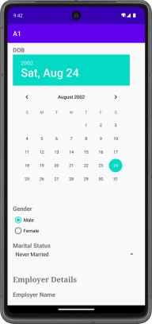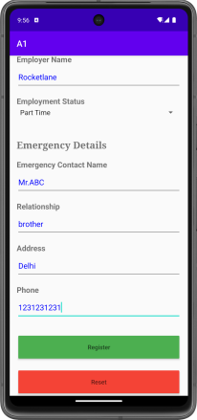

## Learning outcomes

Basic GUI components and layouts that are available

Passing data between activities

# Exercise 2 - Keyboard application

T Shivcharan

205001100

CSE-A

## Aim

To implement a keyboard application using Android Studio

## Code

### activity_main.xml

<?xml version="1.0" encoding="utf-8"?>

<RelativeLayout xmlns:android="http://schemas.android.com/apk/res/android"

xmlns:tools="http://schemas.android.com/tools"

android:layout_width="match_parent"

android:layout_height="match_parent"

android:orientation="vertical"

tools:context=".MainActivity">

<TextView

android:id="@+id/text_bar"

android:layout_width="match_parent"

android:layout_height="wrap_content"

android:layout_marginLeft="6dp"

android:layout_marginTop="24dp"

android:layout_marginRight="6dp"

android:hint="Enter text..."

android:text=""

android:textSize="24sp" />

<GridLayout

android:id="@+id/keyboard"

android:layout_width="match_parent"

android:layout_height="200dp"

android:layout_alignParentBottom="true"

android:background="#202020"

android:padding="1dp" />

</RelativeLayout>

### MainActivity.java

package com.example.qwerty;

import androidx.appcompat.app.AppCompatActivity;

import androidx.core.content.res.ResourcesCompat;

import android.os.Bundle;

import android.util.DisplayMetrics;

import android.view.Gravity;

import android.widget.Button;

import android.widget.GridLayout;

import android.widget.TextView;

import android.graphics.Typeface;

public class MainActivity extends AppCompatActivity {

private final String[][] letterKeys = {

{"Q", "W", "E", "R", "T", "Y", "U", "I", "O", "P"},

{"A", "S", "D", "F", "G", "H", "J", "K", "L"},

{"↑", "Z", "X", "C", "V", "B", "N", "M", "←"},

{"?123", ",", " ", ".", "⮐"}

};

private final String[][] numberKeys = {

{"1", "2", "3", "4", "5", "6", "7", "8", "9", "0"},

{"@", "#", "₹", "_", "&", "-", "+", "(", ")", "/"},

{"*", "\"", "'", ":", ";", "!", "?", "<", ">", "=", "←"},

{"ABC", ",", " ", ".", "⮐"}

};

private TextView textBar;

private GridLayout keyboard;

private DisplayMetrics displayMetrics;

private Boolean isCaps = false;

private Typeface customFont;

private void init() {

textBar = findViewById(R.id.text_bar);

textBar.setText("|");

keyboard = findViewById(R.id.keyboard);

displayMetrics = new DisplayMetrics();

getWindowManager().getDefaultDisplay().getMetrics(displayMetrics);

customFont = ResourcesCompat.getFont(this, R.font.oswald);

}

@Override

protected void onCreate(Bundle savedInstanceState) {

super.onCreate(savedInstanceState);

setContentView(R.layout.activity_main);

init();

initKeyboard(letterKeys);

}

private void initKeyboard(String[][] keys) {

keyboard.removeAllViews();

int rowIndex = 0;

for (String[] row : keys) {

int colIndex = 0;

int width = displayMetrics.widthPixels / (row.length + 4);

for (String letter : row) {

addButtonToKeyboard(letter, width, rowIndex, colIndex);

colIndex++;

}

rowIndex++;

}

}

private boolean isChar(String key) {

return key.length() == 1 && Character.isLetter(key.charAt(0));

}

private void addButtonToKeyboard(String key, int width, int row, int col) {

Button button = new Button(this);

if (isChar(key)) button.setText(key.toLowerCase());

else {

button.setText(key);

button.setTypeface(customFont);

button.setWidth(0);

button.setPadding(0, 0, 0, 0);

}

GridLayout.LayoutParams params = new GridLayout.LayoutParams();

params.width = width;

params.height = GridLayout.LayoutParams.WRAP_CONTENT;

params.rowSpec = GridLayout.spec(row);

params.columnSpec = GridLayout.spec(col);

params.setGravity(Gravity.FILL);

button.setLayoutParams(params);

button.setClickable(true);

setHandler(button, key);

keyboard.addView(button);

}

private void setHandler(Button button, String key) {

if (key.length() == 1 && Character.isLetter(key.charAt(0))) {

button.setOnClickListener(view -> {

if (isCaps) textBar.append(key.toUpperCase());

else textBar.append(key.toLowerCase());

});

return;

}

switch (key) {

case "↑":

button.setOnClickListener(view -> isCaps = !isCaps);

break;

case "←":

button.setOnClickListener(view -> {

CharSequence currentText = textBar.getText();

if(currentText.length()!=0) {

CharSequence newText = currentText.subSequence(0, currentText.length() - 1);

textBar.setText(newText);

}

});

break;

case "?123":

button.setOnClickListener(view -> initKeyboard(numberKeys));

break;

case "ABC":

button.setOnClickListener(view -> initKeyboard(letterKeys));

break;

case "⮐":

button.setOnClickListener(view -> textBar.append("\n"));

break;

default:

button.setOnClickListener(view -> {

CharSequence currentText = textBar.getText();

CharSequence newText = currentText.subSequence(0, currentText.length() - 1);

textBar.setText(newText);

textBar.append(String.valueOf(key.charAt(0)));

textBar.append("|");

}

);

break;

}

}

}

## Output

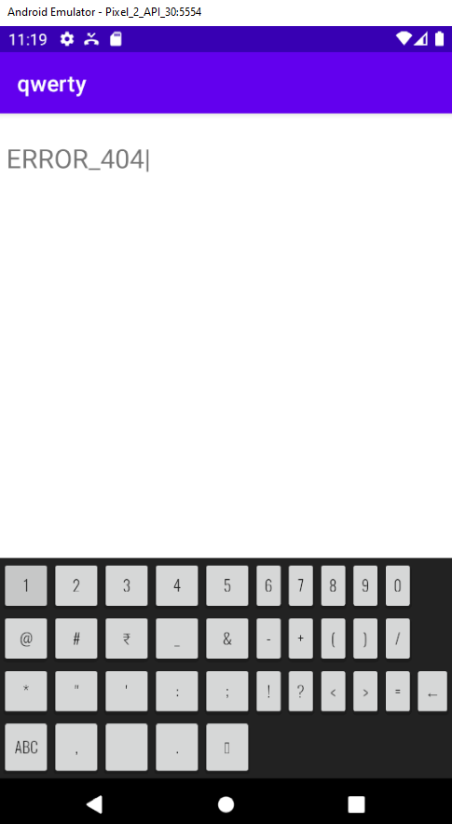

## Learning outcomes

Thus a keyboard was implemented using Android Studio

# Exercise 3 - Application Development using basic graphicalPrimitives

T Shivcharan

205001100

CSE-B

## Aim

Design a CAR using Shape drawables with the help of relevant shapes such as Line, Circle,

Rectangle and Arc.

a. Move the car forward by pressing forward button so that car moves from a predefined

starting point to the predefined endpoint.

b. On pressing backward button, rotate the car to 180 degrees from the current point to the

starting point.

c. Implement a Tap-to-zoom animation on any image.

d. Implement the Card flipping animation.

## Code

**Drawables:**

**car.xml**

<layer-list xmlns:android="http://schemas.android.com/apk/res/android">

<item android:drawable="@drawable/car_body" />

<item

android:drawable="@drawable/car_roof"

android:gravity="top"

/>

<item

android:drawable="@drawable/car_window"

android:top="10dp"

android:left="20dp"

android:right="50dp"

android:bottom="20dp"

/>

<item

android:drawable="@drawable/car_window"

android:top="10dp"

android:left="75dp"

android:right="20dp"

android:bottom="20dp"

/>

<item

android:drawable="@drawable/car_wheel"

android:gravity="left|bottom"

android:left="5dp"

android:bottom="0dp"

/>

<item

android:drawable="@drawable/car_wheel"

android:gravity="right|bottom"

android:right="5dp"

android:bottom="0dp"

/>

</layer-list>

**car_body.xml**

<shape xmlns:android="http://schemas.android.com/apk/res/android">

<solid android:color="#123" />

<corners android:radius="8dp" />

<size android:width="100dp" android:height="40dp"/>

</shape>

**car_roof.xml**

<shape xmlns:android="http://schemas.android.com/apk/res/android">

<solid android:color="#000000" />

<corners android:radius="2dp" />

<size android:width="20dp" android:height="15dp" />

</shape>

**car_wheel.xml**

<shape android:shape="oval"

xmlns:android="http://schemas.android.com/apk/res/android">

<solid android:color="#000000" />

<size android:width="20dp" android:height="20dp" />

<corners android:radius="3dp" />

</shape>

**car_window.xml**

<?xml version="1.0" encoding="utf-8"?>

<shape xmlns:android="http://schemas.android.com/apk/res/android">

<solid android:color="#333" />

<corners android:radius="4dp" />

<size android:width="20dp" android:height="20dp" />

</shape>

**lane_marking.xml**

<shape xmlns:android="http://schemas.android.com/apk/res/android">

<solid android:color="#FFFFFF" />

<size android:width="10dp" android:height="2dp" />

</shape>

**road.xml**

<layer-list xmlns:android="http://schemas.android.com/apk/res/android">

<!-- Road Background (Gray) -->

<item>

<shape android:shape="rectangle">

<solid android:color="#333" />

</shape>

</item>

<item android:drawable="@drawable/lane_marking"

android:top="10dp"

android:right="80dp"

android:left="10dp"

android:bottom="10dp"/>

<item android:drawable="@drawable/lane_marking"

android:top="10dp"

android:right="45dp"

android:left="45dp"

android:bottom="10dp"/>

<item android:drawable="@drawable/lane_marking"

android:top="10dp"

android:right="10dp"

android:left="80dp"

android:bottom="10dp"/>

</layer-list>

**Layout :**

**activity_main.xml**

<?xml version="1.0" encoding="utf-8"?>

<androidx.constraintlayout.widget.ConstraintLayout

xmlns:android="http://schemas.android.com/apk/res/android"

xmlns:app="http://schemas.android.com/apk/res-auto"

xmlns:tools="http://schemas.android.com/tools"

android:layout_width="match_parent"

android:layout_height="match_parent"

tools:context=".MainActivity">

<ImageView

android:id="@+id/carImageView"

android:layout_width="wrap_content"

android:layout_height="wrap_content"

android:src="@drawable/car"

app:layout_constraintBottom_toBottomOf="parent"

app:layout_constraintTop_toTopOf="parent"

app:layout_constraintVertical_bias="0.302"

tools:layout_editor_absoluteX="0dp" />

<ImageView

android:id="@+id/roadImageView"

android:layout_width="410dp"

android:layout_height="111dp"

android:layout_marginTop="256dp"

android:layout_marginEnd="1dp"

android:layout_marginBottom="364dp"

android:src="@drawable/road"

app:layout_constraintBottom_toBottomOf="parent"

app:layout_constraintEnd_toEndOf="parent"

app:layout_constraintHorizontal_bias="0.0"

app:layout_constraintStart_toStartOf="parent"

app:layout_constraintTop_toTopOf="parent" />

<Button

android:id="@+id/forwardButton"

android:layout_width="117dp"

android:layout_height="45dp"

android:layout_marginTop="60dp"

android:text="Forward"

app:layout_constraintEnd_toEndOf="parent"

app:layout_constraintStart_toStartOf="parent"

app:layout_constraintTop_toBottomOf="@+id/roadImageView" />

<Button

android:id="@+id/sunFlipId"

android:layout_width="wrap_content"

android:layout_height="wrap_content"

android:layout_marginBottom="108dp"

android:text="Flip Image"

app:layout_constraintBottom_toBottomOf="parent"

app:layout_constraintEnd_toEndOf="parent"

app:layout_constraintHorizontal_bias="0.496"

app:layout_constraintStart_toStartOf="parent"

app:layout_constraintTop_toBottomOf="@+id/backwardButton"

app:layout_constraintVertical_bias="0.384" />

<Button

android:id="@+id/backwardButton"

android:layout_width="wrap_content"

android:layout_height="wrap_content"

android:layout_marginTop="16dp"

android:text="Backward"

app:layout_constraintEnd_toEndOf="parent"

app:layout_constraintStart_toStartOf="parent"

app:layout_constraintTop_toBottomOf="@+id/forwardButton" />

<ImageView

android:id="@+id/sunId"

android:layout_width="79dp"

android:layout_height="55dp"

android:layout_marginTop="84dp"

app:layout_constraintEnd_toEndOf="parent"

app:layout_constraintStart_toStartOf="parent"

app:layout_constraintTop_toTopOf="parent"

app:srcCompat="?attr/actionModeCloseDrawable" />

<!-- Add other UI elements here if needed -->

</androidx.constraintlayout.widget.ConstraintLayout>

**MainActivity.java**

package com.example.abex3;

import androidx.appcompat.app.AppCompatActivity;

import android.animation.ObjectAnimator;

import android.os.Bundle;

import android.os.Handler;

import android.view.View;

import android.view.animation.AccelerateDecelerateInterpolator;

import android.widget.Button;

import android.widget.ImageView;

public class MainActivity extends AppCompatActivity {

private ImageView carImageView;

private ImageView sunImageView;

private Button forwardButton;

private Button backwardButton;

private Button sunFlipButton;

private int carXPosition = 0;

private final int endpoint = 800;

private final int startpoint = 0;

boolean isClicked=false;

@Override

protected void onCreate(Bundle savedInstanceState) {

super.onCreate(savedInstanceState);

setContentView(R.layout.activity_main);

carImageView = findViewById(R.id.carImageView);

sunImageView = findViewById(R.id.sunId);

forwardButton = findViewById(R.id.forwardButton);

backwardButton = findViewById(R.id.backwardButton);

sunFlipButton = findViewById(R.id.sunFlipId);

forwardButton.setOnClickListener(new View.OnClickListener() {

boolean isOperationInProgress = false;

@Override

public void onClick(View v) {

if (!isOperationInProgress) {

isOperationInProgress = true;

backwardButton.setEnabled(false);

forwardButton.setEnabled(false);

final Handler handler = new Handler();

final Runnable carMovement = new Runnable() {

@Override

public void run() {

carXPosition += 10;

if (carXPosition <= endpoint) {

carImageView.setX(carXPosition);

handler.postDelayed(this, 100); // 100 milliseconds delay

} else {

isOperationInProgress = false;

backwardButton.setEnabled(true);

forwardButton.setEnabled(true);

}

}

};

handler.post(carMovement);

}

}

});

backwardButton.setOnClickListener(new View.OnClickListener() {

boolean isOperationInProgress = false;

private boolean isCarFlipped = false;

@Override

public void onClick(View v) {

if (!isOperationInProgress) {

isOperationInProgress = true;

backwardButton.setEnabled(false);

forwardButton.setEnabled(false);

flipCar();

final Handler handler = new Handler();

final Runnable carMovement = new Runnable() {

@Override

public void run() {

carXPosition -= 10;

if (carXPosition >= startpoint) {

carImageView.setX(carXPosition);

handler.postDelayed(this, 100); // 100 milliseconds delay

} else {

isOperationInProgress = false;

backwardButton.setEnabled(true);

forwardButton.setEnabled(true);

flipCar();

}

}

};

handler.post(carMovement);

}

}

private void flipCar() {

ObjectAnimator flipAnimator;

if (isCarFlipped) {

flipAnimator = ObjectAnimator.ofFloat(carImageView, "rotationY", 180f, 0f);

isCarFlipped = false;

} else {

flipAnimator = ObjectAnimator.ofFloat(carImageView, "rotationY", 0f, 180f);

isCarFlipped = true;

}

flipAnimator.setDuration(500);

flipAnimator.setInterpolator(new AccelerateDecelerateInterpolator());

flipAnimator.start();

}

});

sunImageView.setOnClickListener(new View.OnClickListener(){

@Override

public void onClick(View v) {

if(!isClicked){

sunImageView.setScaleX(2);

sunImageView.setScaleY(2);

isClicked=true;

}

else{

sunImageView.setScaleX(1);

sunImageView.setScaleY(1);

isClicked=false;

}

}

});

sunFlipButton.setOnClickListener(new View.OnClickListener() {

private boolean isArrowFlipped = false;

@Override

public void onClick(View v) {

ObjectAnimator flipAnimator;

if (isArrowFlipped) {

flipAnimator = ObjectAnimator.ofFloat(sunImageView, "rotationY", 180f, 0f);

isArrowFlipped = false;

} else {

flipAnimator = ObjectAnimator.ofFloat(sunImageView, "rotationY", 0f, 180f);

isArrowFlipped = true;

}

flipAnimator.setDuration(500);

flipAnimator.setInterpolator(new AccelerateDecelerateInterpolator());

flipAnimator.start();

}

});

}

}

## Output

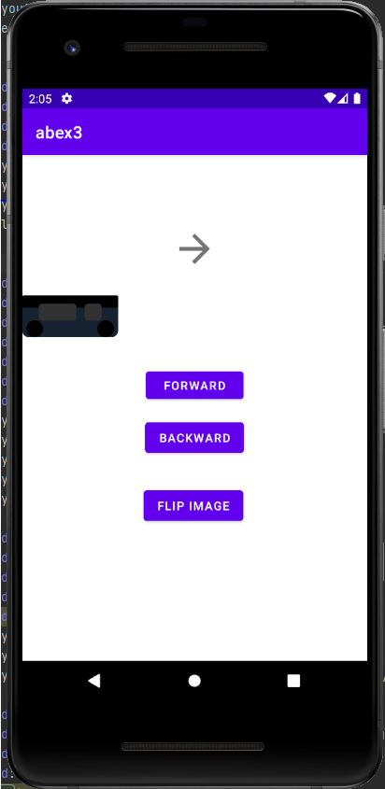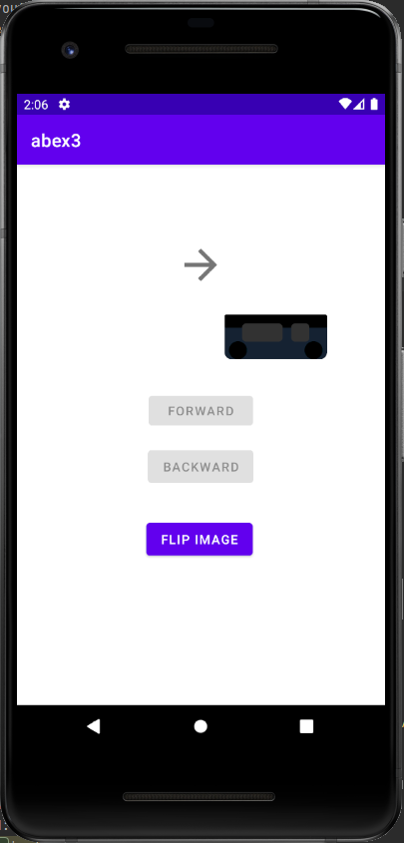

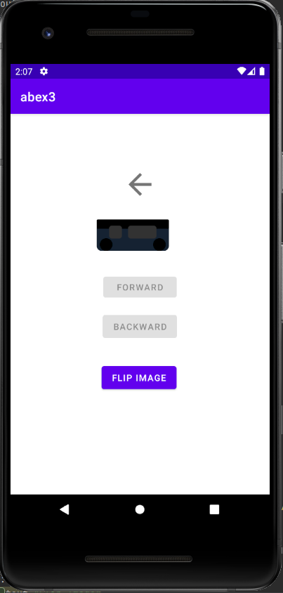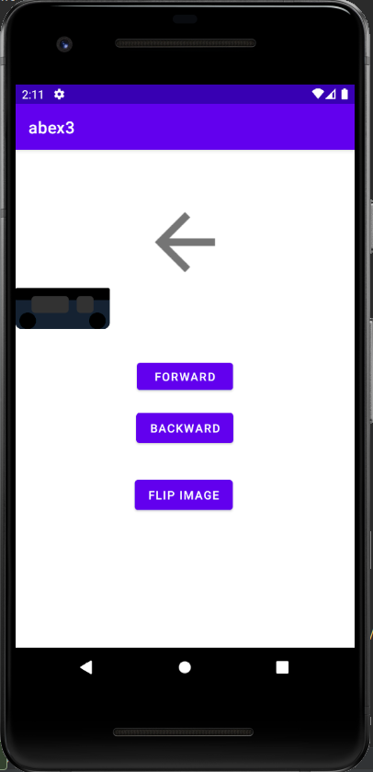

## Learning outcomes

* Proficient in creating user interfaces using shape drawables and relevant shapes.
* Implemented event listeners for user interaction and learned to navigate between activities.
* Successfully added animations, improving user engagement with tap-to-zoom and card flipping features.

# Ex. No. 4 Android Application Development using Database

**Aim:** Develop a Product information application in Android that enables to perform CRUD operations on data stored in SQLite Database.

**Layout Used:** Linear Layout, Table Layout

**Intents:** Insert, Retrieve, Retrieve All, Update, Delete and Main

# Code:

**MainActivity.java:**

package com.example.ex4;

import androidx.appcompat.app.AppCompatActivity; import android.content.Intent;

import android.os.Bundle; import android.view.View; import android.widget.Button;

public class MainActivity extends AppCompatActivity {

@Override

protected void onCreate(Bundle savedInstanceState) { super.onCreate(savedInstanceState); setContentView(R.layout.activity_main);

final Database[] db = new Database[1]; Button create = findViewById(R.id.create);

create.setOnClickListener(new View.OnClickListener() { @Override

public void onClick(View v) {

db[0] = new Database(MainActivity.this);

}

});

Button insert = findViewById(R.id.insert); insert.setOnClickListener(new View.OnClickListener() {

@Override

public void onClick(View v) {

Intent intent = new Intent(MainActivity.this, Insert.class); startActivity(intent);

}

});

Button delete = findViewById(R.id.delete); delete.setOnClickListener(new View.OnClickListener() {

@Override

public void onClick(View v) {

Intent intent = new Intent(MainActivity.this,Delete.class); startActivity(intent);

}

});

Button retrieve = findViewById(R.id.read); retrieve.setOnClickListener(new View.OnClickListener() {

@Override

public void onClick(View v) {

Intent intent = new Intent(MainActivity.this,Retrieve.class); startActivity(intent);

}

});

Button retrieveAll = findViewById(R.id.read_all); retrieveAll.setOnClickListener(new View.OnClickListener() {

@Override

public void onClick(View v) {

Intent intent = new Intent(MainActivity.this,RetrieveAll.class); startActivity(intent);

}

});

Button update = findViewById(R.id.update); update.setOnClickListener(new View.OnClickListener() {

@Override

public void onClick(View v) {

Intent intent = new Intent(MainActivity.this,Update.class); startActivity(intent);

}

});

}

}

# Database.java:

package com.example.ex4;

import android.content.ContentValues; import android.content.Context; import android.database.Cursor;

import android.database.sqlite.SQLiteDatabase; import android.database.sqlite.SQLiteOpenHelper;

public class Database extends SQLiteOpenHelper { private static final String DB_NAME = "product";

private static final int DB_VERSION = 3;

private static final String TABLE_NAME = "prod"; private static final String ID_COL = "id";

private static final String NAME_COL = "name"; private static final String BRAND_COL = "brand"; private static final String DESC_COL = "desc"; private static final String PRICE_COL = "price";

public Database(Context context) {

super(context, DB_NAME, null, DB_VERSION);

}

@Override

public void onCreate(SQLiteDatabase db) {

String query = "CREATE TABLE " + TABLE_NAME + " ("

+ ID_COL + " INTEGER PRIMARY KEY, "

+ NAME_COL + " TEXT,"

+ BRAND_COL + " TEXT,"

+ DESC_COL + " TEXT,"

+ PRICE_COL + " TEXT)";

// at last we are calling a exec sql

// method to execute above sql query db.execSQL(query);

}

// this method is use to add new course to our sqlite database.

public void addProduct(String id,String name,String brand, String desc, String price) {

// on below line we are creating a variable for

// our sqlite database and calling writable method

// as we are writing data in our database. SQLiteDatabase db = this.getWritableDatabase();

// on below line we are creating a

// variable for content values.

ContentValues values = new ContentValues();

// on below line we are passing all values

// along with its key and value pair. values.put(ID_COL,id); values.put(NAME_COL, name); values.put(BRAND_COL,brand); values.put(DESC_COL, desc); values.put(PRICE_COL, price);

// after adding all values we are passing

// content values to our table. db.insert(TABLE_NAME, null, values);

// at last we are closing our

// database after adding database. db.close();

}

public void deleteProduct(String id){ SQLiteDatabase db = this.getWritableDatabase();

db.delete(TABLE_NAME,ID_COL+"= ?",new String[]{id});

}

public void updateProduct(String id,String price){

SQLiteDatabase db = this.getWritableDatabase(); ContentValues values = new ContentValues(); values.put(PRICE_COL, price); db.update(TABLE_NAME, values, ID_COL + "=?", new

String[]{String.valueOf(id)});

}

public Cursor retrieveAll(){

SQLiteDatabase db = this.getReadableDatabase();

return db.query(TABLE_NAME, null, null, null, null, null, null);

}

public Cursor retrieve(String id){

SQLiteDatabase db = this.getReadableDatabase(); String[] projection = {

NAME_COL, BRAND_COL, DESC_COL, PRICE_COL

};

// Define the condition for retrieval (e.g., where id = ?) String selection = ID_COL + " = ?";

String[] selectionArgs = { id };

// Execute the query Cursor cursor = db.query(

TABLE_NAME, // Table name projection, // Columns to return selection, // Selection (WHERE clause) selectionArgs, // Selection arguments null, // Group by null, // Having

null // Order by

);

// The cursor now contains the retrieved row(s) return cursor;

}

@Override

public void onUpgrade(SQLiteDatabase db, int oldVersion, int newVersion) {

// this method is called to check if the table exists already. db.execSQL("DROP TABLE IF EXISTS " + TABLE_NAME);

onCreate(db);

}

}

# Insert.java:

package com.example.ex4;

import android.content.Intent; import android.os.Bundle; import android.util.Log; import android.view.View; import android.widget.Button; import android.widget.RadioButton;

import android.widget.RadioGroup; import android.widget.TextView; import

androidx.appcompat.app.AppCompatActivity; public

class Insert extends AppCompatActivity {

@Override

protected void onCreate(Bundle savedInstanceState){ super.onCreate(savedInstanceState); setContentView(R.layout.insert);

Button backi = findViewById(R.id.backi); backi.setOnClickListener(new View.OnClickListener() {

@Override

public void onClick(View v) {

Intent intent = new Intent(Insert.this,MainActivity.class); startActivity(intent);

}

});

Button submiti = findViewById(R.id.submiti); submiti.setOnClickListener(new View.OnClickListener() {

@Override

public void onClick(View v) {

Database db = new Database(Insert.this);

TextView textView = findViewById(R.id.idi); String id = textView.getText().toString(); textView = findViewById(R.id.namei); String name = textView.getText().toString();

RadioGroup radioGroup = findViewById(R.id.radioGroup); int selectedRadioButtonId =

radioGroup.getCheckedRadioButtonId(); RadioButton selectedRadioButton =

findViewById(selectedRadioButtonId);

String brand = selectedRadioButton.getText().toString(); Log.d("Debug",brand);

textView = findViewById(R.id.desci); String desc = textView.getText().toString(); Log.d("Debug",desc);

textView = findViewById(R.id.pricei); String price =

textView.getText().toString();

db.addProduct(id,name,brand,desc,price);

}

});

}

}

# Retrieve:

package com.example.ex4;

import android.content.Intent; import android.database.Cursor; import android.os.Bundle; import android.view.View; import android.widget.Button; import android.widget.TextView;

import androidx.appcompat.app.AppCompatActivity;

public class Retrieve extends AppCompatActivity {

@Override

protected void onCreate(Bundle savedInstanceState){ super.onCreate(savedInstanceState); setContentView(R.layout.retrieve);

Button backr = findViewById(R.id.backr); backr.setOnClickListener(new View.OnClickListener() {

@Override

public void onClick(View v) {

Intent intent = new Intent(Retrieve.this,MainActivity.class); startActivity(intent);

}

});

Button retrieve = findViewById(R.id.retrieve); retrieve.setOnClickListener(new View.OnClickListener() {

@Override

public void onClick(View v) {

TextView textView = findViewById(R.id.idr); String id = textView.getText().toString();

Database db = new Database(Retrieve.this); Cursor cursor = db.retrieve(id);

String name="",brand="",desc="",price="";

if (cursor.moveToFirst()) {

do {

// Retrieve values from 'column1' and 'column2' as strings int columnIndex = cursor.getColumnIndex("name");

if (columnIndex != -1) {

name = cursor.getString(columnIndex);

}

columnIndex = cursor.getColumnIndex("brand"); if(columnIndex!=-1){

brand=cursor.getString(columnIndex);

}

columnIndex = cursor.getColumnIndex("desc"); if(columnIndex!=-1){

desc=cursor.getString(columnIndex);

}

columnIndex = cursor.getColumnIndex("price"); if(columnIndex!=-1){

price=cursor.getString(columnIndex);

}

} while (cursor.moveToNext());

}

textView = findViewById(R.id.namer); textView.setText(name);

textView = findViewById(R.id.brandr); textView.setText(brand);

textView = findViewById(R.id.descr); textView.setText(desc);

textView = findViewById(R.id.pricer); textView.setText(price);

}

});

}

}

# Retrieve All:

package com.example.ex4;

import android.content.Context; import android.content.Intent; import android.database.Cursor; import android.graphics.Color; import android.os.Bundle; import android.util.Log;

import android.view.View; import android.view.ViewGroup; import android.widget.Button;

import android.widget.TableLayout; import android.widget.TableRow;

import android.widget.TextView;

import androidx.appcompat.app.AppCompatActivity; import androidx.constraintlayout.widget.ConstraintLayout; import androidx.constraintlayout.widget.ConstraintSet;

import org.w3c.dom.Text;

public class RetrieveAll extends AppCompatActivity { private TextView newTextView(String text){

TextView tv = new TextView(RetrieveAll.this);

tv.setText(text); tv.setPadding(4,4,4,4); tv.setTextSize(24);

TableRow.LayoutParams layoutParams = new TableRow.LayoutParams(

TableRow.LayoutParams.WRAP_CONTENT, // Adjust width as

needed

needed

);

TableRow.LayoutParams.WRAP_C ONTENT // Adjust height as

layoutParams.rightMargin = 20; tv.setLayoutParams(layoutParams);

return tv;

}

@Override

protected void onCreate(Bundle savedInstanceState){ super.onCreate(savedInstanceState); setContentView(R.layout.retrieve_all);

Database db = new Database(RetrieveAll.this);

Cursor cursor = db.retrieveAll();

ConstraintLayout parent = findViewById(R.id.parent);

// Create layout params for the TableLayout

// ConstraintLayout.LayoutParams tableLayoutParams = new ConstraintLayout.LayoutParams(

// ConstraintLayout.LayoutParams.MATCH_PARENT,

// ConstraintLayout.LayoutParams.MATCH_PARENT

// );

// tableLayoutParams.startToStart = ConstraintLayout.LayoutParams.PARENT_ID

;

// tableLayoutParams.endToEnd = ConstraintLayout.LayoutParams.PARENT_ID

;

// tableLayoutParams.topToTop = ConstraintLayout.LayoutParams.PARENT_ID

;

// tableLayoutParams.bottomToBottom = ConstraintLayout.LayoutParams.PARENT_ID

;

TableLayout tl = new TableLayout(RetrieveAll.this);

TableRow trh = new TableRow(RetrieveAll.this); TextView tv0 = newTextView("Id"); trh.addView(tv0);

tv0 = newTextView("Name"); trh.addView(tv0);

tv0 = newTextView("Brand"); trh.addView(tv0);

tv0 = newTextView("Description");

trh.addView(tv0);

tv0 = newTextView("Price");

trh.addView(tv0); tl.addView(trh);

String id="",name="",brand="",desc="",price=""; if (cursor.moveToFirst()) {

do {

// Retrieve values from 'column1' and 'column2' as strings int columnIndex = cursor.getColumnIndex("id");

if (columnIndex != -1) {

id = cursor.getString(columnIndex);

}

columnIndex = cursor.getColumnIndex("name"); if(columnIndex!=-1){

name=cursor.getString(columnIndex);

}

columnIndex = cursor.getColumnIndex("brand"); if(columnIndex!=-1){

brand=cursor.getString(columnIndex);

}

columnIndex = cursor.getColumnIndex("desc"); if(columnIndex!=-1){

desc=cursor.getString(columnIndex);

}

columnIndex = cursor.getColumnIndex("price"); if(columnIndex!=-1){

price=cursor.getString(columnIndex);

}

Log.d("Debug",id+" "+name+" "+brand+" "+desc+" "+price);

TableRow tr = new TableRow(RetrieveAll.this);

TextView tv1 = newTextView(id); TextView tv2 = newTextView(name); TextView tv3 = newTextView(brand); TextView tv4 = newTextView(desc); TextView tv5 = newTextView(price);

tr.addView(tv1)

;

tr.addView(tv2)

;

tr.addView(tv3)

;

tr.addView(tv4)

;

tr.addView(tv5)

;

tl.addView(tr);

} while (cursor.moveToNext());

}

parent.addView(tl);

// app:layout_constraintEnd_toEndOf="parent"

// app:layout_constraintStart_toStartOf="parent"

// app:layout_constraintTop_toTopOf="parent"

Button retrieveAll = findViewById(R.id.backra); retrieveAll.setOnClickListener(new View.OnClickListener() {

@Override

public void onClick(View v) {

Intent intent = new Intent(RetrieveAll.this,MainActivity.class);

startActivity(intent);

}

});

}

}

# Update:

package com.example.ex4;

import android.content.Intent; import android.os.Bundle; import android.view.View; import android.widget.Button; import android.widget.TextView;

import androidx.appcompat.app.AppCompatActivity;

public class Update extends AppCompatActivity {

@Override

protected void onCreate(Bundle savedInstanceState){ super.onCreate(savedInstanceState); setContentView(R.layout.update);

Button backu = findViewById(R.id.backu); backu.setOnClickListener(new View.OnClickListener() {

@Override

public void onClick(View v) {

Intent intent = new Intent(Update.this,MainActivity.class); startActivity(intent);

}

});

Button update = findViewById(R.id.update); update.setOnClickListener(new View.OnClickListener() {

@Override

public void onClick(View v) {

Database db = new Database(Update.this); TextView textView = findViewById(R.id.idu); String id = textView.getText().toString(); textView = findViewById(R.id.priceu); String price = textView.getText().toString();

db.updateProduct(id,price);

}

});

}

}

# Delete.java:

package com.example.ex4;

import android.content.Intent; import android.os.Bundle; import android.view.View; import android.widget.Button; import android.widget.TextView;

import androidx.appcompat.app.AppCompatActivity;

public class Delete extends AppCompatActivity {

@Override

protected void onCreate(Bundle savedInstanceState){ super.onCreate(savedInstanceState); setContentView(R.layout.delete);

Button backd = findViewById(R.id.backd); backd.setOnClickListener(new View.OnClickListener() {

@Override

public void onClick(View v) {

}

});

Intent intent = new Intent(Delete.this,MainActivity.class); startActivity(intent);

Button delete = findViewById(R.id.delete); delete.setOnClickListener(new View.OnClickListener() {

@Override

public void onClick(View v) {

Database db = new Database(Delete.this);

TextView textView = findViewById(R.id.idd); String id = textView.getText().toString();

db.deleteProduct(id);

}

});

}

}

# Activity_main.xml:

<?xml version="1.0" encoding="utf-8"?>

<androidx.constraintlayout.widget.ConstraintLayout xmlns:android="<http://schemas.android.com/apk/res/android>" xmlns:tools="<http://schemas.android.com/tools>" xmlns:app="<http://schemas.android.com/apk/res-auto>" android:layout_width="match_parent" android:layout_height="match_parent" tools:context=".MainActivity">

<RelativeLayout android:layout_width="match_parent" android:layout_height="match_parent">

<!-- Center the LinearLayout vertically -->

<LinearLayout android:id="@+id/verticalLayout" android:layout_width="wrap_content" android:layout_height="wrap_content" android:layout_centerInParent="true" android:orientation="vertical">

<!-- Add your UI elements within this LinearLayout -->

<Button

android:id="@+id/create" android:layout_width="177dp" android:layout_height="62dp" android:text="Create" />

<Button

android:id="@+id/insert" android:layout_width="177dp" android:layout_height="62dp" android:text="Insert" />

<Button

android:id="@+id/read" android:layout_width="match_parent" android:layout_height="wrap_content" android:text="Retrieve" />

<Button

android:id="@+id/read_all" android:layout_width="match_parent" android:layout_height="wrap_content" android:text="Retrieve All" />

<Button

android:id="@+id/update" android:layout_width="match_parent" android:layout_height="wrap_content" android:text="Update" />

<Button

android:id="@+id/delete" android:layout_width="match_parent" android:layout_height="wrap_content" android:text="Delete" />

<!-- Add more views here as needed -->

</LinearLayout>

</RelativeLayout>

</androidx.constraintlayout.widget.ConstraintLayout>

# Insert.xml:

<?xml version="1.0" encoding="utf-8"?>

<androidx.constraintlayout.widget.ConstraintLayout xmlns:android="<http://schemas.android.com/apk/res/android>"

xmlns:app="<http://schemas.android.com/apk/res-auto>" xmlns:tools="<http://schemas.android.com/tools>" android:layout_width="match_parent" android:layout_height="match_parent">

<LinearLayout android:layout_width="409dp" android:layout_height="665dp" android:layout_marginTop="50dp" android:orientation="vertical"

app:layout_constraintBottom_toBottomOf="parent"

app:layout_constraintStart_toStartOf="parent" app:layout_constraintTop_toTopOf="parent">

<LinearLayout android:layout_width="match_parent" android:layout_height="87dp" android:orientation="horizontal">

<TextView android:id="@+id/textView3" android:layout_width="120dp" android:layout_height="55dp" android:layout_weight="1" android:text="Product Id" android:textSize="24sp" />

<EditText android:id="@+id/idi"

android:layout_width="wrap_content" android:layout_height="58dp" android:layout_weight="1" android:ems="10" android:inputType="textPersonName " android:textSize="24sp" />

</LinearLayout>

<LinearLayout android:layout_width="match_parent" android:layout_height="84dp" android:orientation="horizontal">

<TextView android:id="@+id/textView5" android:layout_width="131dp" android:layout_height="58dp"

android:layout_weight="1" android:text="Product Name" android:textSize="24sp" />

<EditText android:id="@+id/namei"

android:layout_width="wrap_content" android:layout_height="59dp" android:layout_weight="1" android:ems="10" android:inputType="textPersonName " android:textSize="24sp" />

</LinearLayout>

<LinearLayout android:layout_width="match_parent" android:layout_height="94dp" android:orientation="horizontal">

<TextView android:id="@+id/textView6" android:layout_width="198dp" android:layout_height="71dp" android:layout_weight="1" android:text="Brand" android:textSize="24sp" />

<RadioGroup android:id="@+id/radioGroup" android:layout_width="match_parent" android:layout_height="match_parent" android:layout_weight="1" >

<RadioButton android:id="@+id/radio1"

android:layout_width="match_parent" android:layout_height="wrap_content" android:textSize="24sp" android:text="A" />

<RadioButton android:id="@+id/radio2"

android:layout_width="match_parent" android:layout_height="wrap_content" android:textSize="24sp" android:text="B" />

</RadioGroup>

</LinearLayout>

<LinearLayout android:layout_width="match_parent" android:layout_height="93dp" android:orientation="horizontal">

<TextView android:id="@+id/textView7" android:layout_width="146dp" android:layout_height="73dp" android:layout_weight="1" android:text="Description" android:textSize="24sp" />

<EditText android:id="@+id/desci"

android:layout_width="wrap_content" android:layout_height="75dp" android:layout_weight="1" android:ems="10" android:inputType="textPersonName "

android:textSize="24sp" />

</LinearLayout>

<LinearLayout android:layout_width="match_parent" android:layout_height="96dp" android:orientation="horizontal">

<TextView android:id="@+id/textView8" android:layout_width="114dp" android:layout_height="79dp" android:layout_weight="1" android:text="Price" android:textSize="24sp" />

<EditText android:id="@+id/pricei"

android:layout_width="wrap_content" android:layout_height="82dp" android:layout_weight="1" android:ems="10" android:inputType="textPersonName " android:textSize="24sp" />

</LinearLayout>

<Button

android:id="@+id/submiti" android:layout_width="match_parent" android:layout_height="wrap_content" android:text="Submit" />

<Button

android:id="@+id/backi" android:layout_width="match_parent"

android:layout_height="wrap_content" android:text="Back" />

</LinearLayout>

</androidx.constraintlayout.widget.ConstraintLayout>

# Retrieve.xml:

<?xml version="1.0" encoding="utf-8"?>

<androidx.constraintlayout.widget.ConstraintLayout xmlns:android="<http://schemas.android.com/apk/res/android>"

xmlns:app="<http://schemas.android.com/apk/res-auto>" xmlns:tools="<http://schemas.android.com/tools>" android:layout_width="match_parent" android:layout_height="match_parent">

<LinearLayout android:id="@+id/linearLayout" android:layout_width="414dp" android:layout_height="203dp" android:orientation="vertical"

app:layout_constraintEnd_toEndOf="parent" app:layout_constraintHorizontal_bias="1.0" app:layout_constraintStart_toStartOf="parent" tools:ignore="MissingConstraints" tools:layout_editor_absoluteY="-2dp">

<LinearLayout android:layout_width="match_parent" android:layout_height="103dp" android:orientation="horizontal">

<TextView android:id="@+id/textView" android:layout_width="144dp"

android:layout_height="64dp" android:layout_weight="1" android:text="Product Id" android:textSize="24sp" />

<EditText android:id="@+id/idr"

android:layout_width="wrap_content" android:layout_height="83dp" android:layout_weight="1" android:ems="10" android:inputType="textPersonName " android:textSize="24sp" />

</LinearLayout>

<Button

android:id="@+id/retrieve" android:layout_width="match_parent" android:layout_height="wrap_content" android:text="Retrieve" />

<Button

android:id="@+id/backr" android:layout_width="match_parent" android:layout_height="wrap_content" android:text="Back" />

</LinearLayout>

<LinearLayout android:layout_marginTop="50dp" android:layout_width="411dp" android:layout_height="459dp" android:orientation="vertical"

app:layout_constraintBottom_toBottomOf="parent" app:layout_constraintStart_toStartOf="parent"

app:layout_constraintTop_toBottomOf="@+id/linearLayout">

<LinearLayout android:layout_width="match_parent" android:layout_height="84dp" android:orientation="horizontal">

<TextView android:id="@+id/textView5" android:layout_width="131dp" android:layout_height="58dp" android:layout_weight="1" android:text="Product Name" android:textSize="24sp" />

<TextView android:id="@+id/namer" android:layout_width="146dp" android:layout_height="73dp" android:layout_weight="1" android:text="" android:textSize="24sp" />

</LinearLayout>

<LinearLayout android:layout_width="match_parent" android:layout_height="94dp" android:orientation="horizontal">

<TextView android:id="@+id/textView6" android:layout_width="198dp" android:layout_height="71dp" android:layout_weight="1" android:text="Brand"

android:textSize="24sp" />

<TextView android:id="@+id/brandr" android:layout_width="146dp" android:layout_height="73dp" android:layout_weight="1" android:text="" android:textSize="24sp" />

</LinearLayout>

<LinearLayout android:layout_width="match_parent" android:layout_height="93dp" android:orientation="horizontal">

<TextView android:id="@+id/textView0" android:layout_width="146dp" android:layout_height="73dp" android:layout_weight="1" android:text="Description" android:textSize="24sp" />

<TextView android:id="@+id/descr" android:layout_width="146dp" android:layout_height="73dp" android:layout_weight="1" android:text="" android:textSize="24sp" />

</LinearLayout>

<LinearLayout

android:layout_width="match_parent" android:layout_height="96dp" android:orientation="horizontal">

<TextView android:id="@+id/textView8" android:layout_width="114dp" android:layout_height="79dp" android:layout_weight="1" android:text="Price" android:textSize="24sp" />

<TextView android:id="@+id/pricer" android:layout_width="146dp" android:layout_height="73dp" android:layout_weight="1" android:text="" android:textSize="24sp" />

</LinearLayout>

</LinearLayout>

</androidx.constraintlayout.widget.ConstraintLayout>

# Retrieve All:

<?xml version="1.0" encoding="utf-8"?>

<androidx.constraintlayout.widget.ConstraintLayout xmlns:android="<http://schemas.android.com/apk/res/android>"

xmlns:app="<http://schemas.android.com/apk/res-auto>" xmlns:tools="<http://schemas.android.com/tools>" android:layout_width="match_parent" android:layout_height="match_parent" android:id="@+id/parent">

<Button

android:id="@+id/backra" android:layout_width="match_parent" android:layout_height="wrap_content" android:text="Back" app:layout_constraintBottom_toBottomOf="parent" app:layout_constraintEnd_toEndOf="parent" app:layout_constraintStart_toStartOf="parent" />

</androidx.constraintlayout.widget.ConstraintLayout>

# Update.xml:

<?xml version="1.0" encoding="utf-8"?>

<androidx.constraintlayout.widget.ConstraintLayout xmlns:android="<http://schemas.android.com/apk/res/android>"

xmlns:app="<http://schemas.android.com/apk/res-auto>" xmlns:tools="<http://schemas.android.com/tools>" android:layout_width="match_parent" android:layout_height="match_parent">

<LinearLayout android:layout_width="412dp" android:layout_height="352dp" android:orientation="vertical"

app:layout_constraintStart_toStartOf="parent" tools:layout_editor_absoluteY="186dp" tools:ignore="MissingConstraints">

<LinearLayout android:layout_width="match_parent" android:layout_height="107dp"

android:orientation="horizontal">

<TextView android:id="@+id/textView2" android:layout_width="105dp" android:layout_height="80dp" android:layout_weight="1" android:textSize="24sp" android:text="Product Id" />

<EditText android:id="@+id/idu"

android:layout_width="wrap_content" android:layout_height="match_parent" android:layout_weight="1" android:ems="10" android:inputType="textPersonName" android:textSize="24sp" />

</LinearLayout>

<LinearLayout android:layout_width="match_parent" android:layout_height="97dp" android:orientation="horizontal">

<TextView android:id="@+id/textView4" android:layout_width="108dp" android:layout_height="79dp" android:layout_weight="1" android:textSize="24sp" android:text="Price" />

<EditText android:id="@+id/priceu"

android:layout_width="wrap_content" android:layout_height="match_parent" android:layout_weight="1" android:ems="10" android:textSize="24sp" android:inputType="textPersonName" />

</LinearLayout>

<Button

android:id="@+id/update" android:layout_width="match_parent" android:layout_height="wrap_content" android:text="Update" />

<Button

android:id="@+id/backu" android:layout_width="match_parent" android:layout_height="wrap_content" android:text="Back" />

</LinearLayout>

</androidx.constraintlayout.widget.ConstraintLayout>

# Delete.xml:

<?xml version="1.0" encoding="utf-8"?>

<androidx.constraintlayout.widget.ConstraintLayout xmlns:android="<http://schemas.android.com/apk/res/android>"

xmlns:app="<http://schemas.android.com/apk/res-auto>" xmlns:tools="<http://schemas.android.com/tools>" android:layout_width="match_parent" android:layout_height="match_parent">

<LinearLayout android:layout_width="414dp" android:layout_height="475dp"

android:orientation="vertical" app:layout_constraintEnd_toEndOf="parent" app:layout_constraintStart_toStartOf="parent" tools:layout_editor_absoluteY="101dp" tools:ignore="MissingConstraints">

<LinearLayout android:layout_width="match_parent" android:layout_height="152dp" android:orientation="horizontal">

<TextView android:id="@+id/textView" android:layout_width="144dp" android:layout_height="89dp" android:layout_weight="1" android:textSize="24sp" android:text="Product Id" />

<EditText android:id="@+id/idd"

android:layout_width="wrap_content" android:layout_height="match_parent" android:layout_weight="1" android:ems="10" android:inputType="textPersonName" android:textSize="24sp" />

</LinearLayout>

<Button

android:id="@+id/delete" android:layout_width="match_parent" android:layout_height="wrap_content" android:text="Delete" />

<Button

android:id="@+id/backd" android:layout_width="match_parent" android:layout_height="wrap_content" android:text="Back" />

</LinearLayout>

</androidx.constraintlayout.widget.ConstraintLayout>

# Output:

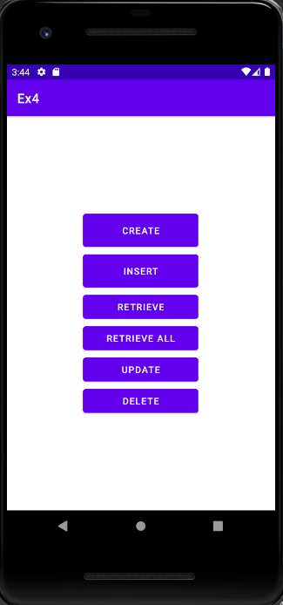

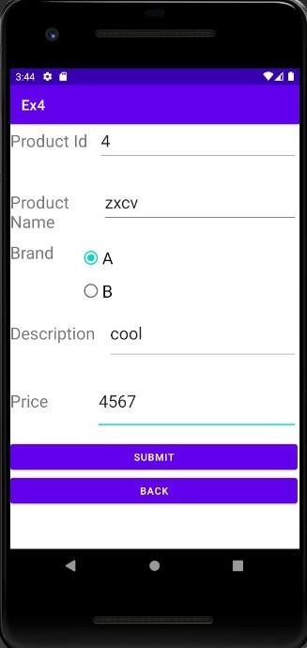

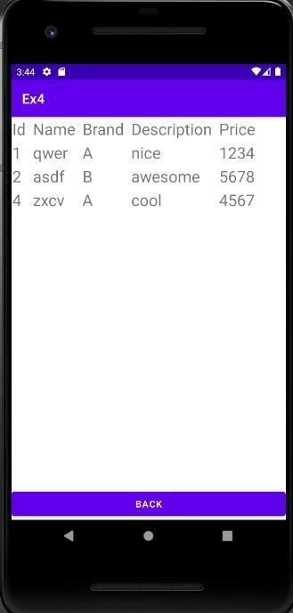

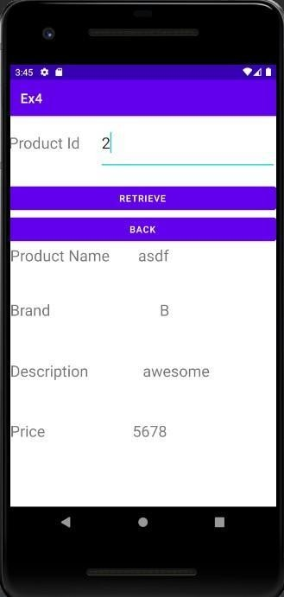

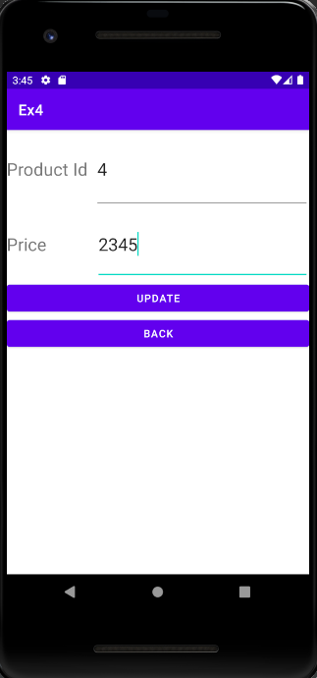

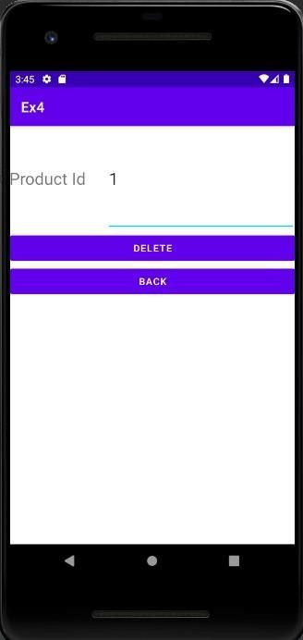

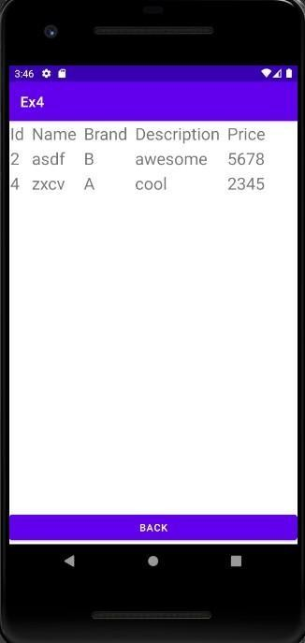

**Best Practices:**

* Used apt names for xml and java files.
* Set padding and margins for dynamically added elements

# Learning Outcomes:

* Learnt to integrate sqlite3 in android studio
* Learnt to do CRUD operations

# Ex. No. 5 Android Application using Multithreading

**Aim:**

Develop an android application to perform multithreading. Define 3 threads to run concurrently when “start” button is clicked.

The first thread should change the color of the text indefinitely The second thread should implement a moving banner

The third thread should display a counter starting from 0 to 1000 When the “Stop” button is pressed all the threads should be stopped

**Layouts Used:** None. Three textViews.

# Code:

**MainActivity.java:**

package com.example.ex5;

import androidx.appcompat.app.AppCompatActivity;

import android.graphics.Color; import android.os.Bundle;

import android.util.Log; import android.view.View; import android.widget.Button;

import android.widget.TextView;

public class MainActivity extends AppCompatActivity {

@Override

protected void onCreate(Bundle savedInstanceState) { super.onCreate(savedInstanceState); setContentView(R.layout.activity_main);

TextView t1 = findViewById(R.id.t1); Thread1 th1 = new Thread1(t1);

TextView t2 = findViewById(R.id.t2); Thread2 th2 = new Thread2(t2);

TextView t3 = findViewById(R.id.t3); Thread3 th3 = new Thread3(t3);

final boolean[] init = {false};

Button start = findViewById(R.id.start); start.setOnClickListener(new View.OnClickListener() {

@Override

public void onClick(View v) { if(!init[0]){

th1.start();

th2.start();

th3.start(); init[0] = true;

}

else{

Log.d("debug","hello"); th1.pause(false); th2.pause(false); th3.pause(false);

}

}

});

Button stop = findViewById(R.id.stop); stop.setOnClickListener(new View.OnClickListener() {

@Override

public void onClick(View v) { th1.pause(true); th2.pause(true); th3.pause(true);

}

});

}

}

# Thread1.java:

package com.example.ex5;

import android.graphics.Color; import android.util.Log;

import android.widget.TextView;

public class Thread1 extends Thread{ TextView t;

int red = 120; int green = 120; int blue = 120;

boolean paused = false; Object lock = new Object(); Thread1(TextView t){

this.t=t;

}

public void pause(boolean paused){ synchronized (lock){

if(paused) this.paused = true; else{

this.paused = false; lock.notifyAll();

}

}

Log.d("Debug",""+paused);

}

public void run(){

while(true) { try {

int color = Color.rgb(red, green, blue); t.setTextColor(color);

red = (red + 20) % 255; green = (green + 10) % 255; blue = (blue + 5) % 255;

Thread.sleep(500);

synchronized (lock){ while(paused){

try{

lock.wait();

}catch(InterruptedException e){

}

}

}

} catch (InterruptedException e) { e.printStackTrace();

}

}

}

}

# Thread2.java:

package com.example.ex5;

import android.util.Log;

import android.view.animation.TranslateAnimation; import android.widget.TextView;

public class Thread2 extends Thread{ TextView t;

int dir = 1;

int translationDistance = 300; boolean paused=false; Object lock = new Object(); Thread2(TextView t){

this.t=t;

}

public void pause(boolean paused){ synchronized (lock){

if(paused) this.paused = true;

else{

this.paused = false; lock.notifyAll();

}

}

Log.d("Debug",""+paused);

}

public void run(){

while (!paused) { try {

TranslateAnimation animation; if (dir == 1) {

animation = new TranslateAnimation(-translationDistance, translationDistance, 0, 0);

} else {

animation = new TranslateAnimation(translationDistance,

-translationDistance, 0, 0);

}

animation.setDuration(3000); // Keep the total duration the same animation.setFillAfter(true);

t.startAnimation(animation);

Thread.sleep(3000)

; dir = 1 - dir;

synchronized (lock){ while(paused){

try{

lock.wait();

}catch(InterruptedException e){

}

}

}

} catch (InterruptedException e) { e.printStackTrace();

}

}

}

}

# Thread3.java:

package com.example.ex5;

import android.util.Log;

import android.widget.TextView;

public class Thread3 extends Thread{ TextView t;

int ctr=0;

boolean paused = false; Object lock = new Object(); Thread3(TextView t){

this.t=t;

}

public void pause(boolean paused){ synchronized (lock){

if(paused) this.paused = true;

else{

this.paused = false; lock.notifyAll();

}

}

Log.d("Debug",""+paused);

}

public void run(){

while (ctr < 3000 && !paused) { try {

Thread.sleep(1000)

; ctr += 1;

// Update the TextView on the UI thread t.post(new Runnable() {

@Override public void run() {

t.setText(Integer.toString(ctr));

}

});

synchronized (lock){ while(paused){

try{

lock.wait();

}catch(InterruptedException e){

}

}

}

} catch (InterruptedException e) { paused = true; e.printStackTrace();

}

}

}

}

# Activity_main.xml:

<?xml version="1.0" encoding="utf-8"?>

<androidx.constraintlayout.widget.ConstraintLayout xmlns:android="<http://schemas.android.com/apk/res/android>"

xmlns:app="<http://schemas.android.com/apk/res-auto>" xmlns:tools="<http://schemas.android.com/tools>" android:layout_width="match_parent" android:layout_height="match_parent" tools:context=".MainActivity" tools:layout_editor_absoluteX="-1dp" tools:layout_editor_absoluteY="-83dp">

<TextView

android:id="@+id/t1" android:layout_width="wrap_content" android:layout_height="wrap_content" android:text="Hello World!" android:textSize="24sp" app:layout_constraintBottom_toBottomOf="parent" app:layout_constraintHorizontal_bias="0.498" app:layout_constraintLeft_toLeftOf="parent" app:layout_constraintRight_toRightOf="parent" app:layout_constraintTop_toTopOf="parent" app:layout_constraintVertical_bias="0.383" />

<TextView android:id="@+id/t2"

android:layout_width="wrap_content" android:layout_height="wrap_content" android:text="Hello World!" android:textSize="24sp" app:layout_constraintBottom_toBottomOf="parent" app:layout_constraintHorizontal_bias="0.501" app:layout_constraintLeft_toLeftOf="parent"

app:layout_constraintRight_toRightOf="parent" app:layout_constraintTop_toTopOf="parent" app:layout_constraintVertical_bias="0.266" />

<TextView android:id="@+id/t3"

android:layout_width="wrap_content" android:layout_height="wrap_content" android:text="0" android:textSize="24sp"

app:layout_constraintBottom_toBottomOf="parent" app:layout_constraintHorizontal_bias="0.498" app:layout_constraintLeft_toLeftOf="parent" app:layout_constraintRight_toRightOf="parent" app:layout_constraintTop_toTopOf="parent" app:layout_constraintVertical_bias="0.155" />

<Button

android:id="@+id/stop" android:layout_width="wrap_content" android:layout_height="wrap_content"

android:layout_marginTop="76dp" android:text="Stop" app:layout_constraintEnd_toEndOf="parent" app:layout_constraintHorizontal_bias="0.684" app:layout_constraintStart_toStartOf="parent" app:layout_constraintTop_toBottomOf="@+id/t1" />

<Button

android:id="@+id/start" android:layout_width="wrap_content" android:layout_height="wrap_content" android:layout_marginTop="76dp" android:text="Start" app:layout_constraintEnd_toEndOf="parent" app:layout_constraintHorizontal_bias="0.236" app:layout_constraintStart_toStartOf="parent" app:layout_constraintTop_toBottomOf="@+id/t1" />

</androidx.constraintlayout.widget.ConstraintLayout>

# Output:

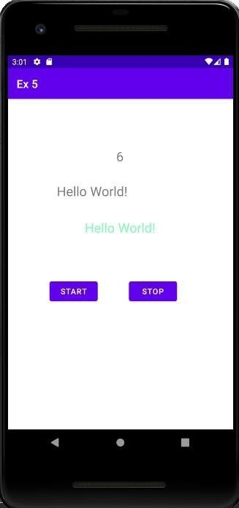

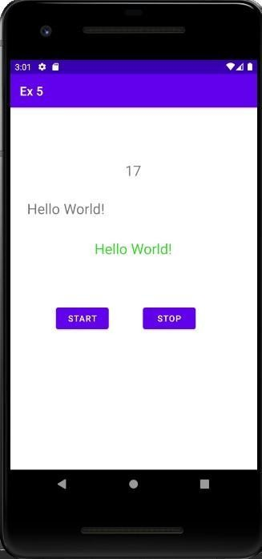

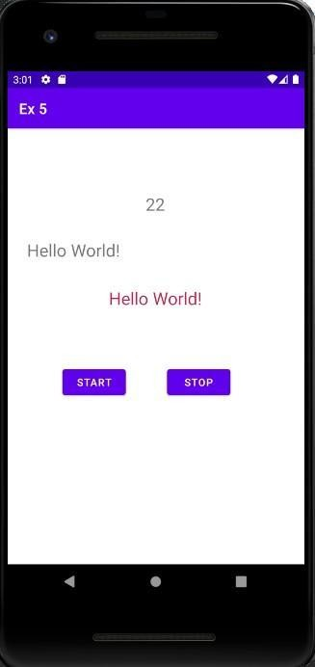

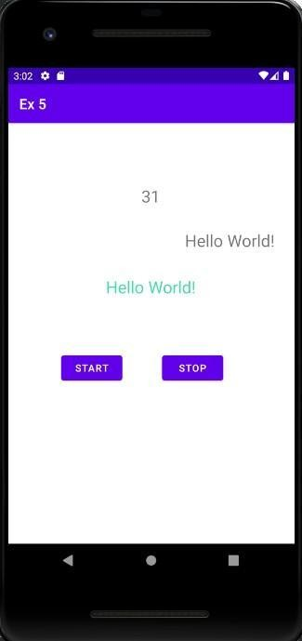

**Best Practices:**

* Names for ids of buttons were set meaningfully
* Implemented pause and resume in a single function
* Handled exceptions

# Learning Outcomes:

* Learnt to implement multithreading
* Learnt to start, stop and resume threads

# Ex. No. 6 Android Application for Location Tracking

**Aim:** 1.Develop an Android Application that uses Geographical Positioning System (GPS) to display the user’s current location in terms of Latitude and Longitude. 2. Develop a mobile app to display the Geo location of a given place.

**Layouts Use:** None. TextViews.

# Code:

**MainActivity.java:**

package com.example.ex6;

import android.Manifest;

import android.annotation.SuppressLint; import android.content.Context;

import android.content.Intent;

import android.content.pm.PackageManager; import android.location.Location;

import android.location.LocationManager; import android.os.Bundle;

import android.os.Looper; import android.provider.Settings; import android.util.Log;

import android.view.View; import android.widget.Button; import android.widget.EditText; import android.widget.TextView; import android.widget.Toast;

import androidx.annotation.NonNull;

import androidx.appcompat.app.AppCompatActivity; import androidx.core.app.ActivityCompat;

import com.google.android.gms.location.FusedLocationProviderClient; import com.google.android.gms.location.LocationCallback;

import com.google.android.gms.location.LocationRequest; import com.google.android.gms.location.LocationResult; import com.google.android.gms.location.LocationServices; import com.google.android.gms.tasks.OnCompleteListener; import com.google.android.gms.tasks.Task;

import android.location.Address; import android.location.Geocoder; import android.widget.Toast; import java.io.IOException;

import java.util.List;

public class MainActivity extends AppCompatActivity {

// initializing

// FusedLocationProviderClient

// object

FusedLocationProviderClient mFusedLocationClient;

// Initializing other items

// from layout file

TextView latitudeTextView, longitTextView; int PERMISSION_ID = 44;

@Override

protected void onCreate(Bundle savedInstanceState) { super.onCreate(savedInstanceState);

setContentView(R.layout.activity_main);

latitudeTextView = findViewById(R.id.latTextView); longitTextView = findViewById(R.id.lonTextView);

mFusedLocationClient = LocationServices.getFusedLocationProviderClient(this);

// method to get the location getLastLocation();

Button display = findViewById(R.id.dis); display.setOnClickListener(new View.OnClickListener() {

@Override

public void onClick(View v) { String loc = ((EditText)

findViewById(R.id.loc)).getText().toString(); Log.d("debug",loc); getLatLngForPlace(loc);

}

});

}

@SuppressLint("MissingPermission") private void getLastLocation() {

// check if permissions are given if (checkPermissions()) {

// check if location is enabled if (isLocationEnabled()) {

// getting last

// location from

// FusedLocationClient

// object

mFusedLocationClient.getLastLocation().addOnCompleteListener(new OnCompleteListener<Location>() {

@Override

public void onComplete(@NonNull Task<Location> task) { Location location = task.getResult();

if (location == null) { requestNewLocationData();

} else {

latitudeTextView.setText(location.getLatitude() + ""); longitTextView.setText(location.getLongitude() + "");

}

}

});

} else {

Toast.makeText(this, "Please turn on" + " your location...", Toast.LENGTH_LONG).show();

Intent intent = new Intent(Settings.ACTION_LOCATION_SOURCE_SETTINGS);

startActivity(intent);

}

} else {

// if permissions aren't available,

// request for permissions requestPermissions();

}

}

@SuppressLint("MissingPermission") private void requestNewLocationData() {

// Initializing LocationRequest

// object with appropriate methods

LocationRequest mLocationRequest = new LocationRequest();

mLocationRequest.setPriority(LocationRequest.PRIORITY_HIGH_ACCUR ACY);

mLocationRequest.setInterval(5); mLocationRequest.setFastestInterval(0); mLocationRequest.setNumUpdates(1);

// setting LocationRequest

// on FusedLocationClient mFusedLocationClient =

LocationServices.getFusedLocationProviderClient(this); mFusedLocationClient.requestLocationUpdates(mLocationRequest,

mLocationCallback, Looper.myLooper());

}

private LocationCallback mLocationCallback = new LocationCallback() {

+ "");

@Override

public void onLocationResult(LocationResult locationResult) { Location mLastLocation = locationResult.getLastLocation(); latitudeTextView.setText("Latitude: " + mLastLocation.getLatitude()

longitTextView.setText("Longitude: " +

mLastLocation.getLongitude() + "");

}

};

// method to check for permissions private boolean checkPermissions() {

return ActivityCompat.checkSelfPermission(this, Manifest.permission.ACCESS_COARSE_LOCATION) == PackageManager.PERMISSION_GRANTED && ActivityCompat.checkSelfPermission(this, Manifest.permission.ACCESS_FINE_LOCATION) == PackageManager.PERMISSION_GRANTED;

// If we want background location

// on Android 10.0 and higher,

// use:

// ActivityCompat.checkSelfPermission(this, Manifest.permission.ACCESS_BACKGROUND_LOCATION) == PackageManager.PERMISSION_GRANTED

}

// method to request for permissions private void requestPermissions() {

ActivityCompat.requestPermissions(this, new String[]{ Manifest.permission.ACCESS_COARSE_LOCATION, Manifest.permission.ACCESS_FINE_LOCATION},

PERMISSION_ID);

}

// method to check

// if location is enabled

private boolean isLocationEnabled() {

LocationManager locationManager = (LocationManager) getSystemService(Context.LOCATION_SERVICE);

return locationManager.isProviderEnabled(LocationManager.GPS_PROVIDER) || locationManager.isProviderEnabled(LocationManager.NETWORK_PROVI DER);

}

// If everything is alright then @Override

public void

onRequestPermissionsResult(int requestCode, @NonNull String[] permissions, @NonNull int[] grantResults) {

super.onRequestPermissionsResult(requestCode, permissions, grantResults);

if (requestCode == PERMISSION_ID) {

if (grantResults.length > 0 && grantResults[0] == PackageManager.PERMISSION_GRANTED) {

getLastLocation();

}

}

}

@Override

public void onResume() { super.onResume();

if (checkPermissions()) { getLastLocation();

}

}

private void getLatLngForPlace(String placeName) { Geocoder geocoder = new Geocoder(this);

try {

List<Address> addresses = geocoder.getFromLocationName(placeName, 1);

if (addresses != null && !addresses.isEmpty()) { Address address = addresses.get(0);

double latitude = address.getLatitude(); double longitude = address.getLongitude(); latitudeTextView.setText("" + latitude); longitTextView.setText("" + longitude);

} else {

// Handle the case where the place name couldn't be geocoded Toast.makeText(this, "Place not found",

Toast.LENGTH_SHORT).show();

}

} catch (IOException e) {

e.printStackTrace();

}

}

}

# Activity_main.xml:

<?xml version="1.0" encoding="utf-8"?>

<androidx.constraintlayout.widget.ConstraintLayout xmlns:android="<http://schemas.android.com/apk/res/android>"

xmlns:app="<http://schemas.android.com/apk/res-auto>" xmlns:tools="<http://schemas.android.com/tools>" android:layout_width="match_parent" android:layout_height="match_parent" tools:context=".MainActivity">

<TextView android:id="@+id/textView4"

android:layout_width="wrap_content" android:layout_height="wrap_content" android:layout_marginTop="48dp" android:fontFamily="sans-serif-black" android:text="Enter location:" android:textSize="24sp" app:layout_constraintEnd_toEndOf="parent" app:layout_constraintHorizontal_bias="0.498" app:layout_constraintStart_toStartOf="parent"

app:layout_constraintTop_toBottomOf="@+id/lonTextView" tools:ignore="MissingConstraints" />

<TextView android:id="@+id/textView"

android:layout_width="wrap_content"

android:layout_height="wrap_content" android:layout_marginTop="124dp" android:fontFamily="sans-serif-black" android:text="Latitude:" android:textSize="24sp" app:layout_constraintEnd_toEndOf="parent" app:layout_constraintHorizontal_bias="0.4" app:layout_constraintStart_toStartOf="parent" app:layout_constraintTop_toTopOf="parent" tools:ignore="MissingConstraints" />

<TextView android:id="@+id/latTextView" android:layout_width="wrap_content" android:layout_height="wrap_content" android:layout_marginTop="36dp" android:text="" android:textSize="24sp"

app:layout_constraintEnd_toEndOf="parent" app:layout_constraintHorizontal_bias="0.406" app:layout_constraintStart_toStartOf="parent" app:layout_constraintTop_toBottomOf="@+id/textView" tools:ignore="MissingConstraints" />

<TextView android:id="@+id/textView2"

android:layout_width="wrap_content" android:layout_height="wrap_content" android:layout_marginTop="24dp" android:fontFamily="sans-serif-black" android:text="Longitude:" android:textSize="24sp" app:layout_constraintEnd_toEndOf="parent" app:layout_constraintHorizontal_bias="0.427" app:layout_constraintStart_toStartOf="parent"

app:layout_constraintTop_toBottomOf="@+id/latTextView" tools:ignore="MissingConstraints" />

<TextView android:id="@+id/lonTextView" android:layout_width="wrap_content" android:layout_height="wrap_content" android:layout_marginTop="48dp" android:text="" android:textSize="24sp"

app:layout_constraintEnd_toEndOf="parent" app:layout_constraintHorizontal_bias="0.44" app:layout_constraintStart_toStartOf="parent" app:layout_constraintTop_toBottomOf="@+id/textView2" tools:ignore="MissingConstraints" />

<Button

android:id="@+id/dis" android:layout_width="wrap_content" android:layout_height="wrap_content" android:text="Display" app:layout_constraintBottom_toBottomOf="parent" app:layout_constraintEnd_toEndOf="parent" app:layout_constraintHorizontal_bias="0.498" app:layout_constraintStart_toStartOf="parent" app:layout_constraintTop_toBottomOf="@+id/textView4" app:layout_constraintVertical_bias="0.639" />

<EditText android:id="@+id/loc"

android:layout_width="wrap_content" android:layout_height="wrap_content" android:ems="10" android:inputType="textPersonName" app:layout_constraintBottom_toBottomOf="parent"

app:layout_constraintEnd_toEndOf="parent" app:layout_constraintHorizontal_bias="0.497" app:layout_constraintStart_toStartOf="parent" app:layout_constraintTop_toBottomOf="@+id/textView4" app:layout_constraintVertical_bias="0.25" />

</androidx.constraintlayout.widget.ConstraintLayout>

# Output:

# 

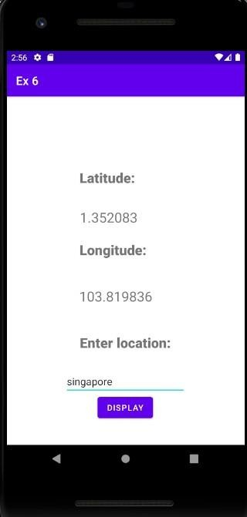

**Best Practices:**

* Used meaningful ids
* Aligned the textviews

# Learning Outcomes:

* Learnt to retrieve coordinates of current locations
* Learnt to retrieve coordinates of a different location using geocoder

**Ex 7: Android Application to write/read a file to/from the SD Card**

**Aim:**

Develop an Android Application to write/read some contents to/from the SD Card.

1. In a TextView write the contents of the file.

2. Use another TextView to read the file name from user.

3. On clicking ‘Write’ Button,

Create a file mentioned in 2nd TextView.

Write the contents (using 1st TextView) in the file.

**Store the file in the SD card**.

4. On clicking ‘Read’ Button,

Move to a new activity.

Read the file name(TextView)

**Read the contents of the file from SD card** and display in a new TextView.

**Layouts Used:** Main Activity and Read Intents. Edit and Text Views. **Code:**

**MainActivity.java:**

package com.example.ex7;

import android.Manifest;

import android.content.Intent;

import android.content.pm.PackageManager;

import android.os.Bundle;

import android.os.Environment;

import android.util.Log;

import android.view.View;

import android.widget.Button;

import android.widget.EditText;

import android.widget.Toast;

import androidx.annotation.NonNull;

import androidx.appcompat.app.AppCompatActivity;

import androidx.core.app.ActivityCompat;

import androidx.core.content.ContextCompat;

import java.io.File;

import java.io.FileOutputStream;

import java.io.IOException;

public class MainActivity extends AppCompatActivity {

private static final int REQUEST_WRITE_EXTERNAL_STORAGE = 1;

@Override

protected void onCreate(Bundle savedInstanceState) {

super.onCreate(savedInstanceState);

setContentView(R.layout.activity_main);

// Request the WRITE_EXTERNAL_STORAGE permission if not granted

if (ContextCompat.checkSelfPermission(this,

Manifest.permission.WRITE_EXTERNAL_STORAGE)

!= PackageManager.PERMISSION_GRANTED) {

ActivityCompat.requestPermissions(this, new

String[]{Manifest.permission.WRITE_EXTERNAL_STORAGE},

REQUEST_WRITE_EXTERNAL_STORAGE);

} else {

// Permission already granted, perform file operations

Button button = findViewById(R.id.write);

button.setOnClickListener(new View.OnClickListener() {

@Override

public void onClick(View v) {

EditText et1 = findViewById(R.id.et1);

String file = et1.getText().toString();

EditText et2 = findViewById(R.id.et2);

String content = et2.getText().toString();

createAndWriteFileToSDCard(file,content);

}

});

}

Button read = findViewById(R.id.read1);

read.setOnClickListener(new View.OnClickListener() {

@Override

public void onClick(View v) {

Intent intent = new Intent(MainActivity.this,Read.class);

startActivity(intent);

}

});

}

// Handle permission request results

@Override

public void onRequestPermissionsResult(int requestCode, @NonNull String[] permissions, @NonNull int[] grantResults) {

super.onRequestPermissionsResult(requestCode, permissions,

grantResults);

if (requestCode == REQUEST_WRITE_EXTERNAL_STORAGE) {

if (grantResults.length > 0 && grantResults[0] ==

PackageManager.PERMISSION_GRANTED) {

Toast.makeText(this, "Permission granted. Can write to SD card.", Toast.LENGTH_SHORT).show();

Button button = findViewById(R.id.write);

button.setOnClickListener(new View.OnClickListener() {

@Override

public void onClick(View v) {

EditText et1 = findViewById(R.id.et1);

String file = et1.getText().toString();

EditText et2 = findViewById(R.id.et2);

String content = et2.getText().toString();

createAndWriteFileToSDCard(file,content);

}

});

} else {

Toast.makeText(this, "Permission denied. Cannot write to SD card.", Toast.LENGTH_SHORT).show();

}

}

}

private void createAndWriteFileToSDCard(String fileName,String fileContent) { // Check if external storage is available

if (isExternalStorageWritable()) {

File sdCard = Environment.getExternalStorageDirectory();

File directory = new File(sdCard.getAbsolutePath() + "/ex7"); // Change to your desired directory

directory.mkdirs();

File file = new File(directory, fileName+".txt"); // Change the file name as needed

try {

FileOutputStream fos = new FileOutputStream(file);

fos.write(fileContent.getBytes());

fos.close();

Toast.makeText(this, "File created and written to SD card",

Toast.LENGTH_SHORT).show();

} catch (IOException e) {

Log.e("FileWriteError", "Error writing to file on SD card: " +

e.getMessage());

}

} else {

Toast.makeText(this, "SD card is not available for writing.",

Toast.LENGTH_SHORT).show();

}

}

private boolean isExternalStorageWritable() {

String state = Environment.getExternalStorageState();

return Environment.MEDIA_MOUNTED.equals(state);

}

}

**Read.java:**

package com.example.ex7;

import android.Manifest;

import android.content.pm.PackageManager; import android.os.Bundle;

import android.os.Environment;

import android.util.Log;

import android.view.View;

import android.widget.Button;

import android.widget.EditText;

import android.widget.TextView;

import android.widget.Toast;

import androidx.annotation.NonNull;

import androidx.appcompat.app.AppCompatActivity; import androidx.core.app.ActivityCompat; import androidx.core.content.ContextCompat;

import java.io.BufferedReader;

import java.io.File;

import java.io.FileReader;

import java.io.IOException;

public class Read extends AppCompatActivity {

private static final int REQUEST_READ_EXTERNAL_STORAGE = 2; private TextView fileContentsTextView;

@Override

protected void onCreate(Bundle savedInstanceState) {

super.onCreate(savedInstanceState);

setContentView(R.layout.read);

fileContentsTextView = findViewById(R.id.content);

// Request the READ_EXTERNAL_STORAGE permission if not granted

if (ContextCompat.checkSelfPermission(this,

Manifest.permission.READ_EXTERNAL_STORAGE)

!= PackageManager.PERMISSION_GRANTED) {

ActivityCompat.requestPermissions(this, new

String[]{Manifest.permission.READ_EXTERNAL_STORAGE},

REQUEST_READ_EXTERNAL_STORAGE);

} else {

// Permission already granted, perform file reading

Button readButton = findViewById(R.id.read2);

readButton.setOnClickListener(new View.OnClickListener() {

@Override

public void onClick(View v) {

EditText fileNameEditText = findViewById(R.id.name);

String fileName = fileNameEditText.getText().toString();

readFileFromSDCard(fileName);

}

});

}

}

// Handle permission request results

@Override

public void onRequestPermissionsResult(int requestCode, @NonNull String[] permissions, @NonNull int[] grantResults) {

super.onRequestPermissionsResult(requestCode, permissions,

grantResults);

if (requestCode == REQUEST_READ_EXTERNAL_STORAGE) {

if (grantResults.length > 0 && grantResults[0] ==

PackageManager.PERMISSION_GRANTED) {

Toast.makeText(this, "Permission granted. Can read from SD card.", Toast.LENGTH_SHORT).show();

Button readButton = findViewById(R.id.read2);

readButton.setOnClickListener(new View.OnClickListener() {

@Override

public void onClick(View v) {

EditText fileNameEditText = findViewById(R.id.name);

String fileName = fileNameEditText.getText().toString();

readFileFromSDCard(fileName);

}

});

} else {

Toast.makeText(this, "Permission denied. Cannot read from SD card.", Toast.LENGTH_SHORT).show();

}

}

}

private void readFileFromSDCard(String fileName) {

if (isExternalStorageReadable()) {

File sdCard = Environment.getExternalStorageDirectory();

File directory = new File(sdCard.getAbsolutePath() + "/ex7"); // Change to your directory

File file = new File(directory, fileName + ".txt");

if (file.exists()) {

try {

BufferedReader br = new BufferedReader(new FileReader(file));

StringBuilder text = new StringBuilder();

String line;

while ((line = br.readLine()) != null) {

text.append(line);

text.append('\n');

}

br.close();

fileContentsTextView.setText(text.toString());

} catch (IOException e) {

Log.e("FileReadError", "Error reading file on SD card: " +

e.getMessage());

fileContentsTextView.setText("Error reading file.");

}

} else {

fileContentsTextView.setText("File not found.");

}

} else {

fileContentsTextView.setText("SD card is not available for reading."); }

}

private boolean isExternalStorageReadable() {

String state = Environment.getExternalStorageState();

return Environment.MEDIA_MOUNTED.equals(state) || Environment.MEDIA_MOUNTED_READ_ONLY.equals(state);

}

}

**Activity_main.xml:**

<?xml version="1.0" encoding="utf-8"?>

<androidx.constraintlayout.widget.ConstraintLayout xmlns:android="http://schemas.android.com/apk/res/android"

xmlns:app="http://schemas.android.com/apk/res-auto" xmlns:tools="http://schemas.android.com/tools"

android:layout_width="match_parent"

android:layout_height="match_parent"

tools:context=".MainActivity">

<TextView

android:id="@+id/tv2"

android:layout_width="wrap_content"

android:layout_height="wrap_content"

android:text="Enter text"

android:textSize="24sp"

app:layout_constraintBottom_toBottomOf="parent" app:layout_constraintEnd_toEndOf="parent"

app:layout_constraintHorizontal_bias="0.498" app:layout_constraintStart_toStartOf="parent" app:layout_constraintTop_toTopOf="parent" app:layout_constraintVertical_bias="0.387" />

<EditText

android:id="@+id/et1"

android:layout_width="wrap_content" android:layout_height="wrap_content" android:layout_marginTop="184dp"

android:ems="10"

android:inputType="textPersonName" android:text=""

app:layout_constraintEnd_toEndOf="parent" app:layout_constraintHorizontal_bias="0.497" app:layout_constraintStart_toStartOf="parent" app:layout_constraintTop_toTopOf="parent" />

<EditText

android:id="@+id/et2"

android:layout_width="wrap_content" android:layout_height="wrap_content" android:ems="10"

android:inputType="textPersonName"

android:text=""

app:layout_constraintBottom_toBottomOf="parent" app:layout_constraintEnd_toEndOf="parent" app:layout_constraintHorizontal_bias="0.497" app:layout_constraintStart_toStartOf="parent" app:layout_constraintTop_toTopOf="parent" />

<TextView

android:id="@+id/tv1"

android:layout_width="wrap_content"

android:layout_height="wrap_content"

android:layout_marginTop="128dp"

android:text="Enter file name"

android:textSize="24sp"

app:layout_constraintEnd_toEndOf="parent" app:layout_constraintStart_toStartOf="parent" app:layout_constraintTop_toTopOf="parent" />

<Button

android:id="@+id/write"

android:layout_width="wrap_content"

android:layout_height="wrap_content"

android:text="Write"

app:layout_constraintBottom_toBottomOf="parent" app:layout_constraintEnd_toEndOf="parent" app:layout_constraintHorizontal_bias="0.498" app:layout_constraintStart_toStartOf="parent" app:layout_constraintTop_toTopOf="parent" app:layout_constraintVertical_bias="0.65" />

<Button

android:id="@+id/read1"

android:layout_width="wrap_content"

android:layout_height="wrap_content"

android:layout_marginBottom="156dp"

android:text="Read"

app:layout_constraintBottom_toBottomOf="parent" app:layout_constraintEnd_toEndOf="parent" app:layout_constraintHorizontal_bias="0.498" app:layout_constraintStart_toStartOf="parent" />

</androidx.constraintlayout.widget.ConstraintLayout> **Read.xml:**

<?xml version="1.0" encoding="utf-8"?>

<androidx.constraintlayout.widget.ConstraintLayout xmlns:android="http://schemas.android.com/apk/res/android"

xmlns:app="http://schemas.android.com/apk/res-auto" xmlns:tools="http://schemas.android.com/tools"

android:layout_width="match_parent"

android:layout_height="match_parent">

<TextView

android:id="@+id/textView3"

android:layout_width="207dp"

android:layout_height="47dp"

android:text="File Content:"

android:textSize="24sp"

app:layout_constraintBottom_toBottomOf="parent" app:layout_constraintEnd_toEndOf="parent"

app:layout_constraintStart_toStartOf="parent"

app:layout_constraintTop_toTopOf="parent"

app:layout_constraintVertical_bias="0.602" />

<TextView

android:id="@+id/textView"

android:layout_width="125dp"

android:layout_height="50dp"

android:text="File Name"

android:textSize="24sp"

app:layout_constraintBottom_toBottomOf="parent" app:layout_constraintEnd_toEndOf="parent" app:layout_constraintHorizontal_bias="0.461" app:layout_constraintStart_toStartOf="parent" app:layout_constraintTop_toTopOf="parent" app:layout_constraintVertical_bias="0.19" />

<EditText

android:id="@+id/name"

android:layout_width="wrap_content"

android:layout_height="wrap_content"

android:ems="10"

android:inputType="textPersonName"

android:text=""

android:textSize="24sp"

app:layout_constraintBottom_toBottomOf="parent" app:layout_constraintEnd_toEndOf="parent" app:layout_constraintHorizontal_bias="0.496" app:layout_constraintStart_toStartOf="parent" app:layout_constraintTop_toTopOf="parent" app:layout_constraintVertical_bias="0.29" />

<EditText

android:id="@+id/content"

android:layout_width="wrap_content"

android:layout_height="wrap_content"

android:ems="10"

android:inputType="textPersonName"

android:text=""

android:textSize="24sp"

app:layout_constraintBottom_toBottomOf="parent" app:layout_constraintEnd_toEndOf="parent" app:layout_constraintHorizontal_bias="0.496" app:layout_constraintStart_toStartOf="parent" app:layout_constraintTop_toTopOf="parent" app:layout_constraintVertical_bias="0.724" />

<Button

android:id="@+id/read2"

android:layout_width="wrap_content"

android:layout_height="wrap_content"

android:text="Read"

app:layout_constraintBottom_toBottomOf="parent" app:layout_constraintEnd_toEndOf="parent" app:layout_constraintHorizontal_bias="0.498"

app:layout_constraintStart_toStartOf="parent"

app:layout_constraintTop_toTopOf="parent"

app:layout_constraintVertical_bias="0.407" />

</androidx.constraintlayout.widget.ConstraintLayout>

**AndroidManifest.xml:**

<?xml version="1.0" encoding="utf-8"?>

<manifest xmlns:android="http://schemas.android.com/apk/res/android" package="com.example.ex7">

<application

android:allowBackup="true"

android:icon="@mipmap/ic_launcher"

android:label="@string/app_name"

android:roundIcon="@mipmap/ic_launcher_round"

android:supportsRtl="true"

android:theme="@style/Theme.Ex7">

<activity

android:name=".MainActivity"

android:exported="true">

<intent-filter>

<action android:name="android.intent.action.MAIN" />

<category android:name="android.intent.category.LAUNCHER" /> </intent-filter>

</activity>

<activity android:name=".Read"></activity>

</application>

<uses-permission

android:name="android.permission.WRITE_EXTERNAL_STORAGE" />

<uses-permission

android:name="android.permission.READ_EXTERNAL_STORAGE" />

<uses-permission

android:name="android.permission.MANAGE_EXTERNAL_STORAGE" />

</manifest>

**Output:**

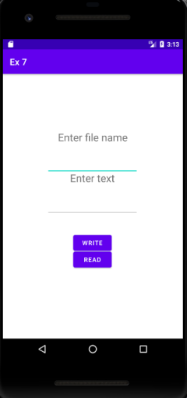

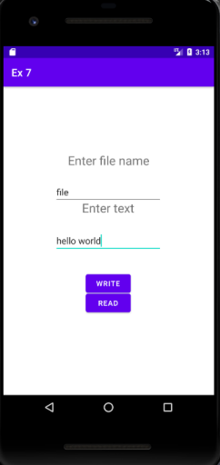

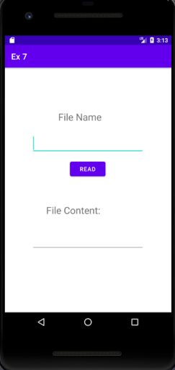

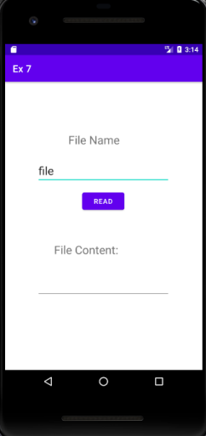

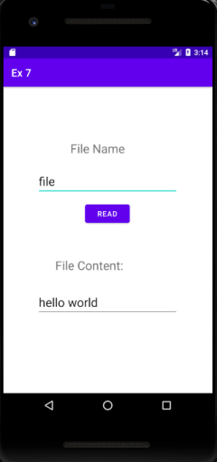

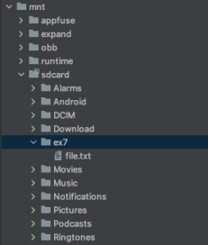

**Best Practices:**

● Used appropriate ids for buttons, views and intents ● Aligned views.

**Learning Outcomes:**

● Learnt to create a file

● Learnt to write to a file and store the file in SD card ● Learnt to read from a file that is in SD card

**Assignment 8 SMS Sending and Notification**

**Objective:**

To develop an android app that sends SMS and creates an alert upon receiving the SMS with text in the notification.

**Source Code:**

**MainActivity.java:**

package com.example.ex8;

import android.Manifest;

import android.content.pm.PackageManager;

import android.os.Bundle;

import android.telephony.SmsManager;

import android.view.View;

import android.widget.Button;

import android.widget.EditText;

import android.widget.Toast;

import androidx.appcompat.app.AppCompatActivity;

import androidx.core.app.ActivityCompat;

import androidx.core.content.ContextCompat;

public class MainActivity extends AppCompatActivity {

private static final int MY_PERMISSIONS_REQUEST_SEND_SMS = 0;

Button sendBtn;

EditText txtphoneNo;

EditText txtMessage;

String phoneNo;

String message;

@Override

protected void onCreate(Bundle savedInstanceState) {

super.onCreate(savedInstanceState);

setContentView(R.layout.activity_main);

sendBtn = (Button) findViewById(R.id.sendbtn);

txtphoneNo = (EditText) findViewById(R.id.etPhone);

txtMessage = (EditText) findViewById(R.id.content);

sendBtn.setOnClickListener(new View.OnClickListener() {

public void onClick(View view) {

sendSMSMessage();

}

});

}

protected void sendSMSMessage() {

phoneNo = txtphoneNo.getText().toString();

message = txtMessage.getText().toString();

if (ContextCompat.checkSelfPermission(this, Manifest.permission.SEND_SMS)

!= PackageManager.PERMISSION_GRANTED) {

if (ActivityCompat.shouldShowRequestPermissionRationale(

this, Manifest.permission.SEND_SMS)) {

} else {

ActivityCompat.requestPermissions(this,

new String[] {Manifest.permission.SEND_SMS},

MY_PERMISSIONS_REQUEST_SEND_SMS);

}

}

}

@Override

public void{onRequestPermissionsResult(int requestCode, String permissions[], int[] grantResults)

switch (requestCode) {

case MY_PERMISSIONS_REQUEST_SEND_SMS: {

if (grantResults.length > 0

&& grantResults[0] == PackageManager.PERMISSION_GRANTED) {

SmsManager smsManager = SmsManager.getDefault();

smsManager.sendTextMessage(phoneNo, null, message, null, null);

Toast.makeText(getApplicationContext(), "SMS sent.", Toast.LENGTH_LONG).show();

}

else {

Toast.makeText(getApplicationContext(), "SMS failed, please try again.",Toast.LENGTH_LONG).show();

return;

}

}

}

}

}

**activity_main.xml**

<?xml version="1.0" encoding="utf-8"?>

<androidx.constraintlayout.widget.ConstraintLayout xmlns:android="http://schemas.android.com/apk/res/android"

xmlns:app="http://schemas.android.com/apk/res-auto"

xmlns:tools="http://schemas.android.com/tools"

android:layout_width="match_parent"

android:layout_height="match_parent"

tools:context=".MainActivity">

<TextView

android:id="@+id/textView2"

android:layout_width="wrap_content"

android:layout_height="wrap_content"

android:text="SMS App"

android:textAppearance="@style/TextAppearance.AppCompat.Display1" android:textColor="#067A6A"

app:layout_constraintBottom_toBottomOf="parent"

app:layout_constraintLeft_toLeftOf="parent"

app:layout_constraintRight_toRightOf="parent"

app:layout_constraintTop_toTopOf="parent"

app:layout_constraintVertical_bias="0.096" />

<TextView

android:id="@+id/textView"

android:layout_width="wrap_content"

android:layout_height="wrap_content"

android:layout_marginTop="28dp"

android:layout_marginEnd="140dp"

android:text="Send an SMS"

android:textAppearance="@style/TextAppearance.AppCompat.Large"

android:textColor="#0C675A"

app:layout_constraintEnd_toEndOf="parent"

app:layout_constraintTop_toBottomOf="@+id/textView2" />

<TextView

android:id="@+id/phno"

android:layout_width="wrap_content"

android:layout_height="wrap_content"

android:layout_marginStart="44dp"

android:layout_marginTop="44dp"

android:text="Phone Number:"

android:textAppearance="@style/TextAppearance.AppCompat.Medium"

android:textColor="#304FFE"

app:layout_constraintStart_toStartOf="parent"

app:layout_constraintTop_toBottomOf="@+id/textView" />

<TextView

android:id="@+id/smstv"

android:layout_width="wrap_content"

android:layout_height="wrap_content"

android:layout_marginStart="44dp"

android:layout_marginTop="104dp"

android:text="SMS Content:"

android:textAppearance="@style/TextAppearance.AppCompat.Medium" android:textColor="#304FFE"

app:layout_constraintStart_toStartOf="parent"

app:layout_constraintTop_toBottomOf="@+id/textView" />

<EditText

android:id="@+id/etPhone"

android:layout_width="199dp"

android:layout_height="39dp"

android:layout_marginStart="12dp"

android:layout_marginTop="36dp"

android:ems="10"

android:inputType="phone"

android:textAppearance="@style/TextAppearance.AppCompat.Body1" app:layout_constraintStart_toEndOf="@+id/phno"

app:layout_constraintTop_toBottomOf="@+id/textView" />

<EditText

android:id="@+id/content"

android:layout_width="341dp"

android:layout_height="123dp"

android:layout_marginTop="68dp"

android:layout_marginEnd="32dp"

android:ems="10"

android:gravity="start|top"

android:hint="Type here"

android:inputType="textMultiLine"

android:textAppearance="@style/TextAppearance.AppCompat.Body1" app:layout_constraintEnd_toEndOf="parent"

app:layout_constraintTop_toBottomOf="@+id/etPhone" />

<Button

android:id="@+id/sendbtn"

android:layout_width="wrap_content"

android:layout_height="wrap_content"

android:layout_marginTop="48dp"

android:layout_marginEnd="160dp"

android:backgroundTint="#00BFA5"

android:text="SEND"

app:layout_constraintEnd_toEndOf="parent"

app:layout_constraintTop_toBottomOf="@+id/content" />

</androidx.constraintlayout.widget.ConstraintLayout>

**Output:**

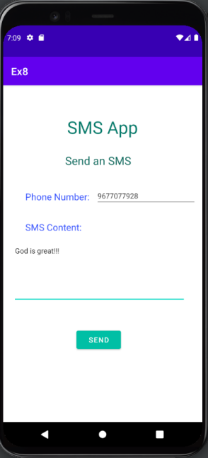

**Result:**

The required program was built and executed successfully.

**Assignment 9**

**Alarm Clock - Android Application**

Develop an Alarm Clock Android Application.

1. Use permission for WAKE_LOCK.

2. Have a TimePicker component followed by a ToggleButton to select time and Alarm On / Off.

3. Use the AlarmManager to set the alarm and send notification on the alarm trigger.

4. Perform 3 different notifications

a. Show a message to user in the activity UI

b. Play the alarm ringtone

c. Send an Android notification message

**Code:**

**Activity_main.xml:**

<?xml version="1.0" encoding="utf-8"?>

<RelativeLayout xmlns:android="http://schemas.android.com/apk/res/android" xmlns:app="http://schemas.android.com/apk/res-auto"

xmlns:tools="http://schemas.android.com/tools"

android:layout_width="match_parent"

android:layout_height="match_parent"

tools:context=".MainActivity">

<TimePicker

android:layout_width="wrap_content"

android:layout_height="wrap_content"

android:id="@+id/time"

/>

<ToggleButton

android:id="@+id/set"

android:layout_width="150dp"

android:layout_height="50dp"

android:layout_below="@+id/time"

android:layout_marginLeft="130dp"

/>

</RelativeLayout>

**Display.xml:**

<?xml version="1.0" encoding="utf-8"?>

<androidx.constraintlayout.widget.ConstraintLayout

xmlns:android="http://schemas.android.com/apk/res/android"

xmlns:app="http://schemas.android.com/apk/res-auto"

android:layout_width="match_parent"

android:layout_height="match_parent">

<TextView

android:id="@+id/textView"

android:layout_width="wrap_content"

android:layout_height="wrap_content"

android:text="Close App to turn off alarm!"

android:padding="50dp"

android:textSize="20dp"

app:layout_constraintStart_toStartOf="parent"

app:layout_constraintTop_toTopOf="parent" />

</androidx.constraintlayout.widget.ConstraintLayout>

**Mainactivity.java:**

package com.example.alarm;

import androidx.appcompat.app.AppCompatActivity;

import android.app.AlarmManager;

import android.app.NotificationChannel;

import android.app.NotificationManager;

import android.app.PendingIntent;

import android.content.Intent;

import android.os.Build;

import android.os.Bundle;

import android.text.format.Time;

import android.view.View;

import android.widget.Button;

import android.widget.TimePicker;

import android.widget.Toast;

import android.widget.ToggleButton;

import com.example.alarm.databinding.ActivityMainBinding; import java.util.Calendar;

public class MainActivity extends AppCompatActivity { private ActivityMainBinding binding;

@Override

protected void onCreate(Bundle savedInstanceState) { super.onCreate(savedInstanceState);

setContentView(R.layout.activity_main);

binding = ActivityMainBinding.inflate(getLayoutInflater()); setContentView(binding.getRoot());

createNotificationChannel();

ToggleButton b1 = findViewById(R.id.set);

TimePicker t1 = findViewById(R.id.time);

t1.setIs24HourView(true);

b1.setOnCheckedChangeListener((buttonView, isChecked) -> {

if (isChecked) {

setAlarm();

} else {

cancelAlarm();

}

});

}

private void createNotificationChannel() {

if(Build.VERSION.SDK_INT >= Build.VERSION_CODES.O) {

CharSequence name = "alarm";

String desc = "Channel for alarm";

int importance = NotificationManager.IMPORTANCE_HIGH;

NotificationChannel channel = new NotificationChannel("alarm", name, importance);

channel.setDescription(desc);

NotificationManager notifs =

getSystemService(NotificationManager.class);

notifs.createNotificationChannel(channel);

}

}

public void setAlarm() {

TimePicker timePicker = findViewById(R.id.time);

AlarmManager alarm = (AlarmManager) getSystemService(ALARM_SERVICE);

Intent intent = new Intent(this, AlarmReceiver.class);

PendingIntent pendingIntent =

PendingIntent.getBroadcast(this.getApplicationContext(), 234, intent, PendingIntent.FLAG_IMMUTABLE);

int hour = timePicker.getHour();

int minute = timePicker.getMinute();

Calendar calendar = Calendar.getInstance();

calendar.set(Calendar.HOUR_OF_DAY, hour);

calendar.set(Calendar.MINUTE, minute);

calendar.set(Calendar.SECOND, 0);

long triggerTime = calendar.getTimeInMillis();

int timeInSec = 1;

alarm.set(AlarmManager.RTC_WAKEUP, triggerTime, pendingIntent); Toast.makeText(this, "Alarm set for " + hour + ":" + minute, Toast.LENGTH_SHORT).show();

}

public void cancelAlarm() {

AlarmManager alarm = (AlarmManager) getSystemService(ALARM_SERVICE);

Intent intent = new Intent(this, AlarmReceiver.class);

PendingIntent pendingIntent =

PendingIntent.getBroadcast(this.getApplicationContext(), 234, intent, PendingIntent.FLAG_IMMUTABLE);

if(alarm != null) {

alarm.cancel(pendingIntent);

}

Toast.makeText(this, "Alarm unset!", Toast.LENGTH_SHORT).show(); }

}

**Alarmreceiver.java:**

package com.example.alarm;

import static androidx.core.content.ContextCompat.startActivity;

import android.app.AlarmManager;

import android.app.Notification;

import android.app.NotificationChannel;

import android.app.NotificationManager;

import android.app.PendingIntent;

import android.content.BroadcastReceiver;

import android.content.Context;

import android.content.Intent;

import android.content.pm.PackageManager;

import android.media.Ringtone;

import android.media.RingtoneManager;

import android.net.Uri;

import android.os.Build;

import android.widget.Toast;

import androidx.appcompat.app.AppCompatActivity;

import androidx.core.app.ActivityCompat;

import androidx.core.app.NotificationCompat;

import androidx.core.app.NotificationManagerCompat;

public class AlarmReceiver extends BroadcastReceiver {

static Uri alarmrt1 =

RingtoneManager.getDefaultUri(RingtoneManager.TYPE_ALARM);

@Override

public void onReceive(Context context, Intent intent) {

Toast.makeText(context, "INSIDE WOHOOO", Toast.LENGTH_LONG).show();

Intent i = new Intent(context, In.class);

intent.setFlags(Intent.FLAG_ACTIVITY_NEW_TASK |

Intent.FLAG_ACTIVITY_CLEAR_TASK);

PendingIntent p = PendingIntent.getActivity(context, 0, i, PendingIntent.FLAG_IMMUTABLE);

NotificationCompat.Builder builder = new

NotificationCompat.Builder(context, "alarm")

.setSmallIcon(R.drawable.ic_launcher_foreground)

.setContentTitle("Your Alarm is going off!!!")

.setContentInfo("You set this alarm!")

.setAutoCancel(true)

.setDefaults(NotificationCompat.DEFAULT_ALL)

.setPriority(NotificationCompat.PRIORITY_HIGH)

.setContentIntent(p);

NotificationManagerCompat notifications =

NotificationManagerCompat.from(context);

if (ActivityCompat.checkSelfPermission(context,

android.Manifest.permission.POST_NOTIFICATIONS) !=

PackageManager.PERMISSION_GRANTED) {

return;

}

else {

notifications.notify(123, builder.build());

}

Ringtone ringtone =

RingtoneManager.getRingtone(context.getApplicationContext(), alarmrt1); //Toast.makeText(context, ringtone.toString(),

Toast.LENGTH_SHORT).show();

intent.putExtra("RINGTONE_URI", alarmrt1);

ringtone.play();

}

public static Uri getInstant() {

return alarmrt1;

}

}

**In.java:**

package com.example.alarm;

import android.content.Intent;

import android.media.Ringtone;

import android.media.RingtoneManager;

import android.net.Uri;

import android.os.Bundle;

import android.widget.Toast;

//ce3c069

import androidx.appcompat.app.AppCompatActivity;

public class In extends AppCompatActivity {

@Override

protected void onCreate(Bundle savedInstanceState) {

super.onCreate(savedInstanceState);

setContentView(R.layout.display);

Intent intent = getIntent();

Uri ringtoneUri = intent.getParcelableExtra("RINGTONE_URI"); Ringtone ringtone = RingtoneManager.getRingtone(In.this, ringtoneUri);

//Toast.makeText(In.this, ringtone.toString(),

Toast.LENGTH_SHORT).show();

if (ringtone.isPlaying()) {

//Toast.makeText(In.this, "yes", Toast.LENGTH_SHORT).show(); ringtone.stop();

}

else {

//Toast.makeText(In.this, "no", Toast.LENGTH_SHORT).show(); }

}

}

**Androidmanifest.java:**

<?xml version="1.0" encoding="utf-8"?>

<manifest xmlns:android="http://schemas.android.com/apk/res/android" xmlns:tools="http://schemas.android.com/tools">

<uses-permission android:name="android.permission.POST_NOTIFICATIONS" /> <uses-permission android:name="android.permission.WAKE_LOCK" /> <uses-permission android:name="android.permission.VIBRATE" />

<application

android:allowBackup="true"

android:dataExtractionRules="@xml/data_extraction_rules"

android:fullBackupContent="@xml/backup_rules"

android:icon="@mipmap/ic_launcher"

android:label="@string/app_name"

android:roundIcon="@mipmap/ic_launcher_round"

android:supportsRtl="true"

android:theme="@style/Theme.Alarm"

tools:targetApi="31">

<activity

android:name=".MainActivity"

android:exported="true">

<intent-filter>

<action android:name="android.intent.action.MAIN" />

<category android:name="android.intent.category.LAUNCHER" /> </intent-filter>

</activity>

<activity android:name=".In"

android:exported="false"

/>

<receiver android:name=".AlarmReceiver"

/>

</application>

</manifest>

**Output:**

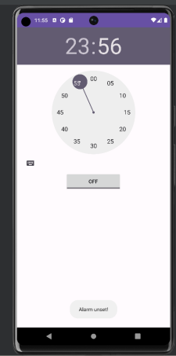 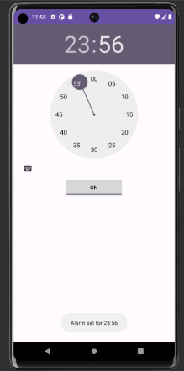

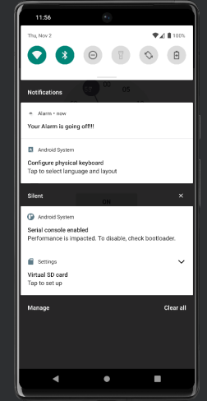 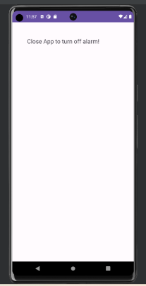

**Best Practices**

1. Keep the index form clean and uncluttered.

2. Use default ringtone as it is known by everyone.

3. Ensure the form works on various mobile devices.

**Learning Outcomes**

1. Learnt how to use UI Elements for Android App development.

2. Learnt how to use Phone shared storage.