# Exercise 1 - Designing Health Insurance Form using GUI Components

T Shivcharan

205001100

CSE-B

## Aim

Generate a Health Insurance registration form to register the patient details under each group.

**Patient Details -** Title, Patient Name, Patient Phone Number (Mobile or Landline use Checkbox), Address, Age, DOB, Gender, Marital Status

**Employer Details -** Patient Employer, Employment Status (full time, parttime, unemployed, retired, student, other Checkbox)

**Emergency contact Details -** Name, Relationship, Address, Phone Number

Use Submit (Button) to submit the details and display the contents. Use the Reset button to clear the form. Display using Table layout.

## Code

### activity_main.xml

<?xml version="1.0" encoding="utf-8"?>

<ScrollView xmlns:android="http: /schemas.android.com/apk/res/android" xmlns:app="http: /schemas.android.com/apk/res-auto"

xmlns:tools="http: /schemas.android.com/tools"

android:layout_width="match_parent"

android:layout_height="match_parent">

<LinearLayout

android:layout_width="match_parent"

android:layout_height="match_parent"

android:layout_marginLeft="16dp"

android:layout_marginRight="16dp"

android:layout_marginBottom="8dp"

android:orientation="vertical"

tools:context=".MainActivity">

<TextView

android:id="@+id/titleTextView"

android:layout_width="match_parent"

android:layout_height="128dp"

android:gravity="center"

android:text="Health Insurance Registration" android:textSize="32sp"

android:textStyle="bold"

android:typeface="serif" >

<TextView

android:id="@+id/title"

android:layout_width="match_parent"

android:layout_height="32dp"

android:gravity="left"

android:text="Patient Details"

android:textSize="22sp"

android:textStyle="bold"

android:typeface="serif" >

<TextView

android:id="@+id/name"

android:layout_width="match_parent"

android:layout_height="26dp"

android:layout_marginTop="16dp"

android:gravity="left"

android:text="Name"

android:textSize="18sp"

android:textStyle="bold"

android:typeface="normal" >

<EditText

android:id="@+id/editName"

android:layout_width="match_parent"

android:layout_height="54dp"

android:hint="Name:"

android:inputType="text"

android:textColor="#0000FF"

android:typeface="sans" >

<TextView

android:id="@+id/number"

android:layout_width="match_parent"

android:layout_height="26dp"

android:layout_marginTop="16dp"

android:gravity="left"

android:text="Number"

android:textSize="18sp"

android:textStyle="bold"

android:typeface="normal" >

<RadioGroup

android:id="@+id/radio_group_id"

android:layout_width="wrap_content"

android:layout_height="wrap_content"

android:layout_marginTop="4dp">

<RadioButton

android:id="@+id/phone_radio_button_id" android:layout_width="wrap_content"

android:layout_height="wrap_content"

android:text="Phone" >

<RadioButton

android:id="@+id/landline_radio_button_id" android:layout_width="wrap_content"

android:layout_height="wrap_content"

android:text="Landline" >

/RadioGroup>

<EditText

android:id="@+id/editNumber"

android:layout_width="match_parent"

android:layout_height="54dp"

android:hint="Number:"

android:inputType="phone" >

<TextView

android:id="@+id/address"

android:layout_width="match_parent" android:layout_height="26dp"

android:layout_marginTop="16dp" android:gravity="left"

android:text="Address"

android:textSize="18sp"

android:textStyle="bold"

android:typeface="normal" >

<EditText

android:id="@+id/editAddress"

android:layout_width="match_parent" android:layout_height="54dp"

android:hint="Address:"

android:inputType="text"

android:textColor="#0000FF"

android:typeface="sans" >

<TextView

android:id="@+id/age"

android:layout_width="match_parent" android:layout_height="26dp"

android:layout_marginTop="16dp" android:gravity="left"

android:text="Age"

android:textSize="18sp"

android:textStyle="bold"

android:typeface="normal" >

<EditText

android:id="@+id/editAge"

android:layout_width="match_parent" android:layout_height="54dp"

android:hint="Age:"

android:inputType="number"

android:textColor="#0000FF"

android:typeface="sans" >

<TextView

android:id="@+id/dob"

android:layout_width="match_parent" android:layout_height="26dp"

android:layout_marginTop="16dp"

android:gravity="left"

android:text="DOB"

android:textSize="18sp"

android:textStyle="bold"

android:typeface="normal" >

<DatePicker

android:id="@+id/dobPicker"

android:layout_width="match_parent" android:layout_height="wrap_content" android:gravity="center" >

<TextView

android:id="@+id/gender"

android:layout_width="match_parent" android:layout_height="26dp"

android:layout_marginTop="16dp"

android:gravity="left"

android:text="Gender"

android:textSize="18sp"

android:textStyle="bold"

android:typeface="normal" >

<RadioGroup

android:id="@+id/gender_group"

android:layout_width="wrap_content" android:layout_height="wrap_content" android:layout_marginTop="4dp">

<RadioButton

android:id="@+id/male"

android:layout_width="wrap_content" android:layout_height="wrap_content" android:text="Male" >

<RadioButton

android:id="@+id/female"

android:layout_width="wrap_content" android:layout_height="wrap_content" android:text="Female" >

/RadioGroup>

<TextView

android:id="@+id/marital_status"

android:layout_width="match_parent"

android:layout_height="26dp"

android:layout_marginTop="16dp"

android:gravity="left"

android:text="Marital Status"

android:textSize="18sp"

android:textStyle="bold"

android:typeface="normal" >

<Spinner

android:id="@+id/marital_status_spinner"

android:layout_width="match_parent"

android:layout_height="wrap_content"

android:entries="@array/marital_status_options" >

<TextView

android:id="@+id/employer"

android:layout_width="match_parent"

android:layout_height="32dp"

android:layout_marginTop="48dp"

android:gravity="left"

android:text="Employer Details"

android:textSize="22sp"

android:textStyle="bold"

android:typeface="serif" >

<TextView

android:id="@+id/employer_name"

android:layout_width="match_parent"

android:layout_height="26dp"

android:layout_marginTop="16dp"

android:gravity="left"

android:text="Employer Name"

android:textSize="18sp"

android:textStyle="bold"

android:typeface="normal" >

<EditText

android:id="@+id/editEmployerName"

android:layout_width="match_parent"

android:layout_height="54dp"

android:hint="Employer Name:"

android:inputType="text"

android:textColor="#0000FF"

android:typeface="sans" >

<TextView

android:id="@+id/employment_status"

android:layout_width="match_parent"

android:layout_height="26dp"

android:layout_marginTop="16dp"

android:gravity="left"

android:text="Employment Status"

android:textSize="18sp"

android:textStyle="bold"

android:typeface="normal" >

<Spinner

android:id="@+id/employment_status_spinner" android:layout_width="match_parent"

android:layout_height="wrap_content"

android:entries="@array/employment_status_options" >

<TextView

android:id="@+id/emergency"

android:layout_width="match_parent"

android:layout_height="32dp"

android:layout_marginTop="48dp"

android:gravity="left"

android:text="Emergency Details"

android:textSize="22sp"

android:textStyle="bold"

android:typeface="serif" >

<TextView

android:id="@+id/emergency_name"

android:layout_width="match_parent"

android:layout_height="26dp"

android:layout_marginTop="16dp"

android:gravity="left"

android:text="Emergency Contact Name"

android:textSize="18sp"

android:textStyle="bold"

android:typeface="normal" >

<EditText

android:id="@+id/edit_emergency_name" android:layout_width="match_parent"

android:layout_height="54dp"

android:hint="Employer Contact Name:" android:inputType="text"

android:textColor="#0000FF"

android:typeface="sans" >

<TextView

android:id="@+id/emergency_relationship" android:layout_width="match_parent"

android:layout_height="26dp"

android:layout_marginTop="16dp"

android:gravity="left"

android:text="Relationship"

android:textSize="18sp"

android:textStyle="bold"

android:typeface="normal" >

<EditText

android:id="@+id/edit_emergency_relationship" android:layout_width="match_parent"

android:layout_height="54dp"

android:hint="Relationship:"

android:inputType="text"

android:textColor="#0000FF"

android:typeface="sans" >

<TextView

android:id="@+id/emergency_address"

android:layout_width="match_parent"

android:layout_height="26dp"

android:layout_marginTop="16dp"

android:gravity="left"

android:text="Address"

android:textSize="18sp"

android:textStyle="bold"

android:typeface="normal" >

<EditText

android:id="@+id/edit_emergency_address" android:layout_width="match_parent" android:layout_height="54dp"

android:hint="Address:"

android:inputType="text"

android:textColor="#0000FF"

android:typeface="sans" >

<TextView

android:id="@+id/emergency_phone" android:layout_width="match_parent" android:layout_height="26dp"

android:layout_marginTop="16dp"

android:gravity="left"

android:text="Phone"

android:textSize="18sp"

android:textStyle="bold"

android:typeface="normal" >

<EditText

android:id="@+id/edit_emergency_phone" android:layout_width="match_parent" android:layout_height="54dp"

android:hint="Phone Number:"

android:inputType="phone"

android:textColor="#0000FF"

android:typeface="sans" >

<Button

android:id="@+id/submit"

android:layout_width="match_parent" android:layout_height="64dp"

android:layout_marginTop="32dp"

android:backgroundTint="#4CAF50"

android:gravity="center"

android:hint="Register"

android:onClick="openTableActivity" > <Button

android:id="@+id/reset"

android:layout_width="match_parent"

android:layout_height="64dp"

android:layout_marginTop="16dp"

android:backgroundTint="#F44336"

android:gravity="center"

android:hint="Reset"

android:onClick="resetFormFields" >

/LinearLayout>

/ScrollView>

### MainActivity.java

package *com.example.a1*;

import *android.content.Intent*;

import *android.support.v7.app.AppCompatActivity*; import *android.os.Bundle*;

import *android.view.View*;

import *android.widget.DatePicker*;

import *android.widget.EditText*;

import *android.widget.RadioButton*;

import *android.widget.Spinner*;

import *java.util.Calendar*;

public class *MainActivity* extends *AppCompatActivity* {

*@Override*

protected void *onCreate*(*Bundle savedInstanceState*) { super.*onCreate*(*savedInstanceState*);

*setContentView*(*R*.*layout*.activity_main);

}

public void *openTableActivity*(*View view*) {

*Intent* intent = new *Intent*(this, *TableActivity*.class);

intent.*putExtra*("name", ((*EditText*)

*findViewById*(*R*.*id*.editName)).*getText*().*toString*()); if (((*RadioButton*)

*findViewById*(*R*.*id*.phone_radio_button_id)).*isChecked*())

intent.*putExtra*("number_type", "Phone");

else if (((*RadioButton*)

*findViewById*(*R*.*id*.phone_radio_button_id)).*isChecked*())

intent.*putExtra*("number_type", "Landline");

intent.*putExtra*("number", ((*EditText*)

*findViewById*(*R*.*id*.editNumber)).*getText*().*toString*());

intent.*putExtra*("address", ((*EditText*)

*findViewById*(*R*.*id*.editAddress)).*getText*().*toString*());

intent.*putExtra*("age", ((*EditText*)

*findViewById*(*R*.*id*.editAge)).*getText*().*toString*());

*DatePicker* datePicker = *findViewById*(*R*.*id*.dobPicker);

int day = datePicker.*getDayOfMonth*();

int month = datePicker.*getMonth*();

int year = datePicker.*getYear*();

*Calendar* calendar = *Calendar*.*getInstance*();

calendar.*set*(year, month, day);

intent.*putExtra*("dob", calendar.*getTime*().*toString*());

if (((*RadioButton*) *findViewById*(*R*.*id*.male)).*isChecked*())

intent.*putExtra*("gender", "Male");

else if (((*RadioButton*) *findViewById*(*R*.*id*.female)).*isChecked*()) intent.*putExtra*("gender", "Female");

intent.*putExtra*("marital_status", ((*Spinner*)

*findViewById*(*R*.*id*.marital_status_spinner)).*getSelectedItem*().*toString*());

intent.*putExtra*("employer_name", ((*EditText*)

*findViewById*(*R*.*id*.editEmployerName)).*getText*().*toString*()); intent.*putExtra*("employment_status", ((*Spinner*)

*findViewById*(*R*.*id*.employment_status_spinner)).*getSelectedItem*().*toString*());

intent.*putExtra*("emergency_name", ((*EditText*)

*findViewById*(*R*.*id*.edit_emergency_name)).*getText*().*toString*()); intent.*putExtra*("emergency_relationship", ((*EditText*)

*findViewById*(*R*.*id*.edit_emergency_relationship)).*getText*().*toString*()); intent.*putExtra*("emergency_address", ((*EditText*)

*findViewById*(*R*.*id*.edit_emergency_address)).*getText*().*toString*()); intent.*putExtra*("emergency_phone", ((*EditText*)

*findViewById*(*R*.*id*.edit_emergency_phone)).*getText*().*toString*());

*startActivity*(intent);

}

public void *resetFormFields*(*View view*) {

((*EditText*) *findViewById*(*R*.*id*.editName)).*setText*("");

((*RadioButton*)

*findViewById*(*R*.*id*.phone_radio_button_id)).*setChecked*(false); ((*RadioButton*)

*findViewById*(*R*.*id*.landline_radio_button_id)).*setChecked*(false); ((*EditText*) *findViewById*(*R*.*id*.editNumber)).*setText*("");

((*EditText*) *findViewById*(*R*.*id*.editAddress)).*setText*("");

((*EditText*) *findViewById*(*R*.*id*.editAge)).*setText*("");

((*DatePicker*) *findViewById*(*R*.*id*.dobPicker)).*updateDate*(1970, 0, 1); ((*RadioButton*) *findViewById*(*R*.*id*.male)).*setChecked*(false);

((*RadioButton*) *findViewById*(*R*.*id*.female)).*setChecked*(false); ((*Spinner*) *findViewById*(*R*.*id*.marital_status_spinner)).*setSelection*(0);

((*EditText*) *findViewById*(*R*.*id*.editEmployerName)).*setText*(""); ((*Spinner*)

*findViewById*(*R*.*id*.employment_status_spinner)).*setSelection*(0);

((*EditText*) *findViewById*(*R*.*id*.edit_emergency_name)).*setText*(""); ((*EditText*)

*findViewById*(*R*.*id*.edit_emergency_relationship)).*setText*(""); ((*EditText*) *findViewById*(*R*.*id*.edit_emergency_address)).*setText*(""); ((*EditText*) *findViewById*(*R*.*id*.edit_emergency_phone)).*setText*(""); }

}

### activity_table.xml

<?xml version="1.0" encoding="utf-8"?>

<TableLayout xmlns:android="http: /schemas.android.com/apk/res/android" android:layout_width="match_parent"

android:layout_height="match_parent"

android:stretchColumns="*">

<TableRow>

<TextView

android:id="@+id/textView_title1"

android:layout_width="100dp"

android:layout_height="wrap_content"

android:text="Patient details"

android:textAlignment="center"

android:textSize="48px"

android:textStyle="bold" >

/TableRow>

<TableRow>

<TextView

android:id="@+id/textView_name"

android:layout_width="100dp"

android:layout_height="wrap_content" android:text="Name" >

<TextView

android:id="@+id/textView_name_value" android:layout_width="match_parent"

android:layout_height="wrap_content" > /TableRow>

<TableRow>

<TextView

android:id="@+id/textView_number"

android:layout_width="100dp"

android:layout_height="wrap_content" android:text="Number" >

<TextView

android:id="@+id/textView_number_value" android:layout_width="match_parent"

android:layout_height="wrap_content" > /TableRow>

<TableRow>

<TextView

android:id="@+id/textView_address"

android:layout_width="100dp"

android:layout_height="wrap_content" android:text="Address" >

<TextView

android:id="@+id/textView_address_value" android:layout_width="match_parent"

android:layout_height="wrap_content" > /TableRow>

<TableRow>

<TextView

android:id="@+id/textView_age"

android:layout_width="100dp"

android:layout_height="wrap_content" android:text="Age" >

<TextView

android:id="@+id/textView_age_value" android:layout_width="match_parent"

android:layout_height="wrap_content" > /TableRow>

<TableRow>

<TextView

android:id="@+id/textView_dob"

android:layout_width="100dp"

android:layout_height="wrap_content" android:text="DOB" >

<TextView

android:id="@+id/textView_dob_value" android:layout_width="match_parent"

android:layout_height="wrap_content" > /TableRow>

<TableRow>

<TextView

android:id="@+id/textView_gender"

android:layout_width="100dp"

android:layout_height="wrap_content" android:text="Gender" >

<TextView

android:id="@+id/textView_gender_value"

android:layout_width="match_parent"

android:layout_height="wrap_content" >

/TableRow>

<TableRow>

<TextView

android:id="@+id/textView_marital_status"

android:layout_width="100dp"

android:layout_height="wrap_content"

android:text="Marital Status" >

<TextView

android:id="@+id/textView_marital_status_value" android:layout_width="match_parent"

android:layout_height="wrap_content" >

/TableRow>

<TableRow>

<TextView

android:id="@+id/textView_title2"

android:layout_width="100dp"

android:layout_height="wrap_content"

android:layout_marginTop="32px"

android:text="Employer details"

android:textAlignment="center"

android:textSize="48px"

android:textStyle="bold" >

/TableRow>

<TableRow>

<TextView

android:id="@+id/textView_employer_name"

android:layout_width="100dp"

android:layout_height="wrap_content"

android:text="Employer Name" >

<TextView

android:id="@+id/textView_employer_name_value"

android:layout_width="match_parent"

android:layout_height="wrap_content" >

/TableRow>

<TableRow>

<TextView

android:id="@+id/textView_employment_status" android:layout_width="100dp"

android:layout_height="wrap_content"

android:text="Employement Status" >

<TextView

android:id="@+id/textView_employment_status_value" android:layout_width="match_parent"

android:layout_height="wrap_content" >

/TableRow>

<TableRow>

<TextView

android:id="@+id/textView_title3"

android:layout_width="100dp"

android:layout_height="wrap_content"

android:layout_marginTop="32px"

android:text="Emergency details"

android:textAlignment="center"

android:textSize="48px"

android:textStyle="bold" >

/TableRow>

<TableRow>

<TextView

android:id="@+id/textView_emergency_name"

android:layout_width="100dp"

android:layout_height="wrap_content"

android:text="Emergency name" >

<TextView

android:id="@+id/textView_emergency_name_value" android:layout_width="match_parent"

android:layout_height="wrap_content" >

/TableRow>

<TableRow>

<TextView

android:id="@+id/textView_emergency_relationship" android:layout_width="100dp"

android:layout_height="wrap_content"

android:text="Emergency relationship" >

<TextView

android:id="@+id/textView_emergency_relationship_value" android:layout_width="match_parent"

android:layout_height="wrap_content" >

/TableRow>

<TableRow>

<TextView

android:id="@+id/textView_emergency_address"

android:layout_width="100dp"

android:layout_height="wrap_content"

android:text="Emergency address" >

<TextView

android:id="@+id/textView_emergency_address_value" android:layout_width="match_parent"

android:layout_height="wrap_content" >

/TableRow>

<TableRow>

<TextView

android:id="@+id/textView_emergency_phone"

android:layout_width="100dp"

android:layout_height="wrap_content"

android:text="Emergency phone" >

<TextView

android:id="@+id/textView_emergency_phone_value" android:layout_width="match_parent"

android:layout_height="wrap_content" >

/TableRow>

/TableLayout>

### TableActivity.java

package *com.example.a1*;

import *android.content.Intent*;

import *android.support.v7.app.AppCompatActivity*;

import *android.os.Bundle*;

import *android.widget.TextView*;

public class *TableActivity* extends *AppCompatActivity* {

*@Override*

protected void *onCreate*(*Bundle savedInstanceState*) {

super.*onCreate*(*savedInstanceState*);

*setContentView*(*R*.*layout*.activity_table);

*Intent* intent = *getIntent*();

*Bundle* extras = intent.*getExtras*();

if (extras = null) return;

((*TextView*)

*findViewById*(*R*.*id*.textView_name_value)).*setText*(extras.*getString*("name")); ((*TextView*)

*findViewById*(*R*.*id*.textView_number_value)).*setText*(extras.*getString*("number")); ((*TextView*)

*findViewById*(*R*.*id*.textView_address_value)).*setText*(extras.*getString*("address") );

((*TextView*)

*findViewById*(*R*.*id*.textView_age_value)).*setText*(extras.*getString*("age")); ((*TextView*)

*findViewById*(*R*.*id*.textView_dob_value)).*setText*(extras.*getString*("dob")); ((*TextView*)

*findViewById*(*R*.*id*.textView_gender_value)).*setText*(extras.*getString*("gender")); ((*TextView*)

*findViewById*(*R*.*id*.textView_marital_status_value)).*setText*(extras.*getString*("ma rital_status"));

((*TextView*)

*findViewById*(*R*.*id*.textView_employer_name_value)).*setText*(extras.*getString*("emp loyer_name"));

((*TextView*)

*findViewById*(*R*.*id*.textView_employment_status_value)).*setText*(extras.*getString*( "employment_status"));

((*TextView*)

*findViewById*(*R*.*id*.textView_emergency_name_value)).*setText*(extras.*getString*("em ergency_name"));

((*TextView*)

*findViewById*(*R*.*id*.textView_emergency_relationship_value)).*setText*(extras.*getSt ring*("emergency_relationship"));

((*TextView*)

*findViewById*(*R*.*id*.textView_emergency_address_value)).*setText*(extras.*getString*( "emergency_address"));

((*TextView*)

*findViewById*(*R*.*id*.textView_emergency_phone_value)).*setText*(extras.*getString*("e mergency_phone"));

}

}

### strings.xml

<resources>

<string name="app_name">A1 /string>

<string-array name="marital_status_options">

<item>Never Married /item>

<item>Married /item>

<item>Widowed /item>

<item>Divorced /item>

<item>Separated /item>

/string-array>

<string-array name="employment_status_options">

<item>Full Time /item>

<item>Part Time /item>

<item>Unemployed /item>

<item>Retired /item>

<item>Student /item>

<item>Other /item>

/string-array>

<string name="title_activity_table">All Details /string> /resources>

## Output

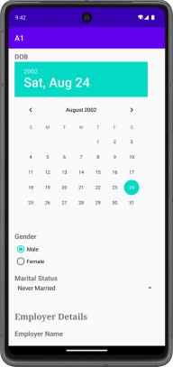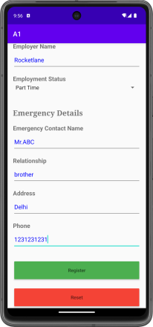

## Learning outcomes

Basic GUI components and layouts that are available

Passing data between activities

# Exercise 2 - Keyboard application

T Shivcharan

205001100

CSE-A

## Aim

To implement a keyboard application using Android Studio

## Code

### activity_main.xml

<?xml version="1.0" encoding="utf-8"?>

<RelativeLayout xmlns:android="http://schemas.android.com/apk/res/android"

xmlns:tools="http://schemas.android.com/tools"

android:layout_width="match_parent"

android:layout_height="match_parent"

android:orientation="vertical"

tools:context=".MainActivity">

<TextView

android:id="@+id/text_bar"

android:layout_width="match_parent"

android:layout_height="wrap_content"

android:layout_marginLeft="6dp"

android:layout_marginTop="24dp"

android:layout_marginRight="6dp"

android:hint="Enter text..."

android:text=""

android:textSize="24sp" />

<GridLayout

android:id="@+id/keyboard"

android:layout_width="match_parent"

android:layout_height="200dp"

android:layout_alignParentBottom="true"

android:background="#202020"

android:padding="1dp" />

</RelativeLayout>

### MainActivity.java

package com.example.qwerty;

import androidx.appcompat.app.AppCompatActivity;

import androidx.core.content.res.ResourcesCompat;

import android.os.Bundle;

import android.util.DisplayMetrics;

import android.view.Gravity;

import android.widget.Button;

import android.widget.GridLayout;

import android.widget.TextView;

import android.graphics.Typeface;

public class MainActivity extends AppCompatActivity {

private final String[][] letterKeys = {

{"Q", "W", "E", "R", "T", "Y", "U", "I", "O", "P"},

{"A", "S", "D", "F", "G", "H", "J", "K", "L"},

{"↑", "Z", "X", "C", "V", "B", "N", "M", "←"},

{"?123", ",", " ", ".", "⮐"}

};

private final String[][] numberKeys = {

{"1", "2", "3", "4", "5", "6", "7", "8", "9", "0"},

{"@", "#", "₹", "_", "&", "-", "+", "(", ")", "/"},

{"*", "\"", "'", ":", ";", "!", "?", "<", ">", "=", "←"},

{"ABC", ",", " ", ".", "⮐"}

};

private TextView textBar;

private GridLayout keyboard;

private DisplayMetrics displayMetrics;

private Boolean isCaps = false;

private Typeface customFont;

private void init() {

textBar = findViewById(R.id.text_bar);

textBar.setText("|");

keyboard = findViewById(R.id.keyboard);

displayMetrics = new DisplayMetrics();

getWindowManager().getDefaultDisplay().getMetrics(displayMetrics);

customFont = ResourcesCompat.getFont(this, R.font.oswald);

}

@Override

protected void onCreate(Bundle savedInstanceState) {

super.onCreate(savedInstanceState);

setContentView(R.layout.activity_main);

init();

initKeyboard(letterKeys);

}

private void initKeyboard(String[][] keys) {

keyboard.removeAllViews();

int rowIndex = 0;

for (String[] row : keys) {

int colIndex = 0;

int width = displayMetrics.widthPixels / (row.length + 4);

for (String letter : row) {

addButtonToKeyboard(letter, width, rowIndex, colIndex);

colIndex++;

}

rowIndex++;

}

}

private boolean isChar(String key) {

return key.length() == 1 && Character.isLetter(key.charAt(0));

}

private void addButtonToKeyboard(String key, int width, int row, int col) {

Button button = new Button(this);

if (isChar(key)) button.setText(key.toLowerCase());

else {

button.setText(key);

button.setTypeface(customFont);

button.setWidth(0);

button.setPadding(0, 0, 0, 0);

}

GridLayout.LayoutParams params = new GridLayout.LayoutParams();

params.width = width;

params.height = GridLayout.LayoutParams.WRAP_CONTENT;

params.rowSpec = GridLayout.spec(row);

params.columnSpec = GridLayout.spec(col);

params.setGravity(Gravity.FILL);

button.setLayoutParams(params);

button.setClickable(true);

setHandler(button, key);

keyboard.addView(button);

}

private void setHandler(Button button, String key) {

if (key.length() == 1 && Character.isLetter(key.charAt(0))) {

button.setOnClickListener(view -> {

if (isCaps) textBar.append(key.toUpperCase());

else textBar.append(key.toLowerCase());

});

return;

}

switch (key) {

case "↑":

button.setOnClickListener(view -> isCaps = !isCaps);

break;

case "←":

button.setOnClickListener(view -> {

CharSequence currentText = textBar.getText();

if(currentText.length()!=0) {

CharSequence newText = currentText.subSequence(0, currentText.length() - 1);

textBar.setText(newText);

}

});

break;

case "?123":

button.setOnClickListener(view -> initKeyboard(numberKeys));

break;

case "ABC":

button.setOnClickListener(view -> initKeyboard(letterKeys));

break;

case "⮐":

button.setOnClickListener(view -> textBar.append("\n"));

break;

default:

button.setOnClickListener(view -> {

CharSequence currentText = textBar.getText();

CharSequence newText = currentText.subSequence(0, currentText.length() - 1);

textBar.setText(newText);

textBar.append(String.valueOf(key.charAt(0)));

textBar.append("|");

}

);

break;

}

}

}

## Output

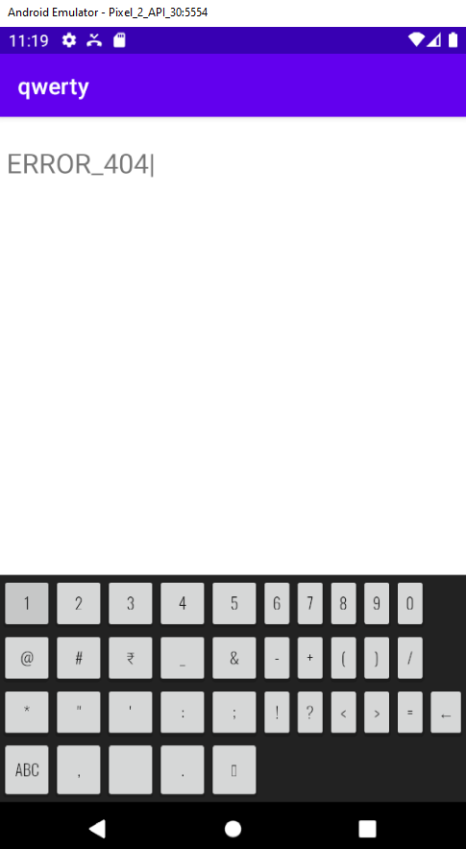

## Learning outcomes

Thus a keyboard was implemented using Android Studio

# Exercise 3 - Application Development using basic graphicalPrimitives

T Shivcharan

205001100

CSE-B

## Aim

Design a CAR using Shape drawables with the help of relevant shapes such as Line, Circle,

Rectangle and Arc.

a. Move the car forward by pressing forward button so that car moves from a predefined

starting point to the predefined endpoint.

b. On pressing backward button, rotate the car to 180 degrees from the current point to the

starting point.

c. Implement a Tap-to-zoom animation on any image.

d. Implement the Card flipping animation.

## Code

**Drawables:**

**car.xml**

<layer-list xmlns:android="http://schemas.android.com/apk/res/android">

<item android:drawable="@drawable/car_body" />

<item

android:drawable="@drawable/car_roof"

android:gravity="top"

/>

<item

android:drawable="@drawable/car_window"

android:top="10dp"

android:left="20dp"

android:right="50dp"

android:bottom="20dp"

/>

<item

android:drawable="@drawable/car_window"

android:top="10dp"

android:left="75dp"

android:right="20dp"

android:bottom="20dp"

/>

<item

android:drawable="@drawable/car_wheel"

android:gravity="left|bottom"

android:left="5dp"

android:bottom="0dp"

/>

<item

android:drawable="@drawable/car_wheel"

android:gravity="right|bottom"

android:right="5dp"

android:bottom="0dp"

/>

</layer-list>

**car_body.xml**

<shape xmlns:android="http://schemas.android.com/apk/res/android">

<solid android:color="#123" />

<corners android:radius="8dp" />

<size android:width="100dp" android:height="40dp"/>

</shape>

**car_roof.xml**

<shape xmlns:android="http://schemas.android.com/apk/res/android">

<solid android:color="#000000" />

<corners android:radius="2dp" />

<size android:width="20dp" android:height="15dp" />

</shape>

**car_wheel.xml**

<shape android:shape="oval"

xmlns:android="http://schemas.android.com/apk/res/android">

<solid android:color="#000000" />

<size android:width="20dp" android:height="20dp" />

<corners android:radius="3dp" />

</shape>

**car_window.xml**

<?xml version="1.0" encoding="utf-8"?>

<shape xmlns:android="http://schemas.android.com/apk/res/android">

<solid android:color="#333" />

<corners android:radius="4dp" />

<size android:width="20dp" android:height="20dp" />

</shape>

**lane_marking.xml**

<shape xmlns:android="http://schemas.android.com/apk/res/android">

<solid android:color="#FFFFFF" />

<size android:width="10dp" android:height="2dp" />

</shape>

**road.xml**

<layer-list xmlns:android="http://schemas.android.com/apk/res/android">

<!-- Road Background (Gray) -->

<item>

<shape android:shape="rectangle">

<solid android:color="#333" />

</shape>

</item>

<item android:drawable="@drawable/lane_marking"

android:top="10dp"

android:right="80dp"

android:left="10dp"

android:bottom="10dp"/>

<item android:drawable="@drawable/lane_marking"

android:top="10dp"

android:right="45dp"

android:left="45dp"

android:bottom="10dp"/>

<item android:drawable="@drawable/lane_marking"

android:top="10dp"

android:right="10dp"

android:left="80dp"

android:bottom="10dp"/>

</layer-list>

**Layout :**

**activity_main.xml**

<?xml version="1.0" encoding="utf-8"?>

<androidx.constraintlayout.widget.ConstraintLayout

xmlns:android="http://schemas.android.com/apk/res/android"

xmlns:app="http://schemas.android.com/apk/res-auto"

xmlns:tools="http://schemas.android.com/tools"

android:layout_width="match_parent"

android:layout_height="match_parent"

tools:context=".MainActivity">

<ImageView

android:id="@+id/carImageView"

android:layout_width="wrap_content"

android:layout_height="wrap_content"

android:src="@drawable/car"

app:layout_constraintBottom_toBottomOf="parent"

app:layout_constraintTop_toTopOf="parent"

app:layout_constraintVertical_bias="0.302"

tools:layout_editor_absoluteX="0dp" />

<ImageView

android:id="@+id/roadImageView"

android:layout_width="410dp"

android:layout_height="111dp"

android:layout_marginTop="256dp"

android:layout_marginEnd="1dp"

android:layout_marginBottom="364dp"

android:src="@drawable/road"

app:layout_constraintBottom_toBottomOf="parent"

app:layout_constraintEnd_toEndOf="parent"

app:layout_constraintHorizontal_bias="0.0"

app:layout_constraintStart_toStartOf="parent"

app:layout_constraintTop_toTopOf="parent" />

<Button

android:id="@+id/forwardButton"

android:layout_width="117dp"

android:layout_height="45dp"

android:layout_marginTop="60dp"

android:text="Forward"

app:layout_constraintEnd_toEndOf="parent"

app:layout_constraintStart_toStartOf="parent"

app:layout_constraintTop_toBottomOf="@+id/roadImageView" />

<Button

android:id="@+id/sunFlipId"

android:layout_width="wrap_content"

android:layout_height="wrap_content"

android:layout_marginBottom="108dp"

android:text="Flip Image"

app:layout_constraintBottom_toBottomOf="parent"

app:layout_constraintEnd_toEndOf="parent"

app:layout_constraintHorizontal_bias="0.496"

app:layout_constraintStart_toStartOf="parent"

app:layout_constraintTop_toBottomOf="@+id/backwardButton"

app:layout_constraintVertical_bias="0.384" />

<Button

android:id="@+id/backwardButton"

android:layout_width="wrap_content"

android:layout_height="wrap_content"

android:layout_marginTop="16dp"

android:text="Backward"

app:layout_constraintEnd_toEndOf="parent"

app:layout_constraintStart_toStartOf="parent"

app:layout_constraintTop_toBottomOf="@+id/forwardButton" />

<ImageView

android:id="@+id/sunId"

android:layout_width="79dp"

android:layout_height="55dp"

android:layout_marginTop="84dp"

app:layout_constraintEnd_toEndOf="parent"

app:layout_constraintStart_toStartOf="parent"

app:layout_constraintTop_toTopOf="parent"

app:srcCompat="?attr/actionModeCloseDrawable" />

<!-- Add other UI elements here if needed -->

</androidx.constraintlayout.widget.ConstraintLayout>

**MainActivity.java**

package com.example.abex3;

import androidx.appcompat.app.AppCompatActivity;

import android.animation.ObjectAnimator;

import android.os.Bundle;

import android.os.Handler;

import android.view.View;

import android.view.animation.AccelerateDecelerateInterpolator;

import android.widget.Button;

import android.widget.ImageView;

public class MainActivity extends AppCompatActivity {

private ImageView carImageView;

private ImageView sunImageView;

private Button forwardButton;

private Button backwardButton;

private Button sunFlipButton;

private int carXPosition = 0;

private final int endpoint = 800;

private final int startpoint = 0;

boolean isClicked=false;

@Override

protected void onCreate(Bundle savedInstanceState) {

super.onCreate(savedInstanceState);

setContentView(R.layout.activity_main);

carImageView = findViewById(R.id.carImageView);

sunImageView = findViewById(R.id.sunId);

forwardButton = findViewById(R.id.forwardButton);

backwardButton = findViewById(R.id.backwardButton);

sunFlipButton = findViewById(R.id.sunFlipId);

forwardButton.setOnClickListener(new View.OnClickListener() {

boolean isOperationInProgress = false;

@Override

public void onClick(View v) {

if (!isOperationInProgress) {

isOperationInProgress = true;

backwardButton.setEnabled(false);

forwardButton.setEnabled(false);

final Handler handler = new Handler();

final Runnable carMovement = new Runnable() {

@Override

public void run() {

carXPosition += 10;

if (carXPosition <= endpoint) {

carImageView.setX(carXPosition);

handler.postDelayed(this, 100); // 100 milliseconds delay

} else {

isOperationInProgress = false;

backwardButton.setEnabled(true);

forwardButton.setEnabled(true);

}

}

};

handler.post(carMovement);

}

}

});

backwardButton.setOnClickListener(new View.OnClickListener() {

boolean isOperationInProgress = false;

private boolean isCarFlipped = false;

@Override

public void onClick(View v) {

if (!isOperationInProgress) {

isOperationInProgress = true;

backwardButton.setEnabled(false);

forwardButton.setEnabled(false);

flipCar();

final Handler handler = new Handler();

final Runnable carMovement = new Runnable() {

@Override

public void run() {

carXPosition -= 10;

if (carXPosition >= startpoint) {

carImageView.setX(carXPosition);

handler.postDelayed(this, 100); // 100 milliseconds delay

} else {

isOperationInProgress = false;

backwardButton.setEnabled(true);

forwardButton.setEnabled(true);

flipCar();

}

}

};

handler.post(carMovement);

}

}

private void flipCar() {

ObjectAnimator flipAnimator;

if (isCarFlipped) {

flipAnimator = ObjectAnimator.ofFloat(carImageView, "rotationY", 180f, 0f);

isCarFlipped = false;

} else {

flipAnimator = ObjectAnimator.ofFloat(carImageView, "rotationY", 0f, 180f);

isCarFlipped = true;

}

flipAnimator.setDuration(500);

flipAnimator.setInterpolator(new AccelerateDecelerateInterpolator());

flipAnimator.start();

}

});

sunImageView.setOnClickListener(new View.OnClickListener(){

@Override

public void onClick(View v) {

if(!isClicked){

sunImageView.setScaleX(2);

sunImageView.setScaleY(2);

isClicked=true;

}

else{

sunImageView.setScaleX(1);

sunImageView.setScaleY(1);

isClicked=false;

}

}

});

sunFlipButton.setOnClickListener(new View.OnClickListener() {

private boolean isArrowFlipped = false;

@Override

public void onClick(View v) {

ObjectAnimator flipAnimator;

if (isArrowFlipped) {

flipAnimator = ObjectAnimator.ofFloat(sunImageView, "rotationY", 180f, 0f);

isArrowFlipped = false;

} else {

flipAnimator = ObjectAnimator.ofFloat(sunImageView, "rotationY", 0f, 180f);

isArrowFlipped = true;

}

flipAnimator.setDuration(500);

flipAnimator.setInterpolator(new AccelerateDecelerateInterpolator());

flipAnimator.start();

}

});

}

}

## Output

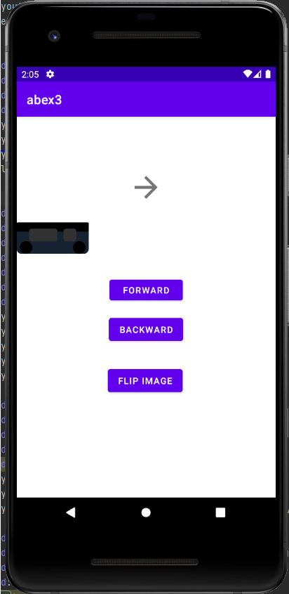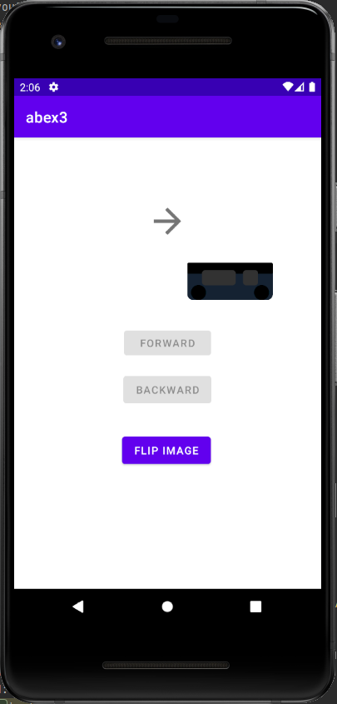

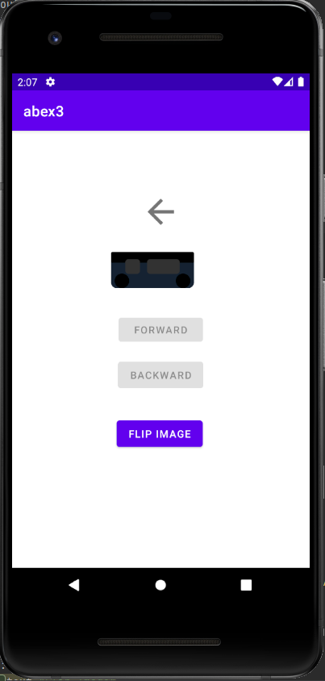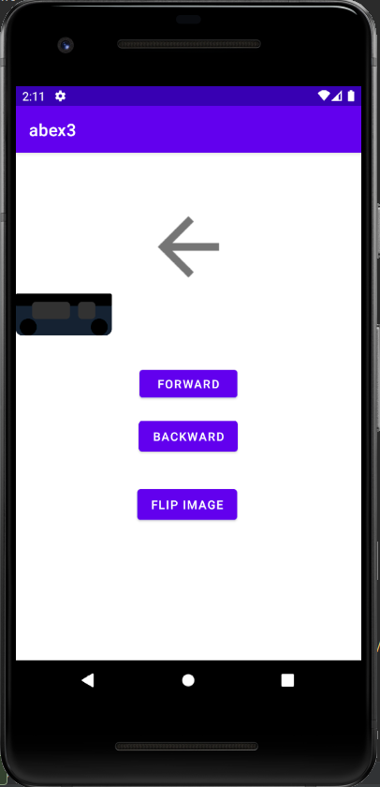

## Learning outcomes

* Proficient in creating user interfaces using shape drawables and relevant shapes.
* Implemented event listeners for user interaction and learned to navigate between activities.
* Successfully added animations, improving user engagement with tap-to-zoom and card flipping features.