1.Write a shell script to create a menu driven program for adding, deletion or finding a record in a database. Database should have the field like rollno, name, semester and marks of three subjects. Last option of the menu should be to exit the menu.

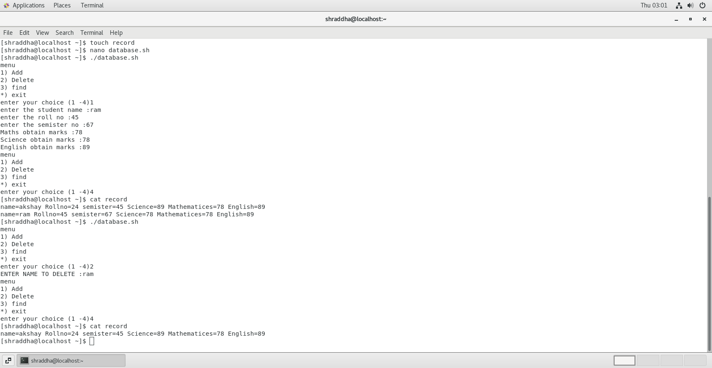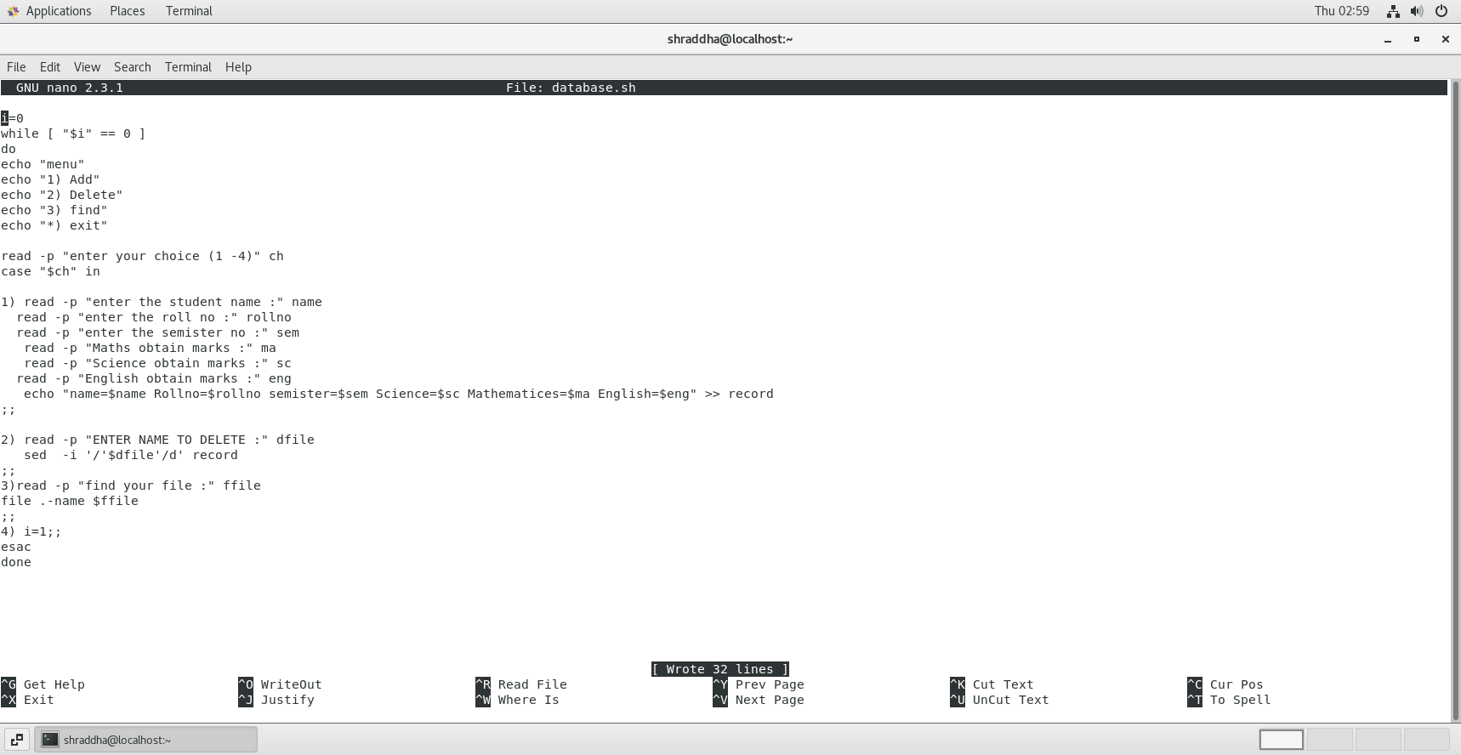

2.Write a unix shell to add records to a file called item.dat The fields being itemcode, qty, sold and rate

item_code to be generated

qty_sold should be greater than 0

1. rate between 100 to 10000

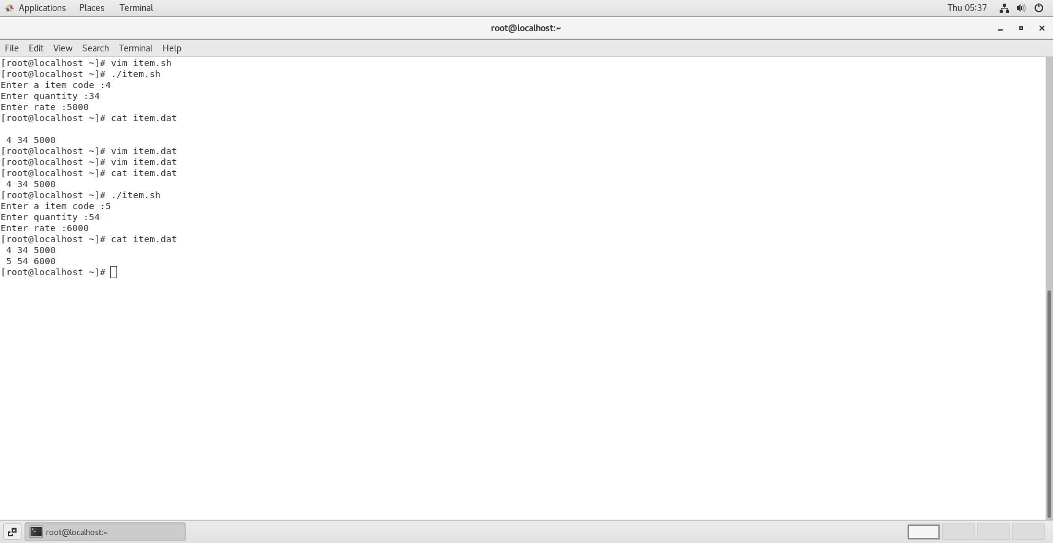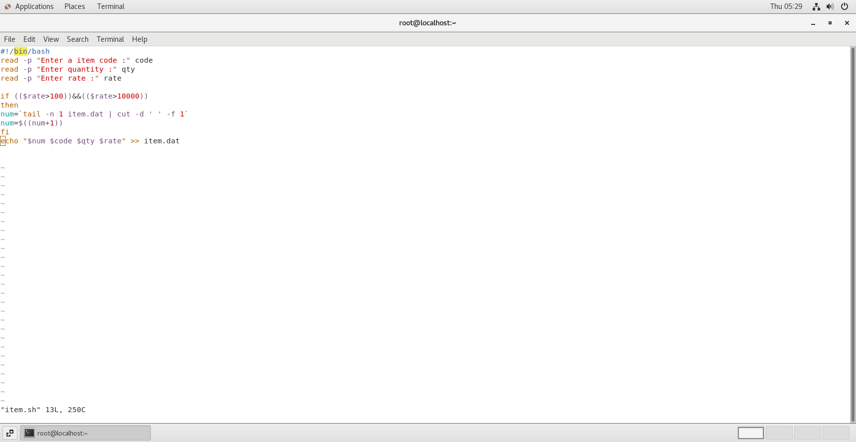

3.Write a scripts which copies the content of file1 to file2 without using cp command It should check If file has a read permissions if not it should print an error message. If file2 exits then it should ask the user whether he wants to overwrite it.

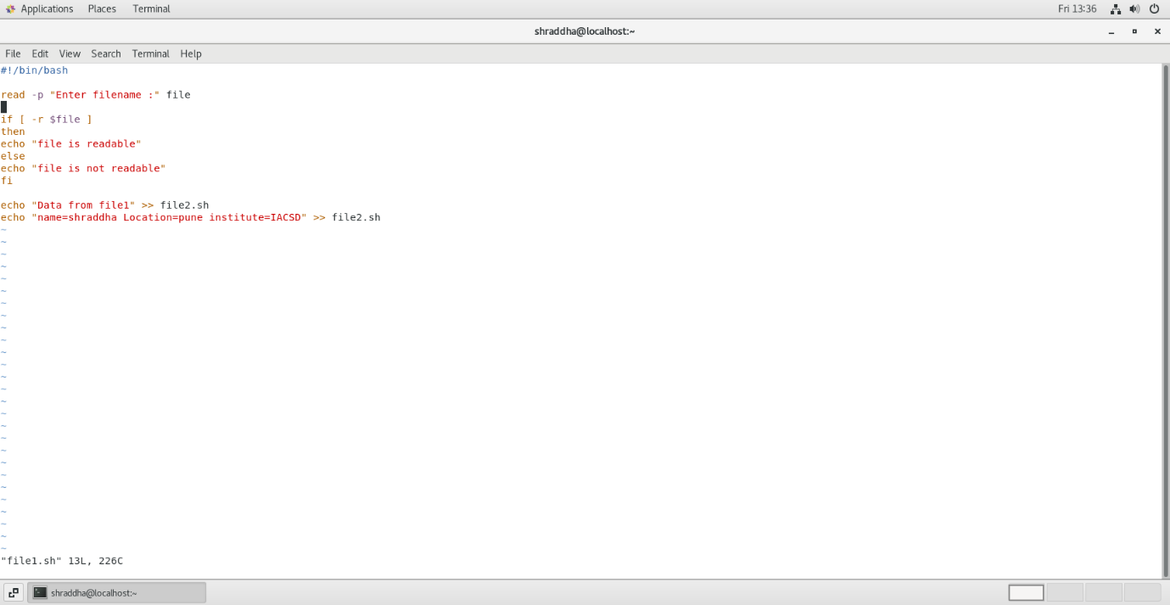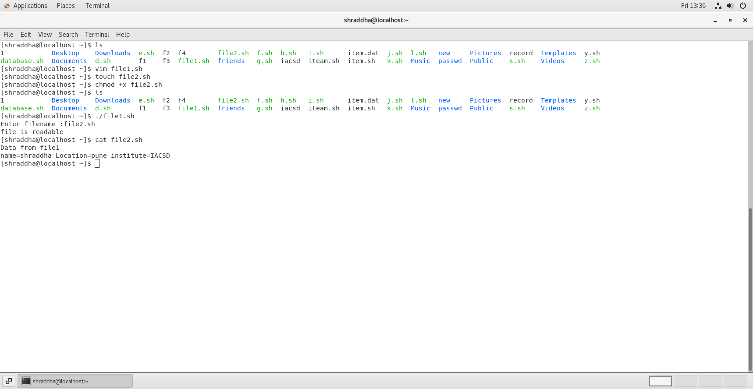

4. Write a shell scripts that delete all files in current directory with 0 byte.

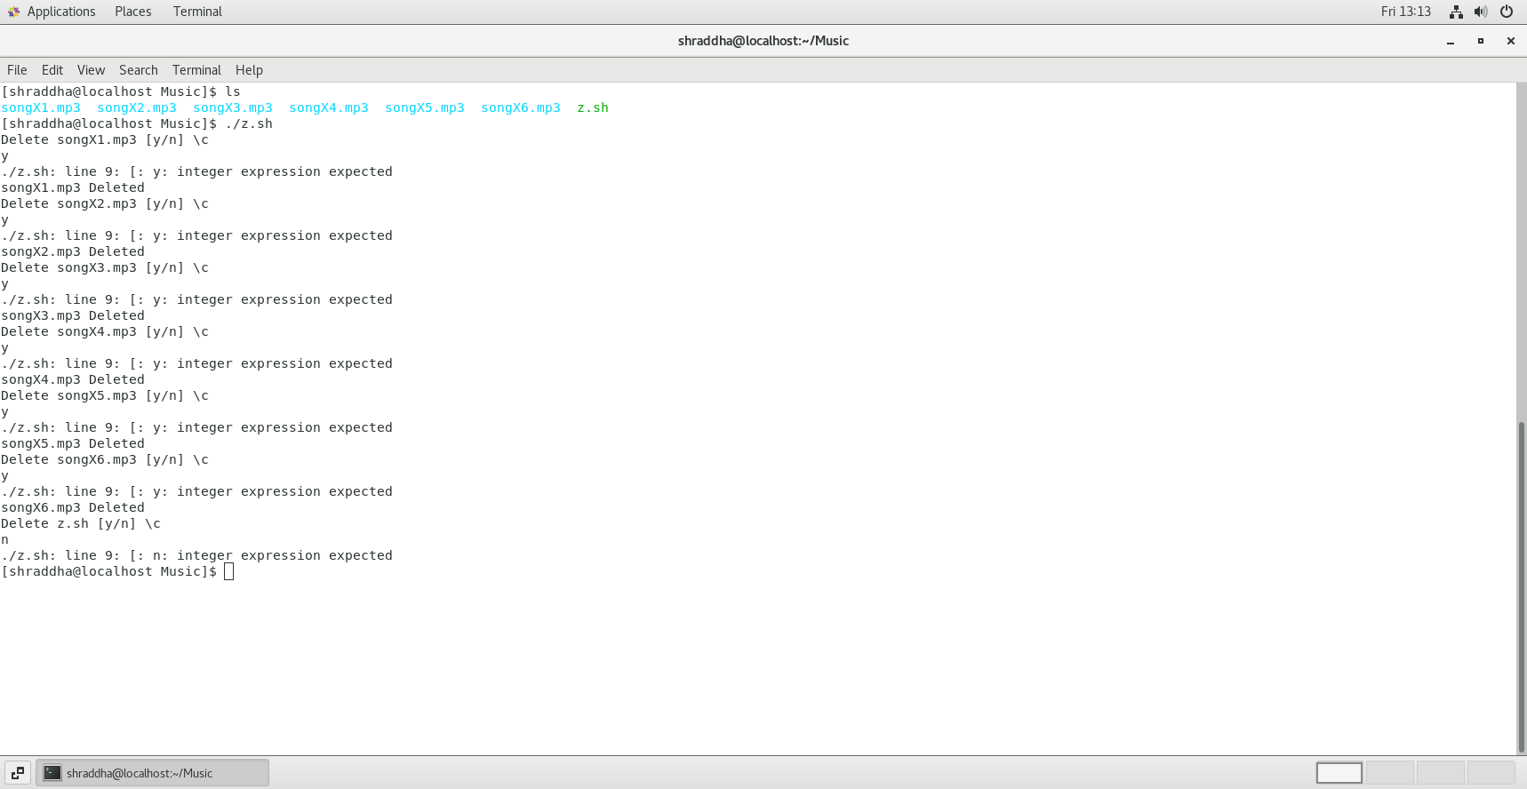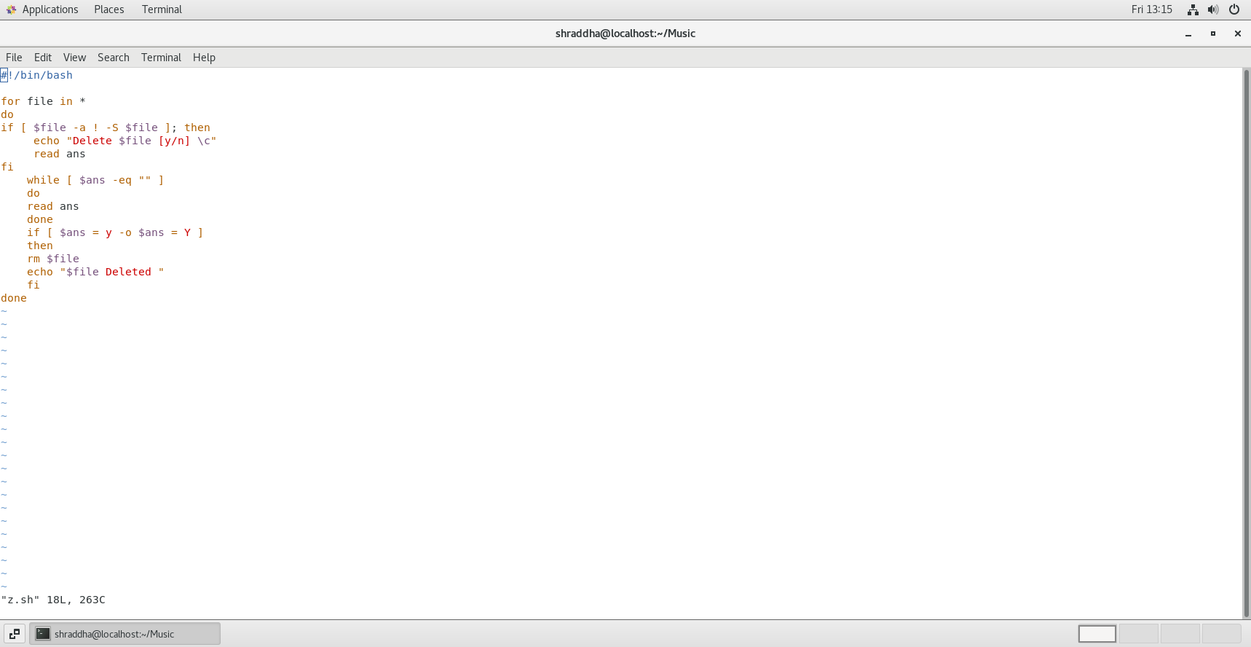

5. Write a shell script to display a directory listing as follows. Your home directory is <home directory name>

File name date time permission

------------- ------ ----- ---------------

Filename1 date time permission

Filename2 date time permission

Filename3 date time permission

………..

………..

Total no. of files : <total number>

Total no of normal file : <number>

Total no of directory : <number

