import java.util.Scanner;

class EndUserInput{

public static void main(String args[])

{

Scanner sc=new Scanner(System.in);

System.out.print("Enter your age=");

int age=sc.nextInt();

System.out.println("your age is=" + age);

System.out.print("Enter ur name=");

String name=sc.next();

System.out.println("your name is=" +name);

}}

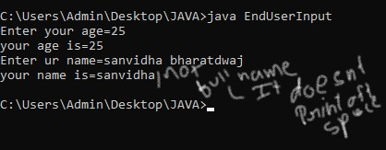

This method typically reads input until it encounters a whitespace character, which could explain why you're only getting the first name "sanvidha" as the output.