Solving the Travelling Salesman Problem: A Comparison of Hill Climbing with Random Restarts and a Genetic Algorithm
UFCEL1-15-M — AI for Search and Optimisation
[Your name] | [Student number] | [Date]

1. Introduction
The Travelling Salesman Problem asks for the shortest closed tour visiting each of n cities once. It is NP-hard: the symmetric case admits (n−1)!/2 tours, so a 50-city instance has roughly 3×10⁶² candidates. Exhaustive search is impossible, and the problem is a standard proving ground for heuristic search (Johnson and McGeoch, 1997).
This report compares two heuristics on the supplied 50-city Euclidean instance: hill climbing with random restarts (single-solution local search) and a genetic algorithm (population-based evolutionary search). Both were implemented from first principles. The hill climber proves better on every metric measured, by margins that are statistically significant and practically large.

2. Algorithm selection and design

2.1 Why hill climbing rather than simulated annealing or tabu search
Hill climbing with random restarts was chosen over simulated annealing and tabu search for two reasons. The Euclidean 2-opt landscape is benign: local optima are numerous but shallow, so a random restart recovers most of what a more sophisticated acceptance rule would buy. Also, annealing and tabu search each add parameters needing their own tuning (a cooling schedule; a tenure and aspiration criterion), and that budget is better spent on the far more parameter-sensitive GA. Restarts give comparable escape capability for one parameter instead of three.

2.2 Design choices
Component | Choice | Justification
Adjustment method | Steepest ascent | Each 2-opt move is scored in constant time by a delta calculation, so sweeping all ~1,200 moves is cheap and taking the best gives fastest descent.
Neighbourhood | 2-opt (segment reversal) | 2-opt is precisely the move that removes a pair of crossing edges (Croes, 1958). Pairwise swap disturbs four edges at once and fits the geometry worse.
Exploration vs exploitation | 20 random restarts | The climber is pure exploitation and halts at the first local optimum. Exploration is reintroduced at the outer level; beyond 20 restarts the improvement curve flattens.

GA component | Choice | Justification
Representation | Path (permutation) | Every chromosome is a valid tour by construction; no repair operator needed.
Selection | Tournament, k = 5 | One readable pressure parameter, invariant to the scale of the objective.
Recombination | Order crossover (OX1), rate 0.9 | Preserves a block from one parent and the relative ordering of the other (Davis, 1985); always emits a valid permutation.
Mutation | Inversion, rate 0.5 | Inversion is a 2-opt move applied at random, so the GA and the climber explore the same landscape.
Elitism | Best 4 survive | The best-so-far can never degrade between generations.
The shared 2-opt landscape is the keystone of the study. Because the GA’s mutation and the climber’s neighbourhood are the same move, neither algorithm is handed a better operator, so any performance difference is attributable to search strategy alone.

3. Methodology
- Both algorithms are stochastic, so a single run is uninformative. Each was run 30 independent times at 10, 20, 30, 40 and 50 cities (the first k rows of the dataset), seeded distinctly from one master seed so every figure is exactly reproducible.
- Three metrics: solution quality (tour length), computational efficiency (runtime), and robustness (standard deviation across runs, which says how far a single run can be trusted).
- Two tests were applied at 50 cities. Welch’s t-test does not assume equal variances, which matters because the GA is visibly more variable; Mann-Whitney U assumes no distribution at all. Agreement between a parametric and a non-parametric test guards against a conclusion that is an artefact of either. Cohen’s d separates statistical significance from practical importance.

4. Hyperparameter tuning of the genetic algorithm
Two parameters dominate the GA’s exploration/exploitation balance: tournament size (selection pressure) and mutation rate. Six configurations were each run five times on the full instance.
Tournament size k | Mutation rate | Mean tour length | SD
5 | 0.50 | 590.69 | 17.73
9 | 0.50 | 590.73 | 9.99
9 | 0.20 | 593.87 | 16.27
5 | 0.20 | 593.94 | 21.09
5 | 0.05 | 605.68 | 9.36
2 | 0.20 | 765.91 | 44.02
Table 1. GA tuning sweep, five runs per configuration, 50 cities.
The sweep does more than pick a winner. Selection pressure matters enormously; mutation rate matters modestly. Dropping to k = 2 costs 175 units, some 30 per cent, because near-random selection destroys the algorithm’s ability to exploit good building blocks. Raising mutation from 0.05 to 0.5 improves the mean by only 15 units, and it helps precisely because inversion is a 2-opt move, so heavy mutation effectively grafts local search onto the population. The chosen configuration was k = 5, mutation 0.5.

5. Results
Cities | HC mean (SD) | HC time (s) | GA mean (SD) | GA time (s) | GA gap
10 | 290.31 (0.00) | 0.005 | 290.31 (0.00) | 1.485 | 0.0%
20 | 386.43 (0.00) | 0.013 | 386.52 (0.10) | 1.637 | 0.02%
30 | 452.05 (0.74) | 0.025 | 470.56 (15.22) | 1.779 | 4.1%
40 | 490.04 (0.44) | 0.047 | 524.10 (26.62) | 1.937 | 7.0%
50 | 568.12 (6.38) | 0.061 | 601.08 (19.41) | 2.108 | 5.8%
Table 2. Mean tour length (SD) and mean runtime over 30 runs per algorithm per size. "GA gap" is the GA’s mean excess over the climber’s.
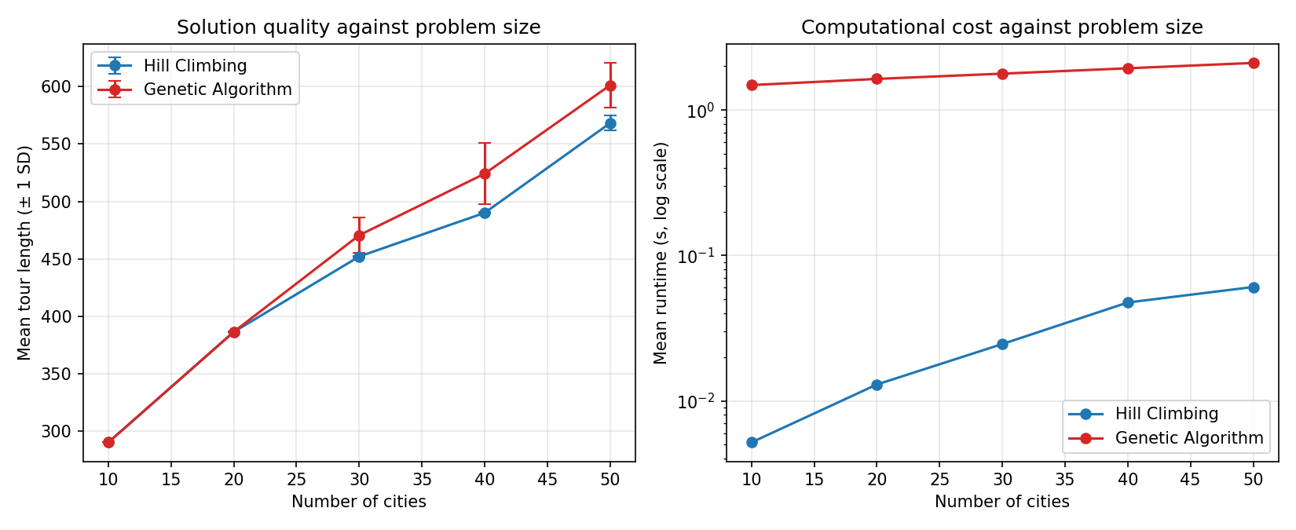
Figure 1. Solution quality (left, error bars one standard deviation) and runtime (right, log scale) against problem size. The quality gap opens from 30 cities onward.

5.1 Solution quality and scalability
At 10 cities the algorithms are indistinguishable: both find 290.31 on all 30 runs, almost certainly the global optimum. At 20 cities they remain within 0.02 per cent. From 30 cities the gap opens and never closes, reaching 5.8 per cent at full size. This is the signature of a search space growing faster than the GA’s fixed budget of 150 × 400 = 60,000 evaluations can cover.
Robustness tells a starker story than the mean. At 50 cities the climber’s standard deviation is 6.38 against the GA’s 19.41; at 40 cities the ratio exceeds sixty. Someone running the GA once cannot know whether they drew a good tour or a poor one, whereas any single hill-climbing run lands near the mean. Deployability depends on that.

5.2 Computational efficiency
The climber is also about 35 times faster at 50 cities (0.061 s against 2.108 s), inverting the conventional expectation. A textbook hill climber re-evaluates each candidate tour in full, costing O(n) per move and O(n³) per sweep. This implementation scores every 2-opt move by a constant-time delta, four look-ups into a pre-computed distance matrix, dropping a sweep to O(n²). The GA cannot use the trick: crossover rebuilds a chromosome wholesale, so its length must be recomputed. The advantage is an implementation decision rather than a property of local search, and it is the kind of decision that dominates real runtime.
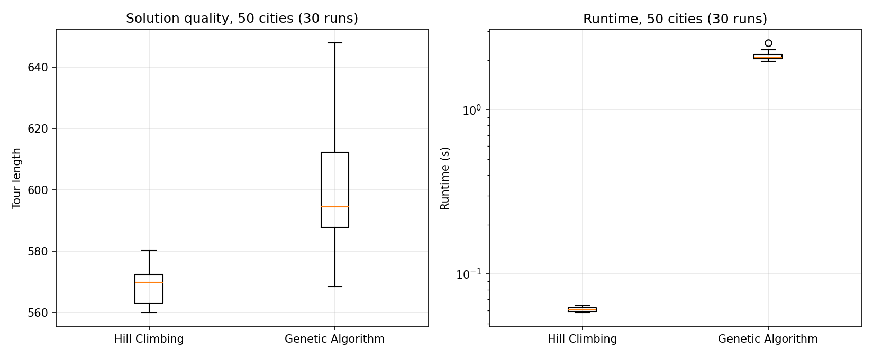
Figure 2. Distribution of tour length and runtime over 30 runs at 50 cities. The GA’s quality distribution is both worse and considerably wider.

5.3 Hypothesis tests
H₀: the two algorithms produce tours of equal mean length on the 50-city instance. H₁: they do not.
Test | Statistic | p-value | Effect size
Welch t-test (tour length) | t = −8.84 | 1.8 × 10⁻¹⁰ | d = −2.28
Mann-Whitney U (tour length) | U = 19.5 | 2.0 × 10⁻¹⁰ | —
Welch t-test (runtime) | t = −98.64 | 3.2 × 10⁻³⁸ | d = −25.47
Table 3. Hypothesis tests, 30 runs per algorithm, 50 cities.
H₀ is rejected decisively at α = 0.05, and both tests agree, so the result is not an artefact of a normality assumption. Cohen’s d of −2.28 sits far beyond the conventional large-effect threshold of 0.8: the distributions barely overlap. Effect size matters alongside the p-value, because with enough samples any trivial difference becomes significant.

6. Discussion and recommendations
The climber wins on quality, speed and robustness, so on this instance the recommendation is unambiguous. The interesting question is what would have to change to reverse it.
- Under ~25 cities: either. Both find the apparent optimum, so pick the one that is simpler to maintain.
- Up to a few hundred cities on a real-time budget: hill climbing with restarts. Faster, more accurate, far more predictable. If time is tight, cut restarts; quality degrades gracefully.
- Where evaluation is expensive, or constraints such as time windows make most neighbours infeasible: the balance shifts to the GA, whose population maintains diverse partial solutions and which does not rely on a cheap delta. That is where evolutionary methods earn their keep, and it is not where this instance sits.
- Large instances demanding the best quality: neither, as implemented. A memetic design, a GA whose offspring are improved by local search before evaluation, dominates both (Johnson and McGeoch, 1997). Our tuning result hints at this: the GA improved as mutation, a 2-opt move here, was turned up.
The main limitation is the single instance. Scalability results come from nested subsets of one dataset, so instance-specific structure is shared across sizes. Validating on TSPLIB instances with known optima would let us quote the gap to a true optimum rather than the gap between two heuristics.

7. Legal and ethical considerations

7.1 Data
The supplied cities.csv is synthetic: its coordinates reproduce the standard NumPy uniform sequence under a fixed seed on [0, 100]². It holds no real locations, no personal data and no third-party copyright, so UK GDPR is not engaged and no licence attaches. Real delivery addresses would change this entirely. Address data is personal data, requiring a lawful basis and a retention policy, and route data can expose sensitive patterns of movement.

7.2 Code and libraries
Every algorithm was written from first principles; no TSP solver, optimisation library or metaheuristic framework was copied or imported. The dependencies (NumPy, pandas, Matplotlib, SciPy) are all BSD-3-Clause: permissive licences allowing commercial use, modification and redistribution provided the copyright notice is retained. Nothing in the stack is copyleft, so a commercial deployment would not be obliged to release its own source. That is deliberate. A GPL-licensed solver such as Concorde would impose exactly that obligation, which is a common reason commercial teams avoid it.

7.3 Commercial setting
Three things would change. Every transitive dependency would need a licence audit, since permissiveness at the top guarantees nothing beneath it. Real route data would bring GDPR obligations. And the ethical surface widens: an optimiser minimising distance may in effect intensify a courier’s workload, and the objective function is where that trade-off silently lives.

7.4 Declaration of generative AI use
[Complete this in your own words. State honestly which tool you used, for what (for example: explaining 2-opt, debugging the crossover operator, checking grammar), and what you did yourself. You will be questioned on the code in the video, so make sure the declaration matches what you can actually explain.]

8. Conclusion
On this 50-city instance, hill climbing with random restarts produces shorter tours (568.12 against 601.08), roughly 35 times faster, and far more consistently. The difference is significant (p < 10⁻⁹) with a large effect size. This is not a general verdict against evolutionary methods. It is a verdict on a well-matched pairing of a cheap, geometry-aware operator with a landscape that suits it, and on a fixed evaluation budget that stops being enough as the space grows.

References
Alanzi, E. and Menai, M.E.B. (2025) ‘Solving the travelling salesman problem with machine learning: a review of recent advances and challenges’, Artificial Intelligence Review, 58(9), p. 267.
Croes, G.A. (1958) ‘A method for solving traveling-salesman problems’, Operations Research, 6(6), pp. 791–812.
Davis, L. (1985) ‘Applying adaptive algorithms to epistatic domains’, in Proceedings of the 9th International Joint Conference on Artificial Intelligence. Los Angeles, pp. 162–164.
Johnson, D.S. and McGeoch, L.A. (1997) ‘The traveling salesman problem: a case study in local optimization’, in Aarts, E. and Lenstra, J.K. (eds) Local Search in Combinatorial Optimization. Chichester: Wiley, pp. 215–310.
Mamatova, Z. and Abdumajidova, M. (2025) ‘The travelling salesman problem: mathematical modeling and optimal solutions’, International Journal of Artificial Intelligence, 1(3), pp. 1204–1212.

