**EXPERIMENT-5**

**Title:  To understand and use SQL Sub-Query**

**Objective:** To understand the use of sql subquery.

**1. Create the following table.**

Supplier-(scode,sname,scity,turnover)

Part-(pcode,weigh,color,cost,sellingprice)

Supplier_Part-(scode,pcode,qty)

ANSWER:-  
-- Creating the Supplier table

create table supplier (

scode int primary key,

sname varchar(50),

scity varchar(50),

turnover int

);

-- Creating the Part table

create table part (

pcode int primary key,

weigh int,

color varchar(20),

cost int,

sellingprice int

);

-- Creating the Supplier_Part table

create table supplier_part (

scode int,

pcode int,

qty int,

foreign key (scode) references supplier(scode),

foreign key (pcode) references part(pcode)

);

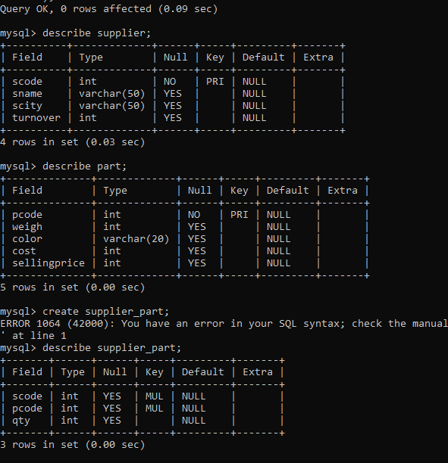

1. **Populate the table**

-- Populating the Supplier table

insert into supplier (scode, sname, scity, turnover) values

(1, 'supplier1', 'bombay', 50),

(2, 'supplier2', 'delhi', 100),

(3, 'supplier3', 'bangalore', null);

-- Populating the Part table

insert into part (pcode, weigh, color, cost, sellingprice) values

(1, 20, 'red', 20, 30),

(2, 30, 'blue', 40, 60),

(3, 25, 'green', 30, 50);

-- Populating the Supplier_Part table

insert into supplier_part (scode, pcode, qty) values

(1, 2, 10),

(2, 1, 20),

(3, 2, 30);

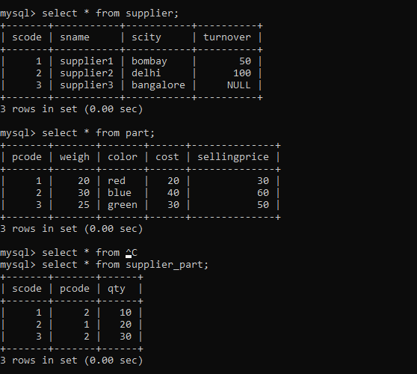

**3. Write appropriate SQL Statement for the following:**

1. Get the supplier number and part number in ascending order of supplier number.

select scode, pcode from supplier_part order by scode;

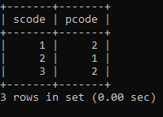

1. Get the details of supplier who operate from Bombay with turnover 50.

select * from supplier where scity = 'bombay' and turnover = 50;

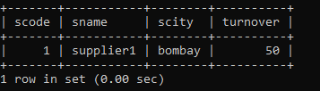

1. Get the total number of supplier.

select count(*) as total_suppliers from supplier;

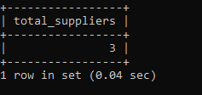

1. Get the part number weighing between 25 and 35.

select pcode from part where weigh between 25 and 35;

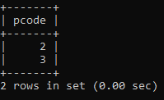

1. Get the supplier number whose turnover is null.

select scode from supplier where turnover is null;

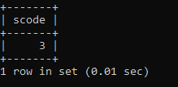

1. Get the part number that cost 20, 30 or 40 rupees.

select pcode from part where cost in (20, 30, 40);

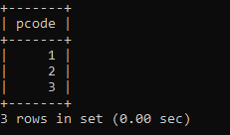

1. Get the total quantity of part 2 that is supplied.

select sum(qty) as total_qty from supplier_part where pcode = 2;

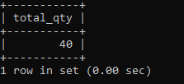

1. Get the name of supplier who supply part 2.

select sname from supplier where scode in (select scode from supplier_part where pcode = 2);

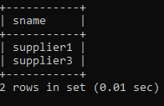

1. Get the part number whose cost is greater than the average cost.

select pcode from part where cost > (select avg(cost) from part);

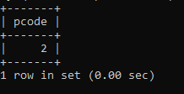

10. Get the supplier number and turnover in descending order of turnover.

select scode, turnover from supplier order by turnover desc;

