Buddgy
Specification Document — Full-Stack Final Project | August 2026

Team
- Darya Abbassov
- Matan Maabari
- Ofek Cofman
Description
Buddgy is a monthly budgeting app built on the Envelope Budgeting method: the user pre-allocates a set amount to each spending category ("envelope") and tracks the remaining balance in each one.
- Core differentiator: Unlike existing expense-tracking tools that look backward ("where did my money go"), Buddgy looks forward — it pulls upcoming planned expenses from Google Calendar and warns the user in advance if they're not on track to stay within budget.
- The AI component: Expenses are entered in free-form text ("coffee and a pastry, 34 shekels"), and a language model extracts structured JSON from it — amount, category, envelope and date. AI sits in the core daily-use flow, not bolted on as an extra.
- Why not a direct bank connection: Automatic bank-account syncing requires licensing and secure credential handling. Instead, the system offers three complementary input channels: AI-based quick entry, CSV import with automatic column mapping, and calendar sync.

Target Users
- Guest — Not logged in. Can view the landing page, the method explanation, and a read-only demo.
- Registered User — The core user of the system. Manages envelopes, transactions, imports and forecasts.
- Admin — System administrator. Manages the global category catalog and users.

Use Cases (Per User)

Guest
- View landing page and explanation of the Envelope Budgeting method
- Sign up via email and password / log in
- View a static demo of the envelope dashboard (read-only)

Registered User
Has all Guest use cases, plus:
- Create, edit and delete envelopes and set a monthly budget per envelope
- Enter an expense in free-form text — the system parses amount, category and envelope and shows it for confirmation before saving
- Add, edit and delete a transaction manually
- Upload a CSV/Excel bank statement, confirm automatic column mapping, and bulk-import
- Connect a Google account and sync calendar events with an amount as future expenses
- Assign a future expense to an envelope and approve or dismiss it
- View end-of-month cash-flow forecast and a warning for a projected shortfall
- Filter and search transactions by envelope, date and amount
- View history of previous months
- Upload a profile picture (external storage)

Admin
Has all Registered User use cases, plus:
- Manage the global category catalog used by the classification engine
- View the user list and disable a user
- View basic usage statistics (number of users, transactions created, AI calls)

Mockups
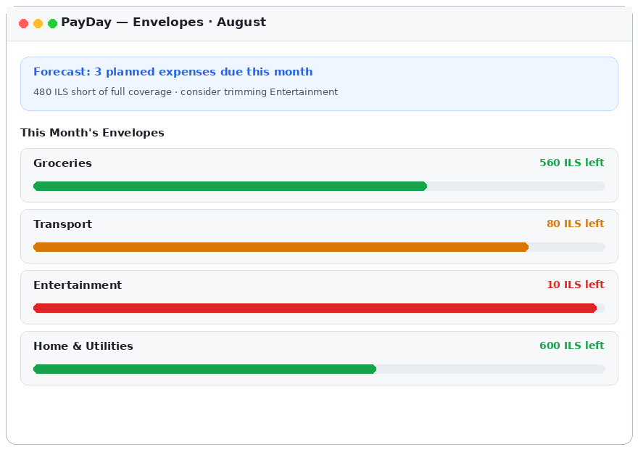
Screen 1 — Envelope dashboard: remaining balance per envelope and forecast alert
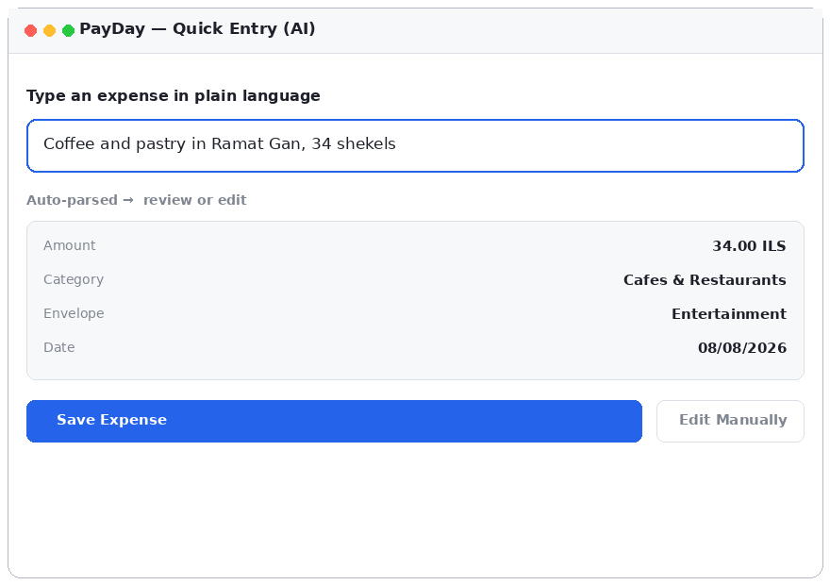
Screen 2 — Quick Entry: free text parsed into structured JSON, shown for confirmation
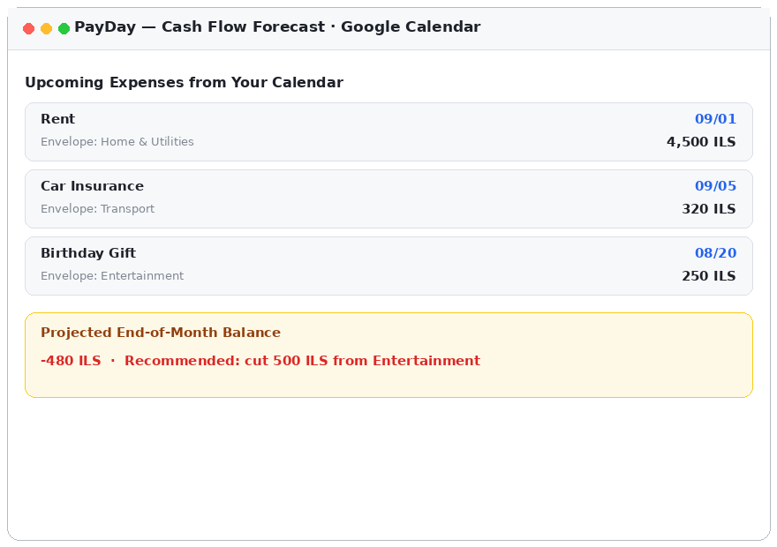
Screen 3 — Cash-flow forecast based on Google Calendar events

DB Diagram
Database: PostgreSQL. All amounts are stored as integers in agorot to avoid floating-point rounding errors.

users
Column | Type | Notes
id | SERIAL PK | Unique identifier
email | VARCHAR(255) | UNIQUE, NOT NULL
password_hash | VARCHAR(255) | bcrypt
full_name | VARCHAR(120)
avatar_url | TEXT | Link to external storage
google_refresh_token | TEXT | Encrypted, NULL until calendar is connected
role | VARCHAR(20) | 'user' | 'admin'
created_at | TIMESTAMP | DEFAULT now()

envelopes
Column | Type | Notes
id | SERIAL PK
user_id | INT FK → users | ON DELETE CASCADE
name | VARCHAR(80) | Envelope name
monthly_budget_agorot | INTEGER | Monthly budget in agorot
color | VARCHAR(7) | Display color
month | DATE | Month this envelope belongs to

transactions
Column | Type | Notes
id | SERIAL PK
user_id | INT FK → users
envelope_id | INT FK → envelopes | NULL if unassigned
amount_agorot | INTEGER | NOT NULL
description | VARCHAR(255) | Original free text
source | VARCHAR(20) | 'quick_entry' | 'csv' | 'manual'
transaction_date | DATE | NOT NULL
dedup_hash | VARCHAR(64) | UNIQUE — prevents duplicate import

planned_expenses
Column | Type | Notes
id | SERIAL PK
user_id | INT FK → users
envelope_id | INT FK → envelopes
title | VARCHAR(160) | Calendar event title
amount_agorot | INTEGER | Extracted from event title
due_date | DATE
google_event_id | VARCHAR(128) | UNIQUE — prevents duplicate sync
is_confirmed | BOOLEAN | DEFAULT false

csv_imports
Column | Type | Notes
id | SERIAL PK
user_id | INT FK → users
file_url | TEXT | Original file in external storage
column_mapping | JSONB | Mapping confirmed by the user
rows_imported | INTEGER
created_at | TIMESTAMP | DEFAULT now()

Server API Endpoints

Auth
POST /api/auth/register → { token, user }
POST /api/auth/login → { token, user }
GET /api/auth/me → { user }

Envelopes & Transactions
GET /api/envelopes?month=2026-08
POST /api/envelopes → create envelope
PUT /api/envelopes/:id → update budget
DELETE /api/envelopes/:id
GET /api/transactions?month=2026-08&envelopeId=3
POST /api/transactions → manual creation
DELETE /api/transactions/:id

AI Quick Entry — full example
POST /api/transactions/parse
Request:
{ "text": "coffee and a pastry in Ramat Gan, 34 shekels" }
Response 200:
{
"amount_agorot": 3400,
"category": "Cafes & Restaurants",
"suggested_envelope_id": 3,
"description": "Coffee and pastry",
"transaction_date": "2026-08-08",
"confidence": 0.93
}

CSV Import
POST /api/imports/preview (multipart/form-data)
Response 200:
{
"importId": 12,
"detectedMapping": { "date": "Transaction Date", "amount": "Charge Amount",
"description": "Merchant" },
"previewRows": [ { "date": "2026-08-01", "amount_agorot": 12990,
"description": "Shufersal Deal" } ]
}
POST /api/imports/:id/confirm → { imported: 47, duplicatesSkipped: 3 }

Calendar & Forecast
GET /api/calendar/connect → Google OAuth redirect
POST /api/calendar/sync → { newEvents: 4 }
GET /api/planned-expenses?month=2026-08
PATCH /api/planned-expenses/:id → confirm / assign to envelope
GET /api/forecast?month=2026-08
Response 200:
{ "projectedBalanceAgorot": -48000, "atRiskEnvelopes": [3],
"recommendation": "Cut 500 ILS from the Entertainment envelope" }

External APIs
- Google Calendar API — Fetches upcoming events with an amount in the title, via OAuth2. This is the system's primary external API.
- Anthropic Claude API — Extracts structured JSON from free text (Structured Output) for quick entry, and detects column structure in CSV files.
- Cloudinary / AWS S3 — External storage for profile pictures and original CSV files.

Extensions
To be implemented only after all use cases above are complete:
- Photograph a receipt and generate an expense from it using a vision model (OCR + LLM)
- Shared envelopes for a couple or household with permissions
- Automated monthly email report with summary and trend analysis
- Savings goals (sinking funds) across multiple months
- PWA with push notifications when an envelope nears depletion
- Export data to CSV and to Google Sheets

