Wisely
Specification Document — Full-Stack Final Project | August 2026

Team
- Darya Abbassov
- Matan Maabari
- Ofek Cofman

Description
Wisely is a grocery-basket price comparison system across Israeli supermarket chains, built on the government price-transparency database that chains are legally required to publish.
- Core differentiator: Existing competitors show static, single-product price tables. Wisely operates at the level of the whole personal basket: the user builds one basket and gets an actionable decision — where to buy it in full, and how much they'd save by splitting it across two chains.
- The AI component: A language model translates a free-text request ("BBQ basket for 8 people") into a concrete product list, and also normalizes non-barcoded product names into structured fields. This is a layer that existing pre-LLM-era market products don't offer.
- Deliberately scoped: Matching is done by barcode (GS1 standard) only, not fuzzy text matching. The system is limited to 2–3 chains and one city. Data collection runs as a scheduled background job fully decoupled from the application server.

Target Users
- Guest — Not logged in. Can search products and see price comparisons, but cannot save a basket.
- Registered User — Builds and saves baskets, gets split recommendations, and sees savings history.
- Admin — Monitors the data-collection pipeline, manages chains and stores, and fixes product data.

Use Cases (Per User)

Guest
- Search for a product by name or barcode
- View a single product's price comparison across available chains
- Select a city and view relevant stores
- Filter products by category
- Sign up / log in

Registered User
Has all Guest use cases, plus:
- Create a shopping basket, add products and set quantities
- Build a basket from a free-text description using AI ("BBQ basket for 8 people")
- Save multiple named baskets and edit them
- Compare the full basket cost across chains and view the difference
- Get a recommended split-basket across two chains for maximum savings
- View a per-product breakdown — where each item is cheapest
- View basket history and cumulative savings
- Upload a profile picture (external storage)

Admin
Has all Registered User use cases, plus:
- View the status of the most recent data-collection run and number of records ingested
- Manually trigger a data import
- Manage the list of active chains and stores in the system
- Edit or hide a product with incorrect data

Mockups
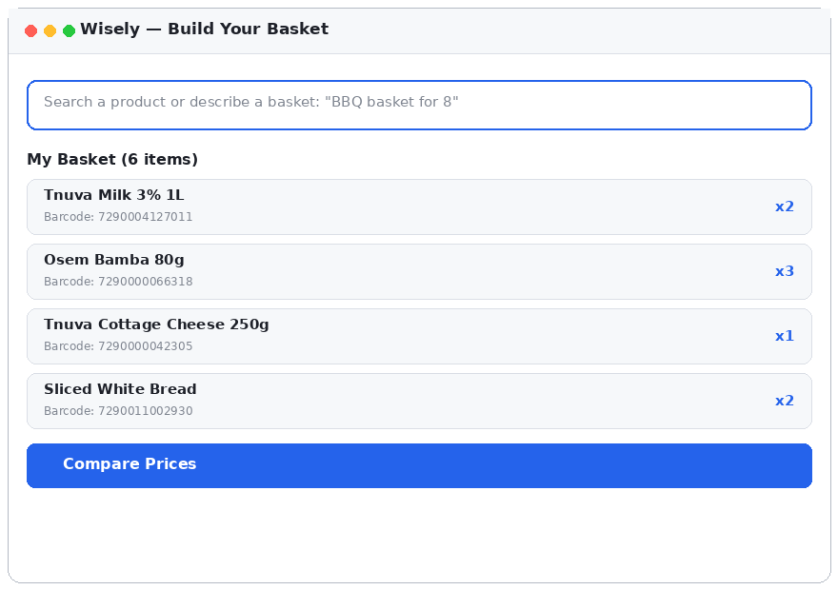
Screen 1 — Basket builder: product search or a free-text description parsed by AI
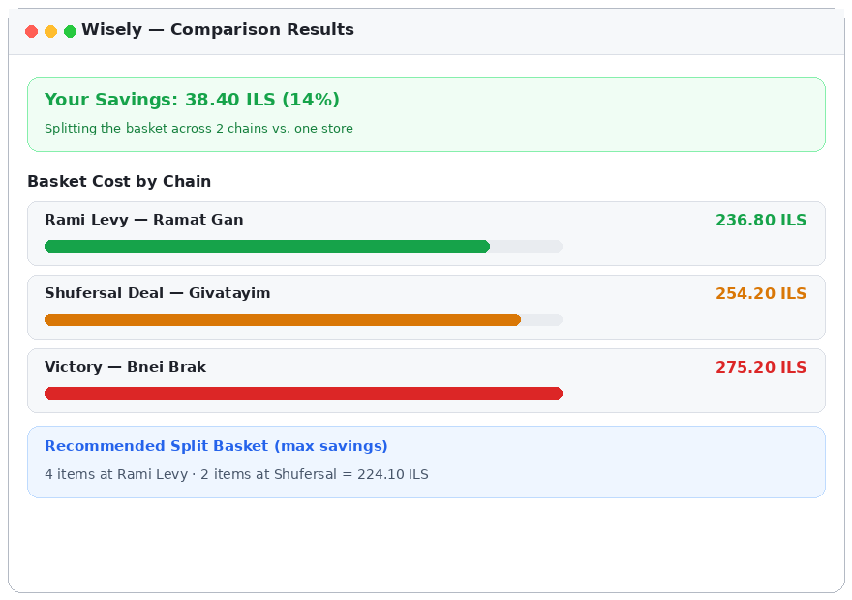
Screen 2 — Comparison results: cost by chain and a recommended split basket

DB Diagram
Database: PostgreSQL. Prices are stored as integers in agorot. The barcode is the matching key across chains.

users
Column | Type | Notes
id | SERIAL PK
email | VARCHAR(255) | UNIQUE, NOT NULL
password_hash | VARCHAR(255) | bcrypt
full_name | VARCHAR(120)
avatar_url | TEXT | External storage
default_city | VARCHAR(60) | Default city for comparisons
role | VARCHAR(20) | 'user' | 'admin'

products
Column | Type | Notes
barcode | VARCHAR(20) PK | GS1 identifier — the matching key
name | VARCHAR(255) | Normalized name
brand | VARCHAR(120) | Extracted via LLM
unit_quantity | NUMERIC(10,2) | e.g. 500
unit_type | VARCHAR(20) | 'gram' | 'ml' | 'unit'
category | VARCHAR(80)
image_url | TEXT | External storage

chains / stores
Column | Type | Notes
chains.id | SERIAL PK
chains.name | VARCHAR(80) | Shufersal, Rami Levy, Victory
stores.id | SERIAL PK
stores.chain_id | INT FK → chains
stores.name | VARCHAR(120) | Branch name
stores.city | VARCHAR(60) | Indexed for search
stores.address | VARCHAR(200)

prices
Column | Type | Notes
id | SERIAL PK
product_barcode | VARCHAR(20) FK | → products
store_id | INT FK → stores
price_agorot | INTEGER | NOT NULL
scraped_at | TIMESTAMP | Collection timestamp
— | UNIQUE | (product_barcode, store_id, scraped_at)

baskets / basket_items
Column | Type | Notes
baskets.id | SERIAL PK
baskets.user_id | INT FK → users | ON DELETE CASCADE
baskets.name | VARCHAR(120) | Basket name
baskets.created_at | TIMESTAMP | DEFAULT now()
basket_items.id | SERIAL PK
basket_items.basket_id | INT FK → baskets
basket_items.product_barcode | VARCHAR(20) FK | → products
basket_items.quantity | INTEGER | DEFAULT 1

import_runs
Column | Type | Notes
id | SERIAL PK
started_at | TIMESTAMP
status | VARCHAR(20) | 'success' | 'failed'
products_upserted | INTEGER
prices_upserted | INTEGER
error_message | TEXT | NULL on success

Server API Endpoints

Auth
POST /api/auth/register → { token, user }
POST /api/auth/login → { token, user }
GET /api/auth/me → { user }

Products & Stores
GET /api/products/search?q=milk&city=Ramat Gan
GET /api/products/:barcode
GET /api/products/:barcode/prices?city=Ramat Gan
GET /api/stores?city=Ramat Gan
Response 200 — /api/products/7290004127011/prices:
{
"product": { "barcode": "7290004127011", "name": "Tnuva Milk 3% 1L" },
"prices": [
{ "chain": "Rami Levy", "store": "Ramat Gan", "priceAgorot": 649 },
{ "chain": "Shufersal Deal", "store": "Givatayim", "priceAgorot": 719 }
]
}

Baskets
GET /api/baskets → user's baskets
POST /api/baskets → create basket
POST /api/baskets/:id/items → add product
PATCH /api/baskets/:id/items/:itemId → update quantity
DELETE /api/baskets/:id/items/:itemId

Compare — the core of the product
GET /api/baskets/:id/compare?city=Ramat Gan
Response 200:
{
"byChain": [
{ "chain": "Rami Levy", "totalAgorot": 23680, "missingItems": 0 },
{ "chain": "Shufersal Deal", "totalAgorot": 25420, "missingItems": 1 }
],
"cheapestSingleChain": "Rami Levy",
"splitRecommendation": {
"totalAgorot": 22410,
"savingsAgorot": 3840,
"stops": [ { "chain": "Rami Levy", "items": 4 },
{ "chain": "Shufersal Deal", "items": 2 } ]
}
}

AI
POST /api/ai/basket-from-text
Request: { "text": "BBQ basket for 8 people" }
Response 200:
{ "items": [ { "query": "charcoal", "quantity": 1 },
{ "query": "kebab", "quantity": 2 },
{ "query": "pita bread", "quantity": 2 } ] }

Admin
GET /api/admin/import-runs → data-collection status
POST /api/admin/import-runs → manual trigger
PATCH /api/admin/products/:barcode

External APIs
- Government price-transparency database — PriceFull and Stores files published by grocery chains per Israeli law. This is the system's primary data source.
- Anthropic Claude API — Translates a free-text request into a product list, and normalizes product names into structured fields (brand, quantity, unit).
- Cloudinary / AWS S3 — External storage for product images and profile pictures.
- Google Maps / Geocoding API — Displaying store locations on a map (optional, extended scope).

Extensions
To be implemented only after all use cases above are complete:
- Extend matching to non-barcoded products (fruits and vegetables) using embeddings and vector search
- Price-history tracking and alerts when a favorite product's price rises
- Shrinkflation detection — quantity reduction without a price cut — based on accumulated data
- Factor store distance from the user into the split recommendation
- Expand to additional chains and cities
- Share a basket between users

