19CS82C – INTERNSHIP/INPLANT TRAINING REPORT

Submitted by
Sarikha S (2212012)
In partial fulfillment for the award of the degree
of
BACHELOR OF ENGINEERING
in
COMPUTER SCIENCE AND ENGINEERING

NATIONAL ENGINEERING COLLEGE
(An Autonomous Institution, Affiliated to Anna University – Chennai)
K.R. NAGAR, KOVILPATTI – 628 503
April 2025

COMPANY NAME | DURATION | DOMAIN
CDAC, Noida | 22rd July 2024 to 5th September 2024 | CyberSecurity

TABLE OF CONTENTS

S.NO | TITLE | PAGE  NO.
1 | INTRODUCTION | 6
 | - Problem Addressed | 6
 | - Problem Statement | 7
 | 1.3 Learning Objective | 7
 | 1.4 Overview of Security Onion | 7
 | 1.5 Importance in Network Security Monitoring | 8
 | 1.6 Integration with Windows Event Logs | 8
2 | APPROACH | 10
 | 2.1 Tools and Technologies Used | 10
 | 2.1.1 Security Onion | 10
 | 2.1.2 Kibana, Suricata, and Additional Tools | 11
 | 2.2 Infrastructure Setup | 11
 | 2.2.1 Virtual Machine and Cloud Environments | 11
 | 2.2.2 Network Diagram with IP Addresses | 12
 | 2.2.3 Security Configuration | 12
 | 2.3 Problem Statement within Infra Approach | 12
3 | IMPLEMENTATION & RESULT | 13
 | 3.1 Step-by-Step Process | 13
 | 3.1.1 Installation of Security Onion | 13
 | 3.1.2 Configuration and Setup | 13
 | 3.2 Screenshots and Indicators of Compromise | 14
 | 3.2.1 Logs Import and Analysis | 16
 | 3.2.2 Detecting Security Threats | 17
4 | REAL-TIME SECURITY ALERTS PROJECT | 20
 | 4.1 Integration with Chat Platforms | 20
 | 4.2 Future Scope | 23
 | 4.3 Secure and Configurable Deployment | 23
5 | FINDINGS & RECOMMENDATIONS | 24
 | 5.1 Findings | 24
 | 5.2 Countermeasures for Cyber Attacks | 24
6 | CERTIFICATE | 28
7 | CONCLUSION & REFERENCES | 29

List of figures:

Figure No. | Title | Page.No
Fig 1.1 | Security Tools Setup and Analysis | 9
Fig 2.1 | Security Tools Platform | 10
Fig 2.2 | Security Onion Setup Page | 11
Fig 3.1 | OS Setup Page | 13
Fig 3.2 | Configuration Settings | 14
Fig 3.3 | Windows Event Viewer | 15
Fig 3.4 | Windows Event Log Analysis | 15
Fig 3.5 | Analysis of Network Activity | 15
Fig 3.6 | Security Onion Dashboard Visualization | 16
Fig 3.7 | Elasticsearch Live Queries | 16
Fig 3.8 | Queries Distribution Dashboard | 16
Fig 3.9 | Logs Import and Analysis | 17
Fig 3.10 | Signature-Based Detection | 17
Fig 3.11 | Anomaly-Based Detection | 18
Fig 3.12 | Kibana Dashboard Log Analysis | 18
Fig 4.1 | VS Code and Docker Setup | 20
Fig 4.2 | Shallot Security Onion Bot – Login Page | 21
Fig 4.3 | Admin Dashboard | 21
Fig 4.4 | API-Test Commands Page | 22
Fig 4.5 | Security Onion Analysis Page | 22
Fig 5.1 | Future Enhancement Flow Diagram | 24
Fig 6.1 | Certificate of Completion | 28

CHAPTER-1
Installing Security Onion for Network Security Monitoring and Analyzing Windows Event Logs

Introduction.

In today’s rapidly evolving digital landscape, organizations face an increasing number of sophisticated cyber threats targeting networks, systems, and user endpoints. Effective Network Security Monitoring (NSM) has become a critical component of cybersecurity to detect, analyze, and respond to malicious activities in real time. Traditional security tools often operate in isolation, making it difficult for security teams to gain complete visibility across network traffic and system-level events. Security Onion is a powerful open-source platform designed for comprehensive network security monitoring, threat detection, and incident response. It integrates multiple security tools such as Suricata, Zeek, and the Elastic Stack to capture, analyze, and correlate network traffic with security alerts. By deploying Security Onion, organizations can monitor suspicious activities, identify Indicators of Compromise (IoCs), and improve overall security posture. In addition to network traffic analysis, Windows Event Logs provide crucial insights into system-level activities, including authentication attempts, privilege escalations, process executions, and policy changes. Analyzing these logs alongside network data enables deeper threat correlation and more accurate detection of attacks such as brute-force attempts, lateral movement, malware execution, and insider threats. This project focuses on installing and configuring Security Onion for network security monitoring and integrating Windows Event Logs for centralized log analysis. The objective is to demonstrate how combining network-based and host-based visibility enhances threat detection, improves incident response, and enables real-time alerting through modern security workflows.

Problem Addressed
Network security is a critical concern for organizations, especially with the increasing frequency and sophistication of cyberattacks. Effective monitoring of network traffic and system logs is essential to detect and respond to potential threats promptly. This project focuses on using Security Onion, an open-source platform, to tackle these challenges. By setting up Security Onion and analyzing Windows event logs, the project addresses the need for a comprehensive network security monitoring solution that can help in identifying and mitigating security threats.

Problem Statement
The main objective of this project is to provide a detailed guide for installing and configuring Security Onion to monitor and analyze network traffic and Windows event logs. The project will cover:
      - Installation of Security Onion on both virtual machines (VMs) and cloud environments (e.g., Azure, AWS).
      - Configuration of Security Onion components to ensure effective monitoring.
      - Integration of Windows event logs into Security Onion for in-depth analysis.
      - Detection of potential security threats and anomalies through the analysis of log data.

Learning Objective
The project aims to achieve the following learning objectives:
      - Installation Skills: Gain practical experience in installing Security Onion on different platforms, including VMs and cloud services.
      - Configuration Skills: Learn how to configure Security Onion to suit specific network security needs.
      - Log Analysis: Develop skills in importing, parsing, and analyzing Windows event logs using Security Onion’s tools.
      - Threat Detection: Understand how to detect security threats and anomalies by analyzing log data.
      - Incident Response: Learn best practices for setting up alerts and responding to detected threats in real time.

Overview of Security Onion
Security Onion is an integrated platform designed for network security monitoring. It combines multiple open-source tools into a unified system, offering a comprehensive solution for threat detection and log management.
- Kibana: A data visualization tool that provides powerful graphical representations of log data, making it easier to analyze and interpret network activity.
- Suricata: An IDS/IPS that monitors network traffic for suspicious behavior, providing alerts for potential intrusions.
- CyberChef: A tool for data transformation and analysis, useful for decoding and manipulating log data.
- InfluxDB: A time-series database that stores and queries log data, facilitating the tracking of changes and trends over time.

1.5 Importance in Network Security Monitoring
      - Security Onion is essential for network security due to its:
      - Centralized Monitoring: It consolidates various security tools into one platform, simplifying data management and analysis.
      - Holistic View: By integrating tools like Kibana, Suricata, and InfluxDB, it offers a comprehensive view of network activity, helping to identify and respond to threats more effectively.
      - Real-Time Threat Detection: It provides real-time analysis of network traffic, enabling early detection of suspicious activities.
      - Enhanced Incident Response: Its unified interface streamlines incident response, improving management and reducing response times.
      - Scalability and Flexibility: Deployable on VMs or cloud environments, it adapts to different organizational needs.
      - Customizable Dashboards: Kibana allows for tailored dashboards that offer visual insights into network activity and security metrics.

1.6 Integration with Windows Event Logs
      - Integrating Windows event logs with Security Onion provides:
      - Detailed System Insights: Logs capture a wide range of system activities, offering crucial information for identifying security issues.
      - Comprehensive Threat Analysis: Correlating system logs with network data enhances the detection of complex threats.
      - Event Correlation: It helps identify patterns by linking Windows event logs with network traffic, revealing sophisticated attacks.
      - Improved Forensics: Historical log data supports in-depth investigations and strengthens future defenses.
      - Automated Parsing: Tools like CyberChef automate log parsing, making it easier to analyze and detect anomalies.
      - Enhanced Alerting: Integration improves alert accuracy and timeliness based on specific log patterns.
      - Compliance and Reporting: Provides detailed records for compliance and auditing purposes.
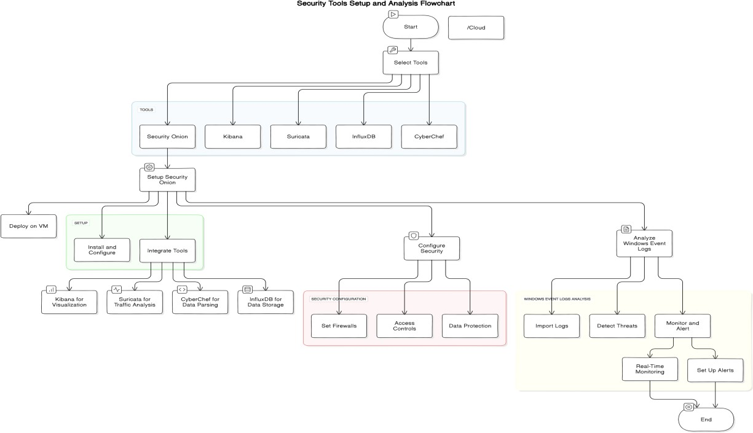

Fig 1.1 Security Tools Setup and Analysis

CHAPTER-2

APPROACH

Tools and Technologies Used
To achieve the objectives of this project, several tools and technologies were utilized:
- Security Onion: A comprehensive platform for network security monitoring and log management, integrating multiple tools into a single interface for ease of use.
- Kibana: Utilized for creating visual dashboards and analysing log data, offering insights into network activity through customizable visualizations.
- Suricata: An open-source IDS/IPS used for real-time network traffic analysis and threat detection, providing alerts for suspicious activities.
- InfluxDB: A time-series database for efficient storage and querying of log data, supporting the analysis of large volumes of time-stamped information.
- CyberChef: Employed for parsing and analysing log data to identify patterns and anomalies, enhancing data analysis capabilities.

Security Onion
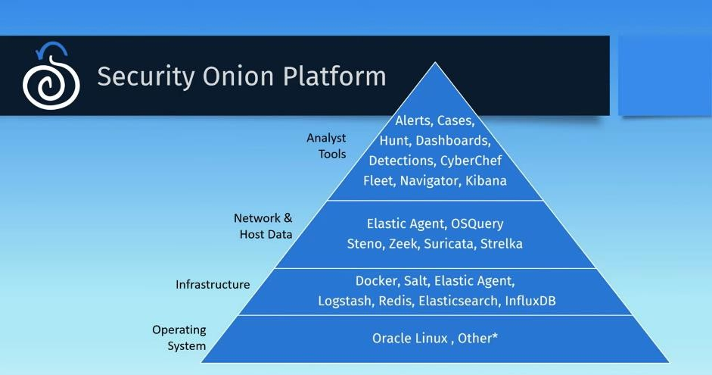
Fig 2.1 Security Tools Platform
Security Onion is selected for its robust capabilities in network security monitoring:
      - Comprehensive Integration: It combines multiple security tools into one platform, making it easier to manage and analyse network data from a single interface.
      - User-Friendly Interface: Offers an intuitive interface for configuring and monitoring network security, reducing the complexity of setup and use.
      - Unified Data Analysis: Facilitates correlation of data from various sources, providing a holistic view of network security.

Kibana, Suricata, and Additional Tools
      - Kibana: Essential for visualizing log data and generating actionable insights through customizable dashboards. It aids in identifying trends and anomalies in network activity.
      - Suricata: Provides real-time network traffic analysis and generates alerts for suspicious activities, crucial for timely threat detection and response.
      - Additional Tools: Tools like CyberChef and InfluxDB extend Security Onion’s capabilities by offering advanced data analysis and storage features.

Infrastructure Setup
Setting up the infrastructure involves deploying Security Onion on virtual machines (VMs) or cloud platforms. The process includes:

Virtual Machine and Cloud Environments
Security Onion can be deployed on either VMs or cloud platforms like Azure and AWS. This flexibility allows for scalable and adaptable solutions:
      - VM Setup: Involves configuring network interfaces, storage options, and ensuring the virtual environment supports Security Onion’s requirements.
      - Cloud Deployment: Includes setting up cloud resources, configuring network settings, and integrating Security Onion with cloud services.
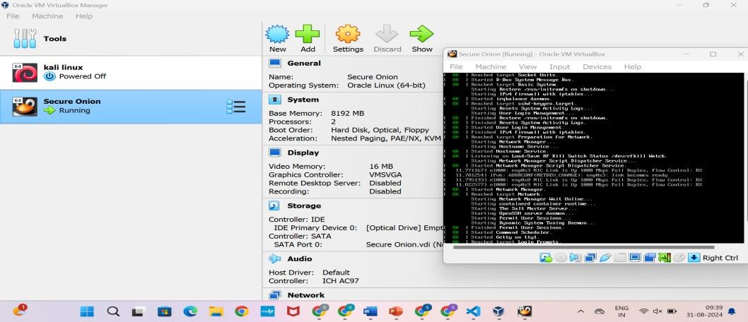
Fig 2.2 Security Onion Setup Page

Network Diagram with IP Addresses
A network diagram illustrating the setup of Security Onion, including VMs, servers, and firewalls, helps visualize the system architecture and data flow:
      - Diagram Components: Shows interconnected components with their respective IP addresses, providing a clear overview of the network setup.

Security Configuration
Proper security configuration is vital for protecting the deployed infrastructure:
      - Firewalls: Configured to control access and block unauthorized connections.
      - Access Controls: Set up to ensure that only authorized users can access sensitive data and system components.
      - Data Protection: Implement measures to prevent data breaches and unauthorized access.

Problem Statement within Infra Approach
The project aims to set up a network security monitoring system using Security Onion. This involves:
- Configuration: Setting up the infrastructure to support effective monitoring and analysis of network traffic and Windows event logs.
- Objective: Ensuring Security Onion is properly configured to detect and respond to potential security threats, enhancing overall network security.

CHAPTER-3
IMPLEMENTATION & RESULT

Implementation

Step-by-Step Process
The implementation section details the procedures for setting up Security Onion, configuring its components, and integrating Windows event logs:

Installation of Security Onion
Begin by installing Security Onion on your chosen platform:
For network visibility, we offer signature based detection via Suricata, rich protocol metadata and file extraction using your choice of either Zeek or Suricata, full packet capture, and file analysis. For host visibility, we offer the Elastic Agent which provides data collection, live queries via osquery, and centralized management using Elastic Fleet. Intrusion detection honeypots based on OpenCanary can be added to your deployment for even more enterprise visibility. All of these logs flow into Elasticsearch and we’ve built our own user interfaces for alerts, dashboards, threat hunting, case management, and grid management.
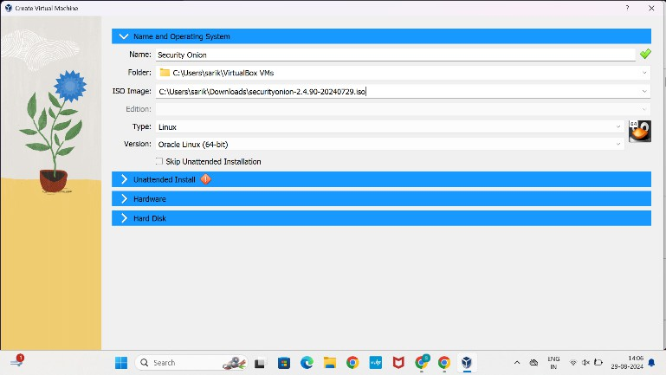
      - Installation Instructions: Follow the official guide to set up Security Onion, including network configuration, dependency installation, and component setup.

Fig 3.1 OS Setup Page

Configuration and Setup
After successfully installing Security Onion, the next critical step is configuring it to align with your specific network monitoring requirements. This involves several key components to ensure the platform is optimized for effective operation:
      - Web Console Setup: The Security Onion web console serves as the primary interface for managing and monitoring the system. Configuring this console involves setting up user accounts, defining access permissions, and customizing dashboards to display relevant security data. This setup is crucial for ensuring that the system is easily accessible and manageable, allowing for streamlined operations and efficient monitoring.
      - Network Interfaces: Properly setting up network interfaces is essential for accurate data collection. This includes configuring monitoring interfaces to capture traffic from different network segments, optimizing interface settings for maximum performance, and ensuring that all critical traffic is being monitored. This step is vital for gathering comprehensive data, which is necessary for detecting and analyzing security threats across the network.
      - Tool Integration: Security Onion integrates several powerful tools, such as Kibana for data visualization, Suricata for network intrusion detection, and CyberChef for data parsing and analysis. Configuring these tools involves setting up data flows between them, ensuring alerts from Suricata are correctly logged and visualized in Kibana, and optimizing CyberChef for advanced data manipulation. Proper
integration enhances Security Onion’s capabilities, making it a robust solution for monitoring, detecting, and responding to security threats.

Screenshots and Indicators of Compromise
Provide visual examples and analysis results:
- Screenshots: Show various configuration settings and log analysis results from Security Onion.
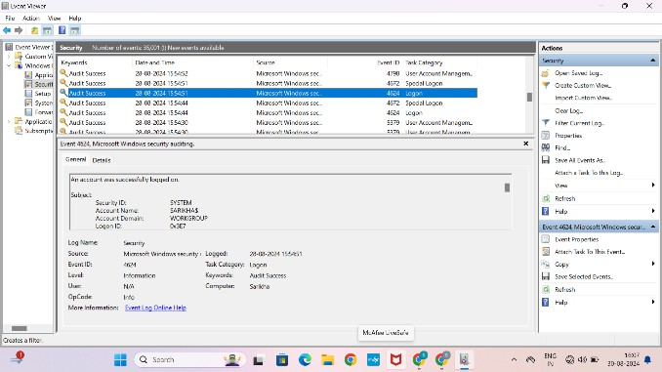
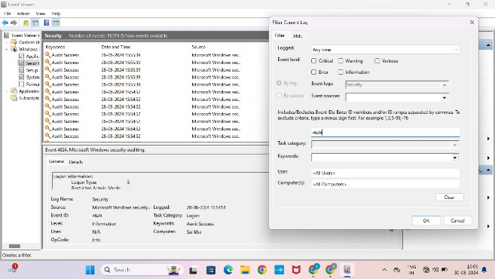
- Indicators of Compromise (IoCs): Include examples of suspicious network activity or unusual log entries identified during analysis.

Fig 3.2 Configuration settings
- Window Event Viewer.
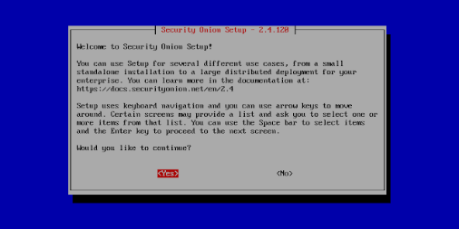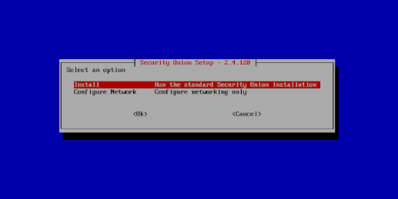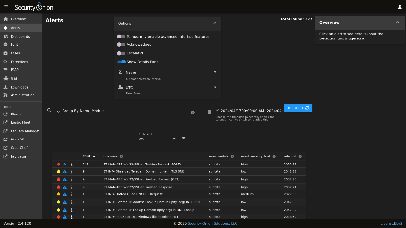
Fig 3.3 Windows Event Viewer
- Event Log Analysis.
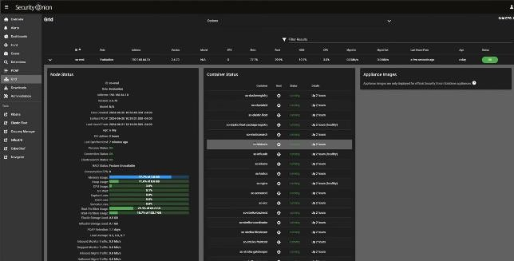
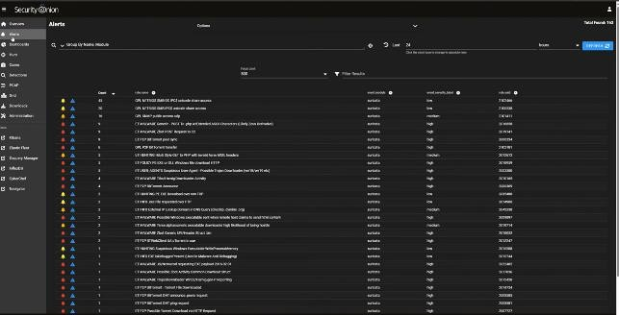
Fig 3.4 Log Analysis
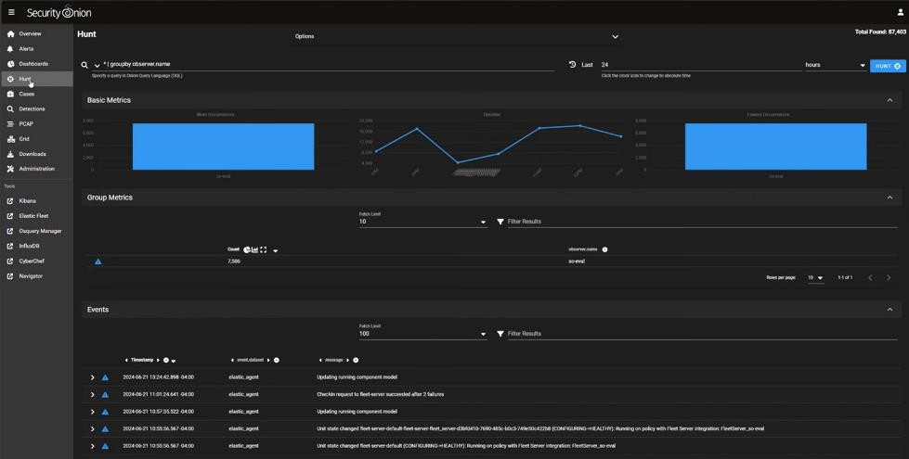
- Suspicious Network Activity.

Fig 3.5 Analysis of Network Activity
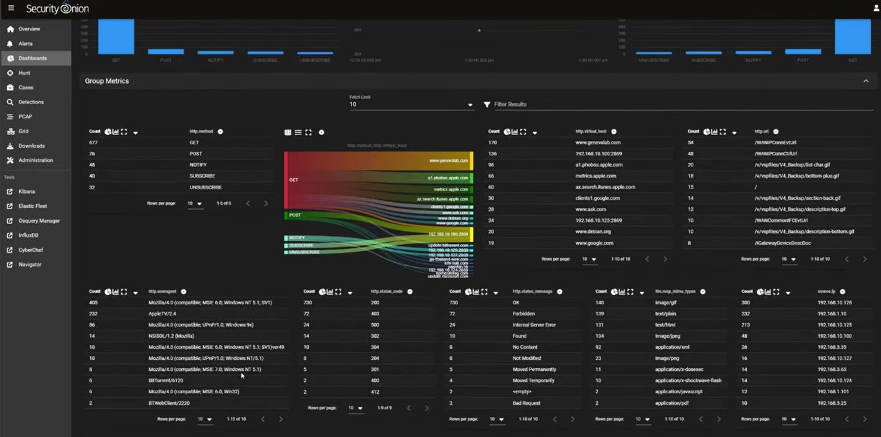
Fig 3.6 Security Onion Dashboard Visualization
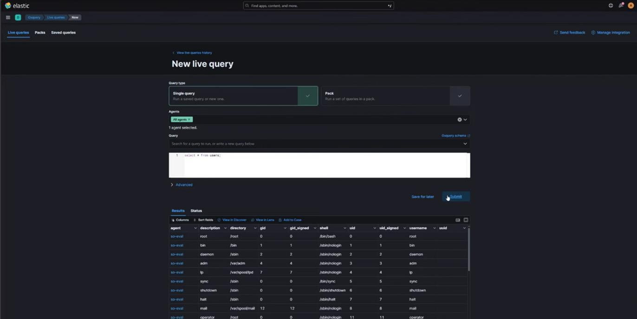

Fig 3.7 Elastic Search Live Queries
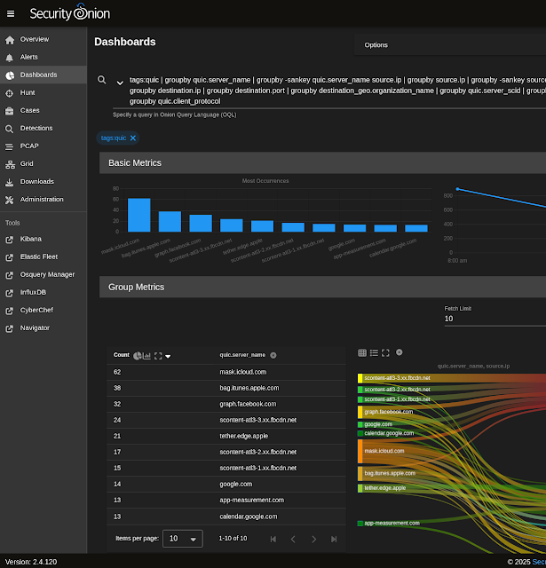
Fig 3.8 Queries Distribution Dashboard

Logs Import and Analysis
Demonstrate the process of importing and analyzing Windows event logs in Security Onion:
      - Import Process: Explain how to import logs into Security Onion.
      - Parsing and Analysis: Describe how to parse and analyze logs to detect potential security threats.
      - Visualization : Show how data is visualized in Kibana for interpretation.
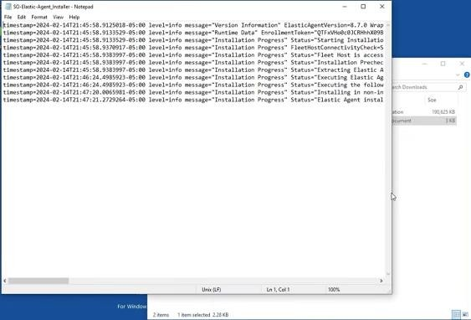
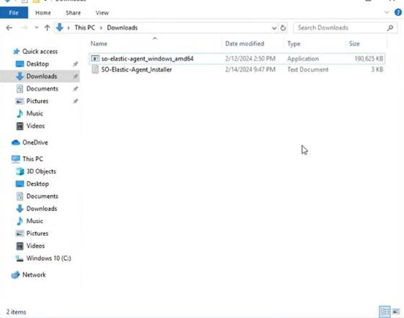

Fig 3.9 Logs Import and Analysis

Detecting Security Threats

Detection Methods
To detect anomalies and security breaches using Security Onion, several techniques are employed:

Signature-Based Detection:
  - Suricata is used to scan network traffic in real-time, comparing it against known threat signatures. This method is effective in identifying well- documented threats, such as malware or intrusion attempts.
  - Rulesets: The system uses predefined rulesets that trigger alerts when specific patterns indicative of malicious activity are detected.
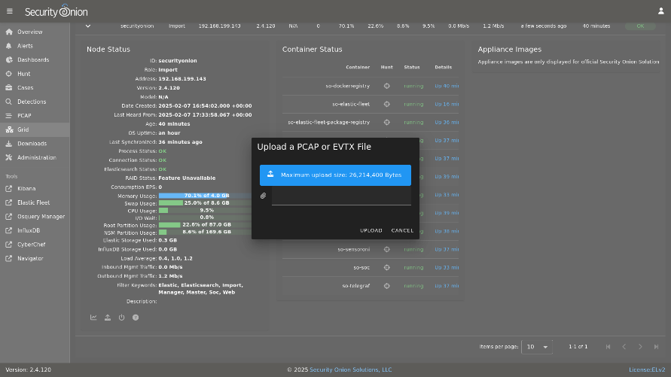

Fig 3.10 Signature-Based Detection

Anomaly-Based Detection:
  - Behavioral Analysis: By monitoring the normal behavior of network traffic and system activities, any deviation from the baseline is flagged as a potential threat. This method is particularly useful for detecting zero-day attacks or sophisticated threats that don't match known signatures.
  - Machine Learning Models: In some configurations, Security Onion can integrate with machine learning models that learn from historical data to predict and identify anomalous patterns that may indicate a security breach.
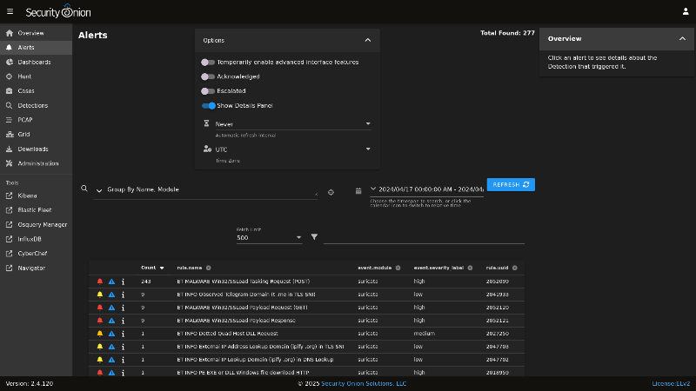

Fig 3.11 Anomaly-Based Detection

Log Analysis:
  - Windows Event Logs: Security Onion imports and analyzes Windows event logs, looking for unusual activity such as multiple failed login attempts, unauthorized access, or changes to critical system files.
  - Kibana Dashboards: Data from logs is visualized in Kibana dashboards, where security analysts can spot trends, spikes in activity, or other indicators that something is amiss.
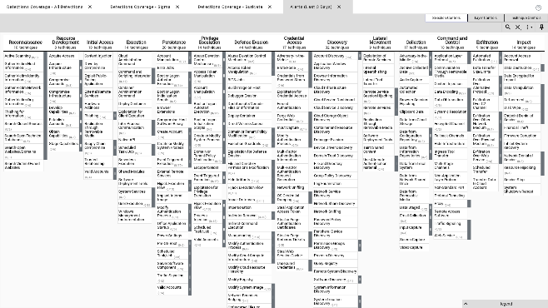

Fig 3.12 Kibana Dashboard Log Analysis

Response Actions
Upon detecting a security threat, the following response actions are typically taken:

Immediate Alerting:
  - Automated Notifications: Security Onion is configured to send immediate alerts to the security team via email or SMS when a potential threat is detected. This ensures that any suspicious activity is promptly addressed.
  - Prioritization: Alerts are categorized based on severity, helping the team prioritize responses to the most critical threats.

Incident Investigation:
  - Detailed Log Review: Analysts conduct a thorough review of the logs and alerts generated, cross-referencing them with other data sources to confirm whether the detected activity is a false positive or a genuine threat.
  - Forensic Analysis: If a breach is suspected, a deeper forensic analysis is performed. This involves tracing the activity back to its origin, identifying compromised systems, and determining the extent of the breach.

Containment and Eradication:
  - Isolating Affected Systems: In the event of a confirmed breach, affected systems are immediately isolated from the network to prevent further spread of the threat.
  - Eradication of Threats: Malicious software or unauthorized access points are removed from the system. This may involve deleting or quarantining infected files, patching vulnerabilities, or resetting compromised accounts.

Recovery and Post-Incident Actions:
  - Restoration: Systems are restored to their normal operational state from backups, ensuring that any damage caused by the breach is undone.
  - Security Enhancements: Post-incident reviews lead to the implementation of additional security measures to prevent future occurrences of similar threats. This might include updating security policies, enhancing monitoring tools, or conducting additional staff training.
CHAPTER – 4
REAL-TIME SECURITY ALERTS PROJECT

Real-Time Security Alerts Project

4.1 Integration with Chat Platforms

This project integrates Security Onion with popular chat platforms such as Discord, Slack, and Matrix to deliver real-time security alerts directly to security teams. Instead of relying solely on dashboards like Kibana, alerts are pushed instantly to communication channels where analysts collaborate daily.

Security events detected by tools such as Suricata, Zeek, and Elastic Stack are processed and formatted into readable alert messages. These alerts include critical information such as:

Alert type and severity

Source and destination IP addresses

Timestamp of the incident

Rule or signature triggered

By sending alerts directly to chat platforms, the system improves incident response time, enables team collaboration, and ensures continuous monitoring without requiring constant dashboard access.

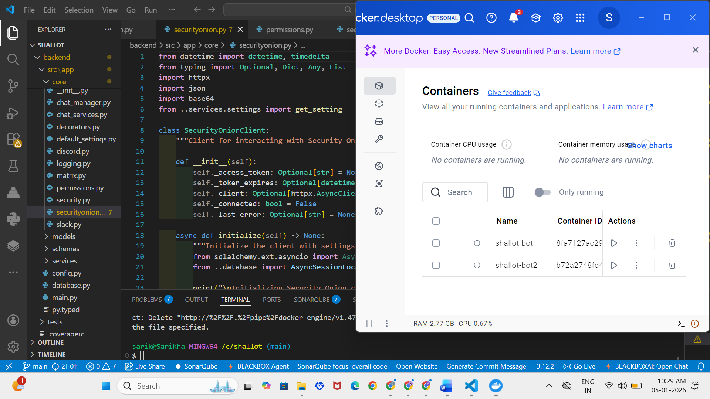

Fig 4.1 VS Code & Docker Setup

Fig 4.1 shows the development environment setup using Visual Studio Code and Docker. VS Code is used for writing and managing the backend and frontend source code, while Docker is used to build, run, and manage the Shallot Security Onion Bot container for consistent deployment.

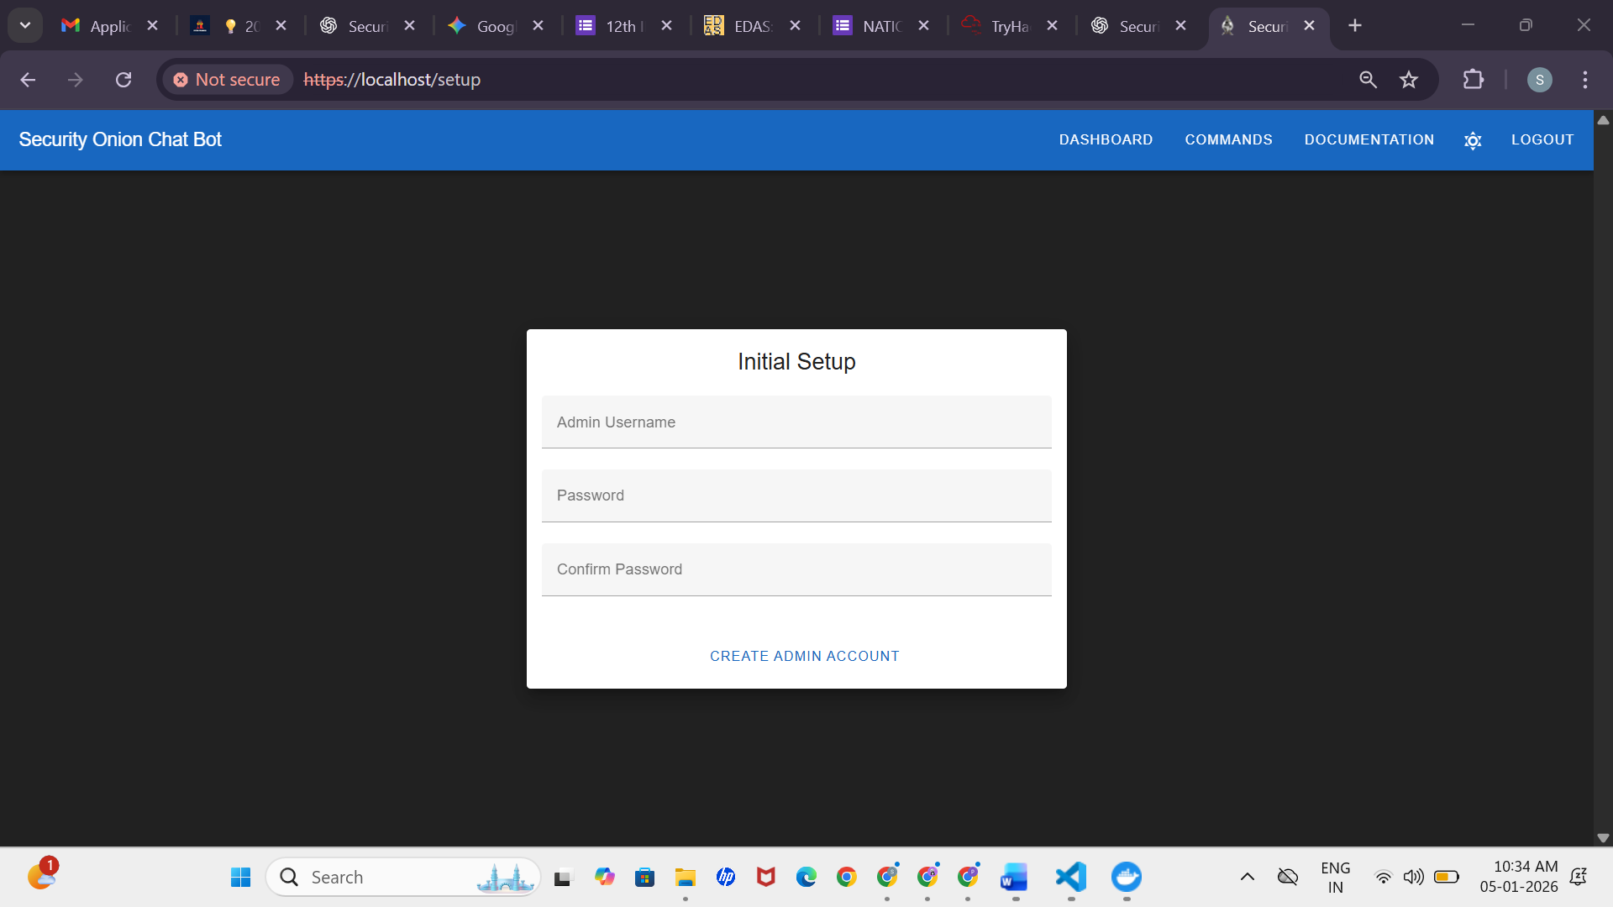

Fig 4.2 Login Page

Fig 4.2 shows the login page of the Shallot Security Onion Bot. This page is used to

authenticate users by verifying their credentials before allowing access to the

application and its security monitoring features.

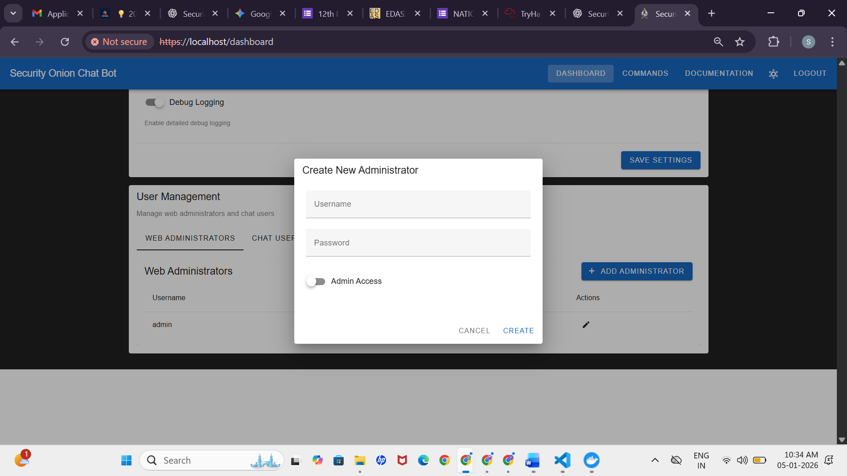

Fig 4.3 Admin Dashboard

Fig 4.3 shows the Admin Dashboard of the Shallot Security Onion Bot. This dashboard

allows the administrator to manage users, configure system settings, and monitor the overall

status of the Security Onion integration.

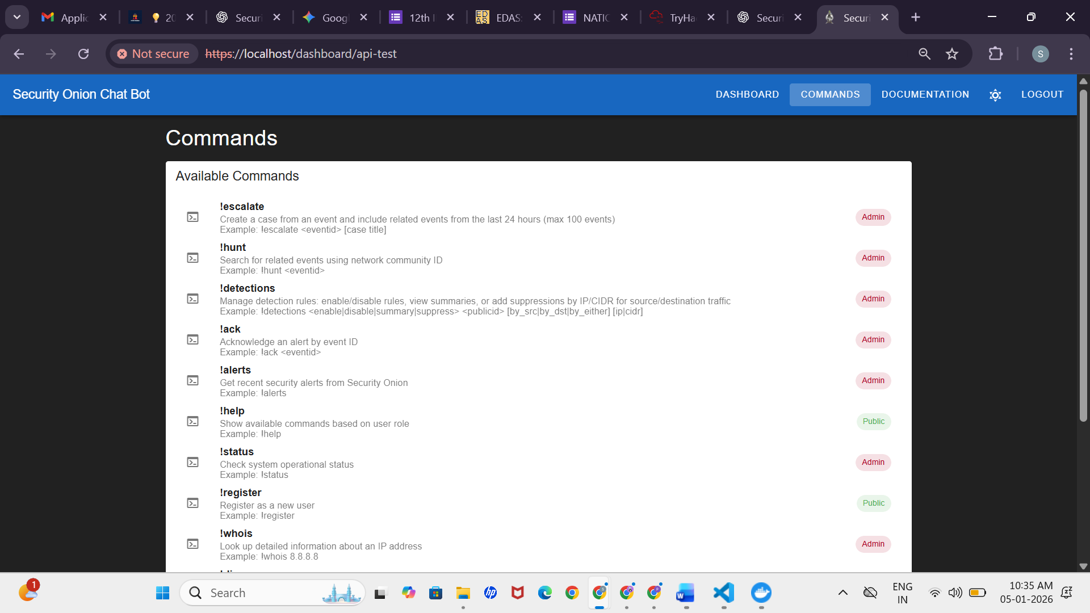

Fig 4.4 API-Test Commands Page

Fig 4.4 shows the API-Test Commands page of the application. This page is used to test and execute backend API commands, helping administrators verify authentication, bot functionality, and API responses.

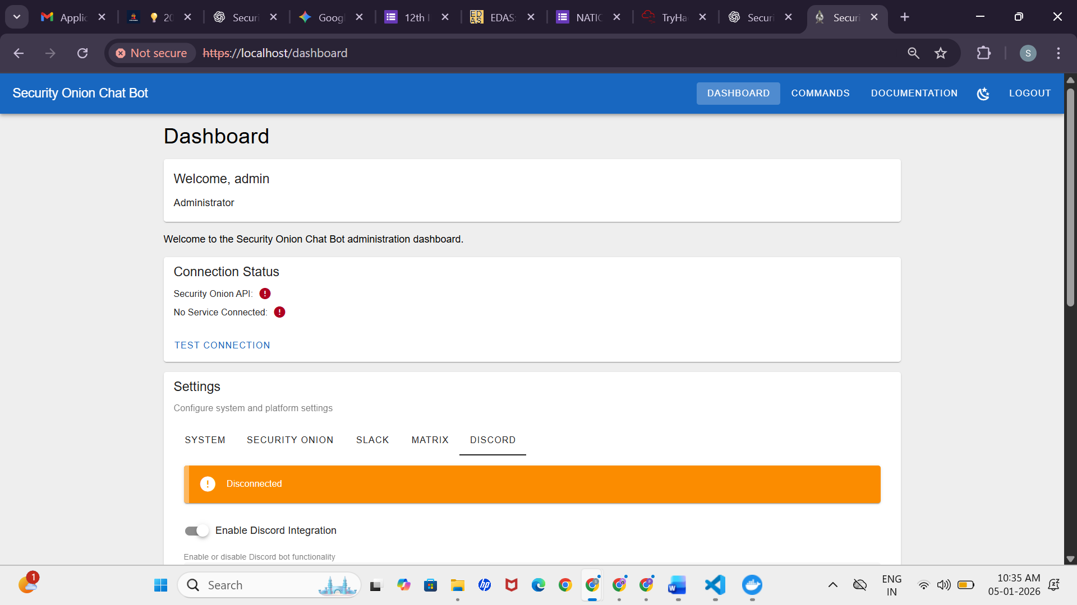

Fig 4.5 Security Onion Analysis Page

Fig 4.5 shows the Security Onion Analysis page. This page displays security alerts and event

information retrieved from the Security Onion platform, enabling users to analyze threats and

monitor network security activities.

4.2 Future Scope

The project can be further enhanced with the following future improvements:

AI-based Alert Prioritization: Machine learning models can be integrated to reduce false positives and prioritize high-risk alerts.

Automated Incident Response: Integration with SOAR tools to automatically block IPs, isolate hosts, or trigger firewall rules.

Mobile Notifications: Push alerts to mobile applications for on-the-go security monitoring.

Extended Platform Support: Support for additional platforms such as Microsoft Teams, Telegram, and email notifications.

Advanced Visualization: Interactive dashboards linked directly from chat alerts for deeper analysis.

4.3 Secure and Configurable Deployment

The alerting system is designed with a strong focus on security and configurability.

Key features include:

Token-Based Authentication - Secure API tokens are used for platform authentication to prevent unauthorized access.

Role-Based Access Control (RBAC) - Different user roles (Admin, Analyst, Viewer) ensure controlled access to commands and alerts.

Persistent Configuration Storage - Settings such as alert channels, prefixes, and permissions are stored in a database for reliability.

Docker-Based Deployment - The entire system can be deployed using Docker, ensuring portability, scalability, and easy setup across environments.

This secure architecture ensures the system is robust, scalable, and production-ready.

CHAPTER – 5

FINDINGS & RECOMMENDATIONS

Findings & Recommendations

Findings
- Effectiveness: Security Onion proved to be highly effective in monitoring network traffic and analysing Windows event logs, integrating multiple tools into a seamless platform for comprehensive security monitoring.
- Threats Detected: The system successfully identified significant security threats such as unusual login attempts, unauthorized access, and potential malware infections, demonstrating its robustness in a real-world setting.
- Insights Gained: The project revealed common vulnerabilities in the network, underscoring the importance of continuous monitoring and timely responses. Key areas for improvement included outdated software and weak access controls.

Recommendations
- Configuration Adjustments: Fine-tune Security Onion settings, such as alert thresholds and log collection, to reduce false positives and improve data accuracy.
- Additional Measures: Implement advanced threat detection tools, stronger encryption, multi-factor authentication, and regular security audits to enhance overall network protection.
- Monitoring Practices: Increase the frequency of log reviews, automate alerts for high-risk activities, and regularly update security rules to maintain proactive threat monitoring.

Countermeasures for Cyber Attacks
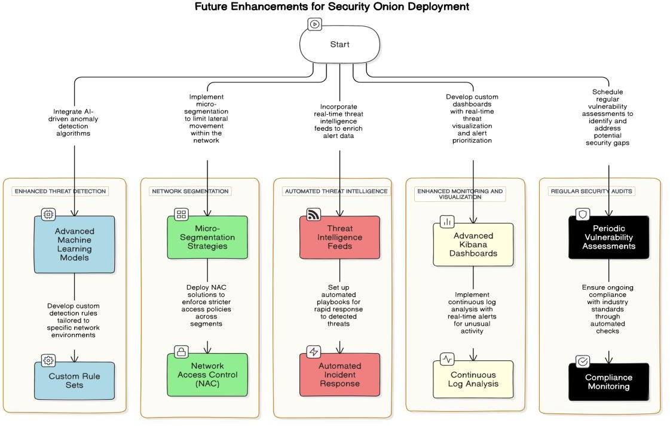
Recommend countermeasures and best practices:

Fig 5.1 Future Enhancement Flow Diagram

Future Approach for Enhancing Security Onion Deployment

Introduction
This section outlines a future approach to enhancing the Security Onion deployment, focusing on advanced threat detection, network segmentation, automated threat intelligence, enhanced monitoring, and regular security audits.

Enhanced Threat Detection
- Advanced Machine Learning Models
Objective: Integrate AI-driven anomaly detection algorithms within Security Onion to improve the identification of sophisticated threats.
Approach: Leverage machine learning models that analyze network traffic patterns and identify deviations from normal behavior. These models can be trained on historical data to recognize emerging threats that traditional signature-based detection might miss.
Outcome: Improved detection accuracy and reduced false positives, enabling more effective threat identification.

Custom Rule Sets
Objective: Develop and deploy custom detection rules tailored to the specific network environment.
Approach: Create bespoke rules based on the unique characteristics and risk profile of the organization's network. These rules will be continuously updated to address new vulnerabilities and threat vectors.
Outcome: Enhanced precision in threat detection, minimizing the chances of overlooking critical incidents.

Network Segmentation Micro-Segmentation Strategies
Objective: Implement micro-segmentation within the network to limit the lateral movement of threats.
Approach: Divide the network into smaller, isolated segments, each with its own security policies. This containment strategy ensures that even if a segment is compromised, the attacker's movement is restricted.
Outcome: Reduced risk of widespread network compromise and improved containment of potential breaches.

Network Access Control (NAC)
Objective: Deploy Network Access Control solutions to enforce strict access policies across network segments.
Approach: Utilize NAC to authenticate and authorize devices attempting to connect to the network, ensuring that only compliant and trusted devices gain access.
Outcome: Strengthened network security by preventing unauthorized devices from accessing sensitive segments.

Automated Threat Intelligence Threat Intelligence Feeds
Objective: Incorporate real-time threat intelligence feeds into Security Onion.
Approach: Integrate feeds from trusted sources to enrich alert data with the latest threat information, allowing for quicker identification of emerging threats.
Outcome: Enhanced situational awareness and faster adaptation to new threats.

Automated Incident Response
Objective: Set up automated response playbooks for rapid reaction to detected threats.
Approach: Design automated workflows that trigger predefined actions (e.g., isolating affected systems, alerting security teams) upon detecting certain threats, reducing the time to respond.
Outcome: Minimized response times and reduced impact of security incidents.

Enhanced Monitoring and Visualization Advanced Kibana Dashboards
Objective: Develop custom Kibana dashboards for real-time threat visualization and alert prioritization.
Approach: Create dashboards that provide a visual overview of network activity, highlighting critical alerts and trends for quick analysis by security teams.
Outcome: Improved visibility into network activity and more effective monitoring of potential threats.

Continuous Log Analysis
Objective: Implement continuous log analysis with real-time alerts for unusual activities.
Approach: Set up continuous monitoring of logs to detect deviations from expected behavior, with real-time alerts sent to security teams for immediate investigation.
Outcome: Early detection of suspicious activities and proactive threat management.

Regular Security Audits Periodic Vulnerability Assessments
Objective: Conduct regular vulnerability assessments to identify and address potential security gaps.
Approach: Schedule assessments to scan the network and systems for vulnerabilities, ensuring that any weaknesses are promptly mitigated.
Outcome: Maintained security posture and reduced likelihood of successful attacks.

Compliance Monitoring
Objective: Ensure ongoing compliance with industry standards through automated checks.
Approach: Implement tools that continuously monitor compliance with regulatory requirements and organizational security policies.
Outcome: Continuous adherence to security standards and reduced risk of regulatory penalties.

CHAPTER - 6
CERTIFICATE


Fig 6.1 Certificate of Completion

CHAPTER – 7
CONCLUSION & REFERNCE

Conclusion
This approach strengthens Security Onion with advanced detection, better network segmentation, and automated threat intelligence. It also improves monitoring and regular audits to enhance overall cybersecurity defenses.

List of References

GitHub Repository:
- Security Onion GitHub Repository: A comprehensive resource for accessing the source code, updates, and community discussions related to Security Onion.

Tools and Libraries:
- Kibana Documentation: Official documentation for Kibana, detailing how to set up, configure, and use Kibana for log analysis and data visualization.
- Suricata Documentation: A resource for understanding how to configure and use Suricata as an IDS/IPS in Security Onion.
- InfluxDB Documentation: Guide for using InfluxDB as a time-series database within Security Onion. InfluxDB Documentation
- CyberChef: A tool used for parsing and analyzing log data within Security Onion.
CyberChef Tool

Articles and Tutorials:
- "Getting Started with Security Onion": An introductory article on setting up and using Security Onion for network security monitoring. Getting Started with Security Onion
- "Monitoring Windows Event Logs with Security Onion": A detailed tutorial on importing and analyzing Windows event logs using Security Onion. Monitoring Windows Event Logs
- "Best Practices for Using Kibana Dashboards": Tips and best practices for creating effective Kibana dashboards for log analysis.

