  - SYLLABUS TO SONG / 25 October 2026

Website + Android App
We built both a responsive full-stack website and a native Android app for MBA Tech → CE → First year → Semester I. Both use the uploaded syllabus and reddish-orange sunrise design.
2 deliverables • 91 topics • 10 ordered units • English and Hindi
Webpage: https://syllabus-to-song-studio.aptcat4096.chatgpt.site
Website access is owner-private; sign in with the owning ChatGPT account if prompted.
Android app: Download the Android 8.0+ demonstration APK
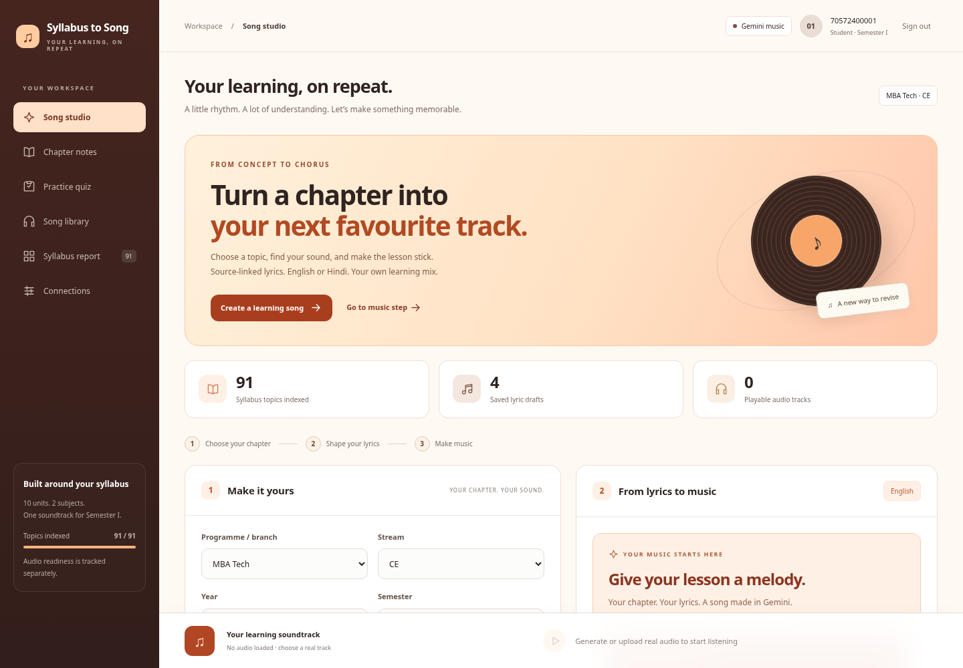
Website dashboard — current UI with sample lyric drafts; no generated song is shown.

Shared learning flow
SAP login → programme/year/semester → Calculus or BEEE → chapter/topic → English or Hindi → music preferences → reviewed lyrics → music route → permitted playback/export.
Website: responsive studio, notes, quizzes, syllabus report, library/player and reviewed source uploads. Android: native controls, local drafts/history/favourites, study tools, owner-GPU connection and Gemini browser handoff.

Native Android companion
Kotlin / Jetpack Compose • SQLite library • MediaPlayer • Android 8.0+
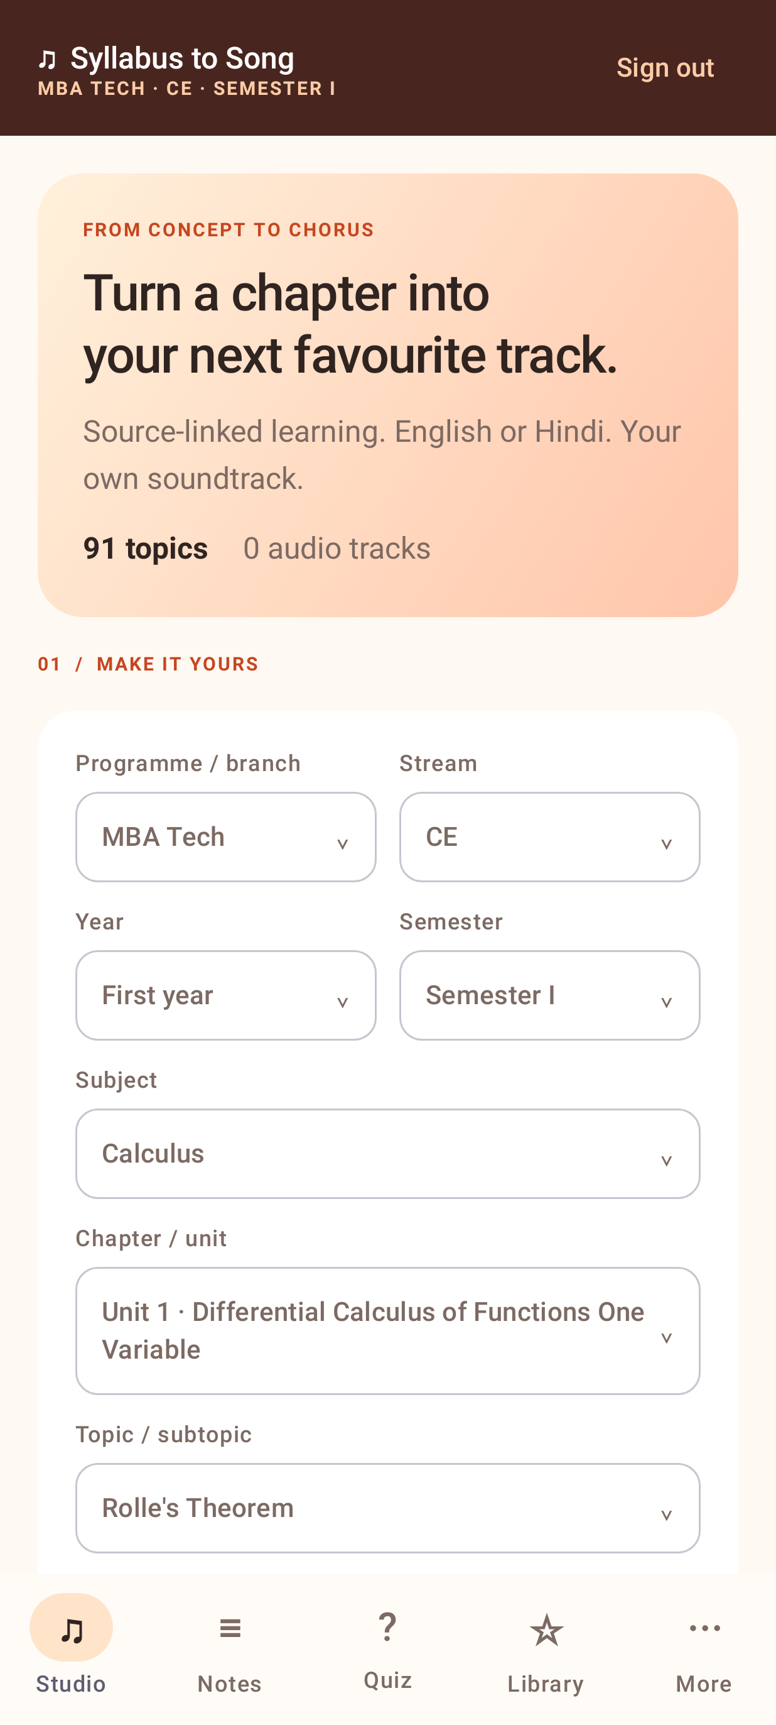 | 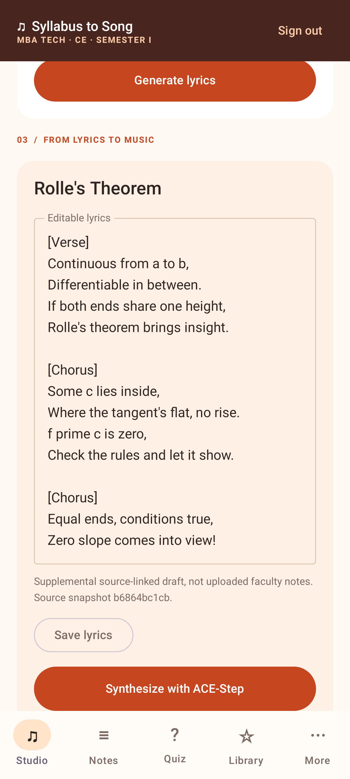 | 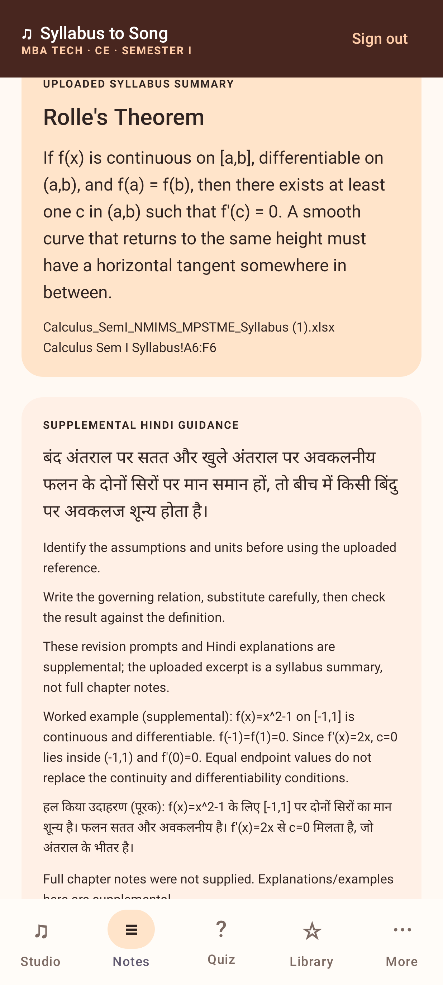
Chapter selection | Editable lyrics + ACE-Step action | Source-linked study
Actual app screens rendered in Robolectric; these are not physical-device screenshots. No audio was generated for the captures.

Implemented features
- SAP sample login, all curriculum selectors and saved editable lyric drafts.
- Genre, mood, voice, tempo, length, difficulty, formula repeats and custom instructions.
- Notes, bilingual quizzes, topic completeness and demo-admin excerpt review.
- History/favourites, foreground playback/seek/replay, permitted audio import/export.
- GPU file import with Android Keystore encryption; Gemini browser fallback.

Actual audio requires a running music service
More → Music connection → connect your running free ACE-Step GPU notebook → generate/edit lyrics → Synthesize with ACE-Step. Free GPU availability/session limits apply. The phone does not run the model.

Features and final status
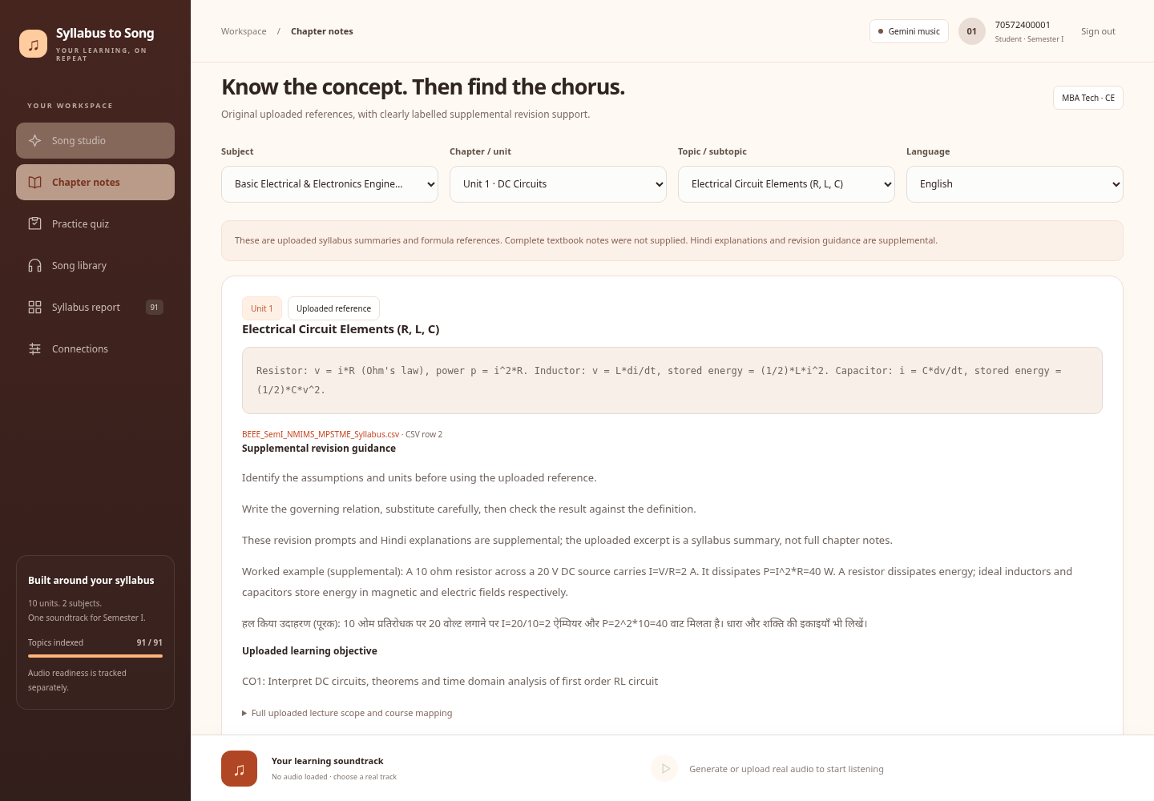 | 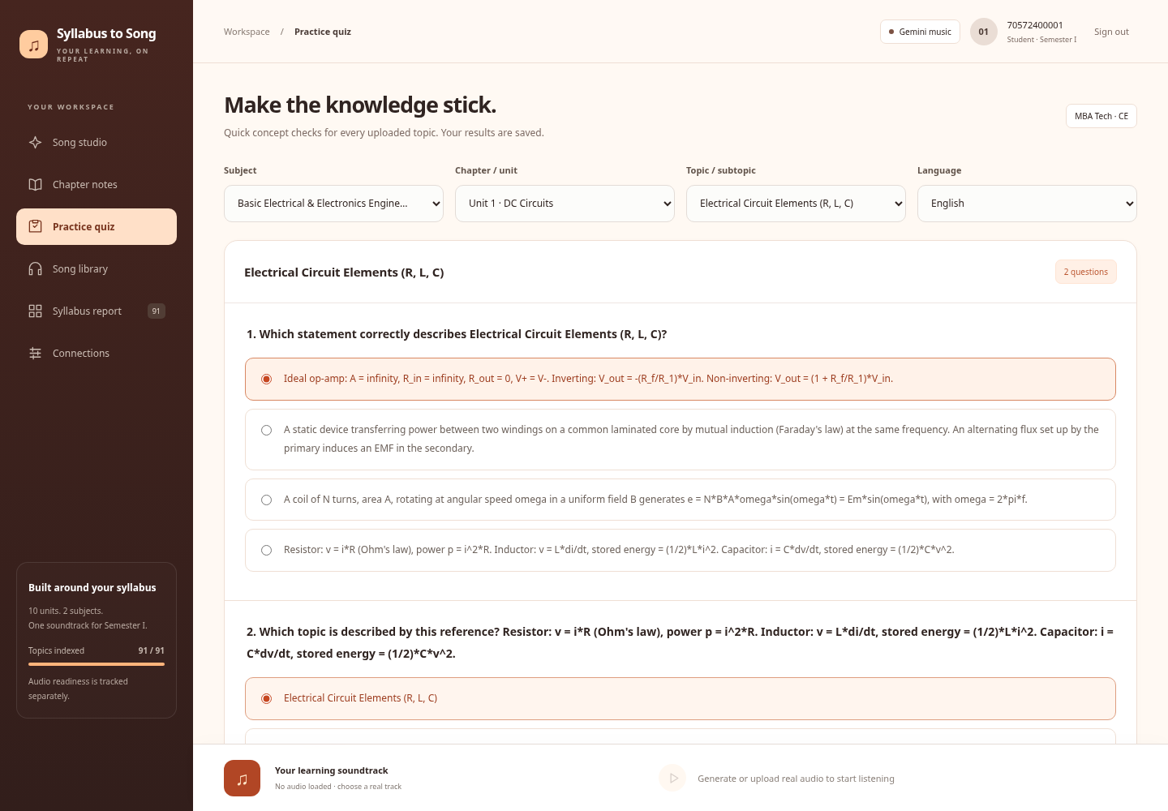
Notes & formula references | Quizzes with feedback
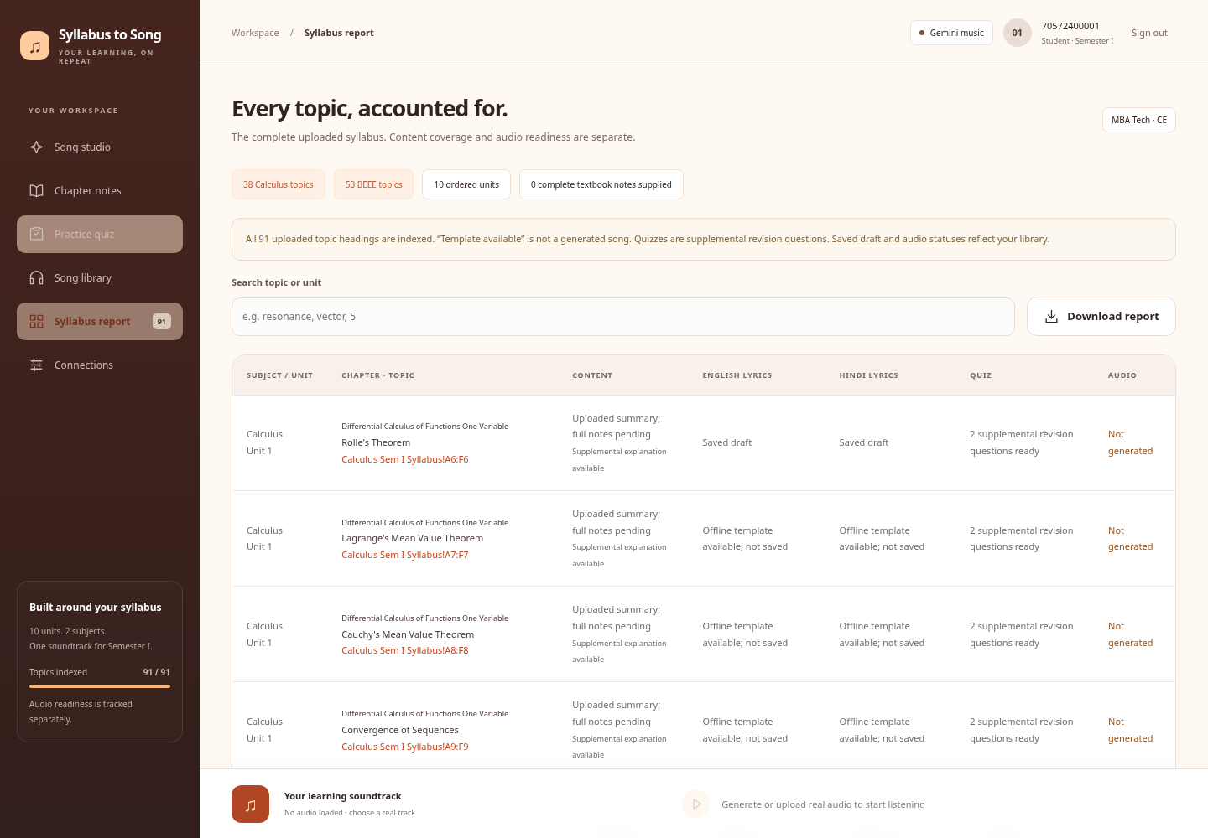 | 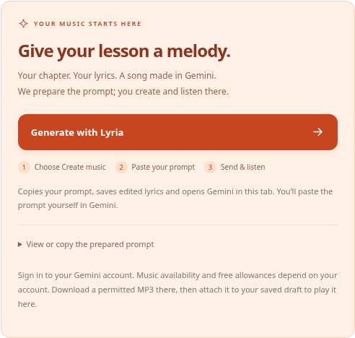
All-topic completeness report | Gemini / Lyria website handoff

Academic scope
38 Calculus + 53 BEEE topics preserve the uploaded unit order, names, source summaries, formulas, locators and supplied objectives. Full chapter notes were not supplied. Explanations, drafts and quizzes are explicitly supplemental.

Verification
38 Python checks; 7 ACE protocol tests; 2 Robolectric/Compose flow tests; Android build/lint and APK signature verification. Website browser checks cover 91 report rows, Gemini navigation, isolated fixture playback and 320/390/768px layouts. GitHub website and Android workflows passed.

Music-generation boundary
No actual educational song or singing quality has been verified through this project. Gemini requires Create music → Paste → Send in its external page. ACE-Step needs an active GPU and a real generation/listening test. No song is fabricated. Native and website libraries are separate; physical-device audio decoding is unverified.
Source: https://github.com/TechWhizSS/Intelligent_Tutoring/tree/codex/development

