# **TITLE PAGE**

# 

**A**

**TECHNICAL REPORT ON STUDENT INDUSTRIAL WORK EXPERIENCE SCHEME (S.I.W.E.S.)**

**UNDERTAKEN AT**

**COMMUNITY INNOVATION HUB**

**PLOT 24, ADJACENT ELIBEL SCHOOL, 5TH AVENUE, ABESAN ESTATE, IPAJA - LAGOS STATE.**

**BY**

**AJASA KEHINDE TIMILEHIN**

**MATRIC NO: 210591011**

**SUBMITTED TO**

**THE DEPARTMENT OF COMPUTER SCIENCE**

**FACULTY OF SCIENCE**

**LAGOS STATE UNIVERSITY, OJO**

**IN PARTIAL FULFILMENT OF THE REQUIREMENTS FOR**

**THE AWARD OF BACHELOR OF SCIENCE IN**

**COMPUTER SCIENCE**

**COORDINATOR: PROF TOYIN ENIKUOMEHIN**

# **CERTIFICATION**

This is to certify that **AJASA KEHINDE TIMILEHIN** with matric number 210591011 completed his twenty-two weeks Student Industrial Work Experience Scheme (S.I.W.E.S.) carried out at **COMMUNITY INNOVATION HUB**, Plot 24, Adjacent Elibel School, 5th Avenue, Abesan Estate, IPAJA - LAGOS STATE.

| _________________________________  **Name of Student** | _________________________________  **Signature and Date** |
| --- | --- |
| ________________________________  **Name of Academic Supervisor** | ________________________________  **Signature and Date** |

# **DEDICATION**

This project is dedicated to God Almighty for His endless grace, wisdom, and guidance throughout this journey.

To my parents, whose unwavering love, support, and encouragement have been my constant source of strength and to all the mentors and natives at the Community Innovation Hub, whose contributions, inspiration, and belief in me made this work possible. Thank you for your guidance and support.

# 

# **ACKNOWLEDGEMENT**

I would like to express my deepest gratitude to everyone who contributed to my successful completion of the SIWES program. This journey has been an enriching experience, made possible by the support and guidance of many incredible individuals.

First and foremost, I would like to sincerely thank Mr Soji Megbowon the Chief Executive Officer of the Community Innovation Hub, and Mr Adewale Paul, the Chief Technical Officer of the Hub. Their visionary leadership and mentoring were instrumental in expanding my knowledge and skills during my industrial training. Special thanks to Mrs Esther Ajayi, the Chief Operating Officer of the Hub, for her unwavering support throughout my time at the Hub. Your mentorship has shaped my professional growth.

I am also deeply thankful to Miss Daniyan Titilayomi, my SIWES supervisor at CIH, for her invaluable guidance, feedback, and support, I must also thank Miss Shedrack Olubunmi and Miss Oluwatobiloba Wonders, whose encouragement, and constant support made my time at the Hub more fulfilling. Your dedication to my development is something I will always cherish.

At Lagos State University, I am immensely grateful to Prof. Toyin Enikuomehin, my SIWES coordinator, for his dedication to ensuring that I had a well-structured and meaningful SIWES experience. I would also like to acknowledge Prof. Aribisala, for his continued inspiration and encouragement. Special thanks to Dr Aiyeniko, the Head of the Department, as well as Dr Sotonwa, Dr Oloyede, Dr Adams Zubair, Dr Adenowo, Dr Raji, Miss Orioke, Mr Shanu, and Mr Ajagbe for their excellent teaching and unwavering support throughout my academic journey.

Finally, I am grateful to my family and friends for being my pillars of strength during this phase, and to God for His guidance, strength, and wisdom that have led me to this point.

# **ABSTRACT**

This report provides an in-depth analysis of the Student Industrial Work Experience Scheme (SIWES) completed at the Community Innovation Hub, Lagos, Nigeria. The primary objective of SIWES is to offer students a platform to apply theoretical knowledge in practical, real-world scenarios, thereby enhancing their professional readiness. My role at the Hub was to instruct and mentor out-of-school children, teaching them the fundamental and advanced concepts of programming. The Hub, known for its commitment to empowering underprivileged youths through technical education, focuses on equipping students with vital skills in software development, design, and modelling.

Throughout the five-month program, I led several coding sessions, introducing students to key programming languages and guiding them through the process of building functional projects. This experience allowed me to develop not only my technical expertise in programming but also my teaching and communication skills, as I translated complex concepts into digestible lessons for a non-technical audience.

The report reflects on my contributions to the Hub's mission of fostering innovation through technology education, the challenges encountered in teaching diverse groups, and the significant growth in my professional abilities. Additionally, it provides a broader perspective on the importance of such tech hubs in addressing educational gaps in underserved communities.

The report is focused on personal reflections and suggestions for improving both the SIWES program and the operations of the Community Innovation Hub, it also emphasizes the critical role of hands-on experience in producing industry-ready graduates, highlighting the transformative impact of SIWES on both the instructor and the learners.

# **TABLE OF CONTENTS**

**TITLE PAGE 1**

**CERTIFICATION 3**

**DEDICATION 4**

**ACKNOWLEDGEMENT 5**

**ABSTRACT 6**

**TABLE OF CONTENTS 7**

**CHAPTER ONE 8**

1.1 INTRODUCTION TO THE STUDENTS INDUSTRIAL WORK EXPERIENCE SCHEME (SIWES) 8

1.2 BODIES INVOLVED IN THE MANAGEMENT OF THE STUDENT INDUSTRIAL WORK EXPERIENCE SCHEME(SIWES) 9

Functions of the Agencies Involved 10

1.3 OBJECTIVES AND SCOPE OF THE STUDENT INDUSTRIAL WORK EXPERIENCE SCHEME(SIWES) IN NIGERIA 10

1.4 THE SIGNIFICANCE OF S.I.W.E.S. IN CONVERTING THEORY-BASED LEARNING TO PRACTICAL SKILLS FOR ENHANCED PRODUCTIVITY 12

1.5 AIMS AND OBJECTIVES OF THE STUDENT INDUSTRIAL WORK EXPERIENCE SCHEME (SIWES) 14

1.6 BENEFITS OF THE STUDENT INDUSTRIAL WORK EXPERIENCE SCHEME (SIWES) TO STUDENTS 15

**CHAPTER TWO 17**

2.1 ABOUT COMMUNITY INNOVATION HUB 17

2.2 HISTORY AND EVOLUTION OF THE COMMUNITY INNOVATION HUB 17

2.3 COMMUNITY INNOVATION HUB CORE VALUES 19

2.4 OUR SERVICES 20

2.5 ORGANIZATIONAL STRUCTURE AND MANAGEMENT 22

Fig 1. Organizational Structure of CIH 22

2.6 COMMUNITY INNOVATION HUB PARTNERS 24

**CHAPTER THREE 26**

3.1 PROGRAMMING INSTRUCTION AND MENTORSHIP 26

3.1.1 INTRODUCTION TO PYTHON PROGRAMMING 26

3.1.2 PROBLEM-SOLVING AND ADVANCED PYTHON CONCEPTS 26

3.2 WEBSITE AND MOBILE APP DEVELOPMENT 28

3.2.1 WORDPRESS CMS PROJECT 28

3.2.2 MOBILE APP DEVELOPMENT USING FLUTTER 29

3.3 MEDIA, TECHNICAL SUPPORT, AND EVENT PARTICIPATION 30

3.3.1 TECHNICAL AND MEDIA SUPPORT 30

3.3.2 CASE STUDY DAYS 31

3.4 DATA SCIENCE AND MISCELLANEOUS TASKS 32

3.4.1 DATA SCIENCE INTRODUCTION 32

3.4.2 GIT AND VERSION CONTROL 33

3.4.3 MISCELLANEOUS TECHNICAL ASSISTANCE 34

3.5 NASA SPACE APPS CHALLENGE PROJECT: SHAPELY 35

**CHAPTER FOUR 38**

4.1 CHALLENGES FACED DURING S.I.W.E.S. AT C.I.H. 38

4.2 KNOWLEDGE GAINED DURING S.I.W.E.S. AT C.I.H. 38

4.3 SKILLS ACQUIRED DURING S.I.W.E.S. AT C.I.H. 39

**CHAPTER FIVE 40**

5.1 SUMMARY 40

5.2 RECOMMENDATIONS 40

5.3 CONCLUSION 41

**REFERENCES 42**

# 

# **CHAPTER ONE**

**INTRODUCTION**

## **1.1 INTRODUCTION TO THE STUDENTS INDUSTRIAL WORK EXPERIENCE SCHEME (SIWES)**

The Student Industrial Work Experience Scheme (SIWES) is a crucial component of technical and vocational education in Nigeria, designed to bridge the gap between theoretical knowledge acquired in the classroom and practical skills needed in the workplace. Established in the early 1970s, the scheme is aimed to equip students in tertiary institutions with essential skills and experiences to enhance their employability and prepare them for the challenges of the rapidly evolving job market.

Historically, the need for practical training in Nigeria's education system became increasingly evident as the nation sought to develop its industrial sector following independence in 1960. In 1973, the Industrial Traning Fund (ITF) established the SIWES program and in 1974, the Federal Government of Nigeria implemented the SIWES program also known as the Industrial Training(IT), initially targeting students in engineering, technology, and applied sciences. This initiative was part of a broader educational reform aimed at enhancing the quality of education and aligning it with national development goals(Nigerian National Policy on Education, 2013).

The SIWES program is structured to last for a minimum of six months, during which students are placed in various industries, organizations, and research institutions relevant to their fields of study. The primary objectives of the scheme include providing students with practical exposure to industrial processes, developing their technical skills, and fostering relationships between academic institutions and industries (Bassey, 2013). Additionally, a significant goal of SIWES is to enhance the employability of graduates, preparing them to contribute effectively to Nigeria’s workforce.

Participation in SIWES has grown significantly over the years. In the 2021/2022 academic session alone, it was reported that over 200,000 students from various higher institutions participated in the program, highlighting its importance and relevance in the educational landscape (National Board for Technical Education, 2022). This increase in student participation demonstrates a growing recognition of the value of industrial training in the academic journey and the commitment of institutions to prepare students for real-world challenges.

SIWES provides students with an invaluable opportunity to familiarize themselves with the practical aspects of their field of study, handling equipment and machinery that may not be available within their educational institutions. It continues to evolve and expand, playing a vital role in equipping students with the necessary skills and experience for a successful transition into the industrial work environment after graduation.

The success of SIWES can be attributed to its collaborative framework involving educational institutions, industries, and government agencies. This partnership ensures that the training provided is relevant to the current needs of the job market, thereby enhancing the employability of graduates. Moreover, the program plays a significant role in fostering innovation and entrepreneurship among students, as they gain insights into industry best practices and challenges.

## **1.2 BODIES INVOLVED IN THE MANAGEMENT OF THE STUDENT INDUSTRIAL WORK EXPERIENCE SCHEME(SIWES)**

The effective management of the Student Industrial Work Experience Scheme (SIWES) in Nigeria is facilitated by several key bodies, including the Federal Government of Nigeria, the Industrial Training Fund (ITF), and various supervising agencies such as the National Universities Commission (NUC), the National Board for Technical Education (NBTE), and the National Commission for Colleges of Education (NCCE). Each of these organizations plays a crucial role in ensuring that the SIWES program operates smoothly and meets its objectives.

### **Functions of the Agencies Involved**

1. Ensure adequate funding for the SIWES program, including student allowances and operational costs.
2. Establish and accredit SIWES units within approved institutions to maintain training standards.
3. Develop policies and guidelines that govern participation in the SIWES program.
4. Oversee students during their placements, ensuring compliance with guidelines and signing logbooks.
5. Vet and process students' logbooks and forward names to ITF area offices.
6. Ensure timely payment of allowances to students and supervisors to support their training.
7. Organize workshops and training sessions to enhance skills and networking opportunities.
8. Collect feedback from stakeholders to assess and improve the SIWES program.
9. Foster partnerships between educational institutions and industry to create real-world training opportunities.

## **1.3 OBJECTIVES AND SCOPE OF THE STUDENT INDUSTRIAL WORK EXPERIENCE SCHEME(SIWES)** **IN NIGERIA**

The Student Industrial Work Experience Scheme (SIWES) in Nigeria is designed to bridge the gap between theoretical knowledge and practical skills, ensuring that students are well-prepared for their professional careers. The primary objectives of SIWES include:

1. **Enhancement of Practical Skills:** SIWES aims to provide students with hands-on training that complements their academic learning, equipping them with the competencies required in the workforce.
2. **Exposure to Industry Practices:** The program familiarizes students with the operational dynamics of various industries, allowing them to understand industry standards and workplace culture.
3. **Development of Professional Networks:** By engaging with industry professionals, students can build valuable relationships that may lead to mentorship and job opportunities.
4. **Promotion of Entrepreneurship:** SIWES encourages students to develop entrepreneurial skills through exposure to innovative practices and business operations, fostering a mindset geared towards creativity and problem-solving.
5. **Contribution to National Development:** SIWES aligns with national development goals by providing students with the skills necessary to contribute meaningfully to various sectors, essential for economic growth.
6. **Integration with Academic Curriculum:** The program is integrated into the academic curriculum, ensuring that practical training complements theoretical learning during specified periods of study.
7. **Collaboration with Various Organizations:** SIWES fosters partnerships between educational institutions and a wide range of organizations, enhancing the quality of training provided to students.

In summary, the Student Industrial Work Experience Scheme (SIWES) in Nigeria is a vital component of the educational system that prepares students for successful careers by enhancing practical skills, providing exposure to industry practices, and fostering professional networks. SIWES ensures that students receive the hands-on training necessary for employability and entrepreneurial growth.

## **1.4 THE SIGNIFICANCE OF S.I.W.E.S. IN CONVERTING THEORY-BASED LEARNING TO PRACTICAL SKILLS FOR ENHANCED PRODUCTIVITY**

The Student Industrial Work Experience Scheme (SIWES) serves as a pivotal mechanism in bridging the gap between theoretical knowledge acquired in academic settings and the practical skills required in the workforce. Its significance lies in its ability to transform classroom concepts into real-world applications, ultimately leading to enhanced productivity among students and contributing to the overall growth of industries in Nigeria.

One of the primary challenges in higher education is the disparity between theoretical learning and practical application. While academic curricula provide essential foundational knowledge, they often lack the hands-on experiences necessary for students to fully grasp the complexities of their fields. SIWES addresses this gap by immersing students in real-world environments where they can apply their theoretical knowledge to actual problems thereby significantly enhancing understanding and retention of theoretical concepts (Kolb, 1984).

The practical training offered through SIWES equips students with essential skills that are often overlooked in traditional academic settings. For instance, students gain proficiency in using industry-standard tools, technologies, and methodologies, making them more competitive in the job market. Moreover, they develop critical soft skills, such as communication, teamwork, and problem-solving, which are crucial for success in any professional environment. According to a report by the National Skills Development Strategy, skills development is directly linked to improved productivity and economic growth (National Planning Commission, 2010).

Employers increasingly seek graduates who possess both theoretical knowledge and practical experience. SIWES enhances employability by providing students with opportunities to demonstrate their competencies in real-world settings. Many industries actively recruit graduates who have undergone industrial training, as they are often perceived as better prepared to meet the demands of the workplace. A study conducted by the Nigerian Economic Summit Group found that graduates with practical experience had a significantly higher chance of securing employment compared to their peers without such experience (Nigerian Economic Summit Group, 2017).

The exposure to real-world challenges during SIWES encourages students to think critically and innovate. By tackling genuine industry problems, students learn to devise practical solutions, thus fostering a mindset geared toward continuous improvement and creativity. This not only benefits the students by enhancing their problem-solving capabilities but also contributes to increased productivity within the organizations where they are placed. The ability to apply theoretical concepts to real challenges often leads to innovative practices that can streamline operations and improve outcomes.

SIWES plays a vital role in national economic development by ensuring that graduates possess the skills and knowledge needed to drive productivity in various sectors. As industries become more competitive, the demand for a skilled workforce that can adapt to new technologies and practices increases. The integration of practical training through SIWES equips students to meet these demands, thereby contributing to the growth and sustainability of industries in Nigeria. Furthermore, the collaboration between educational institutions and industry stakeholders fosters a culture of knowledge-sharing and innovation, which is essential for economic advancement.

## **1.5 AIMS AND OBJECTIVES OF THE STUDENT INDUSTRIAL WORK EXPERIENCE SCHEME (SIWES)**

The Student Industrial Work Experience Scheme (SIWES) is aimed at equipping students with the necessary skills and experiences to excel in their respective fields. The program's aims and objectives are designed to provide holistic development for students, preparing them for the demands of the workforce. The key aims and objectives of SIWES include:

1. **Bridging the Gap Between Theory and Practice:** SIWES aims to connect academic learning with real-world application, enabling students to apply theoretical knowledge in practical settings and thereby enhancing their understanding of course material.
2. **Preparing Students for Employment:** The program seeks to prepare students for successful careers by providing them with hands-on experience that is highly valued by employers in various industries.
3. **Encouraging Professional Development:** SIWES aims to foster professional growth by exposing students to industry practices, enhancing their skills, and promoting networking opportunities with industry professionals.
4. **Skill Acquisition:** To equip students with the practical skills and competencies necessary for their fields, ensuring they are work-ready upon graduation.
5. **Promotion of Innovation and Problem-Solving:** To encourage students to think critically and creatively by tackling real-world challenges during their industrial placements, fostering an innovative mindset.
6. **Enhancement of Employability:** To improve the employability of graduates by providing them with valuable work experience that enhances their resumes and sets them apart in the job market.
7. **Contribution to National Development:** To align with the broader goals of national development by developing a skilled workforce capable of contributing to the economic growth and sustainability of various sectors in Nigeria.

In summary, the aims and objectives of the Student Industrial Work Experience Scheme (SIWES) are designed to provide students with essential skills and experiences that enhance their employability and prepare them for successful careers.

## **1.6 BENEFITS OF THE STUDENT INDUSTRIAL WORK EXPERIENCE SCHEME (SIWES) TO STUDENTS**

The Student Industrial Work Experience Scheme (SIWES) offers numerous benefits to students, significantly enhancing their academic and professional development. The following are six key benefits that highlight the importance of SIWES in shaping students’ careers:

1. **Practical Skill Development:** One of the most significant benefits of SIWES is the opportunity for students to acquire practical skills that complement their academic knowledge. Through hands-on training, students learn to apply theoretical concepts to real-world scenarios, enhancing their technical abilities and making them more proficient in their respective fields.
2. **Enhanced Employability:** Participation in SIWES significantly boosts students' employability. Employers often prioritize candidates with practical experience, as it indicates that they are familiar with industry practices and can adapt quickly to the workplace. By completing industrial training, students enhance their resumes, making them more competitive in the job market.
3. **Networking Opportunities:** SIWES provides students with valuable networking opportunities. By working alongside industry professionals, students can establish connections that may lead to future job placements, internships, or mentorship. Building a professional network during their training can be instrumental in securing employment after graduation.
4. **Development of Problem-Solving Skills:** The challenges encountered during industrial training foster critical thinking and problem-solving skills among students. By working on real-life projects and facing industry-related challenges, students learn to analyze situations, devise solutions, and make informed decisions, essential skills that are highly valued by employers.
5. **Exposure to Industry Standards:** Through SIWES, students gain exposure to the standards and expectations of their respective industries. This experience allows them to understand workplace culture, ethics, and the importance of professionalism, which are essential for successful careers. Familiarity with industry standards also prepares students for seamless integration into the workforce.

In conclusion, the Student Industrial Work Experience Scheme (SIWES) provides students with numerous benefits that contribute to their academic success and career readiness. By fostering practical skills, enhancing employability, and offering networking opportunities, SIWES plays a vital role in preparing students for the complexities of the modern workforce.

# **CHAPTER TWO**

**HISTORY OF THE ORGANIZATION**

## **2.1 ABOUT COMMUNITY INNOVATION HUB**

The Community Innovation Hub (CIH), a subsidiary of the Teenpreneurs Educational Foundation (TEF), was established in 2021 with a vision to promote equality, diversity, and inclusion. Although CIH is relatively new, its parent organization, TEF, was founded in 2015, and since then, both entities have worked towards empowering underserved and out-of-school children through holistic education, leadership incubation, and STEM (Science, Technology, Engineering, and Mathematics) education. Together, they aim to nurture transformational leaders, instilling in them the ability to become young innovators and problem-solvers committed to addressing global challenges.

Since its inception, CIH has trained over 12,000 students, achieving remarkable outcomes in various national and international arenas. With a 30% conversion rate of its students into prestigious competitions, grants, fellowships, and scholarships, CIH stands out as a leader in tech education. Furthermore, over 12% of its students have secured scholarships to study advanced courses abroad, thanks to collaborations with external institutions like the African Leadership University (ALU).

## **2.2 HISTORY AND EVOLUTION OF THE COMMUNITY INNOVATION HUB**

1. **August 2015** 
   1. Teenpreneurs Educational Foundation (TEF) was founded with the mission to provide holistic education, leadership incubation, and STEM education to teenagers and young people, aiming to create transformational leaders.
   2. Started in a small space with just three trainers and about six students
   3. The initial focus was on individuals passionate about learning basic computer operating skills, without a particular emphasis on programming.
2. **September 2016** 
   1. A YouTube channel was created to offer free programming lessons every Saturday, targeting kids and young adults. This initiative was named the Virtual STEM Studio. The initiative has evolved to continue offering free lessons via Google Meet or Microsoft Teams, now accommodating a minimum of 50 students each Saturday from 10 am.
3. **August 2021**
   1. A subsidiary organization of TEF was created, The Community Innovation Hub (CIH). This Hub was specifically designed to serve as an innovation centre for out-of-school children in semi-urban Communities.
4. **November 2022**
   1. An initiative to cater for University students was launched called the University Co-Creation Hub (UCOhub) in collaboration with the Unversity of Medical Sciences (UNIMED) aimed at fostering innovation and collaboration among university students.
5. **June 2024**
   1. CIH now operates two innovation centres in Lagos, Nigeria, and has over 150 active students monthly. They offer training in programming, problem-solving, design, 3D modelling, animation, and communication skills.

The evolution and growth of the **Community Innovation Hub (CIH)** illustrate its dedication to educational innovation and youth empowerment in Nigeria. Established in 2021 as a subsidiary of the **Teenpreneurs Educational Foundation (TEF)**, CIH has expanded from a small initiative to two innovation centres, engaging over **150 active students monthly**. Through programs like the **Virtual STEM Studio** and outreach in secondary schools, CIH has trained more than **12,000 students**, showcasing a commitment to fostering skills in programming, problem-solving, and design, while achieving significant success in competitions and scholarships.

## **2.3 COMMUNITY INNOVATION HUB CORE VALUES**

At the Community Innovation Hub (CIH), our core values are the guiding principles that shape our mission to empower youth and drive innovation:

1. **Inclusivity:** At CIH, we actively promote inclusion, ensuring that every out-of-school child, regardless of background, has access to transformative educational experiences. We believe that diversity enriches our learning environment and fosters creativity.
2. **Innovation:** We embrace innovation as a core value, inspiring our students to think creatively and develop solutions that address pressing societal challenges. At CIH, we cultivate a culture where fresh ideas are celebrated, and entrepreneurial thinking is encouraged.
3. **Collaboration:** At CIH, we understand the power of collaboration. We forge partnerships with educational institutions, organizations, and local communities to enhance our programs and create a supportive ecosystem for our students. Together, we can achieve greater impact and drive change.
4. **Empowerment:** We are dedicated to empowering our students through holistic education and leadership incubation. At CIH, we equip young individuals with the skills, knowledge, and confidence needed to become transformational leaders in their communities and beyond.
5. **Continuous Learning:** At CIH, we champion the idea of continuous learning. We encourage our students to embrace curiosity and adaptability in an ever-evolving world, fostering a mindset that values lifelong learning and personal growth.

These core values reflect our unwavering commitment to nurturing the next generation of innovators and problem-solvers, empowering them to create meaningful change in their communities and beyond.

## **2.4 OUR SERVICES**

At Community Innovation Hub (CIH), we are dedicated to providing educational and skills development services designed to equip young people with the tools they need to thrive in the modern world. Our services are tailored to create real-world impact, focusing on areas that foster creativity, innovation, and leadership.

1. **STEM Education and Training:** We offer hands-on training in Science, Technology, Engineering, and Mathematics (STEM), with a strong focus on programming, coding, and digital skills. Through our sessions, students are introduced to essential technological skills that can set them on a path to becoming future leaders in technology.
2. **Leadership Incubation:** Our leadership programs are designed to instil a sense of responsibility, confidence, and innovation in young people. We create opportunities for students to practice leadership through team projects, mentorship, and workshops aimed at developing strong interpersonal and problem-solving skills.
3. **Workshops and Bootcamps:** CIH hosts a series of workshops and intensive bootcamps focused on programming, design thinking, and 3D modelling. These sessions are designed to give participants deep practical knowledge in key areas of tech while working on real-life projects.
4. **Virtual Learning Platforms:** With the Virtual STEM Studio, we provide free online classes that reach students across Nigeria and beyond. These sessions are available on weekends and are hosted via platforms like Google Meet and Microsoft Teams, where students learn programming and other digital skills in an interactive, virtual environment.
5. **Outreach Programs:** Our outreach programs extend to secondary schools where we bring the CIH experience directly to students in their learning environments. Through these initiatives, we teach skills like programming, animation, and design thinking, ensuring that no student is left behind.
6. **Scholarships and Competitions:** CIH connects students with scholarship opportunities, both locally and internationally, while also preparing them for tech competitions that open doors to grants and fellowships. This is a part of our vision to create pathways for young innovators to access global opportunities.

Our services are designed to ensure that every student, regardless of their background, is equipped with the knowledge and skills to succeed in an increasingly digital and innovation-driven world.

## **2.5 ORGANIZATIONAL STRUCTURE AND MANAGEMENT**

The supplied organogram image presents a clear visualization of the organization's structural layout, showcasing the various roles and connections among different levels within the company.

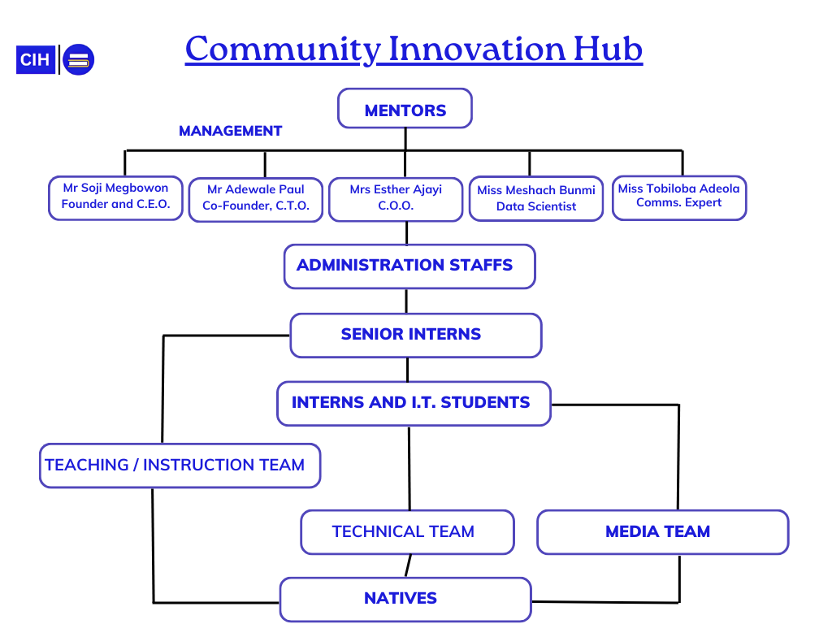

#### Fig 1. Organizational Structure of CIH

Below is a brief of the various functions performed by each department in the Organization:

1. **Mentors:**

Mentors play a crucial role in guiding and coaching students (referred to as "Natives"). They help shape the learning experience by providing hands-on guidance, fostering creativity, and assisting learners in solving real-world problems. Mentors also serve as role models, helping students transition from theory to practical application.

1. **Management Team:**

The management team, which consists of the CEO, CTO, and COO, not only oversees the strategic operations of CIH but also serves as mentors. They are responsible for making major decisions that influence the direction of the hub, ensuring that resources are well-utilized, and fostering an environment of innovation and collaboration.

1. **Administrative Staffs:**

This team ensures the smooth day-to-day operations of CIH. Led by the Secretary, the administrative staff handles payroll, keeps records, and maintains general office management tasks. The Secretary is the point person for all administrative matters and works closely with the management team to ensure operational efficiency.

1. **Senior Interns:**

Senior Interns have the primary responsibility of instructing and teaching the Natives. They provide direct training and mentorship, guiding learners through various technical subjects such as programming, design, and animation. They are a vital link between the management and the interns, ensuring that the instructional goals of the hub are met.

1. **Interns and IT Students:**

Interns and IT students serve as the operational backbone of the hub. Their roles are diverse, ranging from supporting the technical infrastructure to handling media-related tasks. They are also integral to the daily functioning of CIH, ensuring that projects run smoothly and that technical challenges are swiftly addressed.

1. **Technical Team:**

The technical team focuses on maintaining the technical infrastructure of CIH. This includes setting up systems, troubleshooting issues, and ensuring that all technical tools used for training and project development are in perfect working order. They collaborate closely with the other teams to enable smooth execution of all activities.

1. **Media Team:**

This team is responsible for documenting and showcasing the work being done at CIH. They manage the hub’s social media presence, produce visual content for promotional purposes, and help project the hub's mission and activities to a wider audience. Their role is crucial for maintaining the hub’s brand and attracting new students and partners.

1. **Instruction/Teaching Team:**

The instruction team is primarily responsible for delivering the educational content. They work closely with the senior interns and mentors to prepare lesson plans, conduct workshops, and ensure that students are gaining practical knowledge and skills in programming, design thinking, and other relevant areas.

1. **Natives (Students/Learners):**

At the base of the hierarchy are the Natives, the learners who come to CIH to acquire new skills. They are the focus of all activities and initiatives at the hub. Natives are engaged in various learning modules that equip them with skills to become future innovators and problem solvers.

## **2.6 COMMUNITY INNOVATION HUB PARTNERS**

The Community Innovation Hub (CIH) collaborates with several distinguished organizations, both local and international, to advance its mission of providing transformative education and opportunities for young innovators. These partnerships strengthen CIH's capacity to empower underserved communities, equipping them with the tools and resources for success. CIH partners include:

1. **NASA:** National Aeronautics and Space Administration.
2. **LSI:** Limitless Space Institute, an organization focused on advancing human space exploration and inspiring the next generation of space scientists.
3. **LASRIC**: Lagos State Research and Innovation Council, a body dedicated to fostering research and innovation in Lagos State.
4. **Microsoft ADC**: Microsoft Africa Development Center, providing technological support and innovation platforms.
5. **Cuppy Foundation:** A philanthropic foundation established by DJ Cuppy (Florence Otedola) focused on education and empowerment initiatives.
6. **HP:** Hewlett-Packard, a leading global technology company.
7. **British Council:** The UK's international organization for cultural relations and educational opportunities.

These partnerships contribute significantly to CIH's growth and its ability to impact young minds through education, technology, and leadership incubation.

# **CHAPTER THREE**

**DESCRIPTION OF WORK DONE AS AN INTERN AND I.T. STUDENT**

During my SIWES internship at the Community Innovation Hub (C.I.H.). I gathered a lot of practical and hands-on experience most of which was focused on both teaching and developing software programs, some of the activities included:

## **3.1 PROGRAMMING INSTRUCTION AND MENTORSHIP**

Throughout my stay at Community Innovation Hub, a significant part of my work involved teaching programming skills to learners referred to as the "Natives" at the hub. This was a continuous process that built on each lesson, aimed at developing their coding abilities from the basics to advanced concepts.

### **3.1.1 INTRODUCTION TO PYTHON PROGRAMMING**

I began with the fundamentals of Python, including topics like variables, data structures (lists, arrays), and control structures (loops, if-statements). The aim was to give the learners a solid foundation in coding principles, ensuring they understood concepts like variable declaration, casting, and indexing in Python. This culminated in hands-on practice sessions where students used platforms like HackerRank to solve real-life coding problems.

### **3.1.2 PROBLEM-SOLVING AND ADVANCED PYTHON CONCEPTS**

As the weeks progressed, I introduced more complex topics such as modularity, functions, and object-oriented programming (OOP). The learners were taught how to create and call functions, use libraries like Pygame, and implement OOP principles like inheritance and abstraction. These topics were reinforced with challenges on LeetCode, helping learners improve their logical thinking and problem-solving techniques.

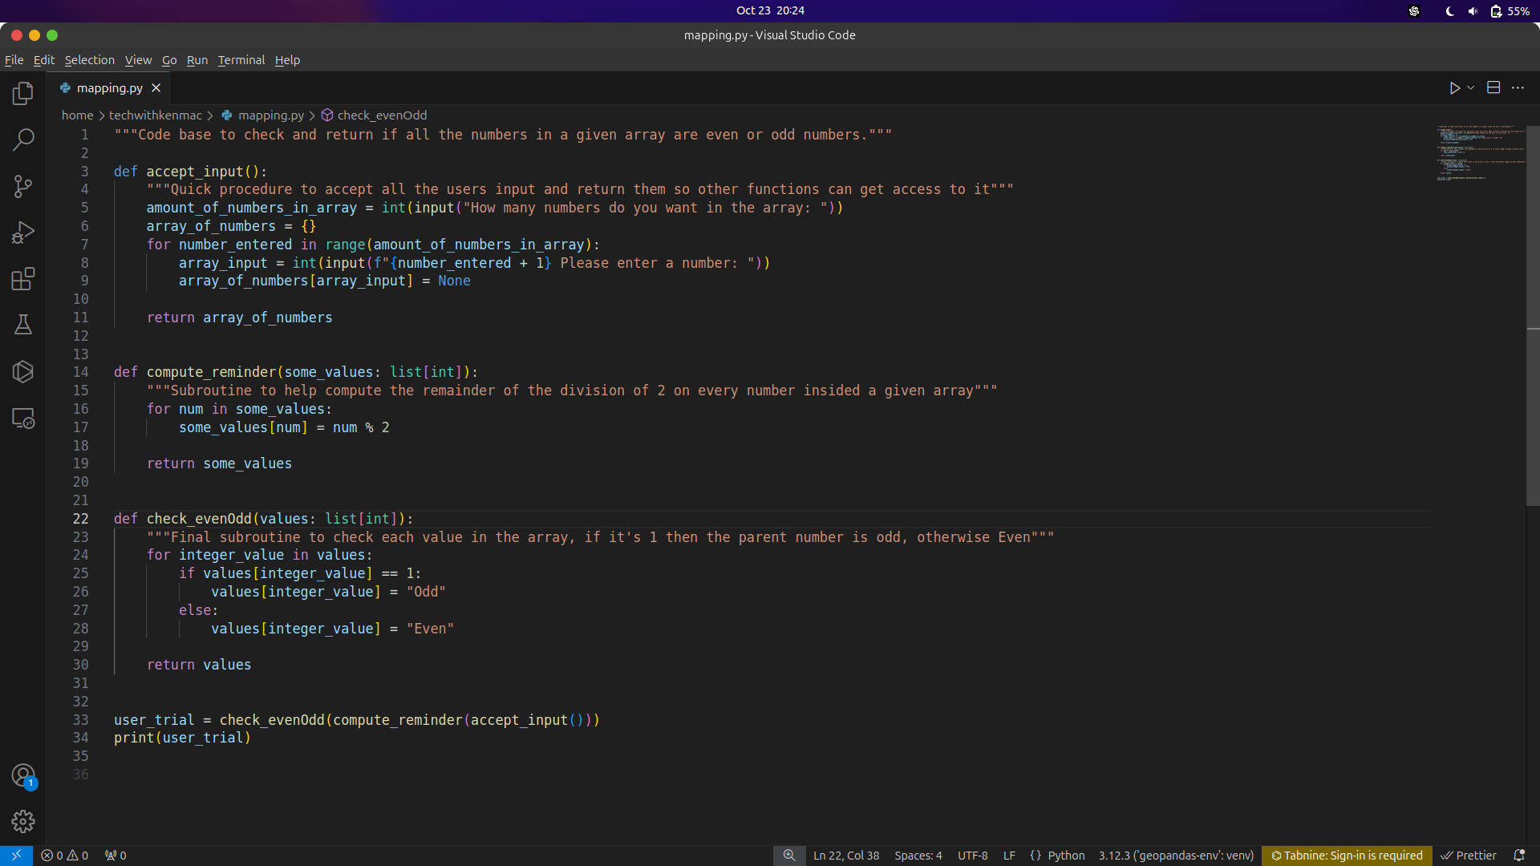

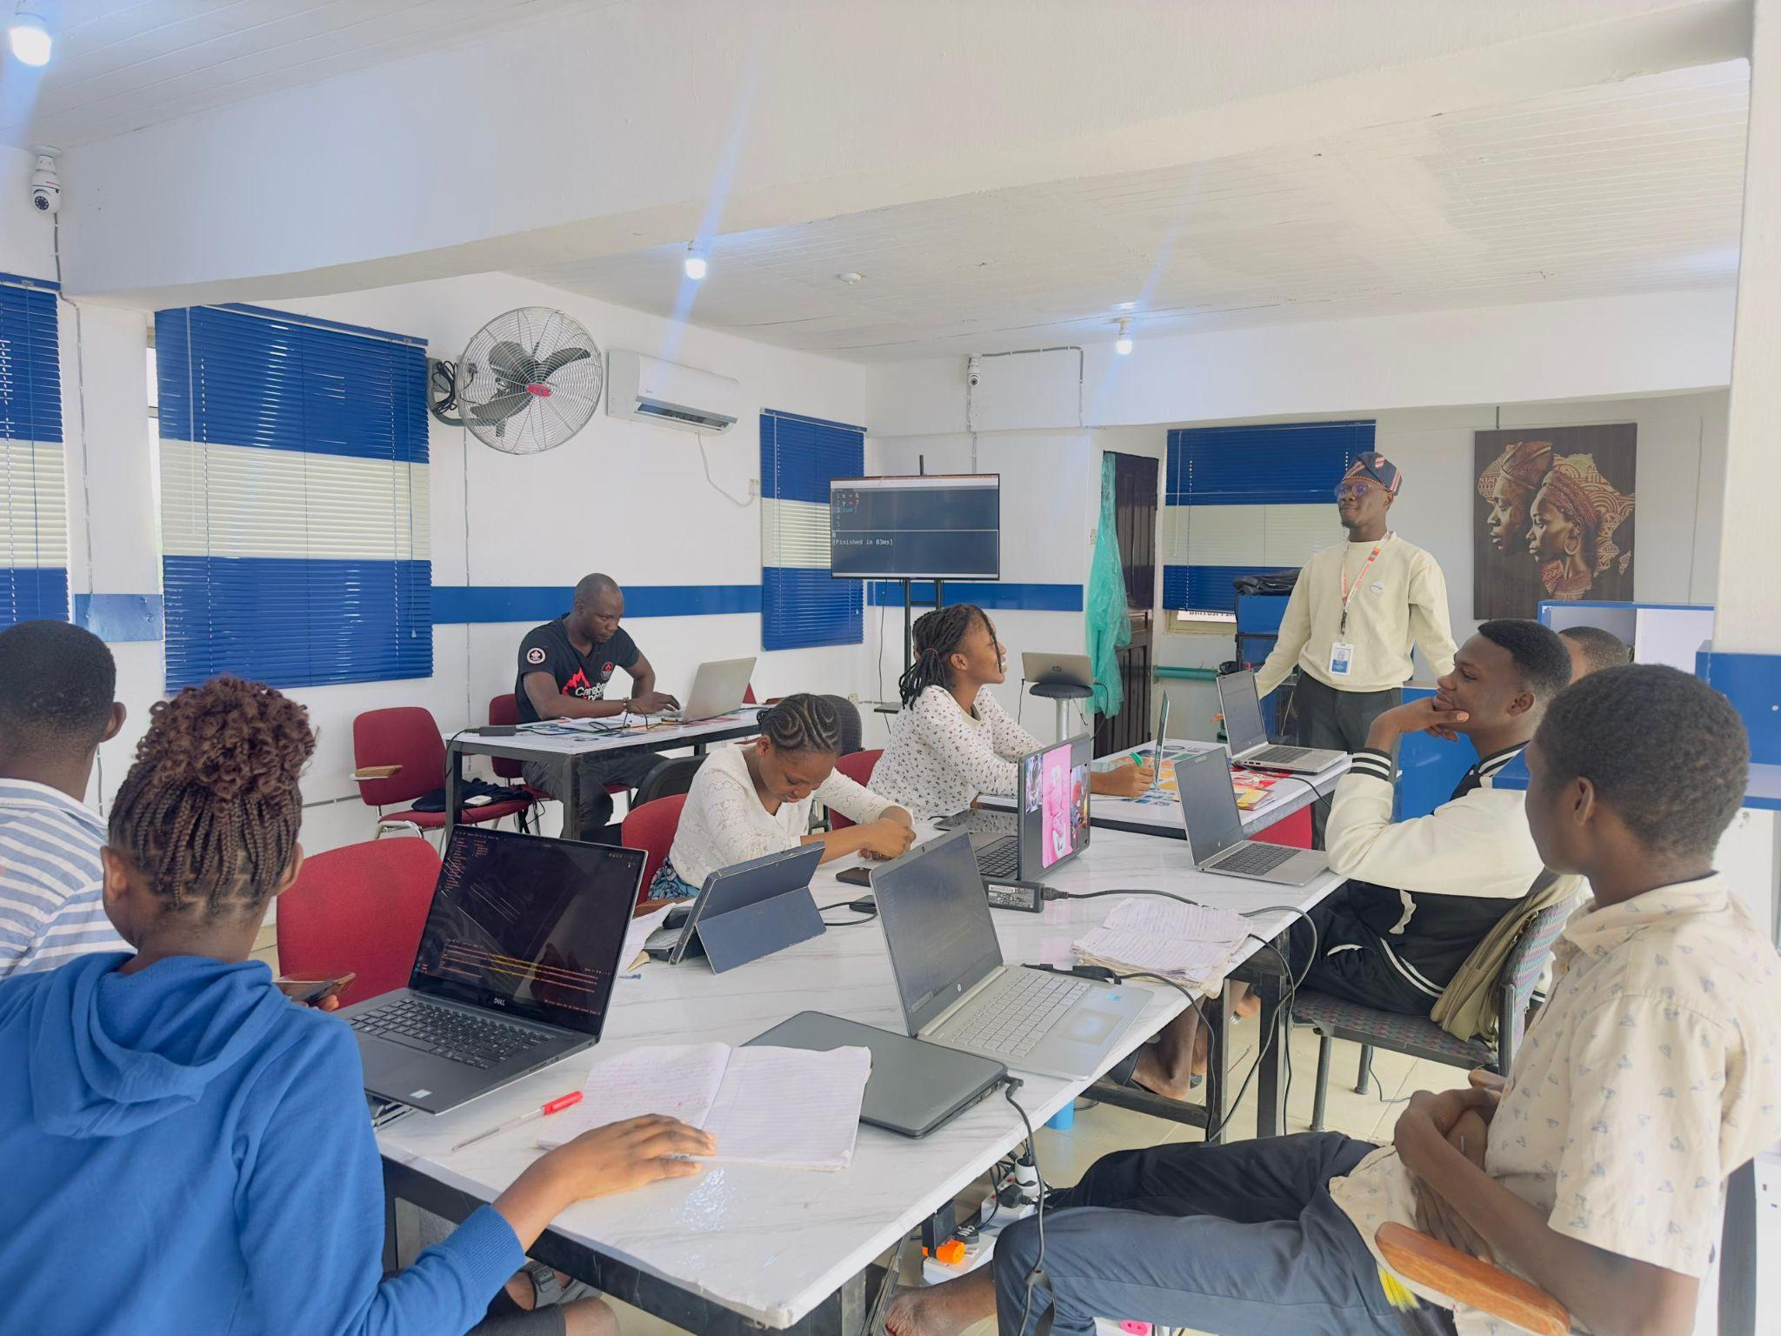

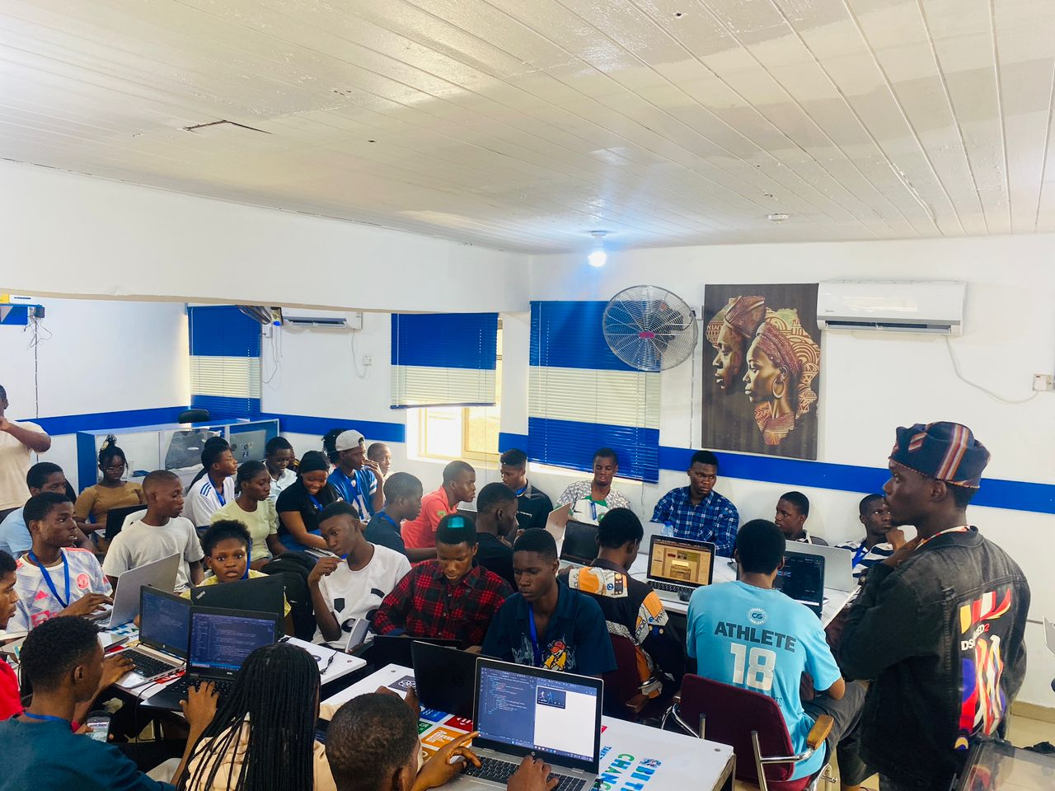

## **3.2 WEBSITE AND MOBILE APP DEVELOPMENT**

Another significant aspect of my internship was working on various projects, ranging from teaching the basics of web development to building basic mobile applications with Flutter. These tasks enabled me to enhance my skills while contributing to real-world solutions.

### **3.2.1 WORDPRESS CMS PROJECT**

I worked extensively with the WordPress Content Management System to build websites without needing to write code from scratch. Starting with basic setup and installation with the WAMP server (Windows, Apache, MySql and PHP), I developed portfolio websites for natives at the hub. I integrated features like menus, dropdown buttons, and header/footer elements to enhance the aesthetic and functionality. The portfolio websites were responsive and visually appealing.

### **3.2.2 MOBILE APP DEVELOPMENT USING FLUTTER**

Later in my internship, I was introduced to mobile app development using Flutter. I learned about creating widgets and integrating images in apps, as well as handling stateful and stateless widgets. My work culminated in building a dice-randomizer app, showcasing my grasp of

Flutter's framework

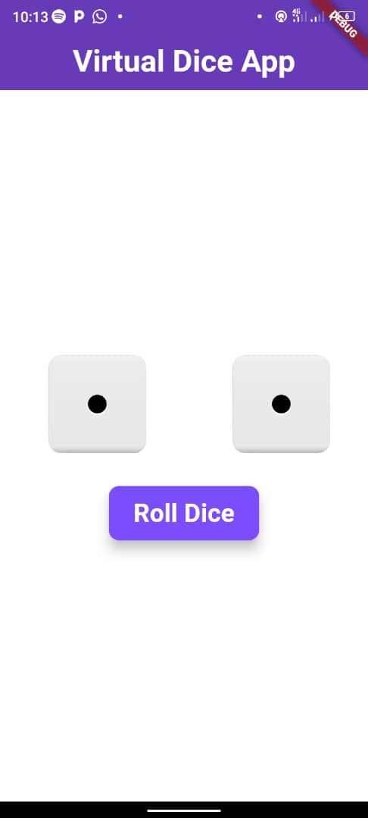

## **3.3 MEDIA, TECHNICAL SUPPORT, AND EVENT PARTICIPATION**

My role extended beyond teaching to assisting with technical and media-related tasks, particularly during important events at the hub.

### **3.3.1 TECHNICAL AND MEDIA SUPPORT**

During CIH’s organized events like Sexual Awareness Day, Hackathons, and CIH Tech-FEST, I was part of the media and technical team responsible for ensuring the event ran smoothly. I helped manage presentations, set up audio-visual equipment, and ensured the technical components, like projector setups, were functional. My involvement allowed me to contribute to the hub's activities beyond just teaching.

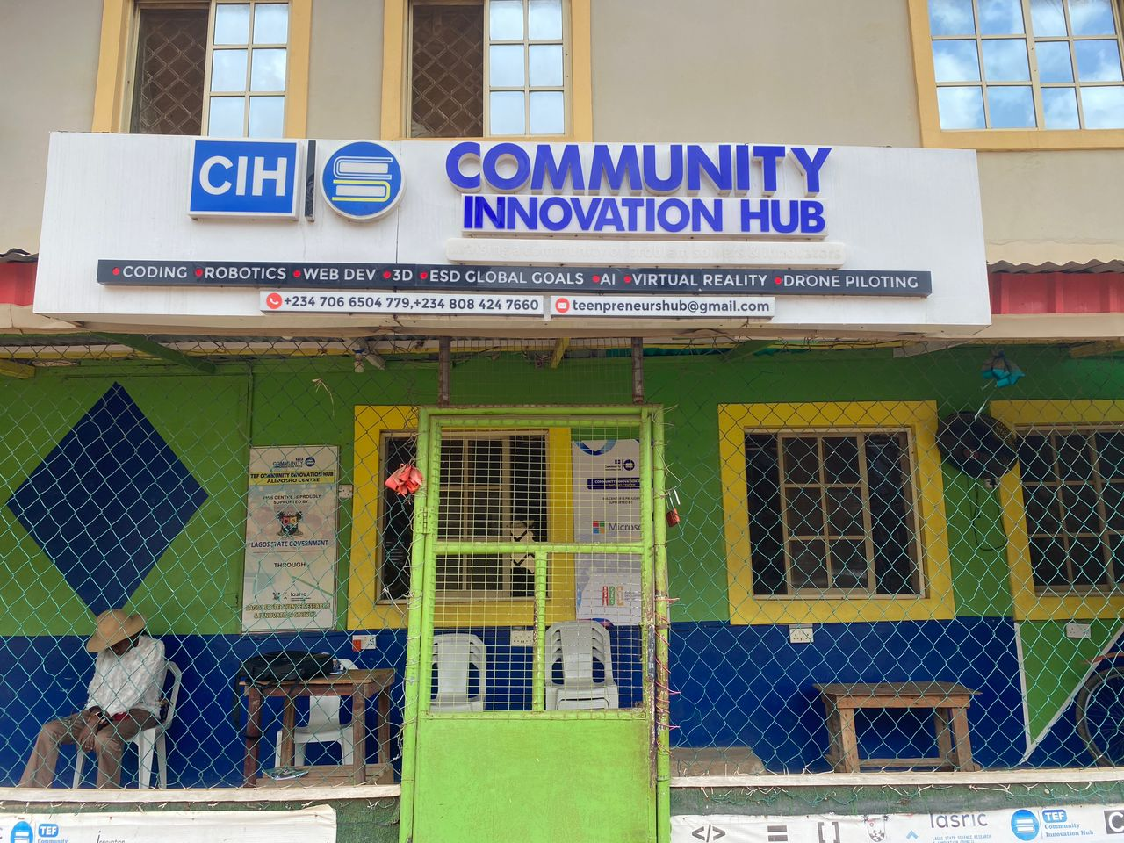

### **3.3.2 CASE STUDY DAYS**

Regular Case Study Days were held to expose the learners to real-world challenges such as time management, communication skills, and problem-solving. My role in these events often included providing technical assistance and supporting the media team in setting up displays and presentations. These events helped foster both personal development and the learners' ability to function in professional environments.

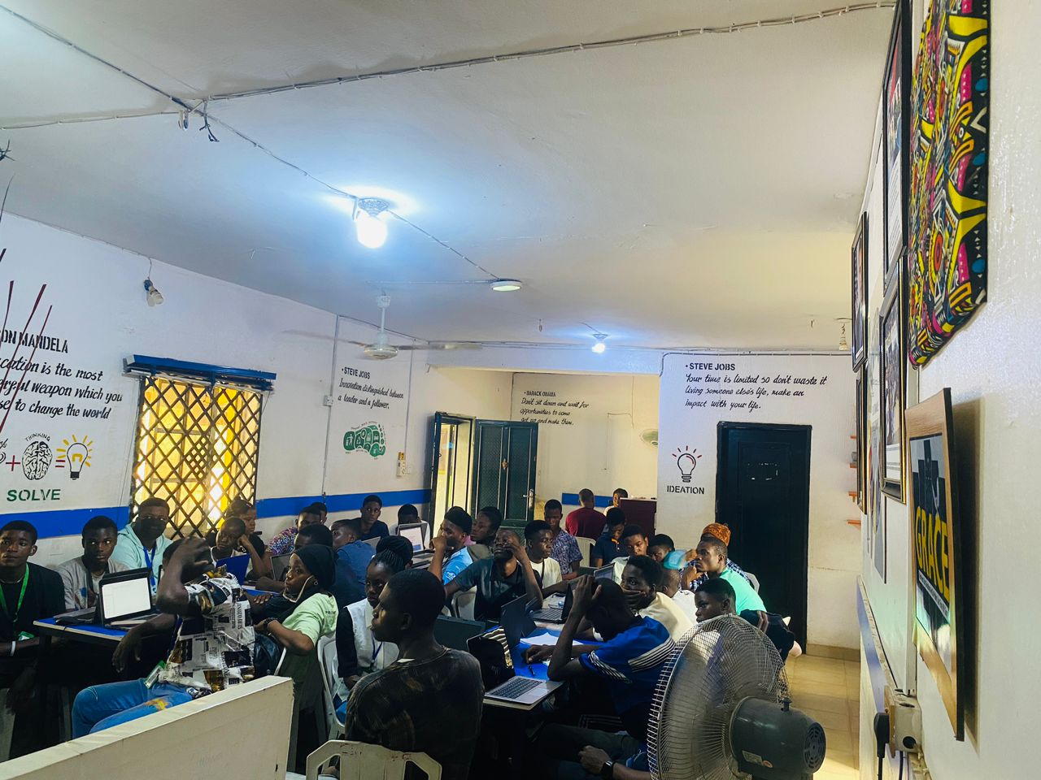

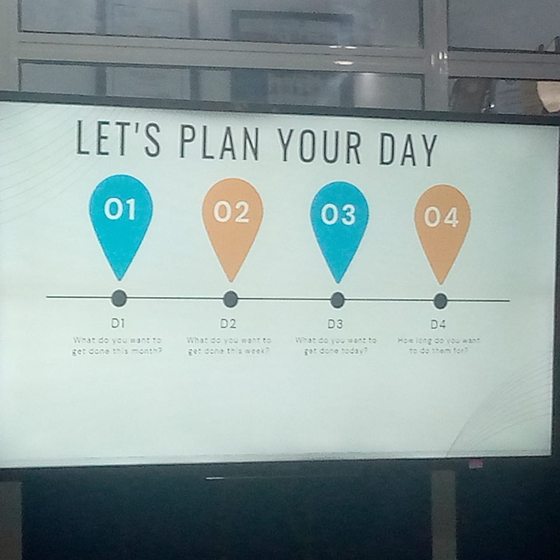

## **3.4 DATA SCIENCE AND MISCELLANEOUS TASKS**

In addition to programming and development, I engaged in a wide range of other activities that further enhanced my knowledge and skills.

### **3.4.1 DATA SCIENCE INTRODUCTION**

I was introduced to the field of data science, learning about data cleaning, data visualization, and basic terminologies. Using the Microsoft Excel spreadsheet Package, I worked on small-scale data projects, including a sales record dashboard for the hub. This dashboard displayed metrics like total sales, profit margins, and quarterly statistics, adding value to the organization’s internal management.

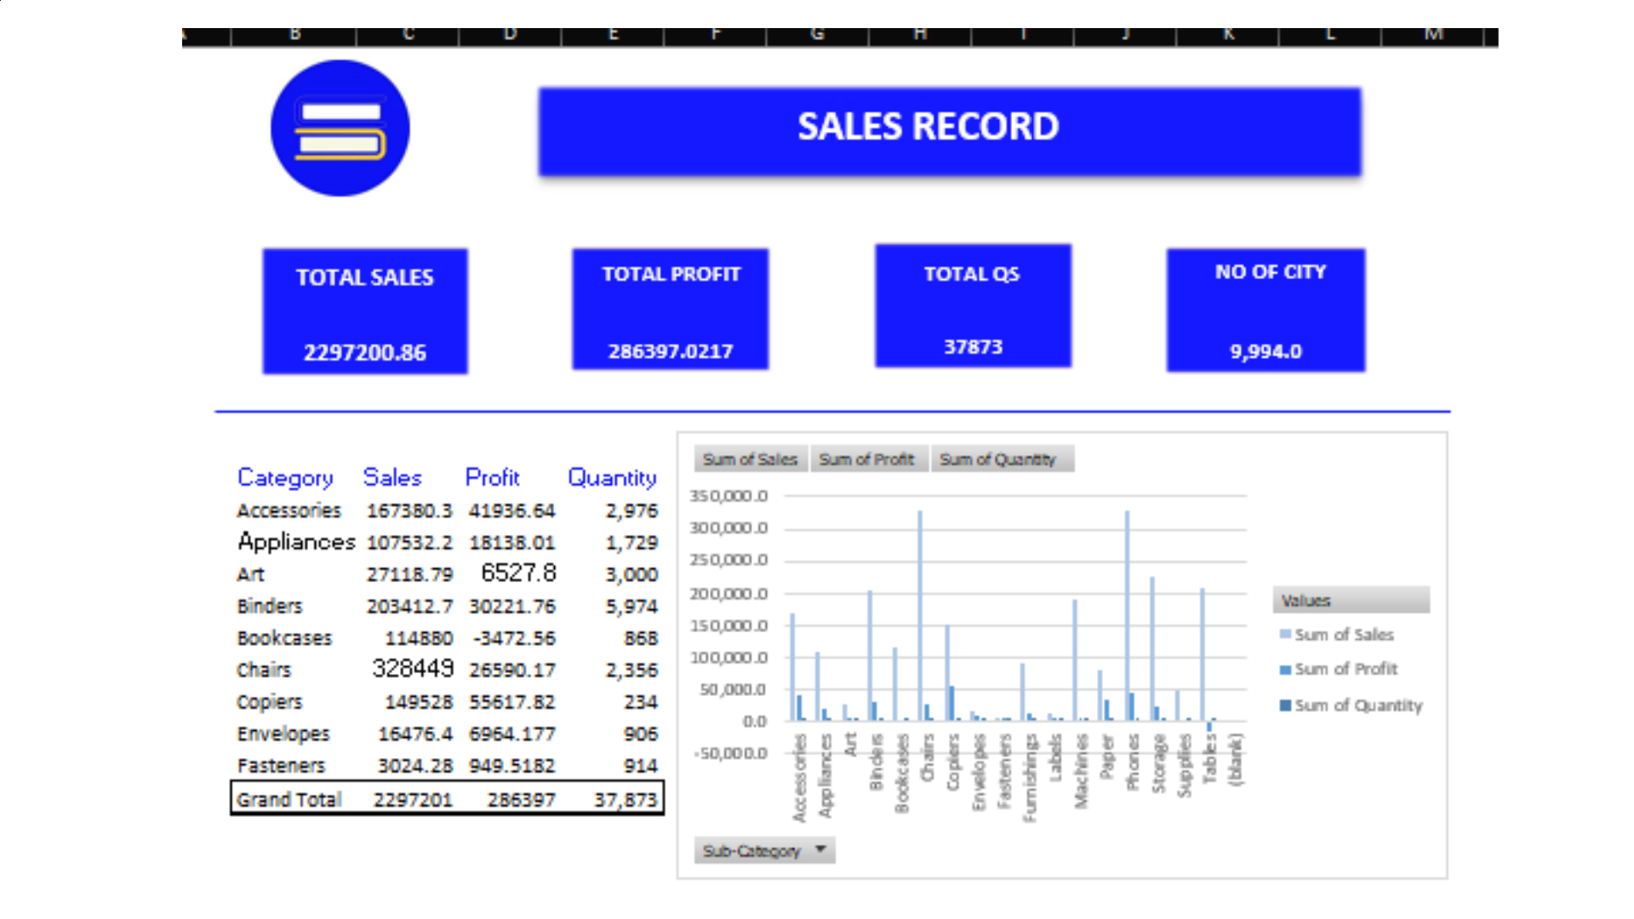

### **3.4.2 GIT AND VERSION CONTROL**

I also introduced learners to Git and version control using GitHub. This was essential for teaching them how to manage their code, collaborate on projects, and contribute to open-source repositories.

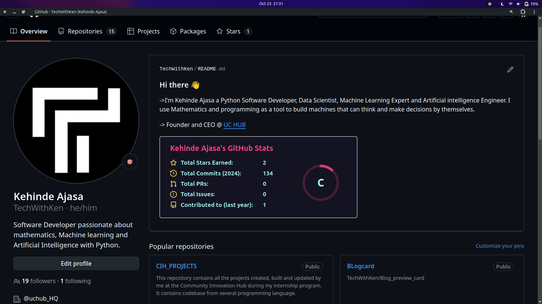

### **3.4.3 MISCELLANEOUS TECHNICAL ASSISTANCE**

Over the course of my internship, I provided technical assistance during events, supported learners in their programming tasks, and acted as a moderator for various activities like Debates and hackathons. These experiences were crucial for developing my soft skills in communication, problem-solving, leadership and teamwork.

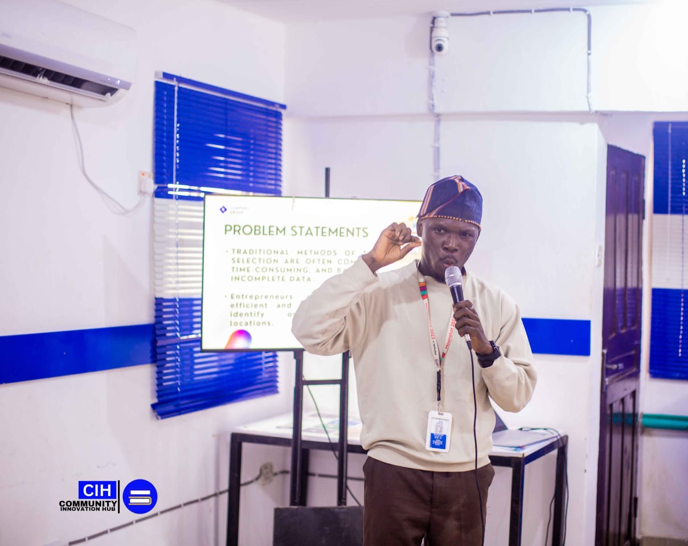

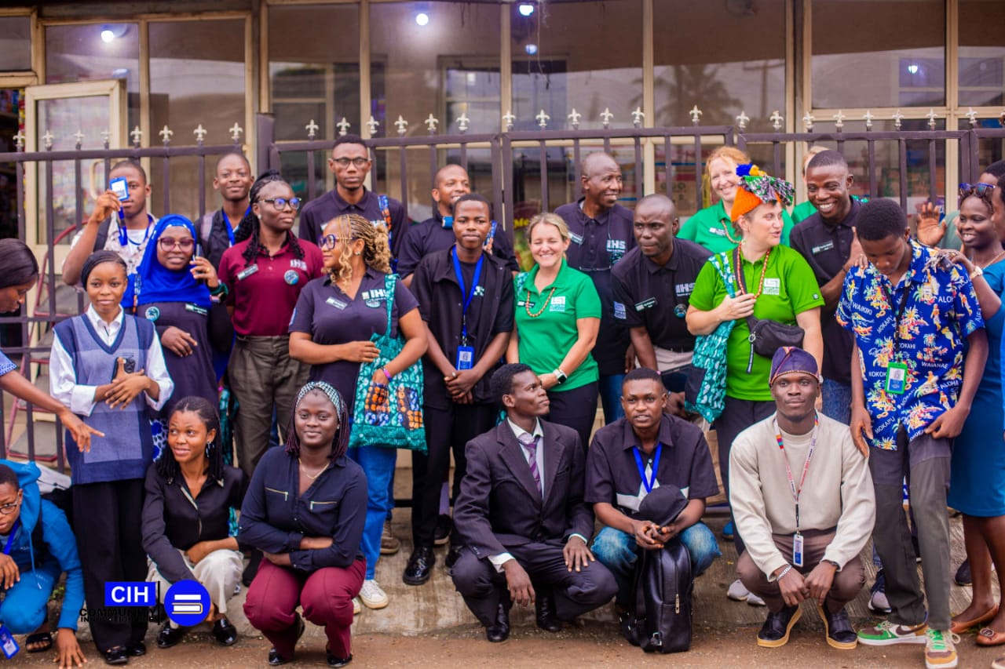

## **3.5 NASA SPACE APPS CHALLENGE PROJECT: SHAPELY**

As part of my industrial training at the Community Innovation Hub, I worked on Shapely, a project designed to help entrepreneurs make data-driven decisions on the most viable locations for their businesses. Using Geographic Information Systems (GIS) and machine learning models, Shapely offers predictive analysis on location suitability based on key factors such as foot traffic, market demand, and competitor density.

The platform provides features such as:

1. **Business Type Search:** Recommending optimal locations tailored to specific business categories.
2. **Geospatial Visualization:** Displaying interactive maps enriched with data layers showing traffic patterns and demographic insights.
3. **Predictive Analysis:** Machine learning models forecast business success in potential locations based on historical data.
4. **User Customization:** Personalized suggestions based on user-defined parameters like budget and target clientele.

<https://shapelydev.vercel.app/> This project culminated in our team securing second runner-up at the **NASA Space Apps Challenge 2024, Local Category in Nigeria,** where Shapely demonstrated its potential to significantly impact how businesses choose their locations by simplifying and optimizing the decision-making process.

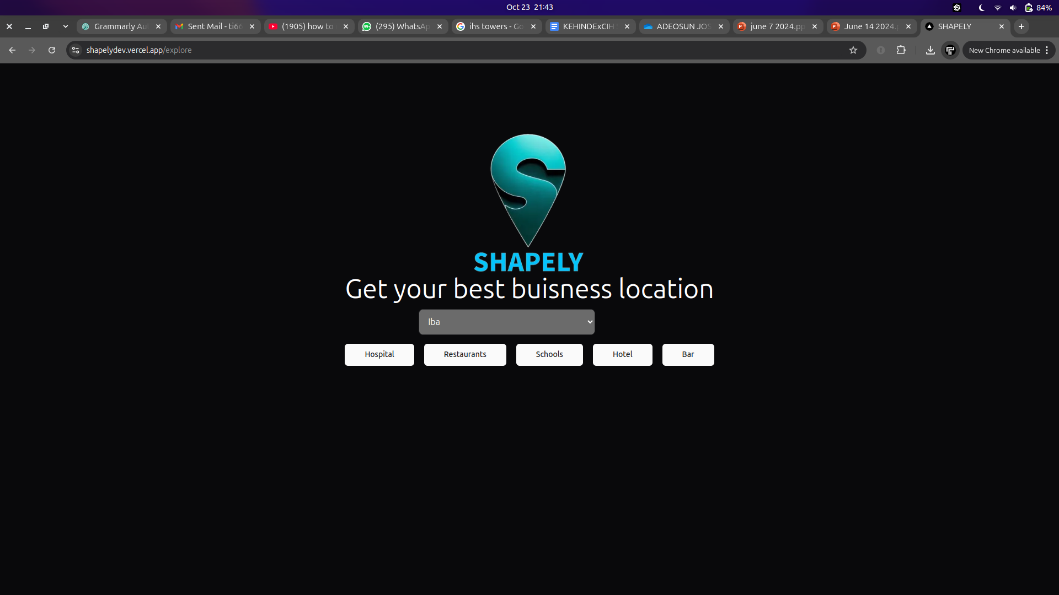

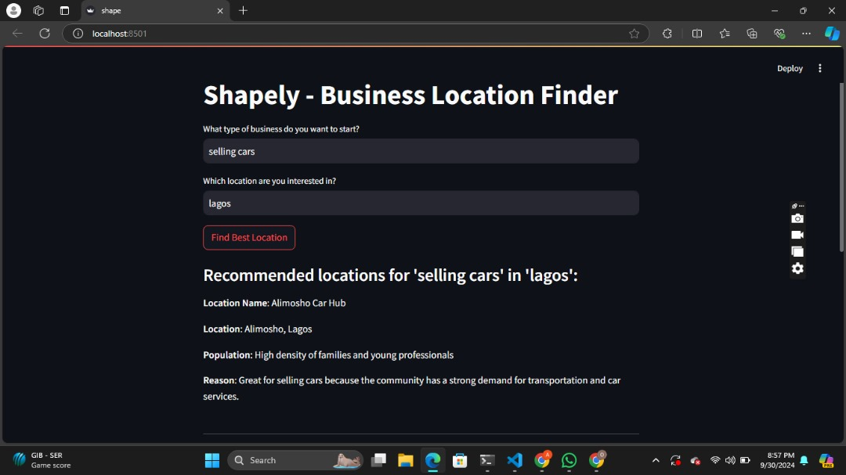

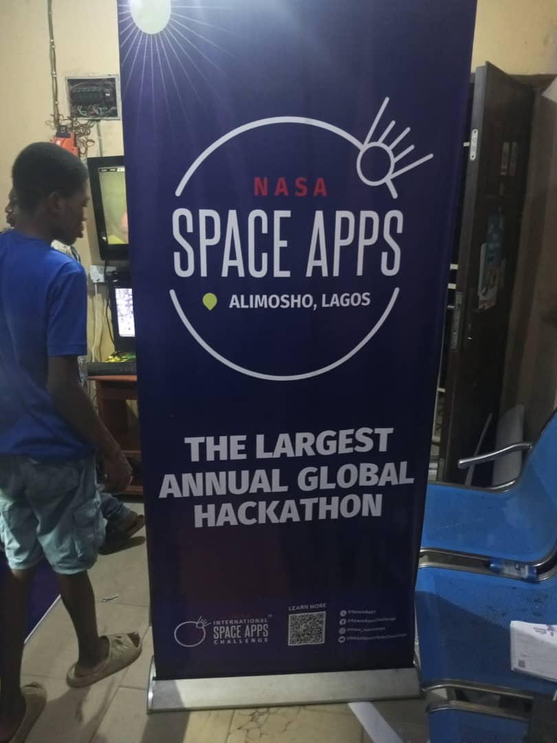

The internship at CIH was a multidimensional learning experience. From teaching programming to developing web and mobile applications, and assisting with media and technical support, I gained hands-on exposure to various aspects of technology. The skills I acquired will be instrumental in my future career, shaping me into a well-rounded developer and educator.

# **CHAPTER FOUR**

**REFLECTION ON WORK EXPERIENCE**

## **4.1 CHALLENGES FACED DURING S.I.W.E.S. AT C.I.H.**

During my industrial training, I encountered several challenges that impacted both my teaching and personal learning experience:

1. **Difficulty in Student Comprehension:** A significant portion of my time was spent re-explaining concepts, as many students struggled to grasp the material quickly. So I had to adopt a more patient and repetitive teaching approach to ensure adequate understanding.
2. **Limited Access to Learning Resources:** Access to high-quality learning resources was limited, which posed a challenge in efficiently acquiring the necessary knowledge for teaching.
3. **Inadequate Infrastructure:** The hub had limited infrastructure in terms of systems needed for teaching. This limitation slowed down practical sessions and impacted students’ ability to learn.

## **4.2 KNOWLEDGE GAINED DURING S.I.W.E.S. AT C.I.H.**

1. I learnt how to teach programming effectively.
2. I learnt the basics of geospatial data and maps.
3. I learnt how to apply machine learning models to make predictions.
4. I learnt how to solve technical issues with limited tools.
5. I learnt how to building websites and web apps.
6. I learnt how to create interactive maps for projects.
7. I learnt about GIT version control tool and the use and importance of commit messages

## **4.3 SKILLS ACQUIRED DURING S.I.W.E.S. AT C.I.H.**

1. Teaching programming to beginners.
2. Data analysis and interpretation.
3. Problem-solving under pressure.
4. Using geospatial tools like GIS.
5. Researching and self-learning new technologies.
6. Developing web applications.
7. Collaboration and teamwork.
8. Creating and presenting reports.
9. Public Speaking and Communication skills

# **CHAPTER FIVE**

**SUMMARY, RECOMMENDATIONS AND CONCLUSION**

## **5.1 SUMMARY**

The Student Industrial Work Experience Scheme (SIWES) provided me with practical exposure in the tech industry, particularly at the Community Innovation Hub, Lagos. My primary role was teaching programming to young learners while also learning new technologies and enhancing my technical skills. I faced challenges, such as adapting my teaching methods to suit various learning paces and self-learning due to limited resources. However, I gained valuable knowledge in software development, GIS technologies, and machine learning applications. Overall, the experience broadened my understanding of real-world tech applications and significantly improved both my instructional and technical capabilities.

## **5.2 RECOMMENDATIONS**

1. **Improved Access to Resources and Learning Materials:** I recommend that the Community Innovation Hub invest in better resources, both online and offline, to facilitate easier access to learning materials for students and instructors. During my SIWES, I often had to self-learn several topics due to resource limitations. By expanding access to a comprehensive library of tutorials, programming tools, and software documentation, the hub can significantly improve the learning experience for both trainers and learners. This would enable smoother transitions in lessons and faster skill development.
2. **Enhanced Student Support and Guidance**: Another key recommendation would be to provide more structured guidance and mentorship for students. Many students struggled to grasp programming concepts, which slowed the overall progress of classes. Implementing a more personalized mentorship system or smaller tutorial groups would allow students to get the individual attention they need, helping them understand complex concepts better. This will, in turn, make teaching more efficient and rewarding, as students will be better prepared and confident.
3. **Periodic Instructor Training and Development**: To maintain high teaching standards and stay updated on the latest technology trends, the Community Innovation Hub should organize periodic training for instructors. During my SIWES, I found that instructors often had to learn new technologies on their own. Regular workshops on emerging tech trends like AI, GIS, and web development would ensure that instructors are always equipped to teach new skills effectively, keeping the hub competitive and relevant.

## **5.3 CONCLUSION**

In conclusion, my SIWES experience at the Community Innovation Hub has been an enriching and transformative journey. Working as a programming instructor in a tech-driven environment, I was exposed to real-world challenges that allowed me to grow both professionally and personally. I took on significant responsibilities, guiding students through complex programming concepts, and addressing gaps in their understanding with patience and innovation. This experience honed my teaching skills and enhanced my problem-solving abilities, particularly in environments where access to learning resources was limited.

Additionally, the need for continuous self-learning emphasized the importance of adaptability and self-reliance. Throughout the internship, I also had the chance to develop a deeper understanding of how community-based organizations contribute to technology education, especially in underserved areas.

The lessons learned from this internship will be invaluable as I move forward in my career, particularly in roles involving tech education, programming, or software development. I am incredibly grateful to the mentors, supervisors, and students at the Community Innovation Hub for their guidance and support, which made this experience fulfilling and impactful. I look forward to applying the skills and knowledge gained from this internship in future endeavors while continuing to learn and grow in the tech industry.

# **REFERENCES**

Industrial Training Fund (ITF)(https://www.siwes.itf.gov.ng/)

National Universities Commission (NUC)(https://www.nuc.edu.ng/)

National Board for Technical Education (NBTE) (2022).

National Commission for Colleges of Education (NCCE) (https://www.ncce.gov.ng)

Nigerian National Policy on Education. (2013). Federal Ministry of Education.

Bassey, M. (2013). *Challenges and prospects of industrial training in Nigeria. Journal of Technical Education and Training.*

Kolb, D. A. (1984). *Experiential learning: Experience as the source of learning and development. Prentice Hall*.

National Planning Commission. (2010). National Skills Development Strategy. Abuja, Nigeria

Nigerian Economic Summit Group. (2017). The future of work: A report on the employability of Nigerian graduates.