BLOCKCHAIN-BASED ELECTRONIC HEALTH RECORD MANAGEMENT SYSTEM
Sulav Shrestha¹, Sagar Panta²
^{1,2}Computer Engineering, United Technical College, Pokhara University, Bagmati, Nepal
Email: ¹Sulavs84@gmail.com, ²pantasagar81@gmail.com

Abstract— The Blockchain-based Electronic Health Record (B-EHR) system represents a significant advancement in healthcare data management. Concerns over data confidentiality and security have become increasingly critical in the healthcare sector, given the need for immediate data accessibility. Traditional centralized systems face accessibility issues, necessitating a transformative solution, and blockchain technology emerges as a promising candidate. This project introduces a patient-controlled, blockchain-based system that efficiently manages and safeguards individuals' health-related data. By harnessing the Ethereum network and utilizing tools such as Ganache, Solidity, and web3.js, this system takes a systematic approach to overcome the limitations of centralized systems. Smart contracts, a cornerstone of blockchain technology, serve as the backbone for storing and processing patients' data in a decentralized manner. Transactions are conducted securely through these smart contracts, ensuring patient privacy and data security. Notably, any modifications to transactions can be verified and propagated across the entire distributed network, enhancing data integrity. Complementing this system is a cryptocurrency wallet like MetaMask, providing a centrally controlled repository where records can be swiftly accessed and secured by authorized individuals, including doctors and patients. This integration significantly improves data accessibility and security within the healthcare domain. Ultimately, this project aims to leverage blockchain technology for simultaneous data retrieval, enhancing efficiency, credibility, and accessibility. It offers a robust framework for securely storing data with tailored access permissions and facilitates the safe transfer of patient medical records. In essence, it introduces a swift and secure health record system and an innovative protocol, promoting greater transparency and ownership of sensitive data in the healthcare sector through blockchain integration.
Keywords—Electronic Health Record, Ethereum, MetaMask, Blockchain, Decentralization, cryptocurrency wallet.

Introduction

Background
The concept of blockchain technology was originated by Satoshi Nakamoto in 2008 with the publication of the Bitcoin whitepaper. Bitcoin, the first decentralized cryptocurrency, introduced the world to the potential of blockchain as a secure and transparent ledger. Since then, blockchain has evolved beyond cryptocurrency and found applications in various industries, including healthcare. Electronic Health Records emerged as a digital form of patient medical records, but they faced challenges such as security vulnerabilities and lack of interoperability. This led to the exploration of blockchain technology as a solution for improving the management and security of EHRs [1]. In the context of healthcare, Electronic Health Records refer to electronic versions of a patient's medical history, containing essential clinical and administrative data relevant to their healthcare. EHRs aim to streamline healthcare processes, improve patient care, and enable seamless information exchange between healthcare providers. However, traditional EHR systems often encounter issues like security of data and vulnerabilities, privacy concerns, and interoperability challenges. Blockchain provides a decentralized and secure approach to managing EHRs. By leveraging its distributed ledger capabilities, blockchain ensures the integrity of records through cryptographic hashing, making it difficult to modify data without consensus from many network participants. Public-key cryptography is utilized to secure data and ensure confidentiality, with each user having a unique public and private key. This cryptographic framework enhances data security and mitigates the risk of unauthorized access to patient information [2] [3].
The implementation of blockchain technology in EHRs offers solutions to various issues faced by traditional systems. One significant problem is the lack of interoperability between different healthcare organizations and systems [3]. Blockchain's decentralized nature enables seamless sharing of data among trusted parties, eliminating the need for costly and inefficient methods of transferring records. Authorized sharing of data can be done securely and efficiently, improving continuity of care and overall efficiency in healthcare delivery. Blockchain technology facilitates the execution of smart contracts, which are automated agreements that carry out actions according to predetermined criteria. These smart contracts streamline the management of consent by allowing data access only under specific conditions. Consequently, this approach addresses privacy apprehensions and aligns with regulatory mandates such as the General Data Protection Regulation (GDPR). When integrated with Electronic Health Records (EHRs), blockchain empowers healthcare systems to bolster data security, enhance privacy, promote interoperability, and empower patients to have greater control over their health data [1] [4].

Statement of problem
Countries like Nepal encounter challenges related to security, interoperability, and patient privacy. These outdated methods lack efficiency and hinder effective healthcare delivery and coordination among providers. To address these issues, a blockchain-based health record management system is essential. Blockchain offers a decentralized, tamper-resistant, and transparent platform for secure data storage and access. It ensures privacy, consent management, and data integrity, and mitigates the risk of fraud or unauthorized access. Implementing blockchain in Nepal can enhance healthcare delivery, and coordination, and facilitate interoperability among healthcare systems [5]. The interoperability capabilities of blockchain can facilitate the seamless sharing and exchange of health records across different healthcare organizations and systems. This would enable healthcare providers to access comprehensive and up-to-date patient information, leading to improved care coordination, accurate diagnoses, and effective treatment planning [6].
According to authors in [5], By adopting a blockchain-based health record management system, Nepal can overcome the limitations of traditional methods and empower both patients and healthcare providers with a secure, interoperable, and efficient solution. This system would enhance data privacy, promote collaboration among healthcare stakeholders, and ultimately improve healthcare outcomes for the population.

Objective
The objective of blockchain-based health record management is:
- To address interoperability issues and enable seamless data exchange among healthcare providers using distributed ledger, standardized protocols, and secure data sharing mechanisms [3] [7] [8].
- To automate and enforce privacy policies and data access controls, securing patient health records by allowing access and interactions solely for authorized individuals in accordance with pre-established rules and conditions [9] [5].

literature review
According to the authors in [10], Linn and Koo built upon the work and discussed the challenges of interoperability in the healthcare sector. They propose storing electronic medical records (EMRs) off-chain in a data lake rather than on a blockchain. While they provide some basic principles for a potential workflow and briefly touch on scalability, access security, and data privacy, they do not offer a new system or comprehensive implementation details. The paper does not include an assessment or description of fault tolerance, disaster recovery, or performance aspects. In the paper [11] presented by Jiang et al., the authors described and implemented BlocHIE, they have developed a Healthcare Information Exchange platform that utilizes blockchain technology and operates in a cloud environment. This platform consists of two interrelated blockchains: EMRChain and PHD-Chain. EMRChain manages Electronic Medical Records (EMRs) by combining off-chain storage and on-chain verification techniques. On the other hand, PHD-Chain is specifically designed for housing personal healthcare data generated by patients themselves. Their proposed consensus algorithm is built upon Proof of Work and features a modified transaction processing method. This approach has shown a commendable throughput of 46 transactions per second, surpassing the capabilities of both Ethereum and Bitcoin. However, it's important to note that the platform's scalability and performance during high-stress and crisis situations still require further testing and evaluation [12].
As per the research paper referenced in [10], Dubovitskaya, Xu et al., and their colleagues introduced a framework for securely sharing electronic medical record (EMR) data with precise access control. They presented a prototype tailored for oncology-specific clinical systems, with a strong emphasis on consent management, efficient data transfer between hospitals, and enhanced management of extended treatment periods. In this system, patient data is encrypted and stored off-chain in a cloud repository, while access permissions and electronic health record (EHR) metadata are stored on-chain. The prototype is built on top of Hyperledger Fabric and employs a PBFT consensus algorithm. However, the scalability of the system has not been verified in real-world scenarios, and the authors acknowledge the need for further performance assessment.
Additionally, in accordance with the authors in [4], the medical chain represents a case study drawn from the industry that shares similarities with other proposals. The medical chain's primary goal is to grant users ownership and control over their health records while promoting transparency among healthcare stakeholders. The provided whitepaper primarily delves into the business plan and lacks comprehensive technical details. Notably, the paper does not explicitly address scalability properties and performance analysis. Nevertheless, a noteworthy feature highlighted in the medical chain involves the implementation of a backup access system for emergencies. This system entails the utilization of an emergency bracelet that caregivers can scan to access critical patient information when the patient is incapacitated or unable to provide consent. In conclusion, blockchain technology holds significant promise for transforming Electronic Health Record (EHR) management systems. It offers decentralized, secure, and transparent solutions for EHR sharing patient control, data integrity, and interoperability. Various blockchain models like Ethereum, Hyperledger, Corda, and Tendermint have been proposed, providing advantages like improved privacy, data security, patient empowerment, and access control [13] [14]. However, addressing scalability, performance, and emergency access backup systems remains crucial for practical blockchain-based health record management.

proposed work
The proposed development involves creating a web application for a Blockchain-based Electronic Health Records system using the Next.js web framework. This application will be seamlessly integrated with the Ethereum-based blockchain to ensure the utmost security of patient data through reliable transactions. Within our healthcare system, each transaction corresponds to various aspects of a patient's medical history, including hospital visits, administrative records, diagnosis reports, treatment specifics, physician's notes, laboratory results, prescriptions, X-rays, and outcomes, among others.
Through this system, patients will gain control over their data-sharing preferences, allowing them to view and grant permission to doctors selectively. They will have the autonomy to decide which parts of their medical history healthcare providers can access, ensuring the privacy and security of the remaining data. The decentralized nature of blockchain promotes interoperability among different healthcare institutions, enabling them to adopt a standardized system for storing health data [3] [7].

System Architecture
The architecture of the system adheres to multiple high-level patterns and principles. It primarily emphasizes the external components of the system that are visible to users and their interactions with one another. Figure 1 illustrates the overall architecture of the system. In this architecture, it consists of three modules (Layers).
The first module is the User Management Layer, which provides a user interface for patients and doctors to interact with the Electronic Health Record system. Through this module, users can input and retrieve data that will be stored in decentralized storage.
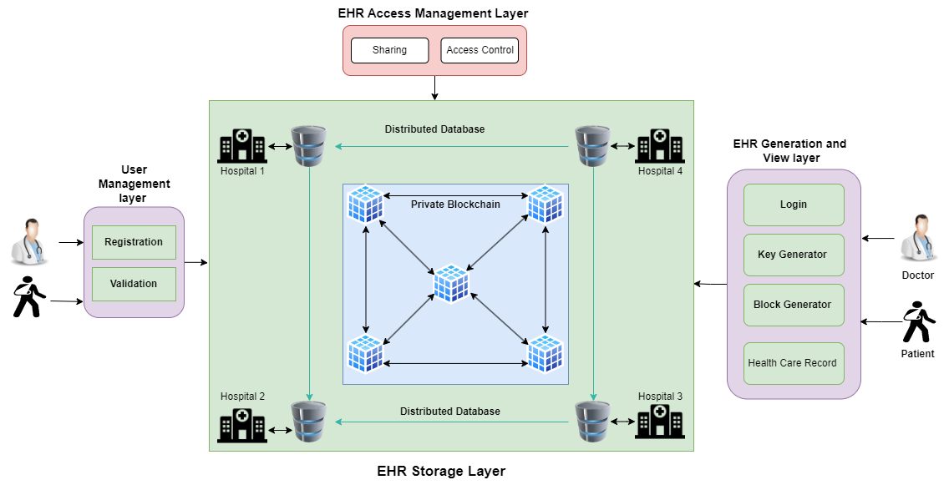
Figure 1: System Architecture
The second module is the EHR Storage Layer, which serves as the backbone of the project. In this module, data is stored in blockchains maintained by hospitals, with databases that are distributed across the network. Popular tools that have been used in this module include Next.js, Ganache, Truffle, and MetaMask. APIs are used to facilitate communication between the User Management Layer and the EHR Storage Layer, with incoming requests triggering data storage procedures in the latter.
The third module is the EHR Generation and View Layer, which provides a comprehensive and efficient means of managing patient health information in electronic format. Healthcare providers can access patient data from multiple sources through this module, which includes tools for searching, filtering, and visualizing trends and patterns in the data.

Flowchart
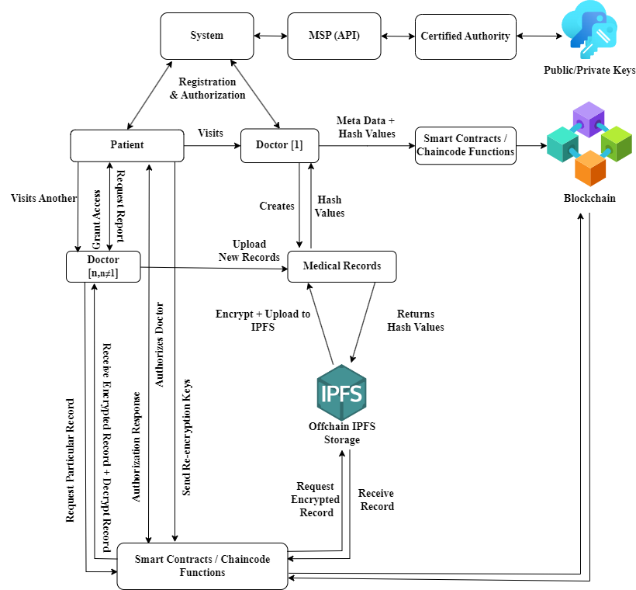
Figure 2 Flowchart of the system
The depicted flowchart outlines the functioning of the Electronic Health Record Management System. It visually represents the processes of encryption, key generation, and access control. When a user registers in the system, three keys are generated: a private key, a public key, and a symmetric key. The private key is retained on the user's device, while the public key is stored in a database. The symmetric key is encrypted with the public key and subsequently stored on the server. Granting access involves the patient supplying their private key. This private key is then utilized to retrieve and decrypt the symmetric key, allowing access to authorized physicians, lab technicians, or doctors.
Storing Electronic Health Records (EHRs) in IPFS involves several steps for security and efficiency. First, medical information is encrypted and converted into a PDF document. Then, it's further encrypted using a symmetric key and stored in IPFS, generating a Content ID (CID) or hash value. This CID is stored as a block in the blockchain. Accessing EHRs requires users to provide their private key. The blockchain is queried to retrieve the CID for a specific patient's EHR. The IPFS network is then used to retrieve the encrypted files, which are decrypted using the private key for viewing. The system's implementation stack includes requesting patient lists from the database, adding encrypted medical files, storing them in IPFS, recording transactions in the blockchain, and finally, retrieving, and decrypting EHR files for viewing by authorized personnel. Key project features include feasibility, cost-efficiency in blockchain usage, robust security with private keys, and scalability by leveraging IPFS for heavy file storage instead of the blockchain.
To simplify the entire flowchart of the system, the entire process is divided into distinct stages for discussion.

Smart Contract Deployment and Interaction
In any blockchain activity, it's crucial to define a smart contract before engaging in any tasks or transactions. The process of deploying and interacting with smart contracts within a blockchain-based Electronic Health Records (EHR) system involves several essential steps. Initially, smart contracts are crafted using the Solidity programming language to outline the functionalities required for managing health records, access permissions, and control mechanisms. These contracts are then compiled using Remix IDE, producing bytecode executable on the blockchain network. The resulting Application Binary Interface (ABI) code is stored in JSON files for each contract type, such as PatientContract.json and DoctorContract.json. Truffle, a development framework, is utilized to further compile the contracts and establish the necessary environment for deployment. Once compiled, the smart contracts are deployed onto the blockchain, enabling them to execute and manage the designated functionalities [12].
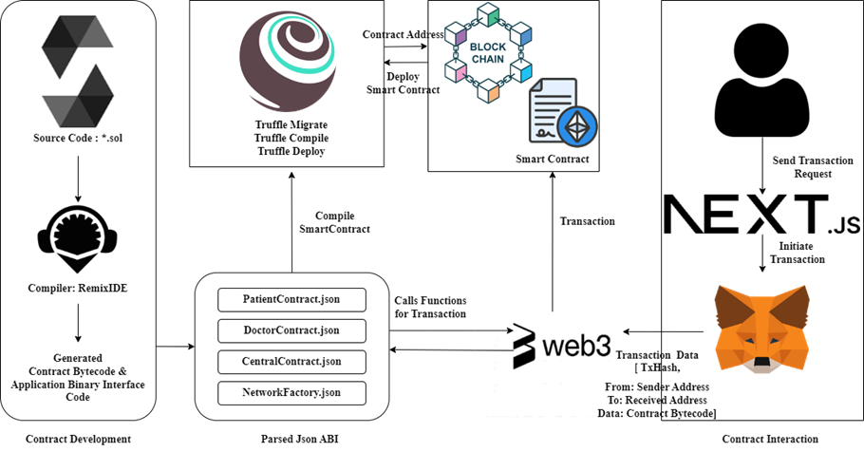
Figure 3 Smart Contract Deployment and Interaction
Following this step, when a user registers in the system, three distinct types of keys are generated: Private, Public, and Symmetric keys. The private key is a highly sensitive component that must be kept secret, known solely to the user. The security of this private key is of utmost importance since anyone with access to it could potentially impersonate the owner or gain unauthorized entry to encrypted medical files. As a precaution, the private key is stored locally on the user's device. On the other hand, the public key is meant for open sharing and serves the purposes of verifying digital signatures and encrypting messages. It is stored on the server, alongside being encrypted together with the symmetric key. This encrypted key is also retained on the server. Lastly, the symmetric key serves a dual role in both data encryption and decryption processes.
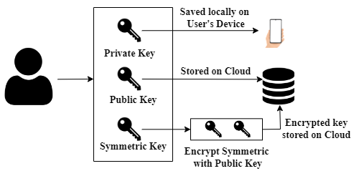
Figure 4 Key Generation Process

Storing EHR on IPFS
In the context of storing Electronic Health Records (EHR) on IPFS, let's first explore the process of saving a file on IPFS before anchoring it on the blockchain. The workflow begins with a doctor, who has been verified and authorized by the blockchain network [3], creating a patient's digital health record. The doctor proceeds to upload specific medical data, including related medical files belonging to the patient. These uploaded files are subjected to encryption using the symmetric key obtained from the server. Subsequently, this newly encrypted file is placed into IPFS. Upon successful upload to IPFS, a hash file is generated and returned. This hash file, along with other pertinent data, is further encrypted and stored within the blockchain at a later stage [13].
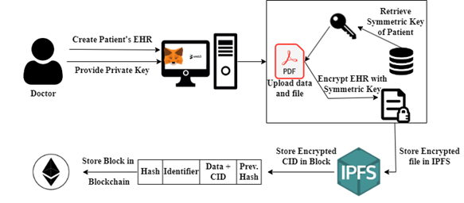
Figure 5 Storing EHR on IPFS

Accessing the HER
Once the medical record is securely stored, let's proceed with the process of accessing the file by a user. Here's how it works:
- Key Authentication: The user initiates the access request by providing two essential keys: their private key and the patient's public key.
- Request to the System: The user submits a request for the patient's Electronic Health Record (EHR) through the system.
- Blockchain Verification: This request is first directed to the blockchain, which, in turn, responds by providing the user with an encrypted CID (Content Identifier) and the patient's data.
- IPFS Retrieval: The CID file is crucial as it serves as the means to locate the content stored on IPFS. The user utilizes this CID to retrieve the encrypted EHR from IPFS.
- Decryption: To decrypt the medical record, the symmetric key is fetched from the server. Following decryption, the patient's EHR is successfully displayed to the authorized user [9].
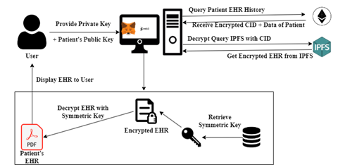
Figure 6 Accessing the EHR

Feasibility Analysis
The adoption of blockchain technology in the healthcare sector in Nepal offers numerous benefits for electronic medical health records. Blockchain provides enhanced security, data integrity, interoperability, patient empowerment, and streamlined processes. However, the feasibility of implementing a blockchain-based EHR system depends on factors such as technological infrastructure, regulatory framework, stakeholder collaboration, data privacy, and scalability. Nepal needs to assess its infrastructure, establish appropriate regulations, foster stakeholder collaboration, ensure privacy protection, and address scalability challenges. With careful consideration of these factors, a blockchain-based EMHR system has the potential to revolutionize healthcare delivery and improve patient outcomes in Nepal [4] [5] [10].

methods and methodologies
In this section, a formal description of the proposed frameworks elucidates the software platform employed in its development and enumerates the advantages it offers. The subsequent section delves into comprehensive explanations of the key constituents driving the implementation of this framework, notably Ethereum and the Interplanetary File System (IPFS).

Smart contracts
A smart contract consists of a set of instructions capable of executing transactions on the blockchain. Whenever users initiate transactions, code is executed. These contracts function directly on the blockchain, making them resistant to tampering and alterations. Smart contracts utilize the Solidity programming language for creating various actions on the blockchain. Programmers can write the necessary operations in Solidity, compile them, and subsequently deploy them onto the Ethereum blockchain. Python is a programming language that implements Ethereum's Solidity language for crafting smart contract code [15].

IPFS and security algorithm
The Interplanetary File System (IPFS) is a distributed data storage technology operating on a peer-to-peer network. It ensures secure and tamper-proof data storage through unique cryptographic hashes assigned to each file. Duplicate files are not allowed, conserving storage space and streamlining data management. IPFS employs the SHA-256 algorithm for security and content-based addressing, enabling efficient data retrieval and ensuring data integrity. In summary, IPFS files are uniquely identified by cryptographic hashes, and duplicate files are prohibited on the network. This feature helps conserve storage space and reduces redundancy within the network. By preventing the creation of duplicate files, IPFS simplifies the management of data and ensures efficient utilization of storage resources across the network. It promotes a more streamlined and optimized approach to file storage and sharing within the IPFS ecosystem [16]. IPFS will generate an address, that is not as secure as it seems, for the purposes of security we have used the SHA-256 algorithm. IPFS prevents duplicate files, conserving storage and optimizing data management. It employs the SHA-256 algorithm for security. IPFS uses content-based addressing with unique hash values for files, ensuring efficient retrieval through a DHT and Merkle DAG structure. This approach safeguards data integrity by comparing retrieved file hashes with originals, preventing, tampering.
In summary, IPFS optimizes storage, security, and efficient data retrieval using cryptographic hash functions and content-based addressing [8].
The IPFS protocol operates as follows:
- Each file in IPFS is assigned a unique cryptographic hash.
- The IPFS network does not allow duplicate files [4].

Use-case Diagram
The use-case diagram is shown in Figure [7]. This application’s use-case has three key entities: an Admin, a patient, and a doctor. various user roles interact to facilitate secure and efficient healthcare management:
- Patients: Patients can securely access their medical test reports and control data sharing through smart contracts. They establish their digital identity with accounts and passwords, allowing them to view personalized treatment plans.
- Doctors: Doctors contribute by adding, updating, and validating patient medical records. They also transparently prescribe medications through the blockchain. They can request access to patient records via contract addresses for seamless data retrieval, aiding in informed medical decisions.
- Admin: Admin play a vital role in overseeing system functionality. They manage user accounts, including doctor and patient profiles, and maintain the overall integrity of the decentralized healthcare ecosystem.
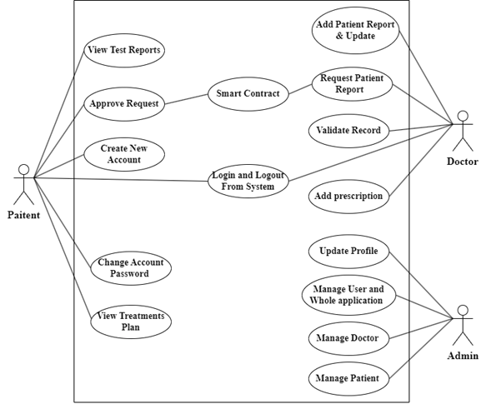
Figure 7 Use Case Diagram

Sequential Diagram
The Sequential Diagram below offers a visual representation illustrating the interactions and communication flow among various entities, including the Patient, Doctor, Web Server, Smart Contract, and IPFS. The following sequential diagram provides insights into the communication process and the steps involved in how patients upload their medical records, subsequently accessed by doctors via blockchain technology.
Initially, patients are required to establish an account within the blockchain system. Once this step is completed, patients gain the capability to upload their medical records in various formats to IPFS. Subsequently, IPFS encrypts and generates a unique hash file for each medical record, which is then securely stored within the Smart Contract. When a doctor requires access to a patient's medical records, they must first seek permission from the respective patient.
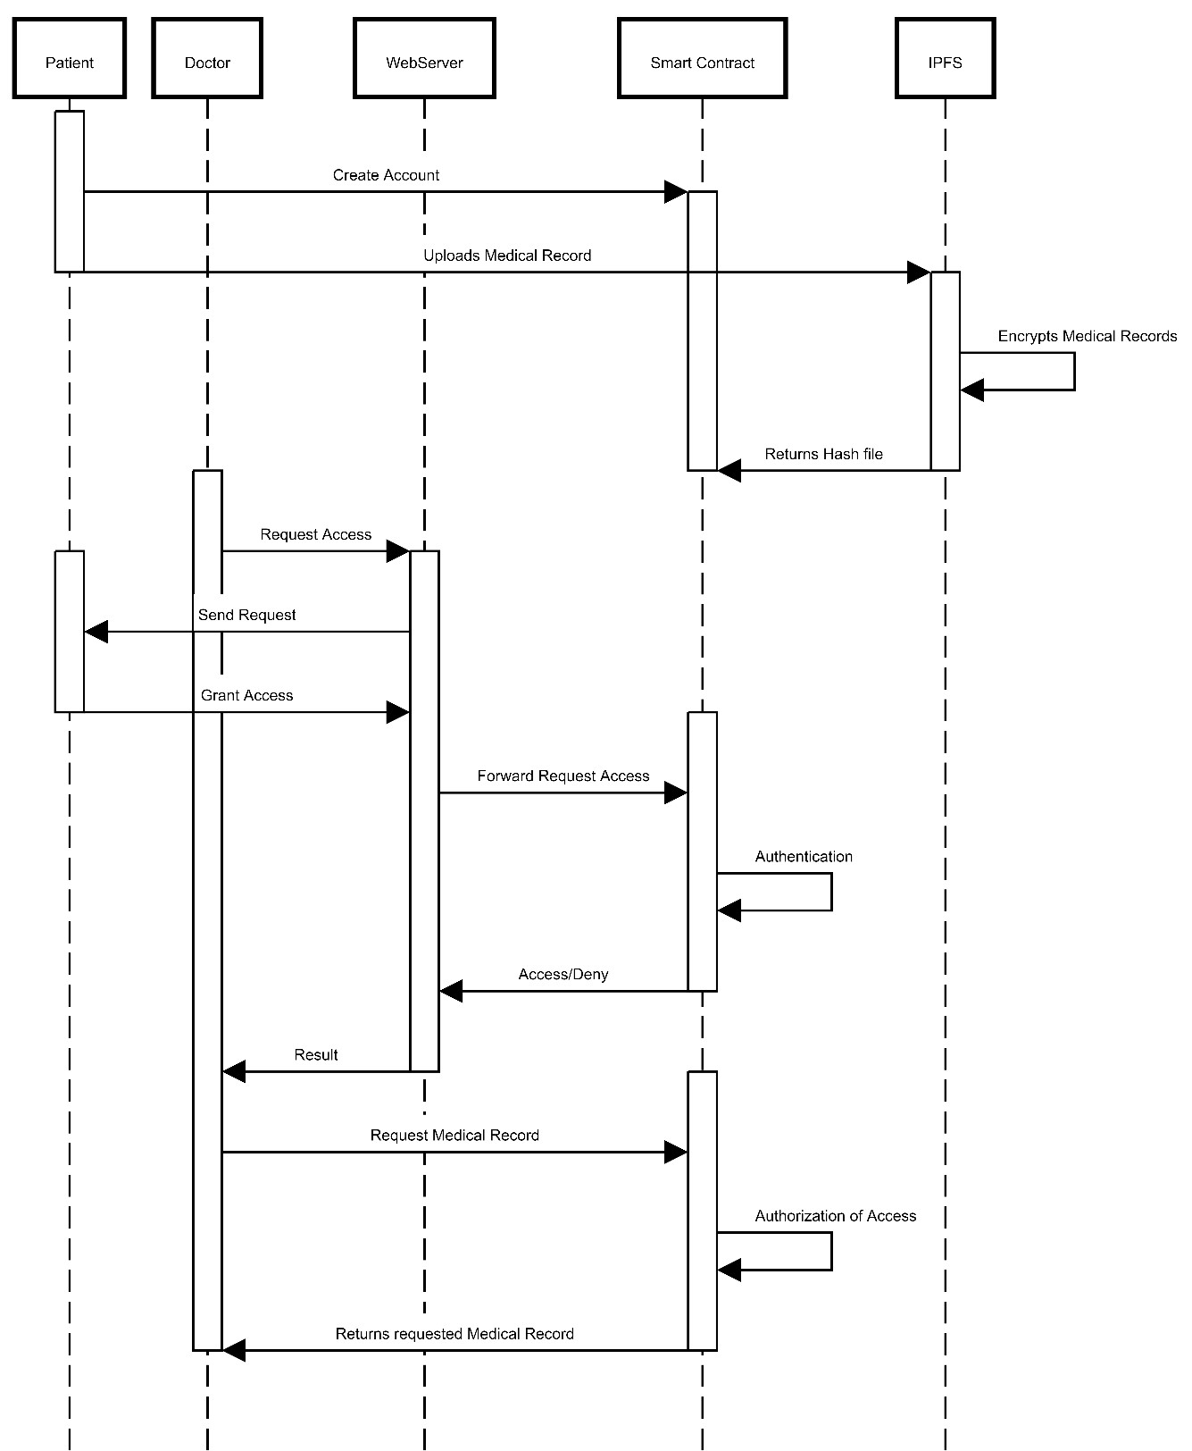
Figure 8 Sequential Diagram for accessing Medical Records
Upon obtaining consent from the patient, the doctor also obtains authorization from the Smart Contract. Following this authentication process, the doctor is granted access to the patient's medical records through the blockchain infrastructure.
let's explore the scenario in which an authorized doctor is uploading their patient's medical record. Figure below explains this case very clearly in this case, the doctor can easily upload the medical record to IPFS, which will then automatically generate a hash file. Subsequently, this hash file is securely uploaded to the Smart Contract for safekeeping and access control.
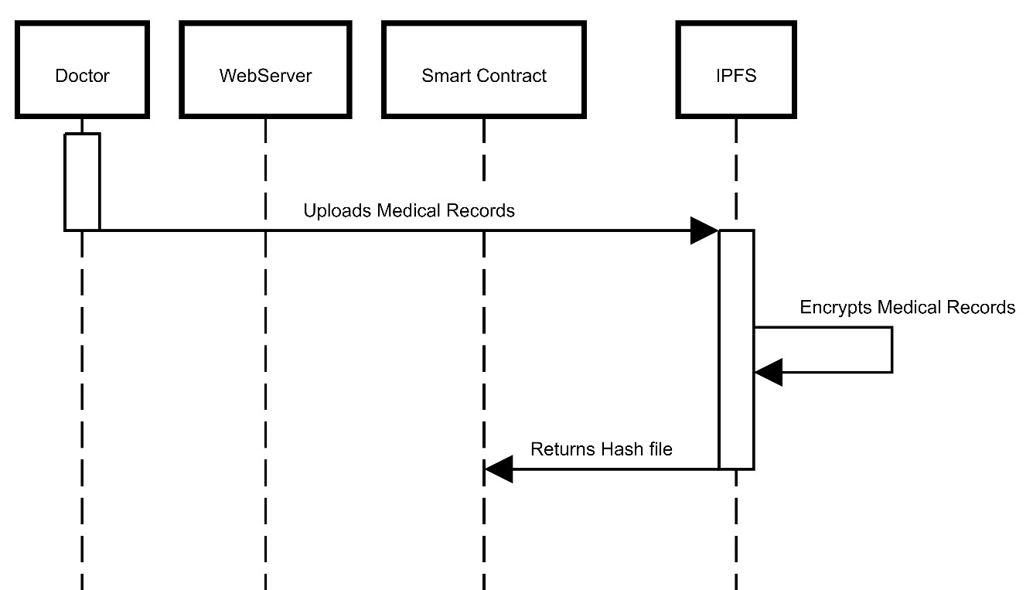
Figure 9 Sequential Diagram for Doctor Uploading Medical Records

Software used

WEB3
Web3 employs the Hypertext Transfer Protocol (HTTP) connection to establish a connection with the Ethereum network through an Ethereum node. This Ethereum node can either be a local node running on the ETH wallet or a remote one. MetaMask, on the other hand, is a browser extension that facilitates Ethereum account operations and can be seamlessly integrated with websites.

Ganache
Ganache is a deterministic blockchain, meaning it consistently begins in the same state. This predictability is advantageous for testing smart contracts because it ensures consistent test results each time you execute them. Ganache is also known for its speed, allowing for swift deployment, and testing of smart contracts. This characteristic makes it a valuable tool for rapid development and iterative processes.

Truffle
Truffle is a developer environment, testing framework, and asset pipeline for blockchains. It allows developers to spin up a smart contract project at the click of a button and provides with a project structure, files, and directories that make deployment and testing much easier. Truffle is an excellent choice for developers who want to develop, test, and deploy smart contracts on a production-ready blockchain.

MetaMask
MetaMask is a leading self-custodial wallet known for offering the most user-friendly and secure method to interact with blockchain-based applications. It serves as a safe and straightforward gateway to access these applications and engage with web3 technologies. One of its notable features is the generation of passwords and keys directly on the user's device, ensuring that only users themselves have access to their accounts and data.

VS-code
Visual Studio Code (VS Code) is a popular, free, and open-source code editor from Microsoft. It's versatile, supporting various programming languages, and designed for modern web and cloud app development.

Solidity
Solidity is a high-level programming language designed for crafting self-executing smart contracts on blockchains, such as Ethereum. It enhances automation, trust, and transparency, enabling applications, including those built with React.js and Next.js, to seamlessly interact with smart contracts for decentralized services.

Language Used
Our website's front-end design is developed using HTML, Tailwind-CSS, Next.js, and React.js. The server and back-end are managed through the Solidity programming language and Python. Two essential tools, Truffle and Ganache, are employed for creating local Ethereum blockchains to construct the system. To establish the blockchain and access the system, we utilize key tools like the Ethereum virtual interface, MetaMask [wallet], Truffle, Yarn [command-line interface], Ganache, and Local Web3.

Results and discussion
This section discusses the access process to the proposed system. This project represents more than just a technological endeavor; it's an innovative and collaborative journey aimed at not only introducing a novel solution but also reshaping healthcare data management fundamentally. Our vision has materialized into an ecosystem that seamlessly integrates blockchain technology with the complex healthcare landscape, transcending conventional models. The outcome isn't just a collection of interfaces but a harmonious blend of data security, user-centric design, and efficient record administration. The journey in creating the blockchain-based Electronic Health Record management system has been defined by dedicated effort and careful design. As examined the outcomes of each interface – Homepage, Doctor, Admin, and Patient – the results of dedicated work. These pages show a collaborative initiative to seamlessly integrate blockchain technology into healthcare, guaranteeing data security, user experience, and streamlined record management.

Homepage
Figure 10 displays the system's homepage, accessible through user account creation. Users can access the system via this homepage, which includes five portals: Dashboard (for system administrators), Doctor, and Patient. Besides these, there's a signup form for patients and unique addresses for doctors and admins.
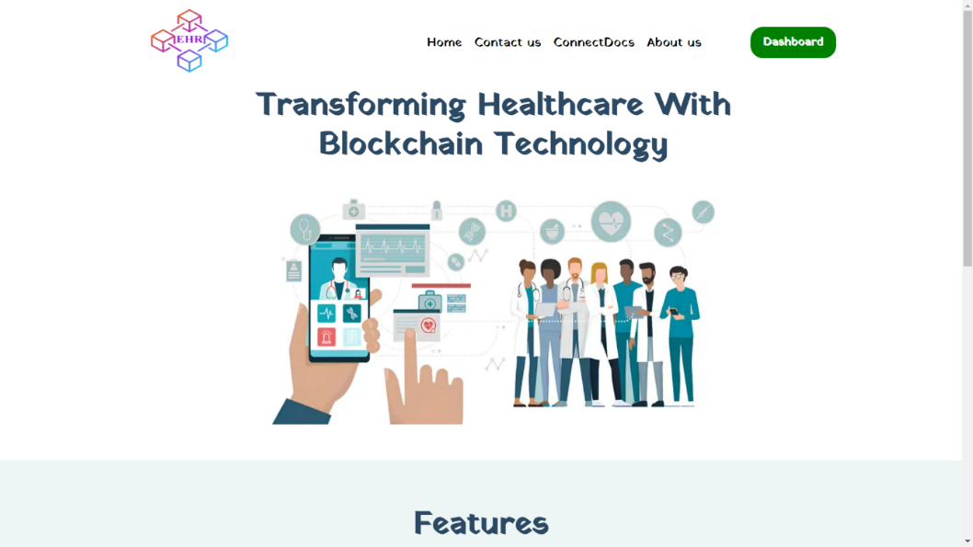
Figure 10 Homepage of the Proposed System
Each user category (doctors, patients, and admins) requires a distinct account for homepage access. Attempting to create an admin account with incorrect or duplicate information will result in an "access denied" message.

Patient uploading their reports.
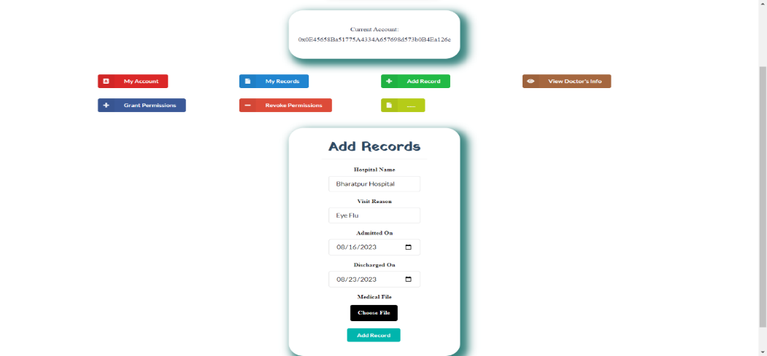
Figure 11 Patients uploading their records.
The above figure 11 describes how the patients can upload or add their medical records. The patient can upload their medical file as well as they can add the hospital’s name, he/she visited for a checkup, the reason for which he/she visited, dates of admission, and discharge.

Doctor accessing records.
Figure 12 shows how doctors’ access medical records: registering patients, creating encrypted blockchain records, managing permissions via smart contracts, verifying with cryptographic keys, decrypting data locally, and logging all interactions on the blockchain for transparency.
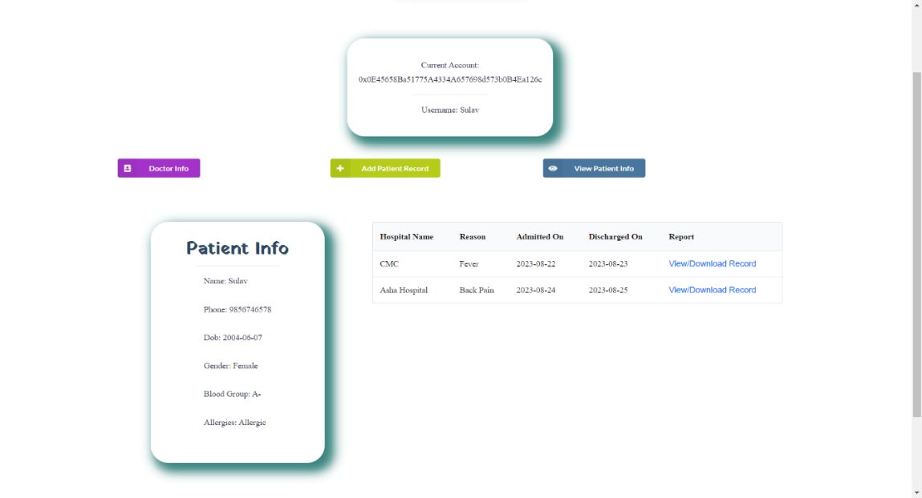
Figure 12 Doctor accessing records.

Admin’s role
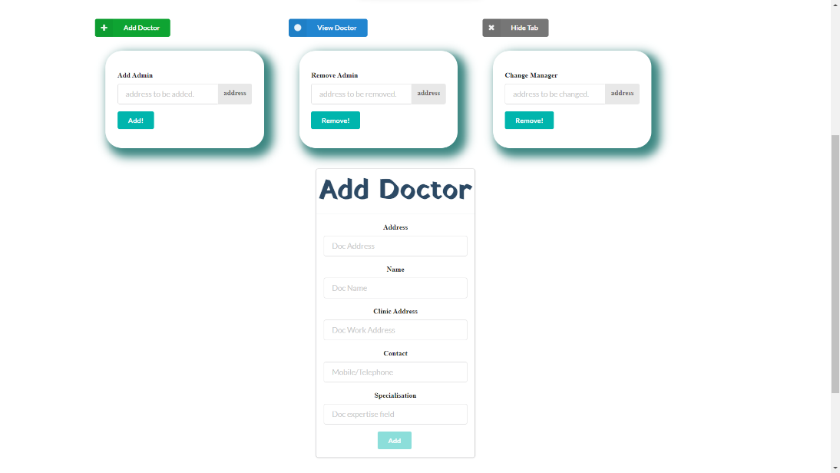

Figure 13 Admin's Role
Figure 13 illustrates that how system administrators can Add doctors, change, and manage doctors and patients likewise. While a super admin can validate admins and doctors and can add or remove them.

Transaction through Ganache
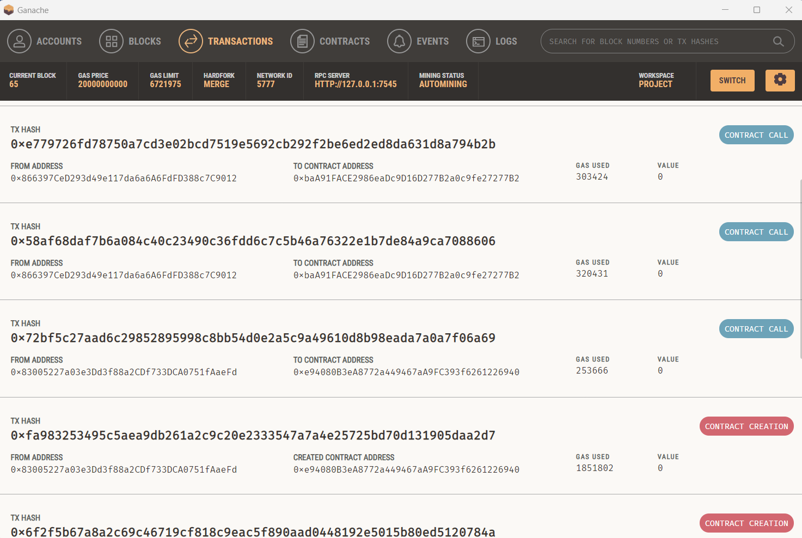
Figure 14 Transactions through Ganache
This figure 14 illustrates the capability to simulate Ethereum network behavior locally, enabling the testing of smart contracts and their interactions without deploying them to the main Ethereum network. It provides a platform for observing contract calls and contract creation processes.

conclusion
In summary, the proposed system Blockchain-Based Electronic Health Record Management System represents a significant leap forward in healthcare technology. By harnessing blockchain, this system revolutionized data security and patient privacy, eliminating unauthorized access. The system streamlines the sharing of Electronic Health Records across healthcare organizations, enhancing overall coordination. System smart contracts efficiently handle patient consent and regulatory compliance, reducing administrative complexities. At the conclusion of this project, it's evident that we are at the forefront of healthcare technology transformation, demonstrating how blockchain can optimize healthcare, making it more efficient, secure, and patient-centered.

References
- Sharma, Ashutosh, Sarishma, Ravi Tomar, Naveen Chilamkurti, and Byung-Gyu Kim. "Blockchain based smart contracts for internet of medical things in e-healthcare." Electronics 9, no. 10 (2020): 1609.
- Watkinson-Powell, Anna, and A. Lee. "Benefits of an electronic medical records system in rural Nepal." Journal of the Nepal Medical Association 52, no. 188 (2012).
- Yang, Huihui, and Bian Yang. "A blockchain-based approach to the secure sharing of healthcare data." In Proceedings of the norwegian information security conference, pp. 100-111. Oslo, Norway: Nisk J, 2017.
- Azaria, Asaph, Ariel Ekblaw, Thiago Vieira, and Andrew Lippman. "Medrec: Using blockchain for medical data access and permission management." In 2016 2nd international conference on open and big data (OBD), pp. 25-30. IEEE, 2016.
- Gharat, Anurag, Pratik Aher, Punit Chaudhari, and Bhavana Alte. "A framework for secure storage and sharing of electronic health records using blockchain technology." In ITM Web of Conferences, vol. 40, p. 03037. EDP Sciences, 2021.
- Sheth, Alpen, and Hemang Subramanian. "Blockchain and contract theory: modeling smart contracts using insurance markets." Managerial Finance 46, no. 6 (2019): 803-814.
- Nishi, Farjana Khanam, Mahizebin Shams-E-Mofiz, Mohammad Monirujjaman Khan, Abdulmajeed Alsufyani, Sami Bourouis, Punit Gupta, and Dinesh Kumar Saini. "Electronic healthcare data record security using blockchain and smart contract." Journal of Sensors 2022 (2022): 1-22.
- Linn, Laure A., and Martha B. Koo. "Blockchain for health data and its potential use in health it and health care related research." In ONC/NIST Use of Blockchain for Healthcare and Research Workshop. Gaithersburg, Maryland, United States: ONC/NIST, pp. 1-10. 2016.
- Akhter Md Hasib, Kazi Tamzid, Ixion Chowdhury, Saadman Sakib, Mohammad Monirujjaman Khan, Nawal Alsufyani, Abdulmajeed Alsufyani, and Sami Bourouis. "Electronic health record monitoring system and data security using blockchain technology." Security and Communication Networks 2022 (2022): 1-15.
- Yue, Xiao, Huiju Wang, Dawei Jin, Mingqiang Li, and Wei Jiang. "Healthcare data gateways: found healthcare intelligence on blockchain with novel privacy risk control." Journal of medical systems 40 (2016): 1-8.
- Albeyatti, A. "Medicalchain whitepaper 2.1." (2018).
- Chaudhuri, A. B. Flowchart and algorithm basics: The art of programming. Mercury Learning and Information, 2020.
- Jiang, Shan, Jiannong Cao, Hanqing Wu, Yanni Yang, Mingyu Ma, and Jianfei He. "Blochie: a blockchain-based platform for healthcare information exchange." In 2018 ieee international conference on smart computing (smartcomp), pp. 49-56. IEEE, 2018.
- Buterin, Vitalik. "A next-generation smart contract and decentralized application platform." white paper 3, no. 37 (2014): 2-1.

Author’s biography
Sulav Shrestha, born in Bharatpur, Nepal, on March 22, 2002, recently completed his bachelor's degree in computer engineering with a remarkable CGPA of 3.55, showcasing his commitment to academic excellence. His journey into technology and innovation has been influenced by figures like Krish Naik, Ganesh from Think School, Dhaval Patel, and Denis Ivy, but his greatest source of inspiration and guidance has been his brother, Rabin Shrestha. Sulav is not only a standout academic but also an adventurer who loves exploring the outdoors, from small hikes to trekking expeditions. His curiosity extends to financial planning and investment, and his treks to various places have deepened his appreciation for the natural world and its wonders.

Sagar Panta, born in Bharatpur, Nepal, on April 15, 2000, recently completed his bachelor's degree in computer engineering with a notable CGPA of 3.51, demonstrating his dedication to academic excellence. His passion for technology and the arts is fueled by YouTube influencers like Telusko, Ganesh from Think School, Easytus4u, and Denis Ivy. Beyond academics and technology, Sagar is an accomplished guitarist, an avid explorer, and a creative soul who loves music and innovation. He actively engages in research projects, presenting papers that reflect his intellectual prowess and earning recognition for his dedication. Sagar's journey embodies a commitment to academic excellence, artistic expression, and technological innovation, making him a well-rounded individual who embraces both analytical and creative pursuits with enthusiasm.


