ToneRank – Intelligent Email Priority Management

Version: 1.0
Author: Rylan Ahmadi (Ry305)
Last Updated: July 2025

ToneRank is a Python application that automatically analyzes and prioritizes the contents of the user’s Gmail inbox based on urgency, helping busy professionals utilize their time and focus on what matters most. The application leverages AI to rank emails and generate actionable to-do lists from the user’s most important messages.
Section 00: Overview

ToneRank reads emails from Gmail and splits them into three categories: emails which have been whitelisted by the user (Category 0), emails which are from institutions, businesses, or organizations (Category 1), and emails from personal email addresses (Category 2). Each category is ordered by tone and urgency—taking into account any user-specified keywords—and are then merged into one master list with Category 0 first, and Category 2 last.

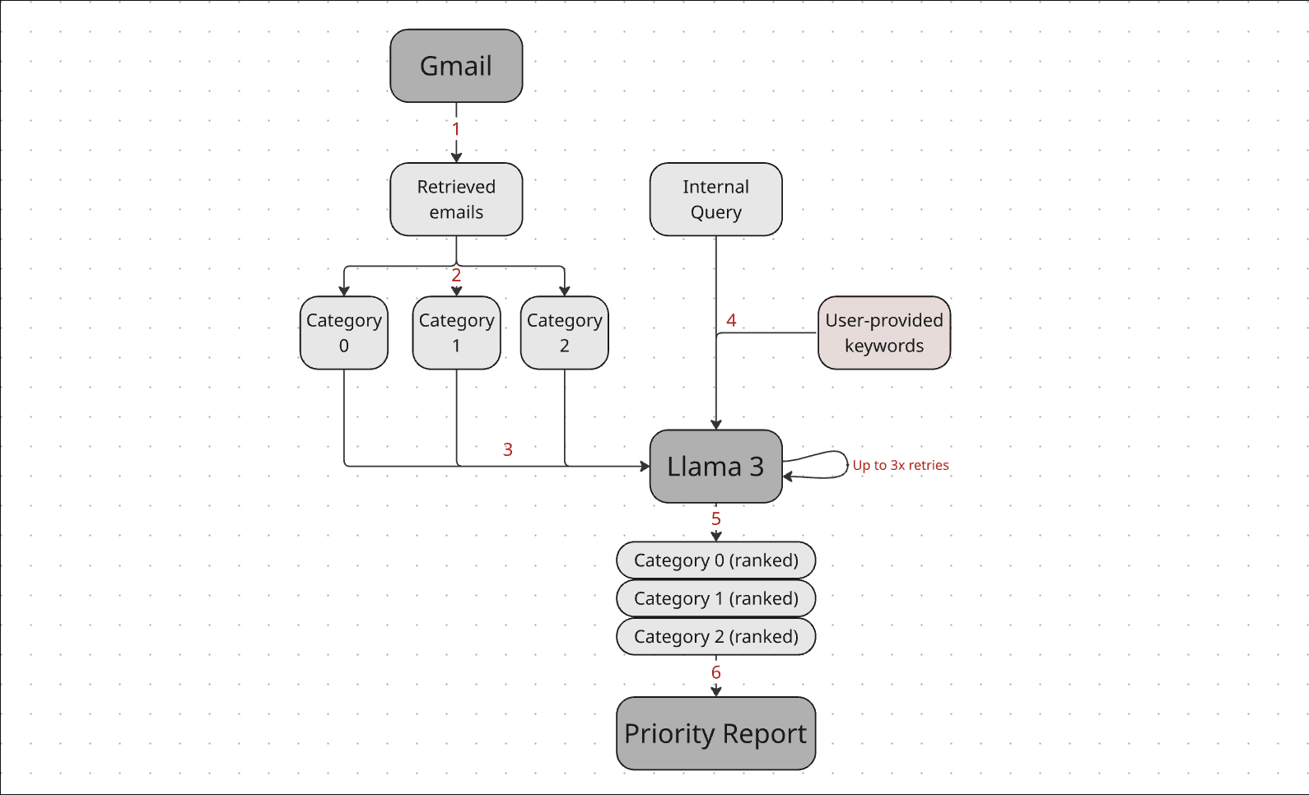

- The Gmail API is used to retrieve all emaisl sent to the user’s email address in the past 24 hours
- The emails are divided into Category 0 (emails whitelisted by the user), Category 1 (emails which are not from a public domain), and Category 2 (emails from a public domain)
- Each email in each category is input to Llama 3.2 (accessed via the Groq API)
- An internal query is used to prompt Llama 3.2 to give each email an urgency score (Uscore)
- If the user has provided keywords, their weight is added to the Uscore and moved to a sub-list at the top of their category
- Each category and sub-list is sorted by Uscore, with the highest Uscore coming first
- The final ranked list of all emails is generated as follows (from highest to lowest):
  - Category 0 keyword sub-list (ranked by Uscore)
  - Category 0 (ranked by Uscore)
  - Category 1 keyword sub-list (ranked by Uscore)
  - Category 1 (ranked by Uscore)
  - Category 2 keyword sub-list (ranked by Uscore)
  - Category 2 (ranked by Uscore)
- A priority report is delivered to the user, including:
  - A to-do list composed from top emails
  - A shortlist of the most urgent emails in the system
  - A full list of all emails in the system, ranked by urgency
  - A list of flagged emails which could not be processed (if necessary)

Section 01: Using ToneRank

Installation and Setup

Prerequisites:
- Python 3.7 or higher
- Gmail account with API access enabled
- Groq API account for Llama3 access

Required Python packages:
- google-api-python-client
- google-auth-httplib2
- google-auth-oauthlib
- groq
- python-dotenv
- termcolor

API Setup:
- Gmail API setup
  - Go to the Google Cloud Console
  - Create a new project or select an existing one
  - Enable the Gmail API for your project
  - Create OAuth 2.0 credentials (Desktop application type)
  - Download the credentials and save as credentials.json in the project directory
- Groq API Setup
  - Sign up at Groq and get your API key
  - Create a .gitignore folder in your project directory
  - Inside .gitignore, create a .env file with your API key:
    - GROQ_API_KEY = your_groq_api_key_here

After downloading the source code from the GitHub and following the above setup instructions, your project directory should contain the below:
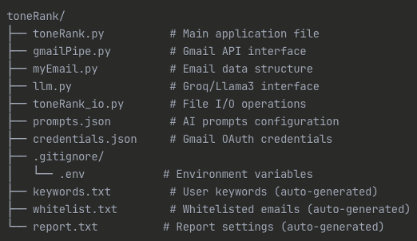
Note: if you have not run the program, the auto-generated files will not yet exist. If they are not created automatically after the first run, a problem has occurred.

Using ToneRank

ToneRank can be started by running the following terminal command:
Python toneRank.py
This will bring up the RoneRank ASCII logo and a main menu, as seen below.
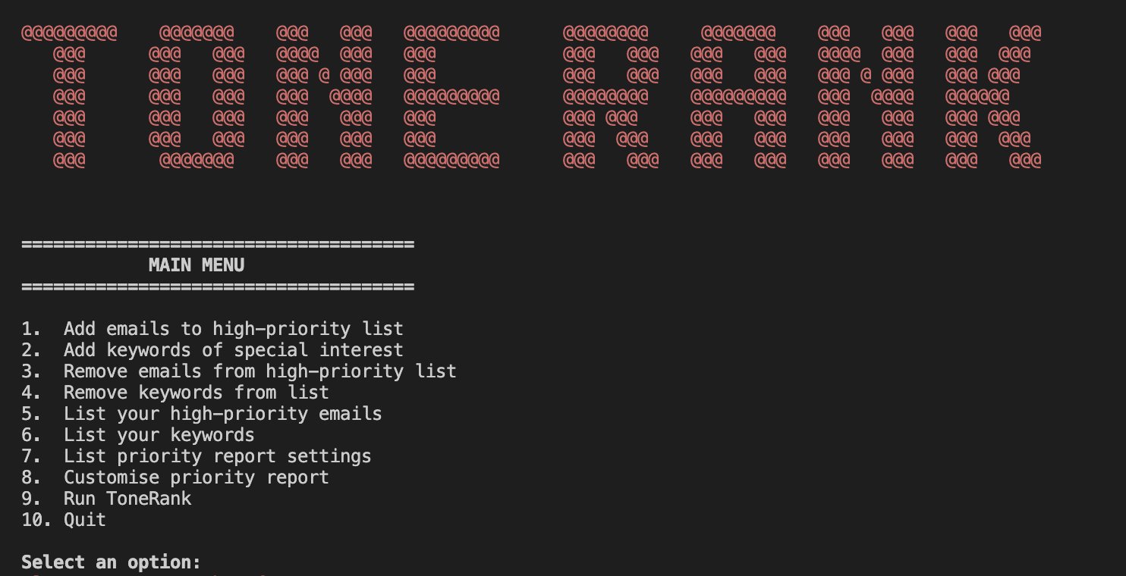

The user can then input a number corresponding to one of the ten options, which will respond as follows:
- Add emails to high-priority list
  - User may whitelist specific email addresses
  - Enter emails separated by spaces (e.g. “john@company.com jane@business.com”)
  - Invalid email formats will be rejected
- Add keywords of special interest
  - Define keywords that indicate higher priority
  - Enter keywords separated by spaces (e.g. “keyword1 keyword2”)
  - When prompted, define a weight for each keyword. This is the modifier which will be added to the base Uscore of an email which contains this keyword
- Remove emails from high-priority list
  - Remove previously whitelisted email addresses
  - Enter target emails separated by spaces
- Remove keywords from list
  - Remove previously added keywords
  - Enter target keywords separated by spaces
- List your high-priority emails
  - Display all currently whitelisted email addresses
- List your keywords
  - Show all keywords with their assigned weights
  - E.g. “keyword1 (weight1), keyword2 (weight2)”
- List priority report settings
  - Display current size of shortlist (by default, the top 5 emails)
  - Display number of emails used to generate to-do list (by default, the top 10 emails)
- Customize priority report
  - Modify how many emails appear in the shortlist (anywhere from 1-10)
  - Adjust how many emails are used to generate to-do list (anywhere from 1-20)
- Run ToneRank
  - Execute the main email analysis feature and generate a priority report
  - Automatically runs option #10 (Quit) upon completion
- Quit
  - Exit the application and save all preferences

Section 02: The Codebase

Technical Architecture

Core components:
- toneRank.py – main application orchestrator
  - Handles user interface and menu systems
  - Coordinates use of gmailPipe.py, llm.py, and toneRank_io.py
  - Access prompts from prompts.json
  - Manages overall application flow
- gmailPipe.py – Gmail API interface
  - Establishes authentication flow with Gmail using OAuth 2.0
  - Retrieves emails from past 24 hours
  - Handles credential refreshing and reauthorization
- myEmail.py – email data structure
  - Defines the Email class used to represent an email within the system. Each object has the below fields:
    - Subject
    - Sender
    - Date
    - Body
    - Uscore
  - Implements comparison operators for sorting by urgency
- llm.py – Groq API interface
  - Manages Groq API connection for Llama3 access
  - Provides retry logic and error handling/caching
- toneRank_io.py – data persistence
  - Handles loading and saving user preferences to file
  - Manages keywords, whitelisted emails, and priority report settings
  - Provides data validation and error handling

toneRank.py

Key constants:
- OPTION_1 through OPTION_10, which specify the menu option constants
- public_email_domains, which represents a set of the 100 most common public email domains, derived from http://email-verify.my-addr.com/list-of-most-popular-email-domains.php

Functions:
- AI Functions
  - urgency_prompt_C1(email, client, prompt_data)
    - Uses llm.py (and an internal prompt from prompts.json) to calculate an urgency score for Category 0 and Category 1 emails using Llama 3
    - Parameters:
      - email: an email object
      - client: an authenticated Groq API client instance
      - prompt_data: loaded JSON data from prompts.json
    - Returns a float between 0.0 and 10.0 (inclusive) representing the Uscore
  - urgency_prompt_C2(email, client, prompt_data)
    - Uses llm.py (and an internal prompt from prompts.json) to calculate an urgency score for Category 2 emails using Llama 3
    - Parameters:
      - email: an email object
      - client: an authenticated Groq API client instance
      - prompt_data: loaded JSON data from prompts.json
    - Returns a float between 0.0 and 10.0 (inclusive) representing the Uscore
  - generate_todo_list(top_ten_email_list, client, prompt_data)
    - Parameters:
      - top_ten_email_list: a formatted string containing the email subjects and bodies of top emails
      - client: an authenticated Groq API client instance
      - prompt_data: loaded JSON data from prompts.json
    - Returns a string representing a numbered to-do list
- Keyword Handling Functions
  - get_keyword_modifier(email)
    - Manually searches for keywords within an email
    - Must be passed an email object
    - Returns a float number, the sum of the weights of all keywords found in the passed email
- User Interface Functions
  - whitelist_emails()
    - Interactive function which adds a batch of user-provided emails to the whitelist
    - Will not add emails with invalid formats to the whitelist
    - Parameters: N/A
    - Returns: N/A
  - remove_whitelisted_emails()
    - Interactive function which removes a batch of user-provided emails from the whitelist (if present)
    - Parameters: N/A
    - Returns: N/A
  - add_keywords()
    - Interactive function which adds a batch of user-provided keywords with custom weights to the list of keywords
    - Parameters: N/A
    - Returns: N/A
  - remove_keywords()
    - Interactive function which removes a batch of user-provided keywords with custom weights to the list of keywords (if present)
    - Parameters: N/A
    - Returns: N/A
  - update_priority_report()
    - Interactive function which allows the user to modify the size of the shortlist and the number of emails used to generate the to-do list
    - If user inputs a value out of the legal range (1-10 for the shortlist, and 1-20 for the to-do list sample size) they will be asked to re-input
    - Parameters: N/A
    - Returns: N/A
- Main Application Functions
  - toneRank_main()
    - Core orchestrator function that executes the complete email analysis pipeline from retrieval to report generation
      - Phase 1: emails from the last 24 hours are retrieved via gmailPipe.py functions, stored in a list
      - Phase 2: emails are split into the three categories, each stored in its own list
      - Phase 3: the AI client is set up using llm.py functions
      - Phase 4: each email in each category is processed and assigned a Uscore composed of the base and modifier, adding a star to the title any email which contained a keyword
      - Phase 5: emails are organized into their final ranking
      - Phase 6: to-do list is generated
      - Phase 7: priority report is generated and printed to the console
    - Parameters: N/A
    - Returns: N/A

gmailPipe.py

The gmailPipe.py file contains the GmailPipe class, which abstracts the Gmail API for greater ease and security of use in toneRank.py. All of the functions in GmailPipe are static

Functions:
- get_gmail_service()
  - Creates an authenticated Gmail API service object with read-only access to the user’s Gmail inbox
    - Loads existing credentials from token.json
      - If credentials expired, but a refresh token exists, it automatically refreshes them and calls _save_credentials()
      - Otherwise, it raises an exception
    - Creates the Gmail API service and returns it
    - If an exception occurs, it calls reauthorize_gmail()
  - Parameters: N/A
  - Returns: an authenticated Gmail API service object
- reauthorize_gmail()
  - Internal helper method which performs a complete OAuth 2.0 authorization flow to obtain fresh Gmail API credentials and a refresh token
    - Credentials are saved to credentials.json
  - Parameters: N/A
  - Returns: a fresh credentials object
- _save_credentials()
  - Internal helper method which saves updated credentials back to the token.json file
  - Parameters: creds, the credentials object to be saved
  - Returns: N/A
- get_emails_last_24_hours()
  - Retrieves all emails received in the last 24 hours and converts them into Email objects using myEmail.py
  - Parameters: N/A
  - Returns: a list of Email objects representing all emails from the past 24 hours

myEmail.py

The myEmail.py file defines the Email class, which represents emails within the system using the fields subject, sender, date, body, and uscore. Upon creation, an Email object has a Uscore of -1.0, a value which will be overwritten later during email processing in toneRank.py.
Besides the initialization code, the Email class contains comparison functions which are used when sorting emails by urgency, and a __repr__ function which is used to generate the string representations of each email which are used when printing the priority report.

llm.py

The llm.py file contains the GroqLlama class, which serves as the LLM interface for toneRank.py and the system as a whole. It abstracts the Groq API, and handles all interactions with Llama 3.2 (specifically, llama3-8b-8192) made via it.

Constants:
- MAX_RETRIES = 3
  - The maximum number of retry attempts for failed API calls
- MAX_RESPONSE_LEN = 300
  - The maximum length of a response generated by Llama 3.2 (in tokens)
- MAX_CACHE_SIZE = 1000
  - The maximum number of rows in the cache
- TEMP = 0.0
  - The temperature of the model

Functions:
- __init__(self)
  - Creates a new GroqLlama instance with an API client and logging configuration
    - Calls both setup_groq() and get_logger()
  - Parameters: N/A
  - Returns: N/A
- setup_groq(self)
  - Configures and initializes the Groq API client using environment variabels for authentication
  - Parameters: N/A
  - Returns: a configured Groq API client object
- get_logger(self)
  - Creates and configures a comprehensive logging system for tracking LLM operations, errors, and debugging info
  - Parameters: N/A
  - Returns: a configured logger instance
- prompt_llama(self, prompt)
  - Internal helper method which performs the actual API call to Groq’s Llama 3.2 model without retry logic or error handling
  - Parameter: prompt, the text prompt to send to the model
  - Returns: the model’s response text
- get_llama_response(self, prompt, delay=1)
  - Queries the Llama 3.2 model with comprehensive retry logic and error handling
    - Uses prompt_llama(self, prompt)
    - Retries up to MAX_RETRIES times
    - With exponential backoff, the wait between retries gets progressively longer
  - Parameters:
    - prompt: the text prompt to send to Llama 3.2
    - delay: the base delay in seconds between retry attempts (without exponential backoff)
  - Returns: the model’s response text
- get_cached_llama_response(client, prompt)
  - Extends the functionality of get_llama_response to also cache responses
  - Parameters:
    - client: an instance of the GroqLlama class
    - prompt: the text prompt to send to the model
  - Returns: the model’s response text

toneRank_io.py

The toneRank_io.py file contains the ToneRank_IO class, which serves as the data persistence and file management layer for the system. All methods in ToneRank_IO are static methods.

Constants:
- KEYWORD_FILE_NAME = “keywords.txt”
  - The name of the file which stores user-defined keywords
- EMAIL_WHITELIST_FILE_NAME = “whitelist.txt”
  - The name of the file which stores emails whitelisted by the user
- PRIORITY_REPORT_FILE_NAME = “report.txt”
  - The name of the file which stores user preferences for the priority report
- MAX_KEYWORDS
  - The maximum number of keywords which can be stored in the system
- MIN_TOP_EMAIL_SIZE, MAX_TOP_EMAIL_SIZE, and DEFAULT_TOP_EMAIL_SIZE
  - The minimum, maximum, and default values for the length of the shortlist of top emails (1, 10, and 5, respectively)
- MIN_TODO_SAMPLE_SIZE, MAX_ TODO_SAMPLE_SIZE, and DEFAULT_ TODO_SAMPLE_SIZE
  - The minimum, maximum, and default values for the number of emails consulted when generating a to-do list (1, 20, and 10, respectively)

Class Variables:
- keywords: the list of user-defined keywords with weights
- email_whitelist: the list of user-whitelisted emails
- top_email_size: the current number of emails in the shortlist
- todo_list_sample_size: the number of emails currently used to generate the to-do list

Functions:
- initialize_files()
  - Ensures that the required data files (keywords.txt, whitelist.txt, and report.txt) exist before attempting to load them, creating empty files if necessary
  - Parameters: N/A
  - Returns: N/A
- add_keyword(keyword, weight)
  - Adds a new keyword to the keyword dictionary, enforcing capacity limits and preventing duplicates
  - Parameters:
    - keyword: the keyword to add to the system
    - weight: the Uscore weight for this keyword
- remove_keyword(keyword)
  - Removes a specified keyword from the keyword dictionary
  - Parameter: keyword, the keyword to add to the system
  - Returns: N/A
- add_email_to_whitelist(email)
  - Adds an email to the whitelist
  - Parameter: email, the email address to add to the whitelist
  - Returns: N/A
- remove_email(email)
  - Removes an email from the whitelist
  - Parameter: email, the email address to remove
  - Returns: N/A
- load_remote_data()
  - Loads all persistent user configuration data from files and uses them to instantiate the class variables when the application starts
    - Calls initialize_files() before anything else
  - Parameters: N/A
  - Returns: N/A
- save_local_data()
  - Saves all current user configuration data from the class variables to their files for future use
  - Parameters: N/A
  - Returns: N/A

