ELSYS Website Rebuild – C4 Model (v2)
System context, containers and key components for the new ELSYS Web Platform

Author: Martin Bozhilov
Programme: ICT & Personalized Program (Open Learning), Fontys UAS
Date: 07-01-2026
Version: 0.2

1. Purpose of this document
This document explains the updated C4 model for the ELSYS website rebuild. The goal is to give coaches and the software expert a clear, structured view of how the system is organised: who uses it, which technical building blocks are involved, and how the main components of the Next.js web application fit together.
The model is split into three levels:
- Level 1 – System Context: how the ELSYS Web Platform fits into its environment.
- Level 2 – Container View: the main technical building blocks (Next.js app, database, filesystem content, etc.).
- Level 3 – Component View: the most important components inside the Next.js web application container.

2. Level 1 – System Context
At system level, the ELSYS Web Platform is a public website with an integrated admin console. It is used by three main personas and interacts with several external systems.
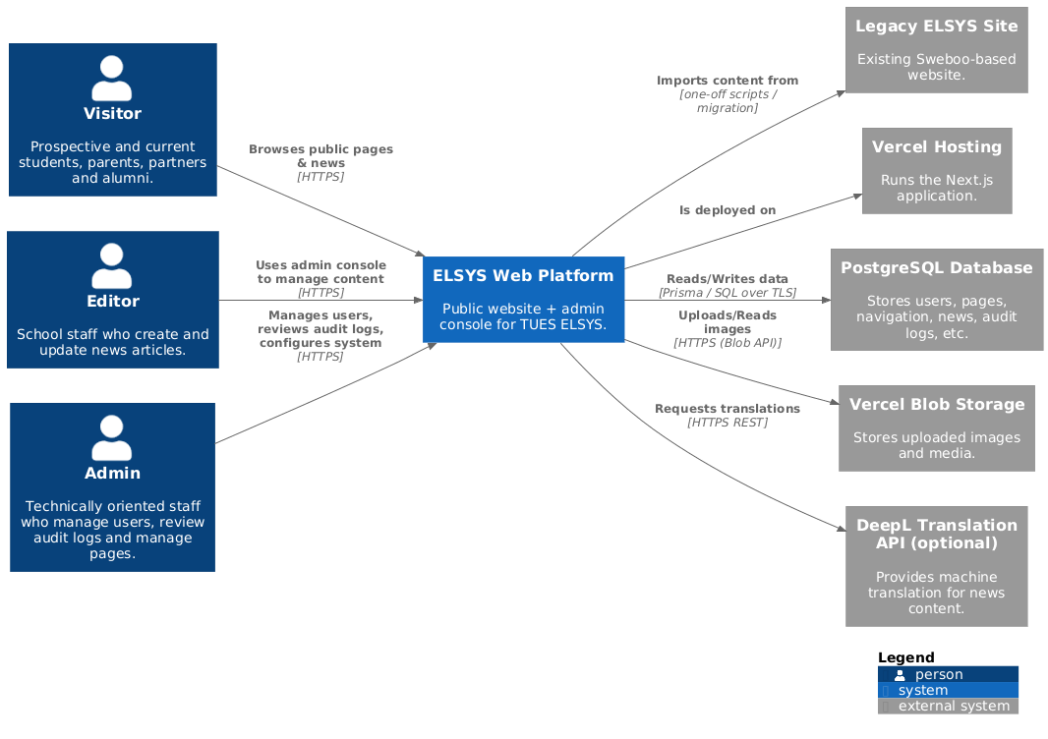

2.1 People
- Visitor – prospective and current students, parents, partners and alumni who browse the public site.
- Editor – school staff who create and update pages and news articles using the admin console.
- Admin – technically oriented staff who manage users, review audit logs and configure the system.

2.2 Systems
The central system is the “ELSYS Web Platform”, which I am rebuilding as a modern Next.js application. Around it are several external systems:
- Legacy ELSYS Site – the existing Sweboo-based website. It is a source of content during migration but is not part of the new runtime architecture.
- Vercel Hosting – the platform that runs the Next.js application.
- PostgreSQL Database – stores users, pages, navigation, news, audit logs and other structured data.
- Vercel Blob Storage – stores uploaded images and media for news and other content.
- DeepL Translation API (optional) – provides machine translation for news content when seeding translations.

2.3 Interactions
From the perspective of the users:
- Visitors browse public pages and news of the ELSYS Web Platform over HTTPS.
- Editors use the admin console to manage content (pages and news) over HTTPS.
- Admins use the same admin console to manage users, settings and audit logs over HTTPS.
From the perspective of the ELSYS Web Platform:
- It imports content from the Legacy ELSYS Site using one-off migration scripts.
- It is deployed on Vercel Hosting.
- It reads and writes structured data in the PostgreSQL Database via Prisma over TLS.
- It uploads and reads images via the Vercel Blob Storage API (when used).
- It can call the DeepL Translation API to translate news content between locales (optional).

3. Level 2 – Container View
The container view zooms into the ELSYS Web Platform and shows the main technical building blocks. Each container has a clear responsibility and a specific technology stack.
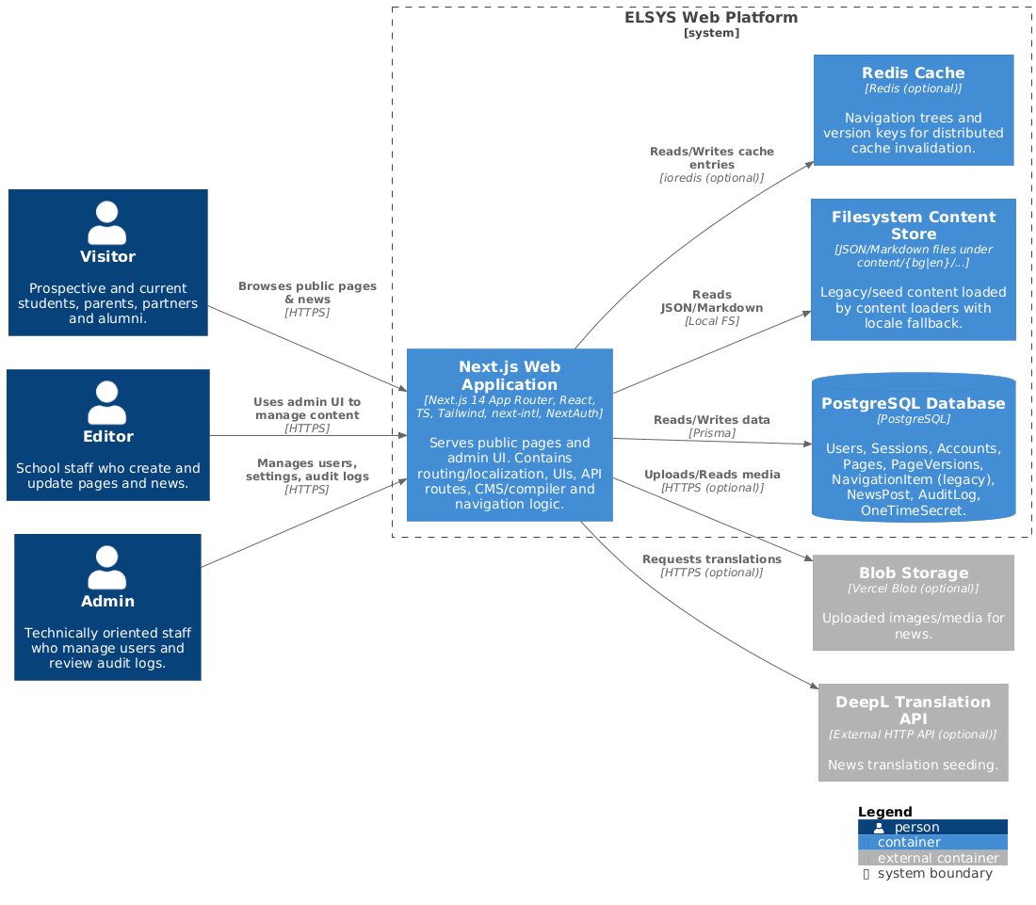

3.1 Next.js Web Application
The “Next.js Web Application” is the core container. It is built with Next.js 14 (App Router), React, TypeScript, Tailwind CSS, next-intl and NextAuth. It serves all public pages under locale-prefixed routes (for example /bg and /en) and exposes the admin UI under /admin.
Responsibilities:
- Implement routing and localization for the public and admin areas.
- Render the public UI for visitors (home page, news, blog and other sections).
- Render the admin UI for editors and admins (pages, navigation, news, users, settings).
- Expose API routes under /api/* for admin CRUD operations and supporting endpoints (navigation, locale-path, route-alias, one-time secrets, etc.).
- Integrate with the database, filesystem content, caches and external services.

3.2 PostgreSQL Database
The “PostgreSQL Database” stores all structured data for the platform. Prisma is used as the ORM. Key models include:
- User, Session, Account – for authentication and authorisation.
- Page and PageVersion – for CMS pages and their block-based content versions.
- NavigationItem (legacy) – for older navigation data that is still supported during migration.
- NewsPost – for multi-locale news articles.
- AuditLog – for audit trail entries.
- OneTimeSecret – for onboarding flows and single-use tokens.

3.3 Filesystem Content Store
The “Filesystem Content Store” holds JSON and Markdown files under content/{bg|en}/…. It is used mainly for legacy or seed content that has not yet been migrated into the CMS. Content loaders inside the web application read this data with locale fallback.

3.4 Redis Cache (optional)
The “Redis Cache” is an optional container used to store navigation trees and version keys for distributed cache invalidation. If Redis is not configured, the application falls back to in-memory caching only; the system remains functional but less scalable.

3.5 Blob Storage and DeepL API (optional)
Two further external containers are involved:
- “Blob Storage (Vercel Blob)” – stores uploaded images and media for news posts and other content. The database stores only references and metadata.
- “DeepL Translation API” – used to translate news content between locales when editors choose to seed a translation. If no API key is configured, the system simply does not offer automatic translation and editors work manually.
Together, these containers provide the data, content and infrastructure services that the Next.js Web Application builds upon.

4. Level 3 – Component View (Next.js Web Application)
The component view zooms into the “Next.js Web Application” container and splits it into the main components that collaborate to serve public and admin requests. This level is still technology-agnostic enough for discussion, but close enough to the codebase that a software expert can map components to actual modules and files.
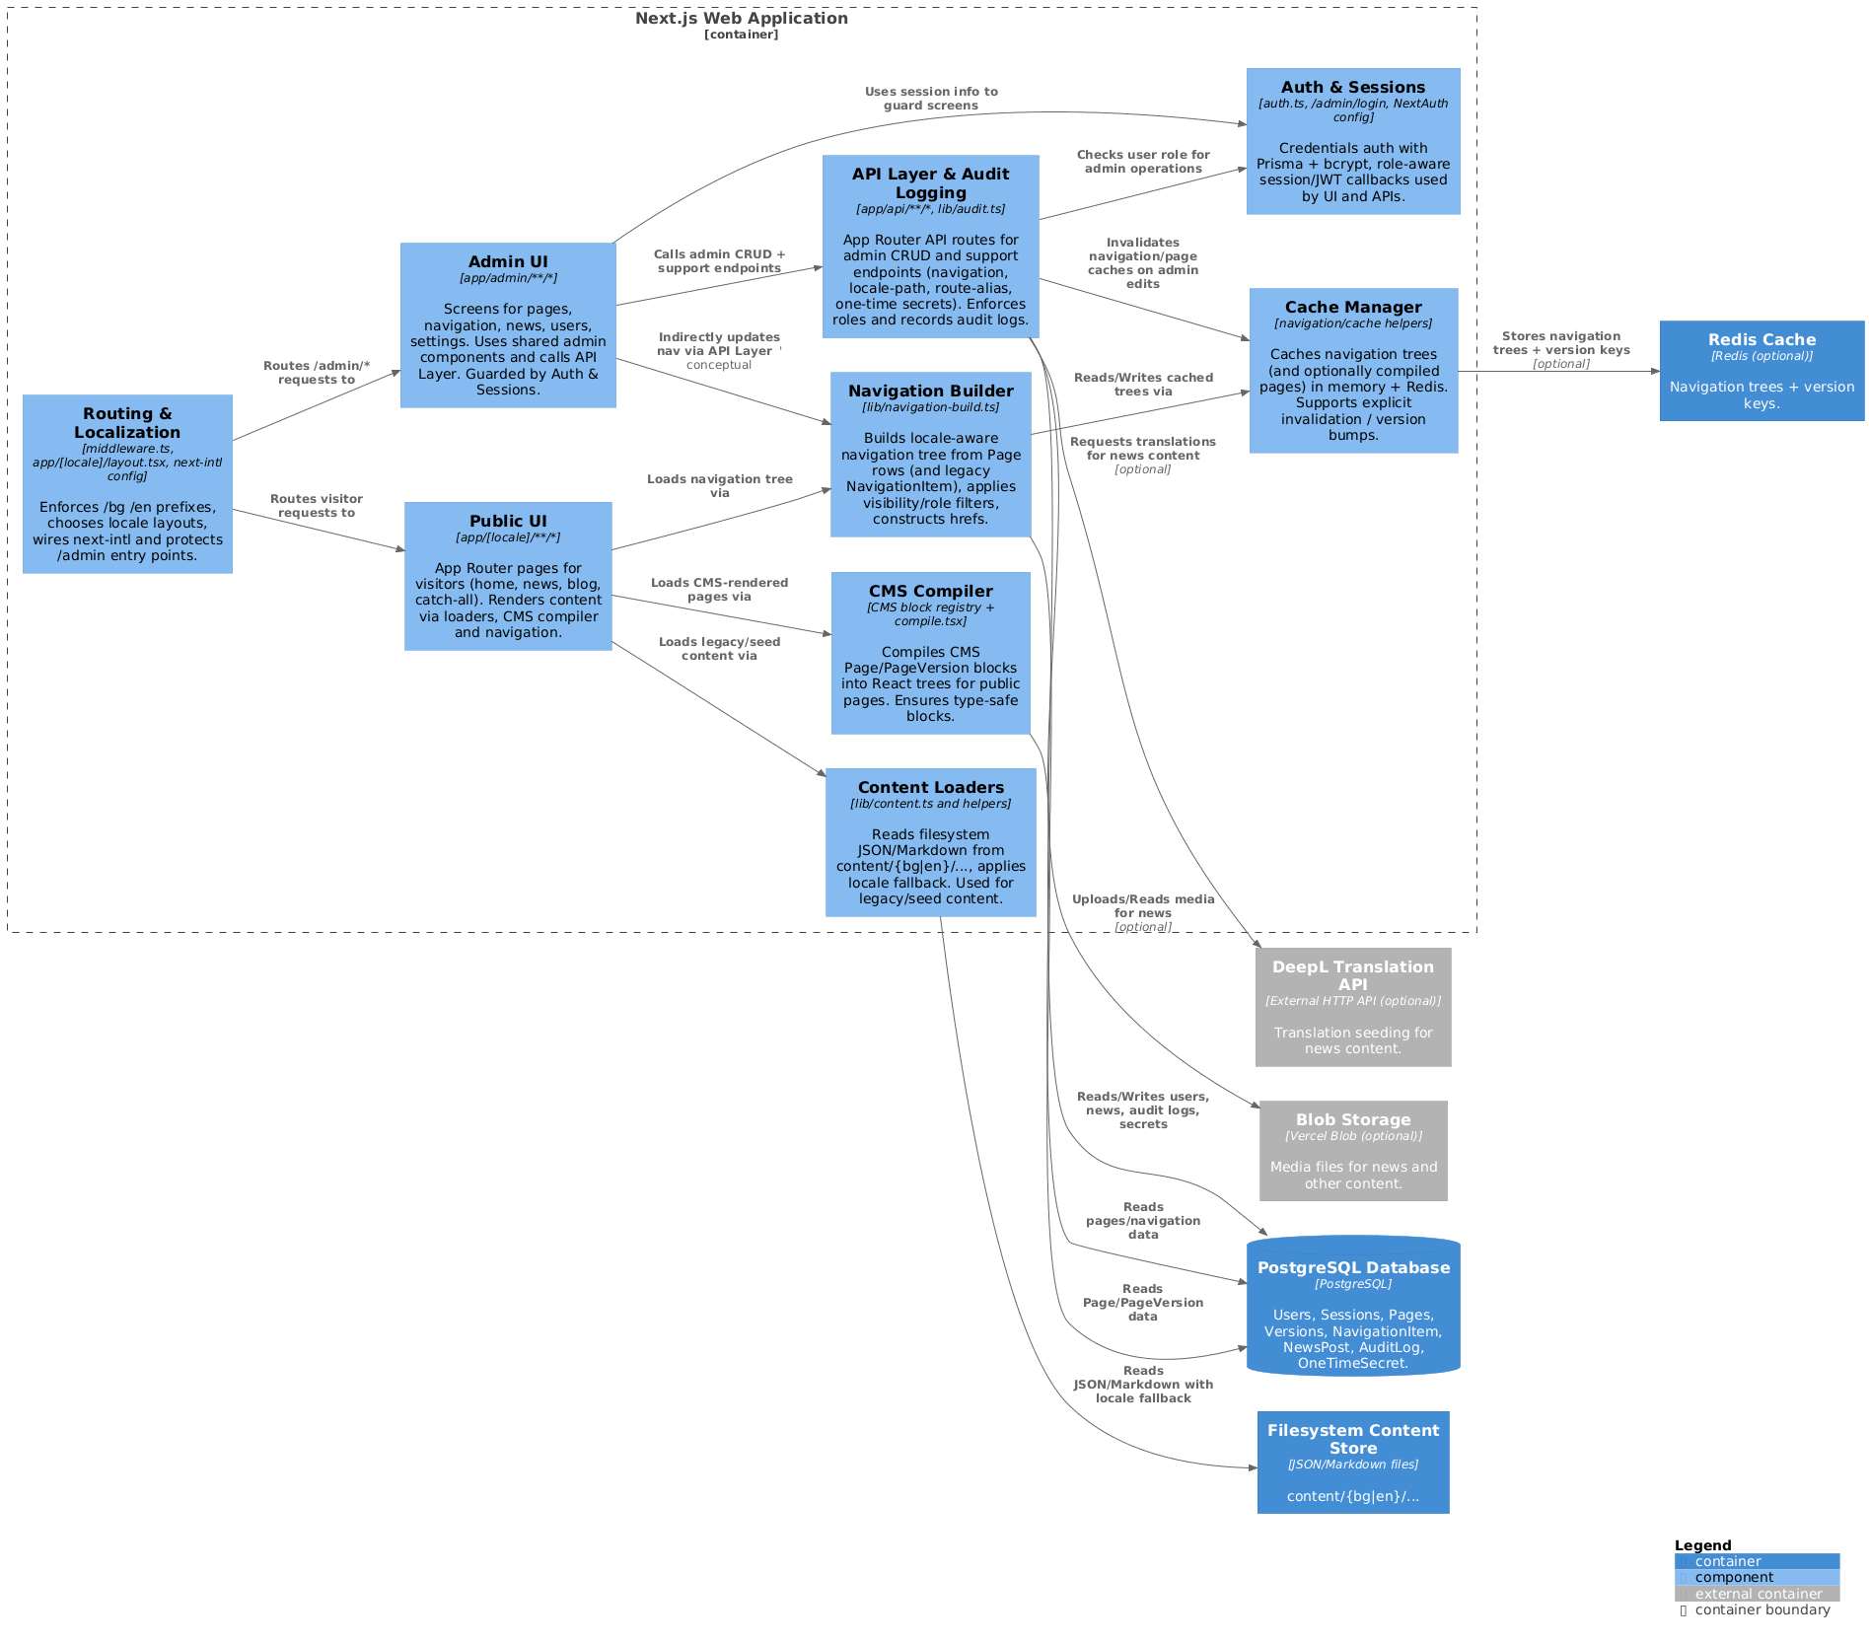

4.1 Routing & Localization
The “Routing & Localization” component consists of middleware and layouts under app/[locale]/… together with the next-intl configuration. It enforces locale prefixes (/bg, /en), selects the correct locale layout for each request and wires up translation resources. It also protects /admin entry points so that unauthenticated users are redirected to the login page.

4.2 Auth & Sessions
The “Auth & Sessions” component is implemented with NextAuth using a credentials provider, PrismaAdapter and bcrypt. It validates logins, issues JWTs and sessions, and enriches them with user roles and ids. Both the admin UI and the API layer use this component to check whether the current user is an editor or admin before allowing sensitive actions.

4.3 Public UI
The “Public UI” component covers all locale-prefixed App Router pages in app/[locale]/”/*. These routes handle the main visitor-facing flows: home page, news listing and detail pages, and other informational sections. Public pages obtain their data from three sources via other components:
- the CMS Compiler (for CMS-managed pages),
- the Content Loaders (for filesystem-based content), and
- the Navigation Builder (for menus and navigation links).

4.4 Admin UI
The “Admin UI” component lives under app/admin/*. It provides screens for managing pages, navigation, news, users and settings. It uses shared admin components such as a BlockEditor and layout panels. Every admin page is guarded by Auth & Sessions and communicates with the API Layer to perform CRUD operations. This keeps write logic and validation on the server side, while the admin UI remains focused on user interaction.

4.5 Content Loaders
The “Content Loaders” component, implemented in modules like content.ts, reads JSON and Markdown from the Filesystem Content Store. It applies locale fallback rules (for example, if a Bulgarian version is missing it can fall back to English) and returns structured data that can be rendered by the Public UI. This component is important during migration, because it allows legacy or seed content to stay in the file system while the rest of the platform is already running on the new architecture.

4.6 CMS Compiler
The “CMS Compiler” component handles page content stored in the database. It loads Page and PageVersion records via Prisma, validates the blocks using a block registry and turns them into React component trees. In practice this means that editors can build pages from blocks, while the compiler guarantees that only known, validated blocks are rendered. The Public UI relies on this component whenever a page is fully managed by the CMS.

4.7 Navigation Builder
The “Navigation Builder” component constructs a locale-aware navigation tree from Page rows (and legacy NavigationItem records where needed). It groups pages by logical group id, selects the best locale variant, applies visibility flags and role-based filters, and finally produces a nested structure of menu items with hrefs. Both the Public UI and the Admin UI use this component indirectly when they need navigation data.

4.8 Cache Manager
The “Cache Manager” component stores navigation trees (and potentially compiled pages) in memory and, when configured, in Redis. It exposes simple operations such as “get navigation tree for locale” and “invalidate navigation cache”. Admin operations that change pages or navigation call into the Cache Manager via the API Layer to bump version keys and clear old entries. This ensures that visitors quickly see updated menus without each request having to rebuild the navigation from scratch.

4.9 API Layer & Audit Logging
The “API Layer & Audit Logging” component consists of App Router API routes under app/api/* and a reusable audit helper. Admin endpoints (for pages, navigation, news, users, settings) enforce roles by calling Auth & Sessions, perform validation and data access via Prisma, and then record audit entries that capture who did what and when. Support endpoints, such as navigation JSON, locale-path, route-alias and one-time secret handling, are also implemented here. This centralises all write logic and side effects in one well-defined component.

4.10 Interactions between components
At runtime, a typical user flow crosses several components:
- A visitor request hits Routing & Localization, which selects the locale and forwards to a Public UI page.
- The Public UI asks the Navigation Builder (via the Cache Manager) for the navigation tree, and the CMS Compiler or Content Loaders for page content.
- When an editor saves a change in the Admin UI, the request is sent to the API Layer, which consults Auth & Sessions, updates the database via Prisma, writes an audit log entry and finally asks the Cache Manager to invalidate the relevant caches.
These interactions mean that each component has a clear responsibility but they still form a coherent pipeline from HTTP request to rendered page.

5. Conclusion
This updated C4 model gives a structured overview of the ELSYS website rebuild from three angles: system context, containers and components. At the highest level it shows how visitors, editors and admins interact with the platform and which external systems are involved. The container view explains which technical building blocks exist in the architecture (Next.js app, PostgreSQL, filesystem content, Redis, Blob storage and DeepL). Finally, the component view opens up the Next.js Web Application and shows how routing, authentication, public UI, admin UI, content loading, CMS compilation, navigation building, caching and the API layer with auditing all work together.

