## Visual Studio Configuration

1. Right click on Dependencies under IFFCO.Web & click on Manage NuGet Packages.

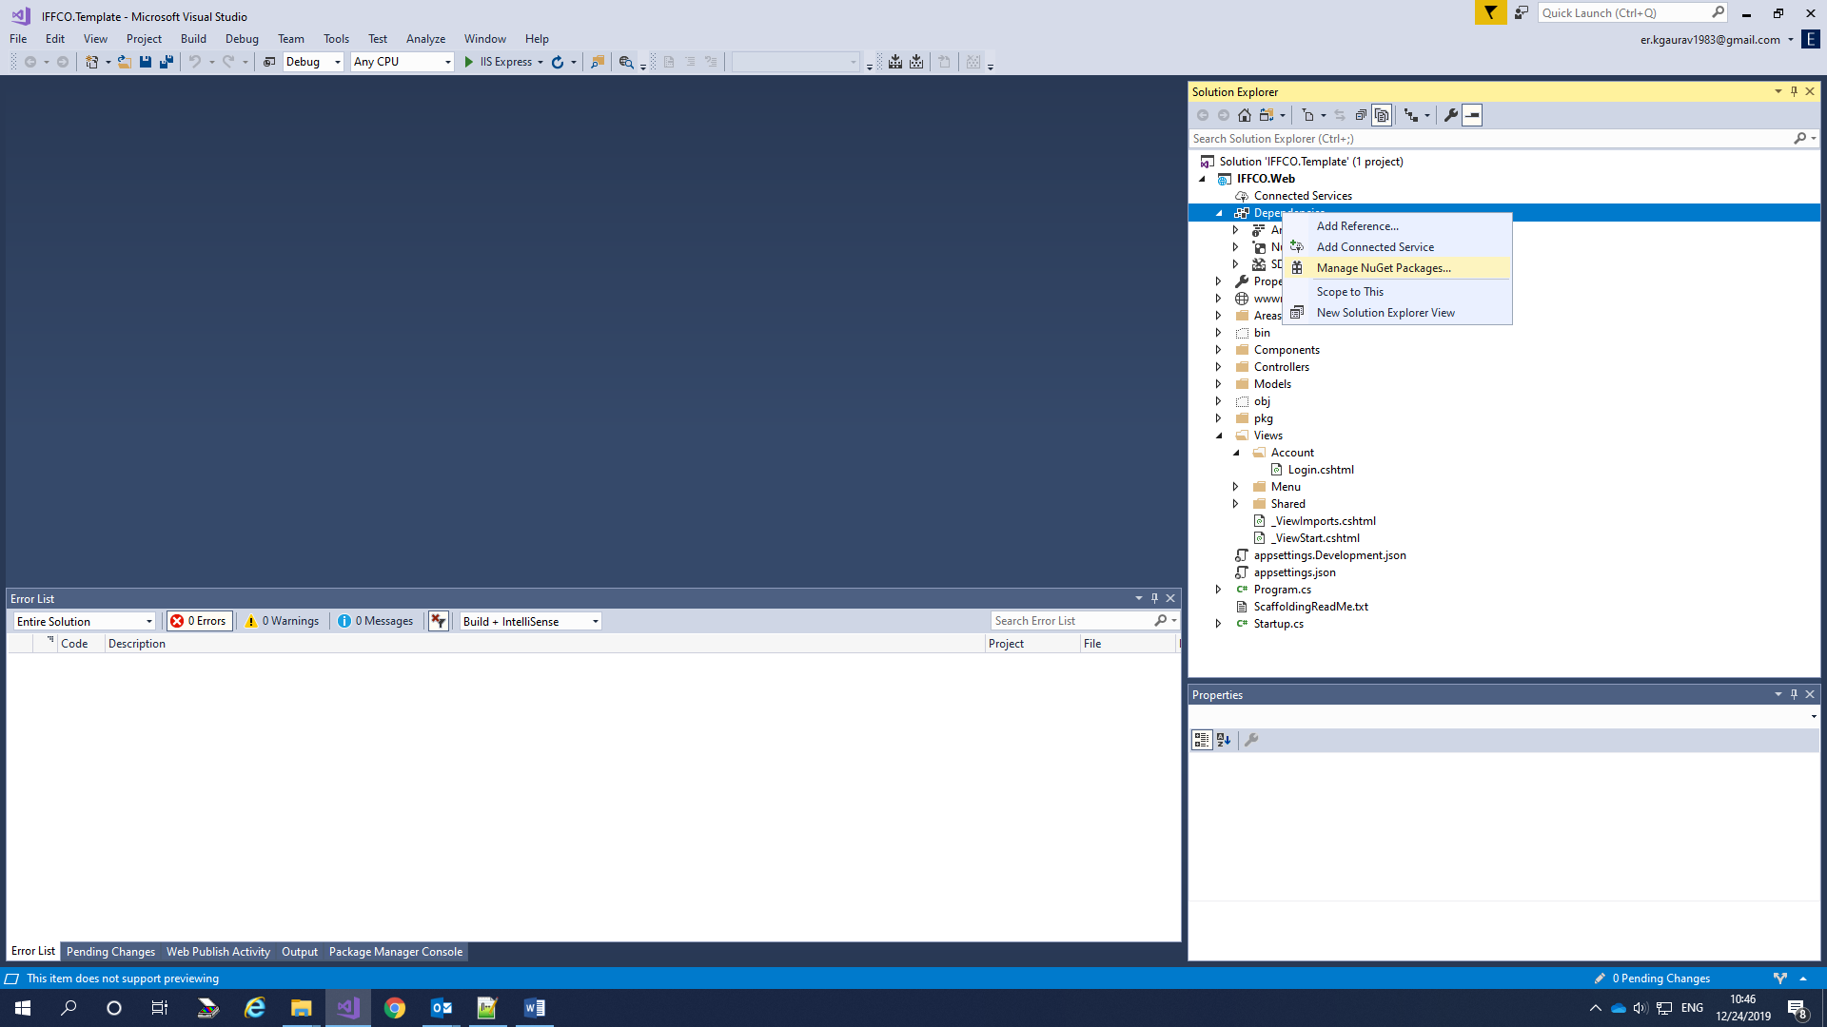

1. Click on “Setting” button next to Package Source.

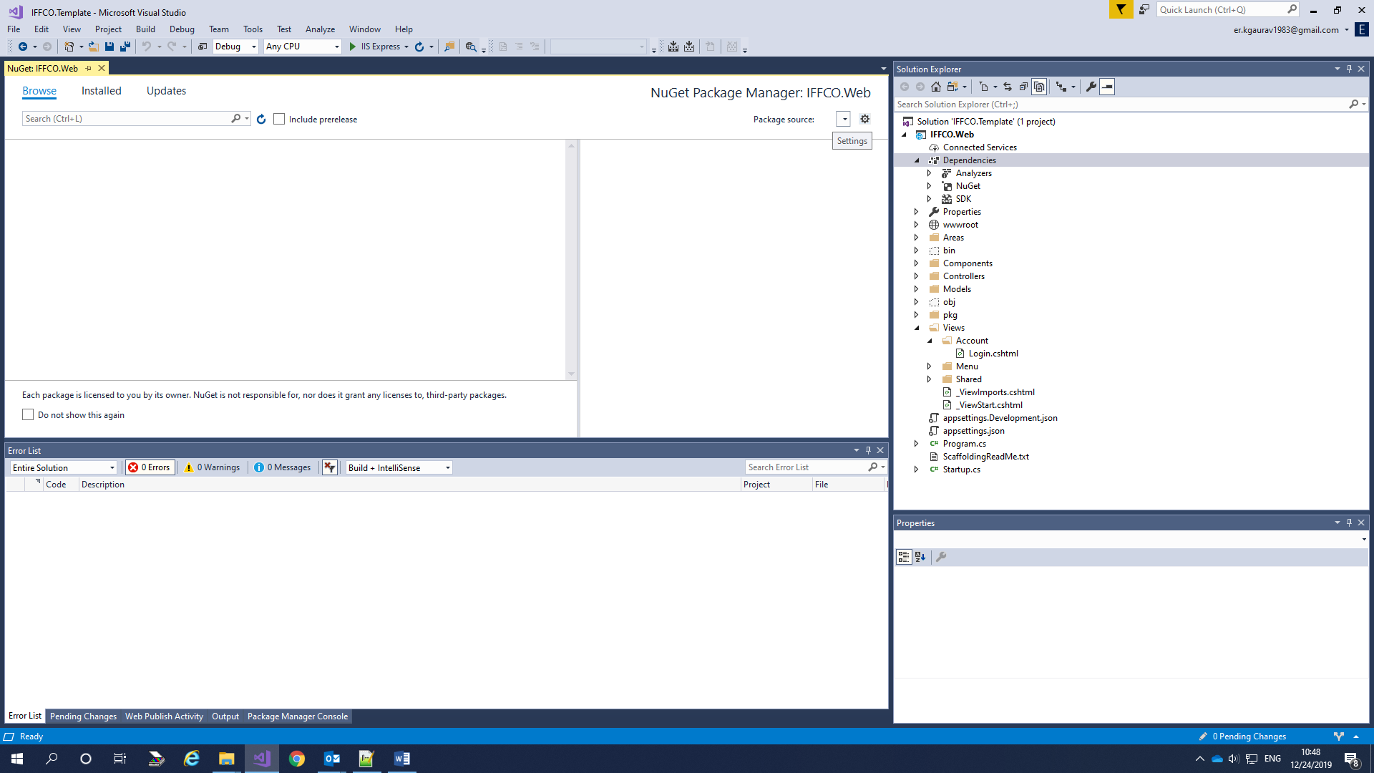

1. Click “+” sign to add Package Source.

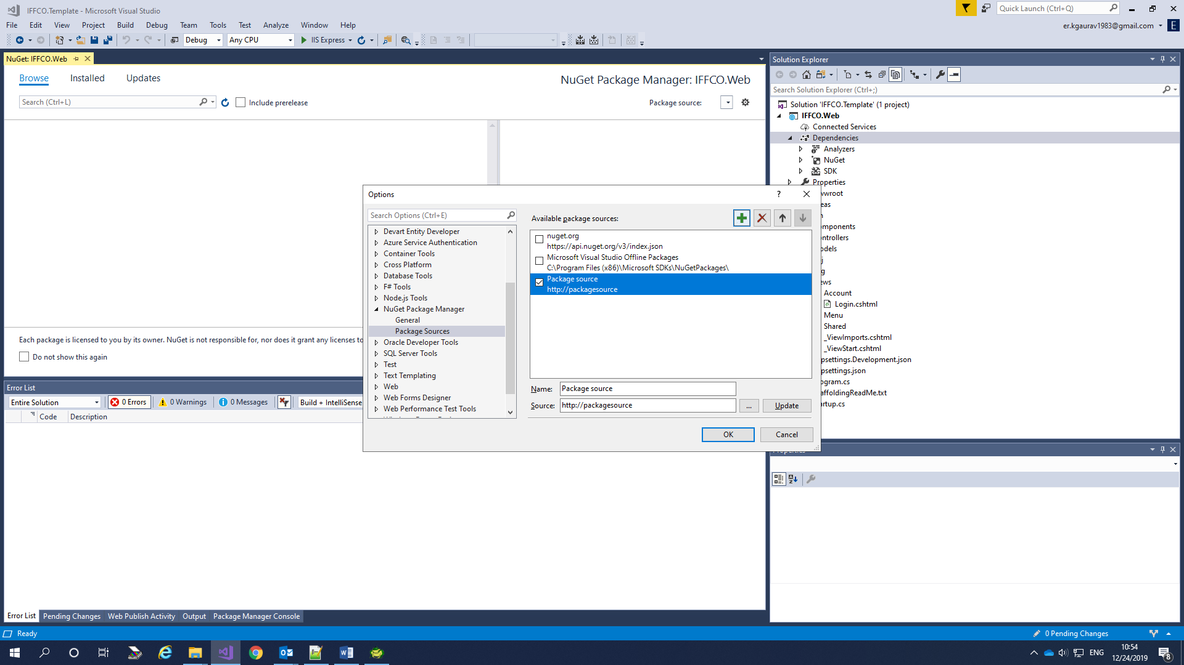

1. Change Name as “pkg” and click on “…” next to source.

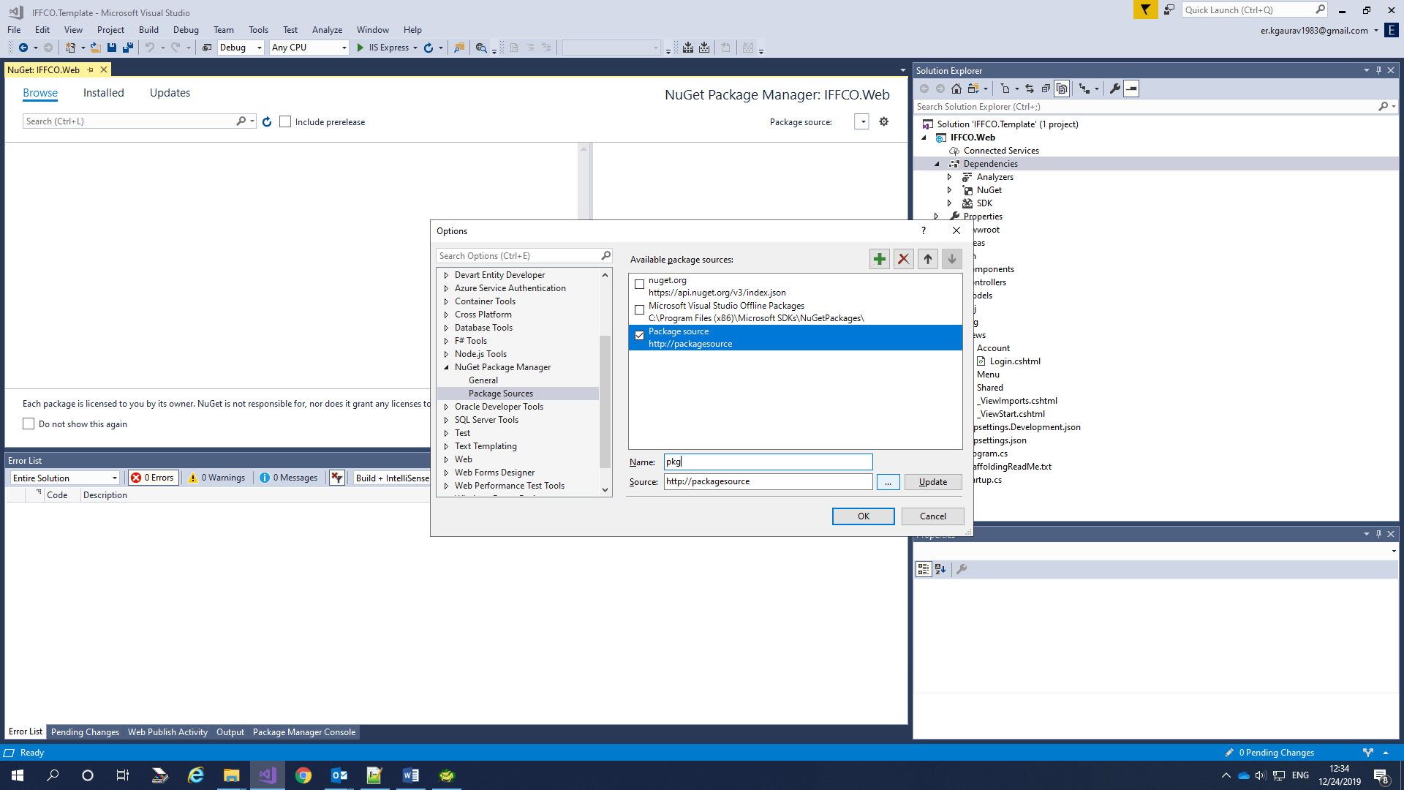

1. Select the “pkg” folder Under IFFCO.TEMPLATE\IFFCO.Web\pkg and Click on Update button.

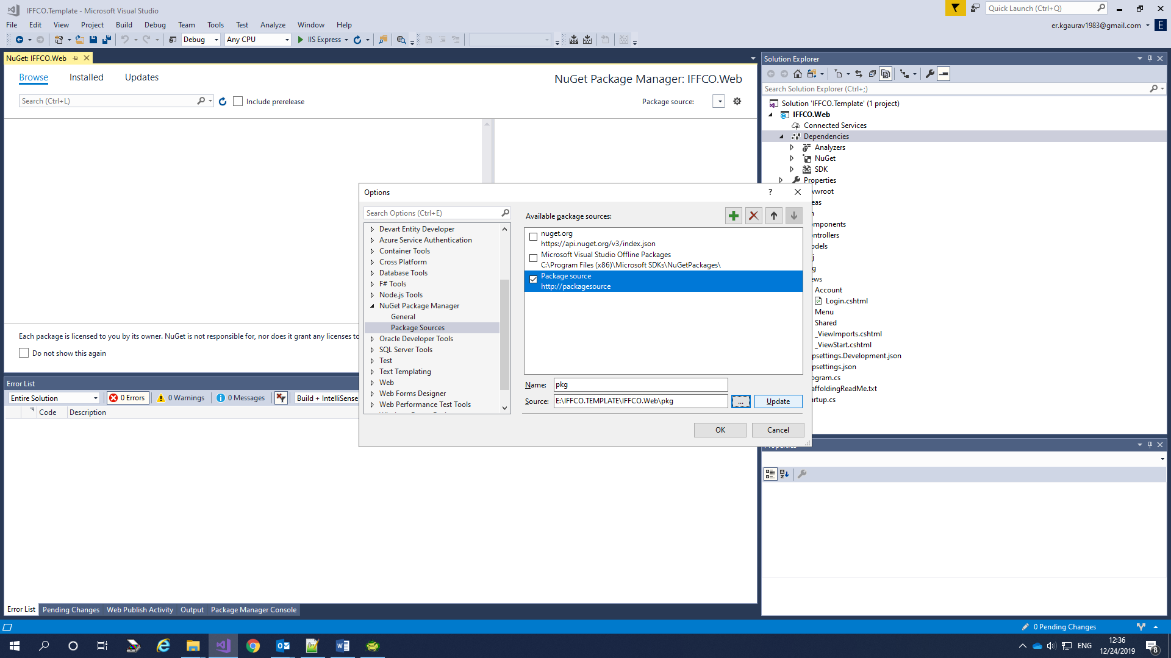

1. Click “OK” to finish the process.