

An open source puzzle game featuring real world images.

Developed by Techcrafter in 2022!

Instructions And Documentation

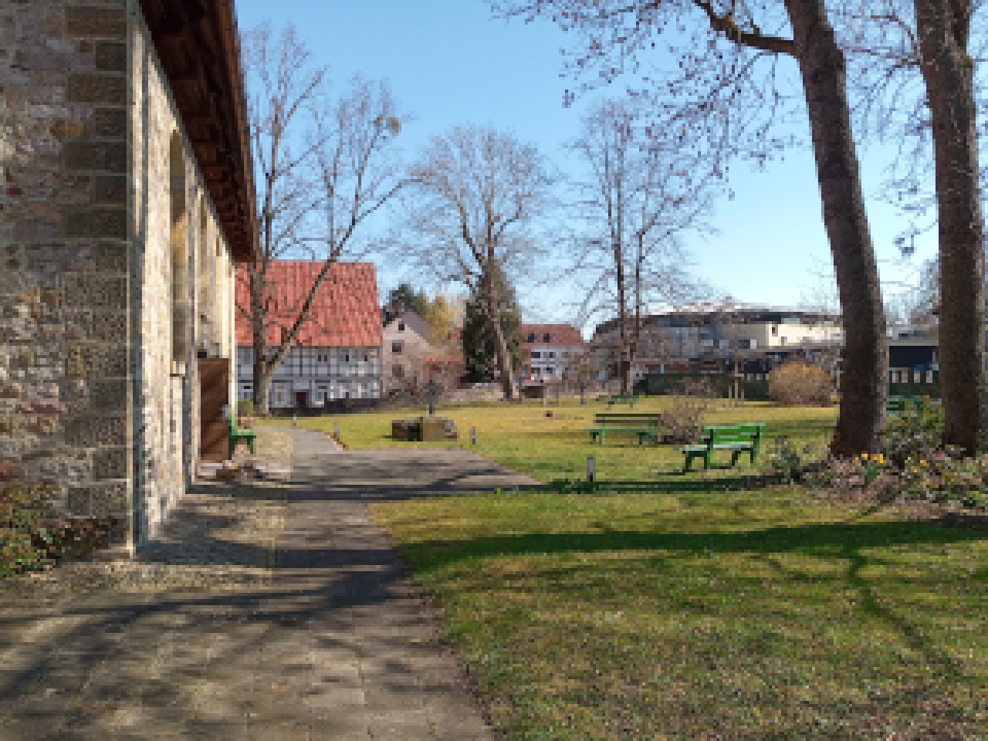
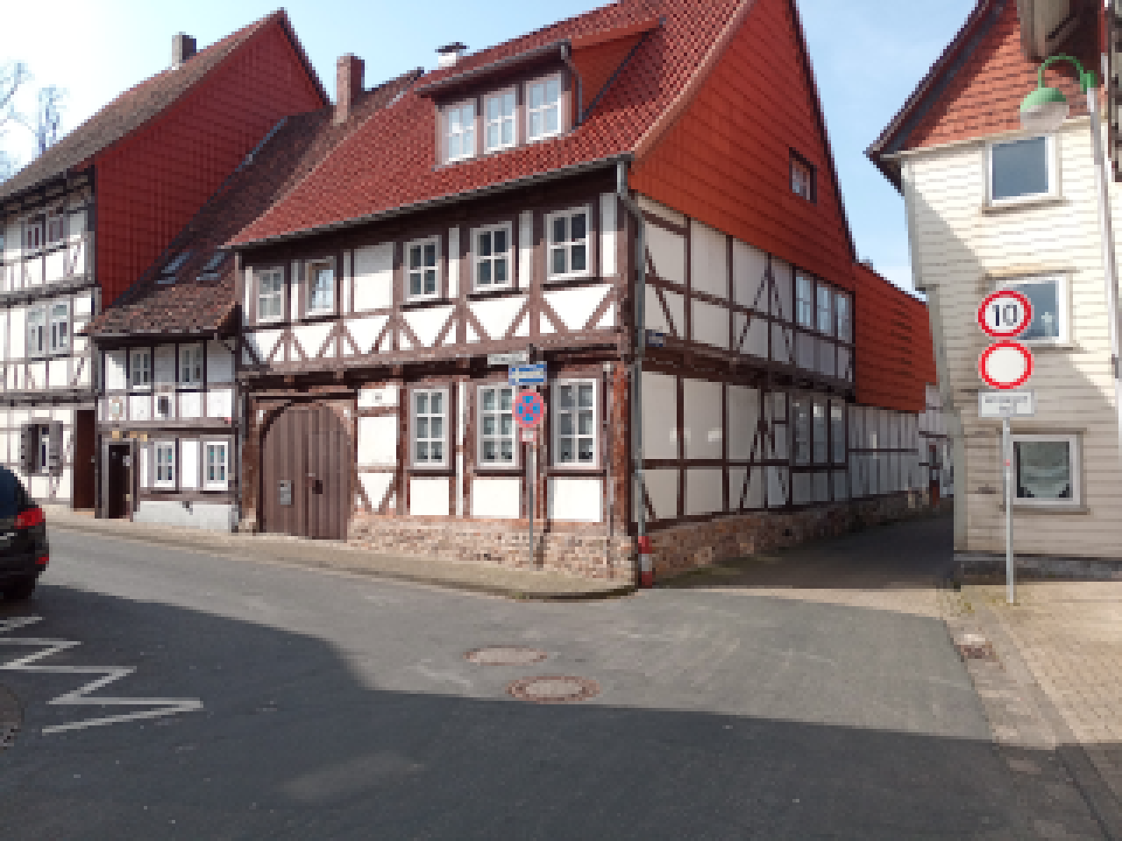

TIME-EN_US:1.0
1. About The Project

TIME is an open source puzzle game, which uses photos of real world places and combines them into a short, but sweet little puzzle game. The game itself was made using Processing <https://processing.org/>.
Binaries as well as the source code are available for free download:

Binaries – itch.io - <https://techcrafter-jw.itch.io/time>
Source Code – GitHub - <https://github.com/Techcrafter/TIME>

Although I’m completely aware that Processing is not designed for ‘professional game development’ by any means, I initially created this game as a school related project which should be developed with Processing, so there you go.

2. Basic Game Concept

As you can directly see, the game is designed to give pretty much of a retro atmosphere in terms of resolution/image quality and is supposed to remind you of classic titles like Phantasmagoria or Myst.

3. Controls And Interaction

Playing TIME is a pretty simple task. You don’t even need your keyboard, just a mouse with at least one button (which is pretty normal by today’s standards I guess).

Here a list of possible actions and their mouse pointers:
Mouse Pointer | Action | Description
  Green | None | You’re currently not pointing on a path, object, ... you can interact with.
  Blue | Move | You’re currently pointing on a path that brings you to another screen.
  Red | Collect/Inspect | You’re currently pointing on an object/item or place that you can collect or inspect in more detail.

To interact with something (if your pointer is blue or red), click on it with any mouse button.
4. Items/Findings And Their Use

There are several items that can be found while playing. Not all of them are required to complete the game, but most of them are. Important to keep in mind, is that you often can’t see when and where you use one of your items. I need to admit that I was just too lazy to add this into the game, but I think that’s what makes this game a bit more special! It creates the illusion of time passing by, because progress doesn’t look like it’s directly caused by specific items, it seems to be way more like ‘general progress’.

5. Menu Elements And User Interface

  Symbol | Action | Description
 | Load save | Continue a saved game right from where you left.
 | Check for updates | Connects to the internet and checks for available application updates.
 | Save game | Saves the current state of the game, so that you can continue from here whenever you wish to (unless you delete the save of course).  There can be only one save at a time. When saving your game, you will automatically overwrite your old save (if one exists)!

6. Code And Documentation

Most of the documentation is built right into the code itself with the help of comments. If you want to dig into it yourself, feel free to do so. Just make sure that you install the Processing Sound Library before, as TIME requires it to run properly!

In case you still got any questions, feel free to contact me by e-mail at <contact@techcrafter.de>.

7. Editor

Map data is stored in the appropriate .dat files. To make editing them much easier, the game has a built-in editor that can be enabled by changing the static Boolean named ‘editor’ to ‘true’.
This can only be done by modifying the variable in the source code and is not possible with the binary release of the game (at least not without some tricks)!
Keep in mind that the editor was never really intended to be used by someone else than myself, but I didn’t want to remove it, so I just left it in. Maybe someone has fun playing around with this!

In case you are really curious on how this editor works/how to use it (and you don’t want to figure out the code yourself), you can contact me via e-mail and I will try to help you as best as I can: <contact@techcrafter.de>

8. Legal Information

TIME - An open source puzzle game featuring real world images.
Copyright (C) 2022 Techcrafter

This program is free software: you can redistribute it and/or modify
it under the terms of the GNU General Public License as published by
the Free Software Foundation, either version 3 of the License, or
(at your option) any later version.

This program is distributed in the hope that it will be useful,
but WITHOUT ANY WARRANTY; without even the implied warranty of
MERCHANTABILITY or FITNESS FOR A PARTICULAR PURPOSE. See the
GNU General Public License for more details.

You should have received a copy of the GNU General Public License
along with this program. If not, see <https://www.gnu.org/licenses/>.

