Customer_support_system project

Changing directory to D:\
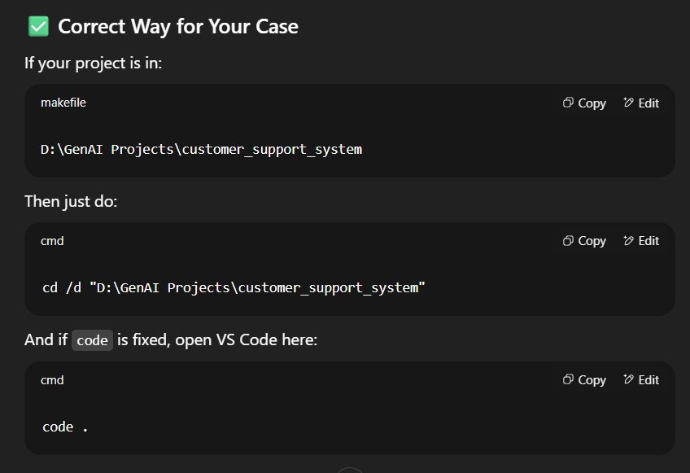
Create file
- requirements.txt to keep all required packages like langchain,etc.
- .gitignore – where we keep all the thing that doesn’t want to be tracked by git
env
venv
.env
- README.md – to keep all instructions
- setup.py – using this file we can install all local packages inside ur virtual environment

Create folder
- data – now we use here csv data but in realtime we should make connectivity with servers, cloud, databases, etc
- utils – inside we keep all utility function
- notebook
- prompt_library – to keep all prompts as json or anything
- data_ingestion – we can keep the complete code in it.We can prepare the data, clean the data, can ingest data into vector databases. Here we can write all those code.
- retriever – to write code based on retriever inside this folder
- templates – to
- static – to

Create file
main.py – to define endpoints and create fastapi inside it
config.py – to keep all configurations inside

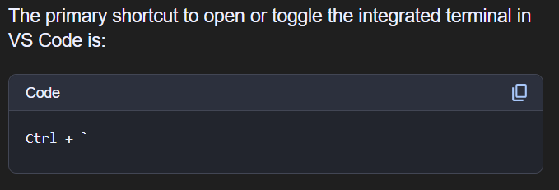

In terminal – select git bash – then initiate
git init

Create environment
conda create -p env python=3.10 -y

Now we should create file inside folders
data ingestion – create __init__.py
prompt library – create __init__.py - this prompt library cab be json,lama,py
create prompt.py file
retriever – create retrieval.py
static – create style.css
templates – create chat.html
utils – create llm_utils.py
notebook – create customer_support.ipynb – experiment file

