Flow of data during the stages of the project

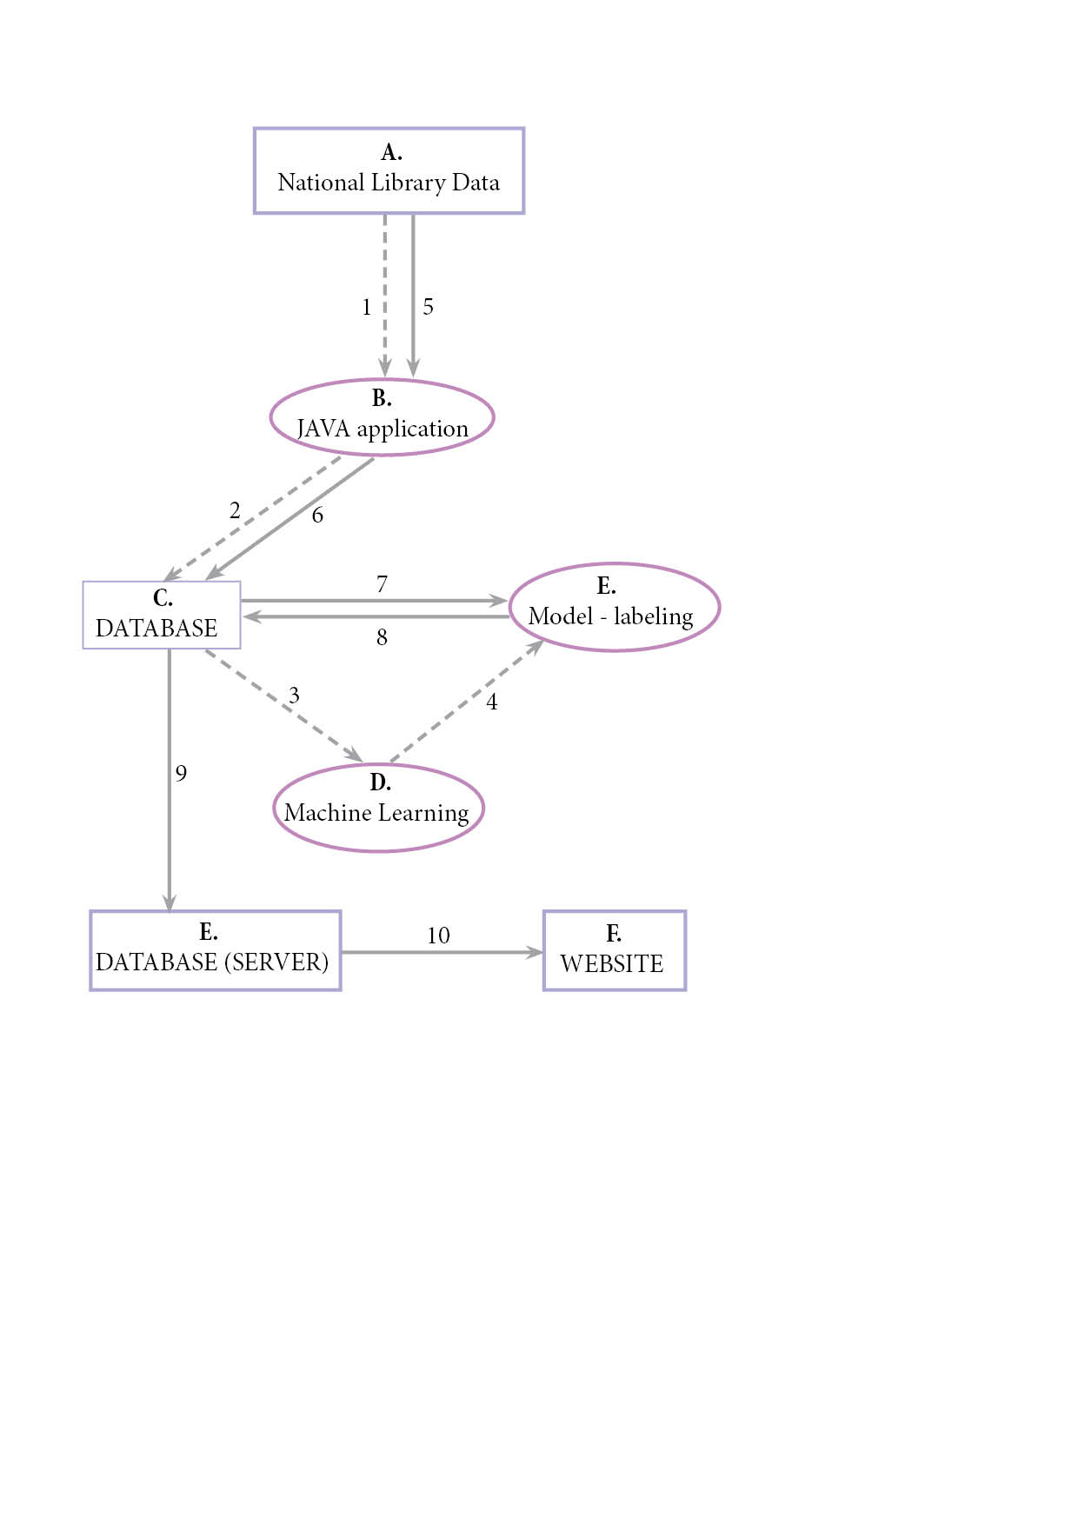

1. Extraction of articles that contain words relating to crime from A.

Prerequisite: List of words to look for, Understanding of API

1. Database set-up and populating with data necessary after parsing the HTML and cleaning the data in B.

Prerequisite: Information that needs to be in Database. Type of database.

1. Extracting data and sending to Machine Learning from the Database (C.)

Prerequisite: Deciding on domains. Manually labelling the articles with domains.

1. The connection between articles and manual labelled domains is made in D. and it results in a model;

Prerequisite: Understanding machine learning libraries

1. Extracting new data from the Library based on same list of initial words.