Basic data caching:

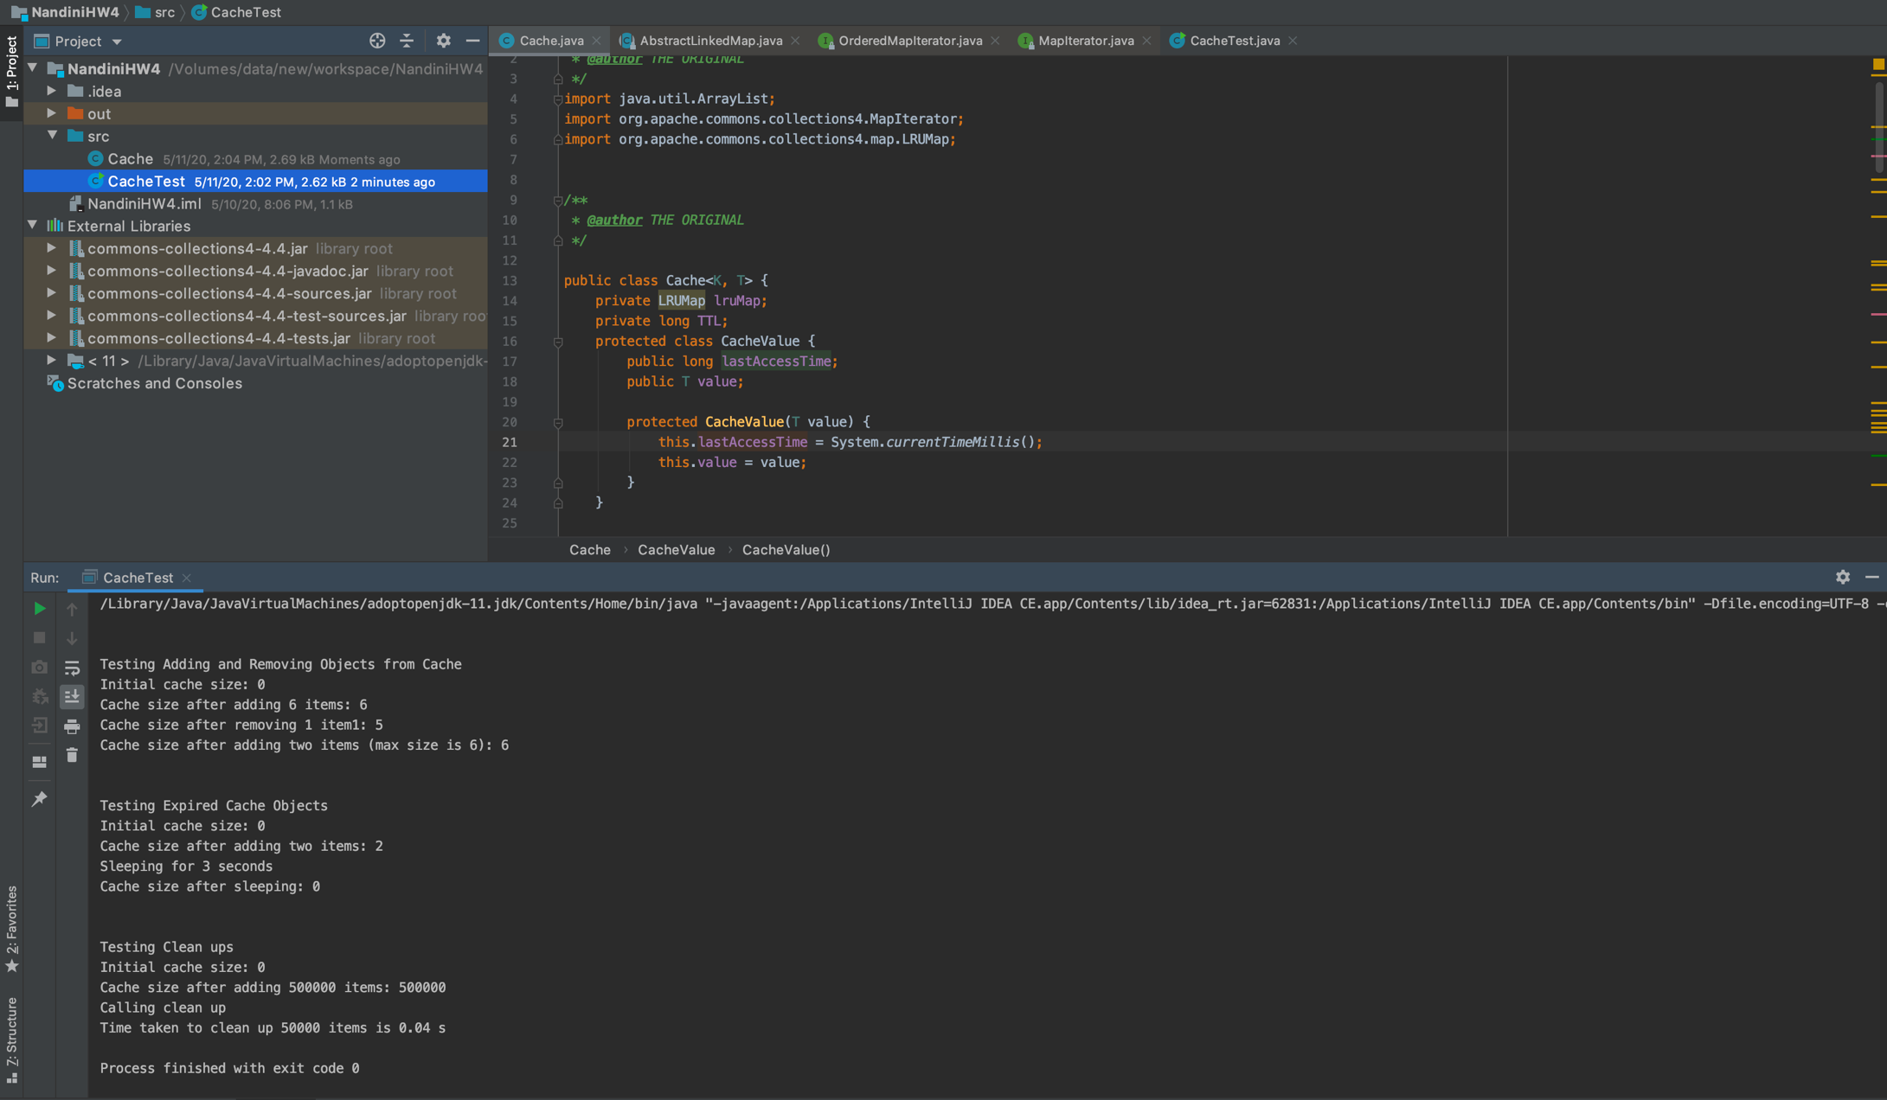

Fig: Showing basic LRU cache operations such as adding removing