TEAM MEMBER Santhosh.J

Phase-1 Document Submission 510421106302

Project: Public Transport Optimization

ABSTRACT

A significant amount of research work carried out on traffic management systems, but intelligent traffic monitoring is still an active research topic due to the emerging technologies such as the Internet of Things (IoT) and Artificial Intelligence (AI). The integration of these technologies will facilitate the techniques for better decision making and achieve urban growth. However, the existing traffic prediction methods mostly dedicated to highway and urban traffic management, and limited studies focused on collector roads and closed campuses. Besides, reaching out to the public, and establishing active connections to assist them in decision making is challenging when the users are not equipped with any smart devices.

PUBLIC TRANSPORT OPTIMIZATION

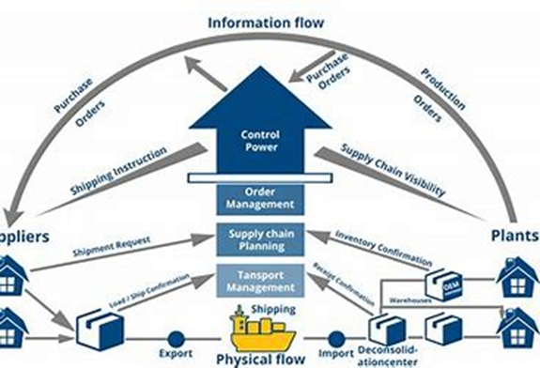

OBJECTIVE:

The objective of public transport optimization is to make the transportation network as efficient as possible by applying data and technology. It involves analyzing shipments, rates, lanes, and constraints to generate realistic load plans, trip plans, driver selection, and tour planning. The goal is to reduce costs, improve productivity, and increase customer satisfaction.

Phase 1: Public Transport Optimization

DEFINITION:

The public transportation sector in developing countries, in general, has faced several challenges and been affected by many problems. One of the most relevant problems in this context is the surplus or deficit of public transportation vehicles and trips for different routes due to the improper estimation of the passenger demand as well as the

number and size of vehicles needed to meet this demand. Moreover, in some areas, public transportation services do not run according to a fixed timetable or even clear operating hours, with these hours changing irregularly and without notice.

Smart transportation systems improve traffic flow and safety, reducing travel times and fuel consumption. It is imperative to use IoT infrastructures more and seamlessly integrate information and communication technologies (ICT) to create a sustainable, intelligent transportation system.

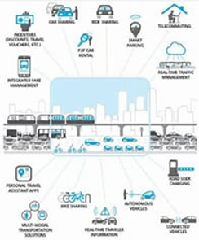

IOT SENSOR DESIGN:

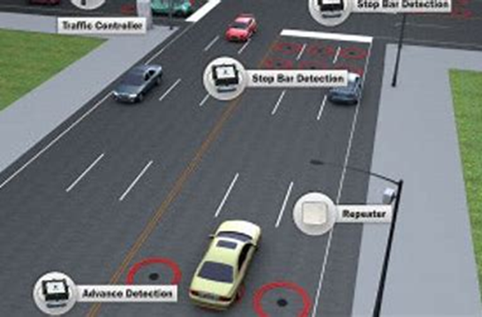

A device that provides a usable output in response to a specified measurement.

The sensor attains a physical parameter and converts it into a signal suitable for processing the characteristics of any device or material to detect the presence of a particular physical quantity.

Real time traffic:

Real-time traffic monitoring systems play a key role in the transition toward smart cities. A considerable amount of literature has been published on intelligent traffic management systems based on the IoT paradigm. Autonomous traffic sensing is at the heart of smart city infrastructures, wherein smart wireless sensors are used to measure traffic flow, predict congestion, and adaptively control traffic routes. Doing so effectively provides an awareness that enables more efficient use of resources and infrastructure.

•This research proposes an IoT based system model to collect, process, and store real-time traffic data.

•The objective is to provide real-time traffic updates on traffic congestion

•The early-warning messages will help citizens to save their time, especially during peak hours and unusual traffic incidents through roadside message units.