Joseph G. Roberts

ITGM 220-OL1

Joshua Lomelino

07/15/2017

Complex Patterns

# Reference Images

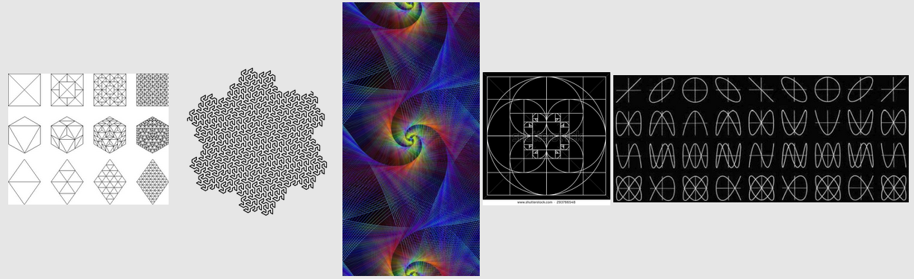

# Sketches

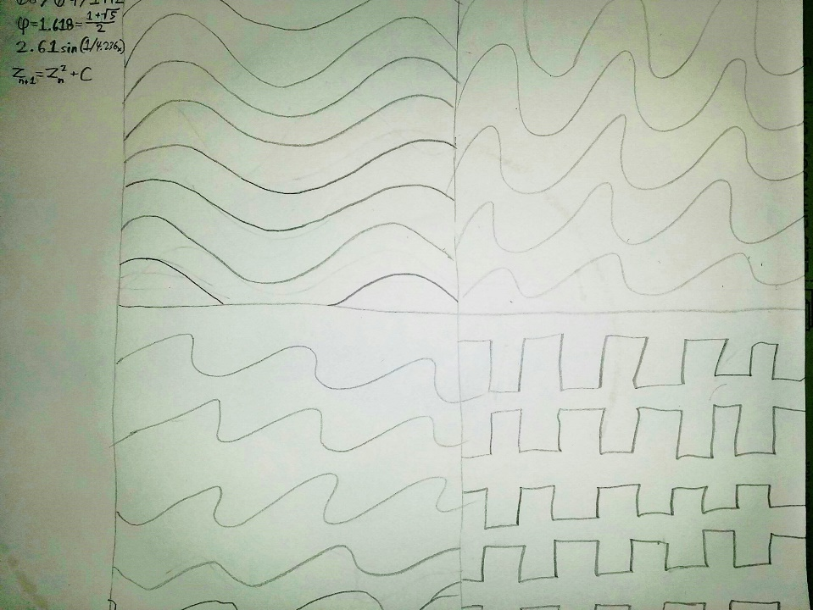

# Screen Capture

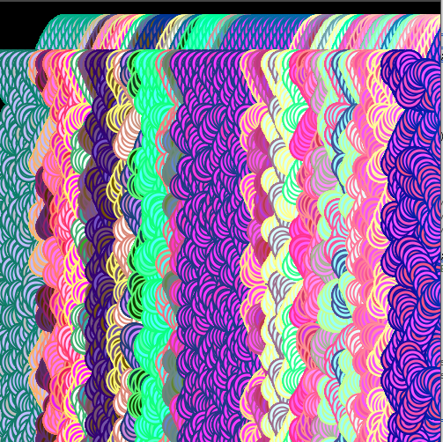

## RobertsJ_pattern

float phi = 1.618; //nummerical phi (not to be confused with pi)

int randIntVal = 0; //random integer

int a=1; //variable a

int b=2; //variable b

int n1=0; //number 1

int n2=0; //number 2

int s = second(); // Values from 0 - 59

int m = minute(); // Values from 0 - 59

int h = hour(); // Values from 0 - 23

int mouseXcor=0; //stored mouse X cordinates at time of left click

int mouseYcor=0; //stored mouse Y cordinates at time of left click

float gRat=(a+b)/a; //the Golden Ratio Equation

void **setup**()

{

  frameRate(30);

  size(500,500);

  background(0,0,0);

}

void **draw**()

{

  s = second(); //updates second variable

  m = minute(); //updates minute variable

  h = hour(); //updates hour variable

  float wavA = 0.0; //used for wave cordinates

  float inc = TWO_PI/25.0; //used to increment wavA variable

  int aRed=255; //used for red stroke value for wavA

  int aGreen=0; //used for blue stroke value for wavA

  int aBlue=0; //used for green stroke value for wavA

  int cnt1=0;

  int ix=0;

  int iy=30;

  a=50;         //starts a value for gRat

  b=25;         //starts b value for gRat

  n1=5;

  n2=10;

  while (cnt1<10) //repeately draws wave A to to fill screen (aka waveA_redraw)

  {

    s = second(); //updates second variable

    m = minute(); //updates minute variable

    h = hour(); //updates hour variable

    aRed=mouseX;

    aGreen=mouseY;

    aBlue=s+m+h+15;

    ix=s*8;     //updates ix adding 8 to its current value each second

    iy+=50;     //updates iy adding 50 to its current value

    cnt1+=1;    //updates waveA_redraw&apos;s (this loop&apos;s) increment counter

    for (/*none*/;ix < 520; ix+=4) //draws wave A

    {

       stroke(aRed-(gRat-20),aGreen-phi,(aBlue+(n2/n1)));

       strokeWeight(2);

       fill(0);

       bullseye(ix, iy+sin(wavA)*40.0-10, 30, 30); //calls my custom fucntion bullseye and draws the shape according to the passed paramaters; the y coordinates calls the sin() function to create the wave

       wavA = wavA + inc;    //increments wavA variable

       aRed-=3;        //updates aRed variable

       aGreen+=3;      //updates aBlue variable

       aBlue+=2;       //updates aGreen variable

    }

  }

}

void bullseye(float x, float y, float w, float h) //my custom function that draws my custom bullseye shape

{

  while(w>=1&&h>=1) //draws ellipses over each other to create bullseye effect

  {

    int fillRed=mouseXcor; //fill red value

    int fillBlue=mouseYcor; //fill blue value

    int fillGreen=mouseXcor+mouseYcor-randInt(); //fill green value

    fill(fillRed,fillBlue,fillGreen); //sets fill for ellipses

    ellipse(x,y,w,h); //draws ellipse

    w-=10;                 //updates w next for next ellipse

    h-=10;                 //updates h next for next ellipse

  }

}

int randInt() //custom function that returns a randowm integer between 0 and 200

{

  int rand=int(random(200));

  return rand;

}

void **mouseClicked**() //displays (in console window only) and stores the mouse X and Y coordinates whenever the mouse is left clicked

{

  mouseXcor=mouseX;

  mouseYcor=mouseY;

  println("X="+mouseX+",Y="+mouseY);

}