Chemometrics:

The term Acceptable Quality Level (AQL) is used in **[sampling inspection](http://www.micquality.com/six_sigma_glossary/sampling_inspection.htm)**. It is the maximum percentage of defectives that is acceptable as a long-term average. It is associated with the **[Producer's Risk](http://www.micquality.com/six_sigma_glossary/producers_risk.htm)**:

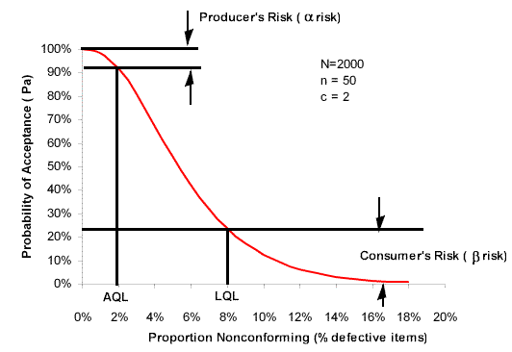

The figure is an **[Operating Characteristics (OC)](http://www.micquality.com/six_sigma_glossary/oc_curve.htm)** Curve.

The Average Run Length is the number of points that, on average, will be plotted on a **[control chart](http://www.micquality.com/six_sigma_glossary/control_charts.htm)** before an out of control condition is indicated (for example a point plotting outside the control limits).

If the process is in control:



If the process is out of control:



Where α is the probability of a Type I error and β the probability of a Type II error.

|  |  |
| --- | --- |
|  |  |
|  |  |
|  |  |
|  |  |