Module: Mernstack - HTML

*• HTML Basics*

Theory Assignment

• Question 1: Define HTML. What is the purpose of HTML in web development?

Ans: Hypertext Markup Language (HTML) is the standard markup language for documents designed to be displayed in a web browser.

HTML describes the structure of a [web page](https://en.wikipedia.org/wiki/Web_page) with HTML constructs, [images](https://en.wikipedia.org/wiki/HTML_element#Images_and_objects) and other objects such as [interactive forms](https://en.wikipedia.org/wiki/Fieldset) may be embedded into the rendered page. HTML provides a means to create [structured documents](https://en.wikipedia.org/wiki/Structured_document) by denoting structural [semantics](https://en.wikipedia.org/wiki/Semantics) for text such as headings, paragraphs, lists, [links](https://en.wikipedia.org/wiki/Hyperlink), quotes, and other items.

• Question 2: Explain the basic structure of an HTML document. Identify the mandatory

tags and their purposes.

Ans: There are three sections in the basic structure of an html document:

First, the entire document is contained within an html element. The html element is called the root element because it contains all the elements in the document, and it may not be contained within any other element. Mandatory tags for defining an HTML document

The head comes next and contains the title element. According to the HTML specifications, every document must contain a descriptive title. The body element comes after the head and contains everything that we want to show up in the browser window. The document structure elements do not affect how the content looks in the browser (as you’ll see in a moment), but they are required to make the document valid (that is, to properly abide by the HTML standards).

structure include <!DOCTYPE html>, <html>, <head>, and <body>.

|  |  |  |  |
| --- | --- | --- | --- |
| [!DOCTYPE html](https://www.geeksforgeeks.org/html-doctypes) | According to the HTML specification or standards, every HTML document requires a document type declaration. | < !DOCTYPE html > | [Try](https://ide.geeksforgeeks.org/tryit.php/8c359013-f2b2-41e7-ba95-931e36070300) |
| [body](https://www.geeksforgeeks.org/html-body-tag) | The body tag in HTML is used to define the main content present inside an HTML page. | <body> Contents… </body> | [Try](https://ide.geeksforgeeks.org/tryit.php/3e50b8b9-02b7-472d-beb0-118ca8cd66f0) |
| [head](https://www.geeksforgeeks.org/html-head-tag) | The head tag in HTML is used to define the head portion of the document which contains information related to the document. | <head>…</head> | [Try](https://ide.geeksforgeeks.org/tryit.php/142b2a94-1c99-4f1d-aa8d-a91c7bf30945) |
| [html](https://www.geeksforgeeks.org/html-html-tag) | The html tag in HTML is used to define the root of HTML and XHTML documents. | <html> Contents </html> | [Try](https://ide.geeksforgeeks.org/tryit.php/3760b6df-3bcb-4c35-a221-3857a0b05331) |

• Question 3: What is the difference between block-level elements and inline elements

in HTML? Provide examples of each.

Ans:

| **Inline Elements** | **Block Elements** |
| --- | --- |
| Inline elements occupy only sufficient width required. | Block Elements occupy the full width irrespective of their sufficiency. |
| Inline elements don’t start in a new line. | Block elements always start in a line. |
| Inline elements allow other inline elements to sit behind. | Block elements doesn’t allow other elements to sit behind |
| Inline elements don’t have top and bottom margin | Block elements have top and bottom margin. |

Examples of block element:

<!DOCTYPE html>

<html lang="en">

<head>

<meta charset="UTF-8">

<meta http-equiv="X-UA-Compatible"

content="IE=edge">

<meta name="viewport"

content="width=device-width, initial-scale=1.0">

<title>Online Games </title>

</head>

<body>

<div class="container" >

<h1>Clash Of Clans(h1) </h1>

<p>

This is a paragraph example of block

element which occupied whole width (p)

</p>

</div>

</body>

</html>

Example of inline element:

<!DOCTYPE html>

<html lang="en">

<head>

<meta charset="UTF-8">

<meta http-equiv="X-UA-Compatible" content="IE=edge">

<meta name="viewport" content=

"width=device-width, initial-scale=1.0">

</head>

<body>

<div class="container">

<h1>Online Games</h1>

<p>

This is a <span>span element </span>

<span>and </span><b>this</b> is a

<a href="#">link</a> which are examples

of inline elements which occupy only

sufficient width.

</p>

</div>

</body>

</html>

• Question 4: Discuss the role of semantic HTML. Why is it important for accessibility

and SEO? Provide examples of semantic elements.

Ans: Semantic HTML elements are HTML tags that convey the meaning or purpose of the content they encapsulate. Unlike non-semantic elements, such as <div> and <span>, which provide no information about their content, semantic elements clearly define their intended use. This not only enhances the readability of the HTML code but also improves the accessibility and SEO of the web page.

Semantic HTML elements include tags such as <header>, <footer>, <article>, <section>, <nav>, and <aside>. Each of these elements provides meaningful information about the content they contain.

**Lab Assignment**

* Task: Create a simple HTML webpage that includes:

• A header (<header>), footer (<footer>), main section (<main>), and aside section

(<aside>).

• A paragraph with some basic text.

• A list (both ordered and unordered).

• A link that opens in a new tab.

Ans:

<!DOCTYPE html>

<html lang="en">

<head>

    <meta charset="UTF-8">

    <meta http-equiv="X-UA-Compatible"

        content="IE=edge">

    <meta name="viewport"

        content="width=device-width, initial-scale=1.0">

    <title> Browser </title>

</head>

<body>0

        <header>

          <h1>My Favourite Browsers</h1>

          <p>Posted by Aman Agrawal</p>

        </header>

        <main>

          <p>Chrome, Firefox, and Edge are the most used browsers today.

            I have used this softwares on my hp victus laptop</p><br>

            <h1>Most Popular Browsers</h1>

              <h2>Google Chrome</h2>

              <p>Google Chrome is a web browser developed by Google, released in 2008.

               Chrome is the world's most popular web browser today!</p><br>

              <h2>Mozilla Firefox</h2>

              <p>Mozilla Firefox is an open-source web browser developed by Mozilla.

                Firefox has been the second most popular web browser since January, 2018.</p><br>

              <h2>Microsoft Edge</h2>

              <p>Microsoft Edge is a web browser developed by Microsoft, released in 2015.

                Microsoft Edge replaced Internet Explorer.</p><br>

<aside>The HP Victus 15 is good for business use. It has a large 15.6-inch display

that's well-suited for multitasking, a spacious and tactile keyboard, and a large

and responsive touchpad. Its Intel 12th Gen. CPU can handle most productivity tasks, like text processing, spreadsheets, and presentations</aside>

          </main>

        <footer>

            <p>Author: Aman Agrawal<br>

            <a href="mailto:amanagrawal@gmail.com">aman@example.com</a></p>

          </footer>

</body>

</html>

Output:

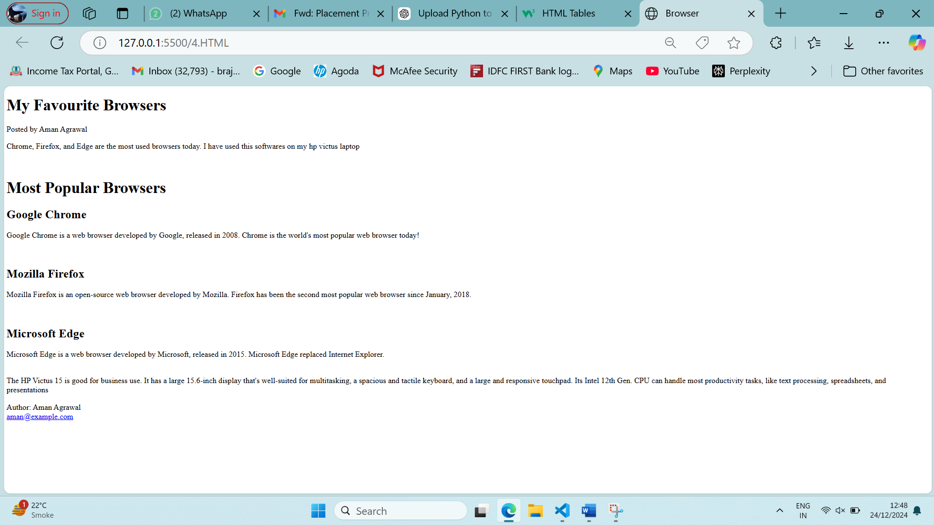

*• HTML Forms*

Theory Assignment

• Question 1: What are HTML forms used for? Describe the purpose of the input, text area,

select, and button elements.

Ans: HTML Forms use the <form> tag to collect user input through various interactive controls.

|  |  |
| --- | --- |
| [<input>](https://www.geeksforgeeks.org/html-input-tag/) | It is used to get input data from the form in various types such as text, password, email etc by changing its type. |
| [<button>](https://www.geeksforgeeks.org/button-tag-vs-input-typebutton-attribute/) | It defines a clickable button to control other elements or execute a functionality. |
| [<select>](https://www.geeksforgeeks.org/html-select-tag/) | It is used to create a drop-down list. |
| [<textarea>](https://www.geeksforgeeks.org/html-textarea-name-attribute/) | It is used to get input long text content. |

• Question 2: Explain the difference between the GET and POST methods in form submission. When should each be used?

Ans: Both GET and POST method is used to transfer data from client to server in HTTP protocol but Main difference between POST and GET method is that GET carries request parameter appended in URL string while POST carries request parameter in message body which makes it more secure way of transferring data from client to server.

• Question 3: What is the purpose of the label element in a form, and how does it improve

accessibility?

Ans: A <label> is used to create a caption for a form control. It help users who have difficulty clicking on very small regions (such as radio buttons or checkboxes) - because when the user clicks the text within the <label> element, it toggles the radio button or checkbox. This way it improves accessibility.

**Lab Assignment**

* Task: Create a contact form with the following fields:

• Full name (text input)

• Email (email input)

• Phone number (tel input)

• Subject (dropdown menu)

• Message (text area)

• Submit button

Additional Requirements:

• Use appropriate form validation using required, minlength, maxlength, and

pattern.• Link form labels with their corresponding inputs using the for attribute.

Ans: <!DOCTYPE html>

<html lang="en">

<head>

    <meta charset="UTF-8">

    <meta name="viewport" content="width=device-width, initial-scale=1.0">

    <title>Contact Form</title>

</head>

<body>

    <h2>Contact Us</h2>

    <form action="#" method="POST">

        <label for="full-name">Full Name</label>

        <input type="text" id="full-name" name="full-name" placeholder="Enter your full name" required minlength="3" maxlength="50"><br>

        <label for="email">Email</label>

        <input type="email" id="email" name="email" placeholder="Enter your email" required><br>

        <label for="phone">Phone Number</label>

        <input type="tel" id="phone" name="phone" placeholder="Enter your phone number" required pattern="\d{10}" title="Please enter a valid 10-digit phone number"><br>

        <label for="subject">Subject</label>

        <select id="subject" name="subject" required>

            <option value="">Select a subject</option>

            <option value="inquiry">General Inquiry</option>

            <option value="support">Support</option>

            <option value="feedback">Feedback</option>

            <option value="other">Other</option>

        </select><br>

        <label for="message">Message</label>

        <textarea id="message" name="message" placeholder="Enter your message here" required minlength="10" maxlength="500"></textarea>

        <button type="submit">Submit</button>

    </form>

</body>

</html>

Output:

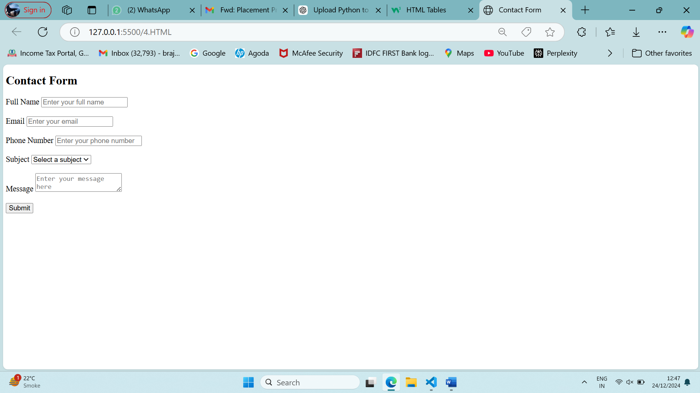

*• HTML Tables*

Theory Assignment

• Question 1: Explain the structure of an HTML table and the purpose of each of the

Following elements: <table>, <tr>, <th>, <td>, and <thead>.

Ans: The <table> tag defines an HTML table. The basic structure HTML table consists of one <table> element and one or more <tr>, <th>, and <td> elements. The <tr> element defines a table row, the <th> element defines a table header, and the <td> element defines a table cell.

| **HTML Tags** | **Purpose** |
| --- | --- |
| [<table>](https://www.geeksforgeeks.org/html-tables) | Defines the structure for organizing data in rows and columns within a web page. |
| [<tr>](https://www.geeksforgeeks.org/html-tr-tag) | Represents a **row** within an HTML table, containing individual cells. |
| [<th>](https://www.geeksforgeeks.org/differentiate-between-th-thead-tags-in-html-table) | Shows a table **header** cell that typically holds titles or headings. |
| [<td>](https://www.geeksforgeeks.org/html-td-tag) | Represents a standard **data** cell, holding content or data. |
| [<thead>](https://www.geeksforgeeks.org/html-thead-tag) | Defines the header section of a table, often containing column labels. |

• Question 2: What is the difference between colspan and rowspan in tables? Provide

examples.

Ans: Rowspan attribute specifies the number of rows of a cell should span. It is used to merge multiple rows. Colspan attribute specifies the number of columns, a cell should span. It is used to merge multiple columns.

Eg of Rowspan:

<!DOCTYPE html>

<html>

<head>

<title>HTML rowspan</title>

</head>

<body>

<h1>Aman Agrawal</h1>

<h2>HTML Table Rowspan</h2>

<table>

<tr>

<th>Name</th>

<th>Class</th>

<th rowspan="3">MVM School</th>

</tr>

<tr>

<td>Radha</td>

<td>10</td>

</tr>

<tr>

<td>Ankur</td>

<td>11</td>

</tr>

</table>

</body>

</html>

Output:

**Aman Agrawal**

**HTML Table Rowspan**

|  |  |  |
| --- | --- | --- |
| **Name** | **Class** | **MVM School** |
| Radha | 10 |
| Ankur | 11 |

Eg of Colspan:

<!DOCTYPE html>

<html lang="en">

<head>

<meta charset="UTF-8">

<title>HTML Table with Colspan</title>

<meta name="viewport" content="width=device-width,

initial-scale=1.0">

<title>HTML Table</title>

</head>

<body>

<h1>GeeksforGeeks</h1>

<h3>Table with Colspan

</h3>

<table>

<thead>

<tr>

<th colspan="2">Name</th>

<th>Class</th>

</tr>

</thead>

<tbody>

<tr>

<td>Mahima</td>

<td>Gupta</td>

<td>1</td>

</tr>

<tr>

<td>Sri</td>

<td>Krishn</td>

<td>3</td>

</tr>

<tr>

<td>Shivika</td>

<td>Goyal</td>

<td>5</td>

</tr>

</tbody>

</table>

</body>

</html>

Output:

**Aman Agrawal**

**Table with Colspan**

| **Name** | | **Class** |
| --- | --- | --- |
| Mahima | Gupta | 1 |
| Sri | Krishn | 3 |
| Shivika | Goyal | 5 |

• Question 3: Why should tables be used sparingly for layout purposes? What is a

Better alternative?

Ans: Client are striving for a web in which content and structure are completely separate from presentation. Given below are some of reasons

* Tables Are Not Accessible**:**Most search engines read the webpage as they read HTML and it becomes difficult for the search engine to render the table layout. This is the main reason why we follow the HTML5 format.
* Tables Are Tricky**:**When you perform nesting in tables then it is difficult to maintain it. When you want to change something after some days then it will become complicated for the developer to debug the code.
* Tables Are Inflexible:When you want to create the table layout with specified widths then it will become a rigid layout or not flexible and then it will take some extra time to load your page properly. The flexible layout always looks good on any device.
* Tables Hurt Search Engine Optimization
* Tables Don’t Always Print Well
* Tables for Layout Are Invalid in HTML 4.01

you can use modern CSS layout techniques to achieve responsive and flexible designs. Here are some alternatives:

1. CSS Flexbox: Flexbox is a one-dimensional layout method for laying out items in rows or columns. It's great for creating flexible and dynamic layouts without the need for complex HTML structures.

2. CSS Grid:

* Grid is a two-dimensional layout system that allows you to create complex layouts with rows and columns. It provides precise control over the placement and sizing of elements.

3. Block Elements with Margin:

* For simple centering of block-level elements, you can use auto margins.

4. Positioning:

* Using CSS positioning (relative or absolute) can also be effective for specific layout requirements.

5. CSS Grid Frameworks:

* Frameworks like Bootstrap or Tailwind CSS provide pre-built components and grid systems to streamline the process of creating responsive layouts.

**Lab Assignment**

• Task: Create a product catalog table that includes the following columns:

• Product Name

• Product Image (use placeholder image URLs)

• Price

• Description

• Availability (in stock, out of stock)

Additional Requirements:

• Use thead for the table header.

• Add a border and some basic styling using inline CSS.

• Use colspan or rowspan to merge cells where applicable

Ans:

<!DOCTYPE html>

<html lang="en">

<head>

    <meta charset="UTF-8">

    <meta name="viewport" content="width=device-width, initial-scale=1.0">

    <title>Catalog Table</title>

</head>

<body>

    <table border="1" cellspacing="0" cellpadding="20" width="100%">

        <thead>Product Catalog Table</thead>

    <tr>

     <th>Product Name</th>

     <th>Product Image(use placeholder image URLs)</th>

     <th>Price</th>

     <th>Description</th>

     <th>Availability (in stock, out of stock)</th>

    </tr>

    <tr>

        <td rowspan="2">Smartphone</td>

        <td rowspan="2"><img src="https://via.placeholder.com/100" alt="Product Image"></td>

        <td>$799</td>

        <td>Latest model with advanced features.</td>

        <td>In Stock</td>

    </tr>

    <tr>

        <td colspan="3">Limited time offer with free shipping!</td>

    </tr>

    <tr>

        <td>Wireless Headphones</td>

        <td><img src="https://via.placeholder.com/100" alt="Product Image"></td>

        <td>$299</td>

        <td>Noise-canceling headphones with high-quality sound.</td>

        <td>Out of Stock</td>

    </tr>

    <tr>

        <td rowspan="2">Smartwatch</td>

        <td rowspan="2"><img src="https://via.placeholder.com/100" alt="Product Image"></td>

        <td>$399</td>

        <td>Fitness tracking and notifications on the go.</td>

        <td>In Stock</td>

    </tr>

    <tr>

        <td colspan="3">Available in multiple colors and sizes.</td>

    </tr>

    </table>Product Catalog Table

Output:

