Techne-Asya: Packet Tracer Lab Portfolio Report

Student Name: Asya Weston

Course: Computer Science / Network Security

Project Title: Packet Tracer - Network Behavior and ACL Mitigation

# Overview

This report covers Packet Tracer lab exercises focused on network packet flow, access control list (ACL) configuration, and behavior changes in response to network topology modifications. Through various simulations, we analyzed how routing, switching, and ACL rules affect the flow of HTTP, DNS, and other protocols across LAN and WAN environments.

# Key Observations

• DNS and HTTP packet routes dynamically reroute when links fail.

• ACLs prevent unauthorized access by blocking remote SSH and HTTPS attempts.

• ICMP packets are selectively allowed via refined ACL rules.

• Traceroute and Simulation mode offer insight into real-time and layer-by-layer network traffic.

# Visuals & Diagrams

Below are visual representations of network flow analysis:

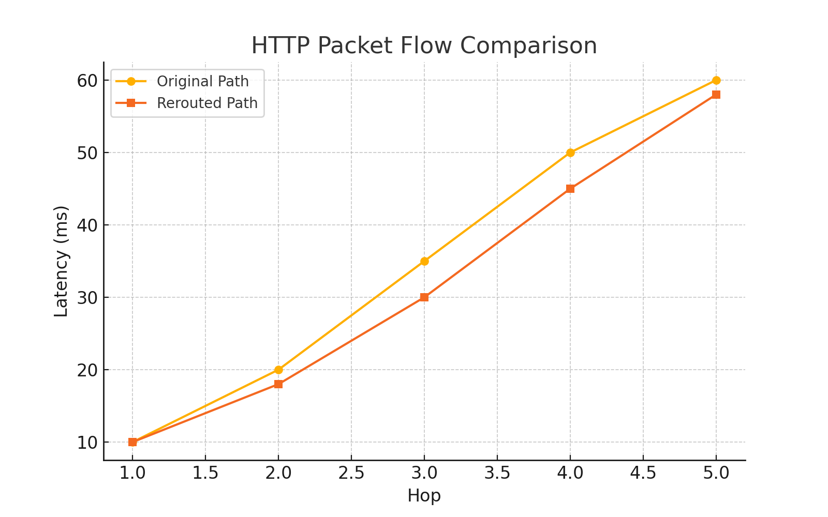

Figure 1: HTTP Packet Flow - Original vs. Rerouted Path

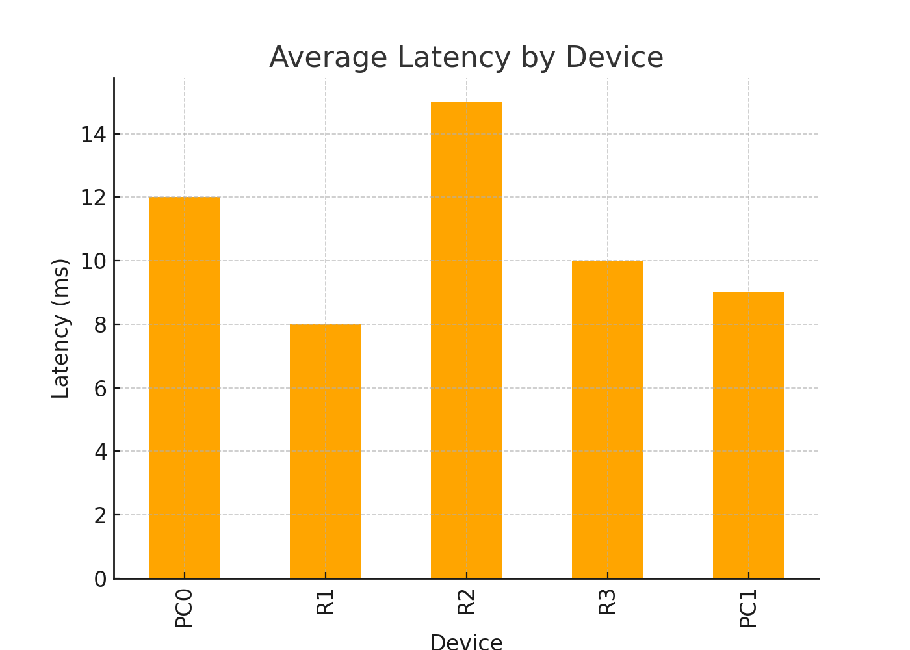

Figure 2: Latency Comparison Across Devices

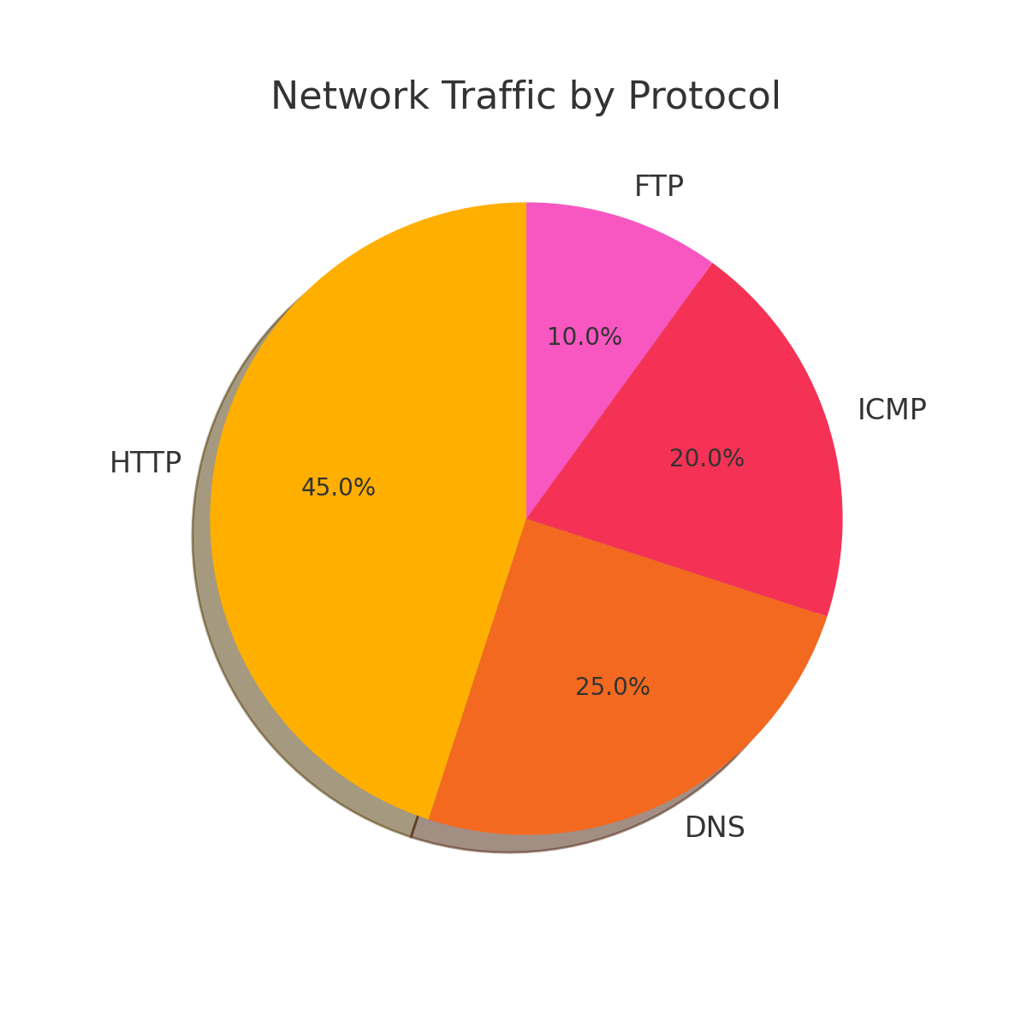

Figure 3: Protocol Distribution of Captured Traffic

# Conclusion

Using Cisco Packet Tracer, this project provided a foundational understanding of traffic behavior under simulated attack conditions. This hands-on approach reinforces the concepts of cybersecurity through network observability, ACL configurations, and routing simulations. The lab exercises are instrumental for students preparing for CCNA, Security+, or network engineering roles.