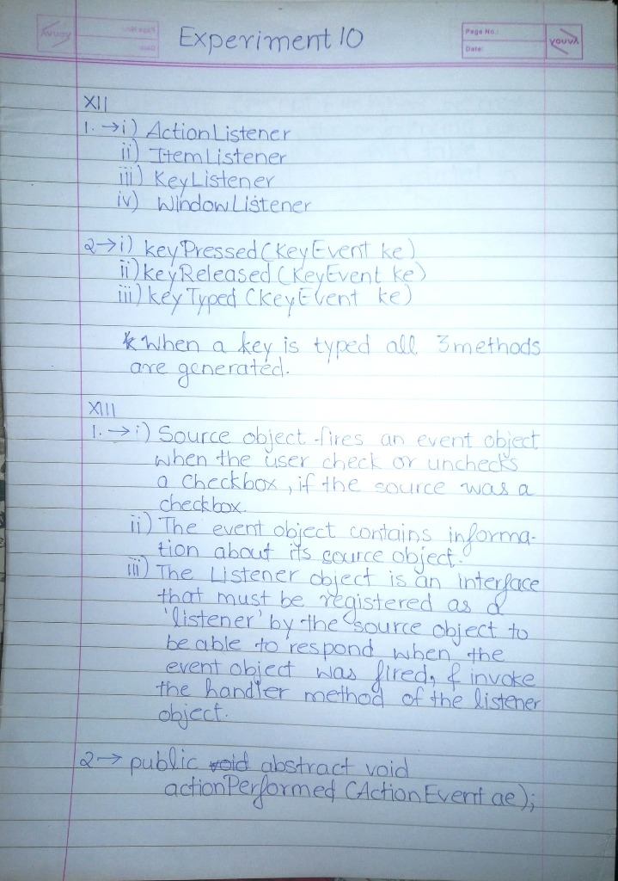

import javax.swing.*;

import java.awt.*;

import java.awt.event.*;

public class KeyEventDemo0 extends JFrame implements KeyListener {

JLabel label;

KeyEventDemo0() {

Container co = getContentPane();

label = new JLabel();

JTextArea ta = new JTextArea();

co.add(ta);

co.add(label);

ta.addKeyListener(this);

setSize(500, 500);

setLayout(new GridLayout(2, 1));

setVisible(true);

}

public void keyPressed(KeyEvent e) {

label.setText("Key Pressed");

}

public void keyReleased(KeyEvent e) {

}

public void keyTyped(KeyEvent e) {

}

public static void main(String[] args) {

new KeyEventDemo0();

}

}

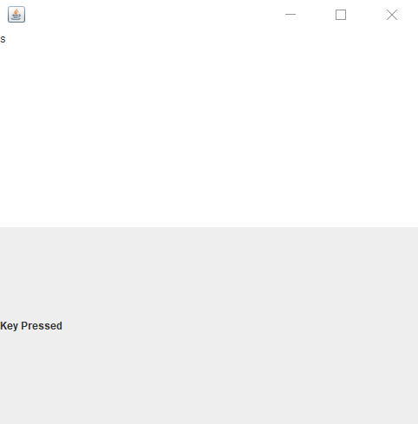

import javax.swing.*;

import java.awt.*;

import java.awt.event.*;

public class KeyEventDemo1 extends JFrame implements KeyListener {

int vsb = JScrollPane.VERTICAL_SCROLLBAR_ALWAYS;

int hsb = JScrollPane.HORIZONTAL_SCROLLBAR_NEVER;

Container co;

JTextArea ta;

KeyEventDemo1() {

co = getContentPane();

ta = new JTextArea(10, 25);

ta.setEnabled(false);

ta.setBackground(Color.black);

JScrollPane jsp = new JScrollPane(ta, vsb, hsb);

addKeyListener(this);

co.add(jsp);

setSize(500, 500);

setLayout(new FlowLayout(FlowLayout.CENTER));

setVisible(true);

}

public void keyReleased(KeyEvent ke) {

String c;

int k = ke.getKeyCode();

switch (k) {

case KeyEvent.VK_ALT:

c = "ALT";

break;

case KeyEvent.VK_CONTROL:

c = "CTRL";

break;

case KeyEvent.VK_SHIFT:

c = "SHIFT";

break;

default:

c = "" + ke.getKeyChar();

break;

}

String str = ta.getText() + "\n" + c + " was RELEASED";

ta.setText(str);

}

public void keyPressed(KeyEvent ke) {

String c;

int k = ke.getKeyCode();

switch (k) {

case KeyEvent.VK_ALT:

c = "ALT";

break;

case KeyEvent.VK_CONTROL:

c = "CTRL";

break;

case KeyEvent.VK_SHIFT:

c = "SHIFT";

break;

default:

c = "" + ke.getKeyChar();

break;

}

String str = ta.getText() + "\n" + c + " was PRESSED";

ta.setText(str);

}

public void keyTyped(KeyEvent ke) {

String c;

int k = ke.getKeyCode();

switch (k) {

case KeyEvent.VK_ALT:

c = "ALT";

break;

case KeyEvent.VK_CONTROL:

c = "CTRL";

break;

case KeyEvent.VK_SHIFT:

c = "SHIFT";

break;

default:

c = "" + ke.getKeyChar();

break;

}

String str = ta.getText() + "\n" + c + " was TYPED";

ta.setText(str);

}

public static void main(String[] args) {

new KeyEventDemo1();

}

}

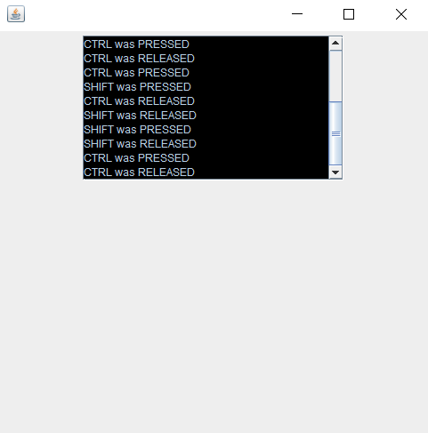

import javax.swing.*;

import java.awt.*;

import java.awt.event.*;

public class MultiplicationProgram extends JFrame implements ActionListener {

Container co;

JTextField jtf1, jtf2, jtf3;

JButton b1, b2;

MultiplicationProgram() {

co = getContentPane();

b1 = new JButton("Multiplication");

jtf1 = new JTextField();

jtf2 = new JTextField();

jtf3 = new JTextField();

co.add(jtf1);

co.add(jtf2);

co.add(b1);

co.add(jtf3);

b1.addActionListener(this);

setLayout(new GridLayout(10, 2));

setTitle("MultiplicationProgram");

setSize(500, 500);

setVisible(true);

}

public void actionPerformed(ActionEvent ae) {

float a = Float.parseFloat(jtf1.getText());

float b = Float.parseFloat(jtf2.getText());

jtf3.setText("Result : " + Float.toString((a * b)));

}

public static void main(String[] args) {

new MultiplicationProgram();

}

}

