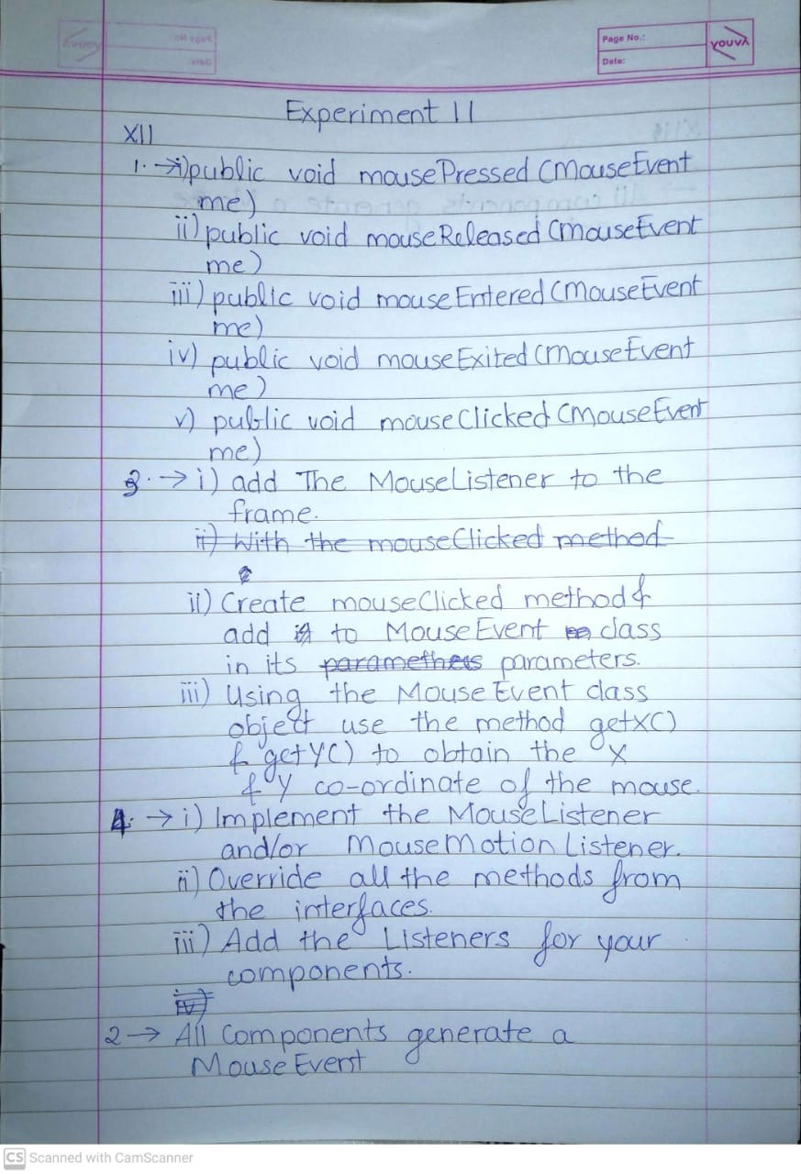

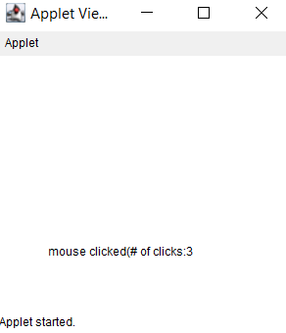

import javax.swing.\*;

import java.awt.\*;

import java.awt.event.\*;

public class MouseDemo0 extends JFrame implements MouseListener

{

Container co;

MouseDemo()

{

co = getContentPane();

co.addMouseListener(this);

setVisible(true);

setSize(500,500);

}

public void mousePressed(MouseEvent e)

{

co.setBackground(Color.red);

}

public void mouseReleased(MouseEvent e)

{

co.setBackground(Color.blue);

}

public void mouseEntered(MouseEvent e)

{

co.setBackground(Color.yellow);

}

public void mouseExited(MouseEvent e)

{

co.setBackground(Color.black);

}

public void mouseClicked(MouseEvent e)

{

co.setBackground(Color.green);

}

public static void main(String[] args) {

new MouseDemo0 ();

}

}

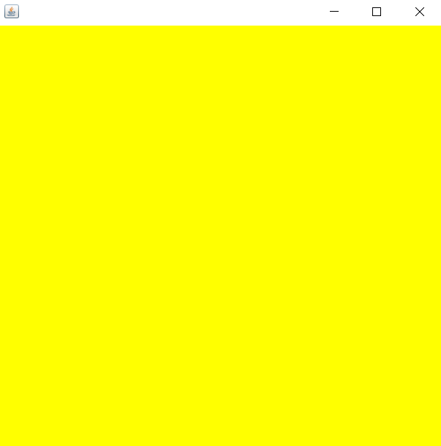

import javax.swing.\*;

import java.awt.\*;

import java.awt.event.\*;

public class MouseDemo1 extends JFrame implements MouseListener

{

Container co;

int counter = 0;

JLabel label;

MouseDemo1() {

co = getContentPane();

label = new JLabel("Counter : " + counter);

co.add(label);

co.addMouseListener(this);

co.setLayout(new FlowLayout(FlowLayout.CENTER));

setVisible(true);

setSize(500,200);

}

public void mousePressed(MouseEvent e) {

}

public void mouseReleased(MouseEvent e) {

}

public void mouseEntered(MouseEvent e) {

}

public void mouseExited(MouseEvent e) {

}

public void mouseClicked(MouseEvent e) {

counter++;

label.setText("Counter : " + counter);

}

public static void main(String[] args) {

new MouseDemo1();

}

}

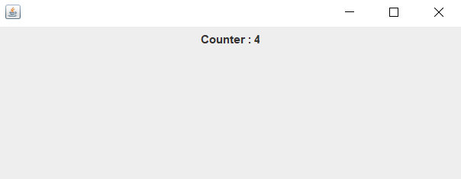

import javax.swing.\*;

import java.awt.\*;

import java.awt.event.\*;

public class MouseDemo2 extends JFrame implements MouseMotionListener

{

Container co;

JLabel l1;

JLabel l2;

MouseDemo2() {

co = getContentPane();

l1 = new JLabel("Mouse Moved : None");

l2 = new JLabel("Mouse Dragged : None");

co.add(l1);

co.add(l2);

co.addMouseMotionListener(this);

setLayout(new FlowLayout(FlowLayout.CENTER));

setVisible(true);

setSize(500,500);

}

public void mouseDragged(MouseEvent e) {

l1.setText("Mouse Dragged : " + e.getX() + ", " + e.getY());

}

public void mouseMoved(MouseEvent e) {

l2.setText("Mouse Moved : " + e.getX() + ", " + e.getY());

}

public static void main(String[] args) {

new MouseDemo2();

}

}

