Experiment 18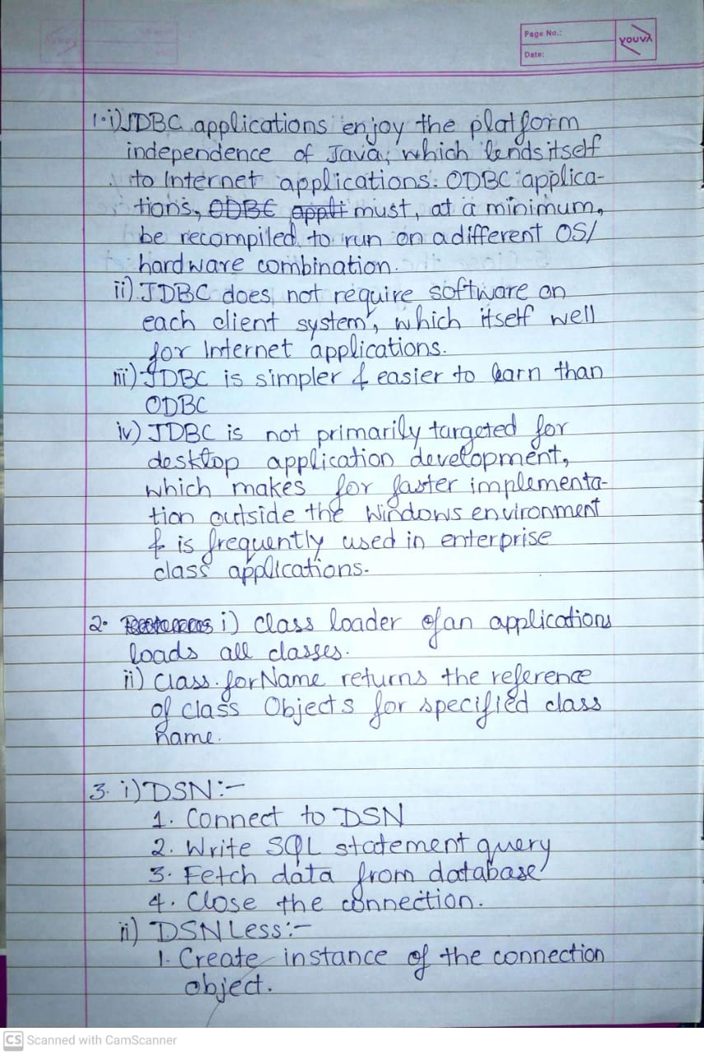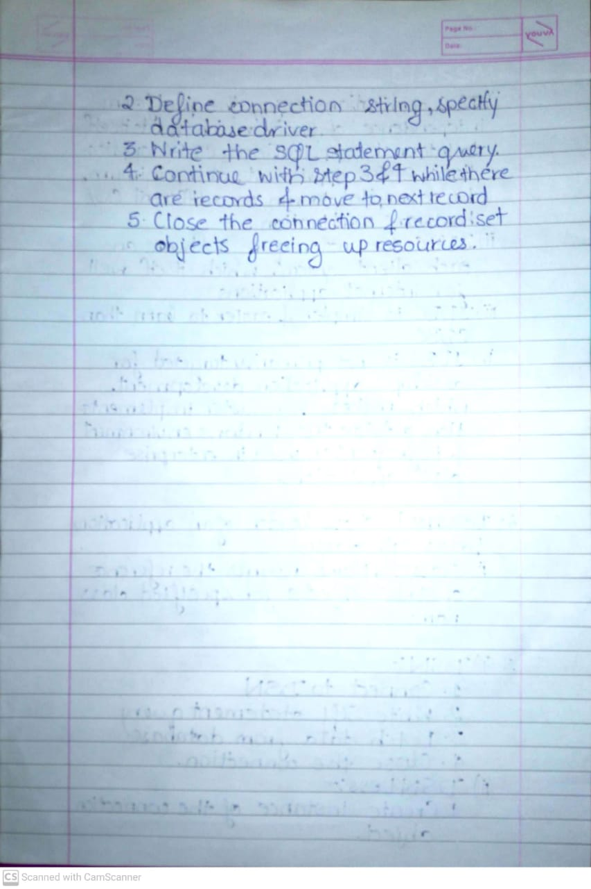

import java.sql.*;

class Exp18a {

public String database = "C:\\Users\\deong\\College\\Java\\Manual-Programs\\Experiment18\\SampleDatabase.accdb";

private Connection conn;

// Create Connection

public void createConnection() {

try {

conn = DriverManager.getConnection("jdbc:ucanaccess://" + database);

} catch (SQLException e) {

System.out.println("Connection Failed");

System.exit(1);

}

}

public void closeConnection() {

try {

conn.close();

} catch (SQLException e) {

System.out.println("Close Connection Failed ?");

}

}

public void updateQuery(String query) {

try {

Statement statement = conn.createStatement();

statement.executeUpdate(query);

} catch (SQLException e) {

System.out.println("Error in updateQuery()");

}

}

public static void main(String[] args) {

Exp18a dbconn = new Exp18a();

try {

Class.forName("net.ucanaccess.jdbc.UcanaccessDriver");

} catch (Exception e) {

System.out.println("Error in Loading Driver");

}

dbconn.createConnection();

// dbconn.updateQuery("DROP TABLE Student;");

dbconn.updateQuery("CREATE TABLE Student (rollno COUNTER PRIMARY KEY, name TEXT(50));");

dbconn.updateQuery("INSERT INTO Student (name) VALUES( 'Deon')");

dbconn.updateQuery("INSERT INTO Student (name) VALUES( 'Agares')");

}

}

import java.sql.*;

public class Exp18b {

public String database = "C:\\Users\\deong\\College\\Java\\Manual-Programs\\Experiment18\\SampleDatabase.accdb";

private Connection conn;

// Create Connection

public void createConnection() {

try {

conn = DriverManager.getConnection("jdbc:ucanaccess://" + database);

} catch (SQLException e) {

System.out.println("Connection Failed");

System.exit(1);

}

}

public void closeConnection() {

try {

conn.close();

} catch (SQLException e) {

System.out.println("Close Connection Failed ?");

}

}

public void query() throws SQLException {

Statement st = conn.createStatement();

String str = "select * from student";

ResultSet rs = st.executeQuery(str);

String text = " ";

System.out.println("Roll Number \t Name");

while (rs.next()) {

text = text + rs.getInt(1) + "\t" + rs.getString(2) + "\n";

}

System.out.print(text);

}

public static void main(String[] args) throws SQLException {

Exp18b dbconn = new Exp18b();

try {

Class.forName("net.ucanaccess.jdbc.UcanaccessDriver");

} catch (Exception e) {

System.out.println("Error in Loading Driver");

}

dbconn.createConnection();

System.out.println("Connection to the database created");

dbconn.query();

}

}



import java.sql.*;

class Exp18c {

public String database = "C:\\Users\\deong\\College\\Java\\Manual-Programs\\Experiment18\\SampleDatabase.accdb";

private Connection conn;

// Create Connection

public void createConnection() {

try {

conn = DriverManager.getConnection("jdbc:ucanaccess://" + database);

} catch (SQLException e) {

System.out.println("Connection Failed");

System.exit(1);

}

}

public void closeConnection() {

try {

conn.close();

} catch (SQLException e) {

System.out.println("Close Connection Failed ?");

}

}

public void updateQuery(String query) {

try {

Statement statement = conn.createStatement();

statement.executeUpdate(query);

} catch (SQLException e) {

System.out.println("Error in updateQuery()");

}

}

public static void main(String[] args) {

Exp18c dbconn = new Exp18c();

try {

Class.forName("net.ucanaccess.jdbc.UcanaccessDriver");

} catch (Exception e) {

System.out.println("Error in Loading Driver");

}

dbconn.createConnection();

dbconn.updateQuery("DROP TABLE Employee;");

dbconn.updateQuery("CREATE TABLE Employee (emp_id INTEGER PRIMARY KEY, emp_name VARCHAR(50));");

}

}

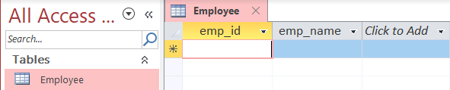

import java.sql.*;

class Exp18d {

public String database = "C:\\Users\\deong\\College\\Java\\Manual-Programs\\Experiment18\\SampleDatabase.accdb";

private Connection conn;

// Create Connection

public void createConnection() {

try {

conn = DriverManager.getConnection("jdbc:ucanaccess://" + database);

} catch (SQLException e) {

System.out.println("Connection Failed");

System.exit(1);

}

}

public void closeConnection() {

try {

conn.close();

} catch (SQLException e) {

System.out.println("Close Connection Failed ?");

}

}

public void printStudents(String where) {

try {

Statement statement = conn.createStatement();

ResultSet resultSet = statement.executeQuery("SELECT * FROM Students WHERE " + where + ";");

while (resultSet.next()) {

String employee = "Student " + resultSet.getString("ID") + ":" + "\n\tName : "

+ resultSet.getString("name") + "\n\tPercentage : " + resultSet.getString("percentage");

System.out.println(employee);

}

} catch (SQLException e) {

System.out.println("Error in Printing Employees With WHERE Condition");

}

}

public static void main(String[] args) {

Exp18d dbconn = new Exp18d();

try {

Class.forName("net.ucanaccess.jdbc.UcanaccessDriver");

} catch (Exception e) {

System.out.println("Error in Loading Driver");

}

dbconn.createConnection();

dbconn.printStudents("percentage > 70");

}

}

